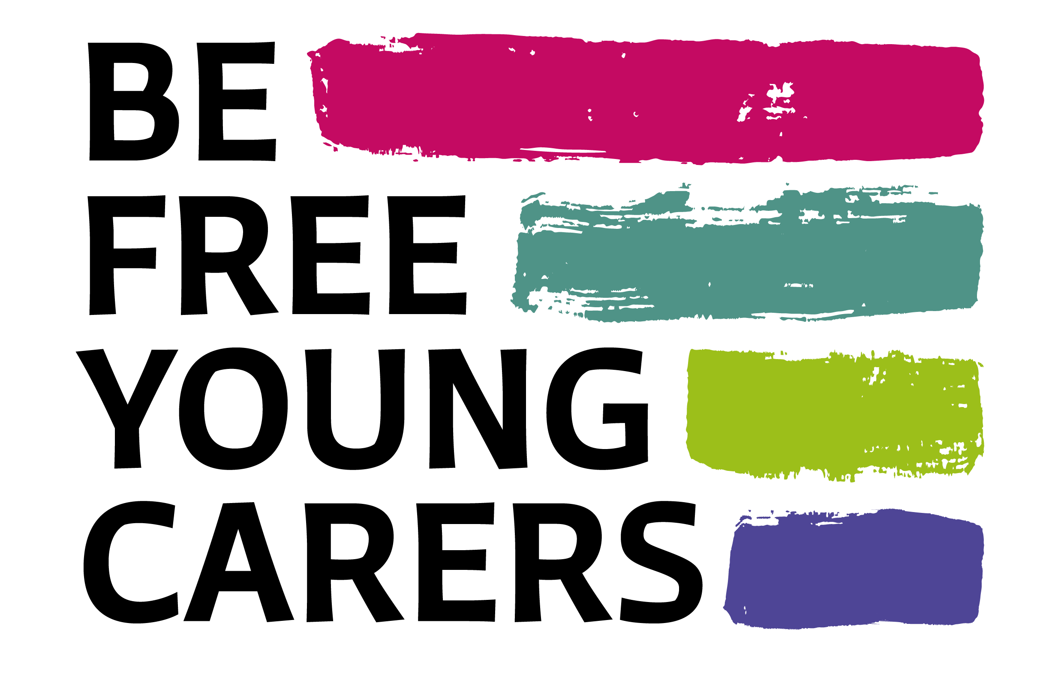

Job Description: Youth Worker

Position type: Full-time, weekend and evening working may be required.
Location: Harwell, Didcot, Oxfordshire (Hybrid)
Salary: £25,000 pa
Hours: 37.5 hours a week
Travel: Travel across Oxfordshire required, driving liscene is essential.
DBS checking: This appointment will be subject to an enhanced DBS check. BFYC is committed to safeguarding and promoting the welfare of children and young people and expects all staff and volunteers to share this commitment.

  - Job description
We are seeking a dynamic individual to join the BFYC team to support young carers in schools in Oxfordshire. Supporting young carers in and out of school, managing a monthly youth club as well as well-being support through one-to-one sessions.
You will provide support and advice to schools to enable them to become young carer friendly by improving awareness of young carers through assemblies, networking meetings and supporting young carer leads. This is a varied and exciting role.
The role involves administrative duties including adding referrals to our CRM system.
Key Responsibilities
- Establish relationships with schools across Oxfordshire offering them support in how they identify and respond to the needs of young carers in their classrooms.
- Assist schools in launching Young Carers Groups and introducing Young Carer Leads in their settings.
- Liaise and work with colleagues to empower Young Carers and their families;
- Develop the active participation of Young Carers, enabling their voice to be heard;
- Support Young Carers and their families to access appropriate support services;
- Provide one-to-one support for Young Carers, liaising with other agencies to help ensure the best outcomes for Young Carers;
- Ensure all tasks, procedures, and practices comply with Be Free Young Carers’ policies, including safeguarding and child protection, health and safety, confidentiality and equal opportunities;
- Assist in the production of newsletters and other communications to Young Carers and their families;
- Keep abreast of, and always follow, national and local policy in relation to safeguarding children and vulnerable adults;
- Monitor and evaluate work, producing records and reports as required;
- Contribute to a safe, positive and friendly working atmosphere;
- Attend training and other meetings as required;
- Monitor and evaluate work, provide reports and information to Trustees and other reporting as required;
- Assist in promoting and publicising Be Free Young Carers;
- Attend and contribute to team meetings and represent Be Free Young Carers at external meetings as required;
- Actively contribute to and support the development of Be Free Young Carers.
This job description is not intended to be comprehensive but indicative. Responsibilities may very from time to time, depending on the needs of the organisation.
  - Person specification
Essential Skills and Experience | Desirable Skills and Experience
Experience of working with children or young people. | Qualifications in a relevant field such as childcare or youth work.
Evidence of continued professional development. | Experience working towards KPIs.
Experience working within a team to achieve goals. | Good understanding of GDPR.
Effective time management skills | Experience working with databases or CRM systems.
Effective and professional communication skills in written and verbal. | Experience with working to deadlines.
Strong organisation abilities.
IT literate.

Benefits:
- 28 days annual leave (plus bank holidays)
- Company pension
- Health & wellbeing programme
- On-site parking
- Christmas shutdown & Birthday leave
- Casual dress
Schedule:
- Monday to Friday. Hybrid working.
Ability to commute/relocate:
- Work Location: Harwell, Didcot. Working across Oxfordshire.
- Must have clean drivers’ licence and access to a car.

