Role Profile
Post Title: | Website and Digital Project Manager

Post Number in PeopleHub if known:
Department: | Marketing & Communications
Job Band / Job Family: | G / Business support

Effective Date:

1. Purpose
The Website and Digital Project Manager will work with teams across the organisation (spanning healthcare, fundraising and retail) to bring innovation and best practice to life through our websites and digital services.

The role will work with colleagues to take ideas for service delivery and income generation from concept stage through to product launch, with ongoing support to ensure our digital platforms are optimised and continually improved.

2. Key relationships
- The role reports to the Senior Digital Manager
- This role line manages the Digital Officer
- The Website and Digital Projects Manager will support Online Community moderation cover
- The role is part of the Marketing & Communications team but involves liaison across most of Sue Ryder. Key internal teams are fundraising, retail, IT, bereavement and healthcare.

3. Qualifications required
- No formal qualifications, requirements specified in section 4

4. Proven knowledge, skills and ability
- Significant experience in project managing digital development projects from conception through to launch.
- A high level of digital literacy with experience of working with complex online platforms and technology to deliver services, alongside an understanding of the different areas of consideration needed to build digital products (hosting, UX, SEO).
- Demonstrable experience of working and collaborating with digital agencies and other external suppliers.
- Experience in running change management processes and appropriate communication/training with stakeholders.
- Line management experience
- Confident CMS user (Wagtail desirable)
- Understanding of best practices with digital communications, including content approaches.
- Understanding of GDPR legislation and how it relates to the capturing and storing of data across a range of services, including confidential healthcare delivery.
- Experience of monitoring user journeys and collecting insights to inform future developments and optimisations, including the use of GA4 and other insight tools.
- Understanding of the importance of developing user-led products and the benefits that this approach brings, as well as experience of using a range of methods for user input.
- Able to work independently and meet deadlines.
- Able to problem-solve and work collaboratively to find creative solutions and ways forward when faced with unexpected obstacles.
- Highly organised and able to prioritise a busy workload with changing priorities.
- Excellent communication skills, both written and verbal.
- A can-do approach - must possess a positive attitude.

Desirable Requirements
- Experience in running design sprints for product development.
- Experience in producing training documentation.
- Experience of working in a bereavement support service environment, with an understanding of the need for confidentiality and empathy that this entails.

5. Complexity and accountability
All expenditure must be signed off by the Head of Digital. The role is empowered to liaise directly with all relevant staff, volunteers, service users and supporters across Sue Ryder.

6. Key responsibilities
Website management
- Oversee the ongoing development of sueryder.org and Grief Guide, managing agency relationships and internal stakeholders.
- Support and develop the Digital Officer to maintain sueryder.org
Project management
- Lead on the development and launch of new public-facing digital platforms and projects across the full project lifecycle, as well as features and functionality to enhance existing platforms across the organisation.
- Ensure that accurate systems are in place on all new developments to track usage and gain insight into performance, to inform continuous improvement across our digital offer.
- Champion the user experience and ensure that user input is sought at appropriate points across projects - either through building our own project user panels or liaising with appropriate agencies to seek user research input.
- Produce project plans with appropriate milestones and ensure regular reporting to internal stakeholders on progress.
- Manage project budgets - including reforecasting expenditure, raising POs and logging invoices - to ensure charity money is being spent as efficiently as possible.
- Manage relationships with external suppliers and project teams and act as the point of contact between them and Sue Ryder.
- Set up and manage project groups with appropriate internal and external stakeholders.
- Manage any training of staff/volunteers on new systems as required for projects, including producing documentation.

Collaborative working
- Working closely and in collaboration with the Digital Team at all times.
- Planning collaboratively with other teams, ensuring joined-up working and user centricity.
- Networking internally with colleagues from other teams and departments, continually looking for opportunities to collaborate and learn from each other.
- Networking externally with sector and industry peers to stay on top of trends and developments.
- To be an ambassador for Sue Ryder by understanding how your role contributes to our ‘One Organisation’ vision and to demonstrate our values in all aspects of the role.
- To undertake other duties that may be necessary, that are in keeping with the nature of this role.

7. Behaviours
Operate within the Sue Ryder values and behaviours standards:
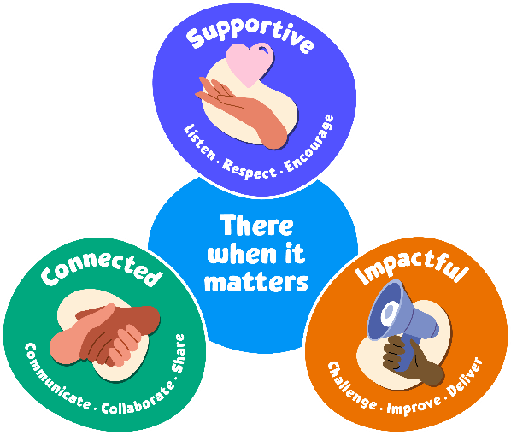
Supportive:
Our first value is supportive. We're here for people when it matters, and that includes each other. We encourage, inspire and help one another, and celebrate success.

The behaviours for this value are listen, respect and encourage.
We will take time to listen and understand; respect and value each other’s differences; and encourage and nurture each other.

Connected:
Our second value is connected. When we work together, we can achieve so much more for the people we support. We respect that everyone at Sue Ryder plays a vital part in delivering quality care.

The behaviours for this value are communicate, collaborate and share.
We will communicate effectively; actively collaborate and appreciate each other’s contribution; and share ideas, experience and knowledge.

Impactful:
Our third value is impactful. We find new and inspiring ways to positively impact the people we support – from small gestures to big breakthroughs. This proactive attitude drives us forward to achieve our ambitions and transform lives.

The behaviours for this value are challenge, improve and deliver.
We will welcome feedback and constructively challenge each other; reflect, learn and continue to improve; and each play our part to deliver the charity’s aims.

8. General
In addition to the specific duties and responsibilities outlined in this job profile, all Sue Ryder colleagues should understand the impact that their role has on achieving our organisational aims. Our values tell us how to do this, as they guide us in our choices and influence our behaviour. We ask all our staff and volunteers to follow our values while being an ambassador for Sue Ryder.
In practice, this means:
- Being able to talk confidently about Sue Ryder, our services and campaigns
- Being able to talk confidently about why we need to fundraise, how we are funded and how people can get involved
- Promoting an equitable, diverse and inclusive environment within the charity
- Keeping up to date with our internal communications; and following the correct organisation processes and using the right systems
- Always connecting with experts from across the organisation to ensure best practice and maximum impact.
Colleagues should also be aware of their specific responsibilities towards the following:
- To adhere to all health and safety and fire regulations and to co-operate with the charity in maintaining good standards of health and safety.
- To uphold ethical and professional standards and not behave in a manner that is likely to bring the charity into disrepute.
- Demonstrate a commitment to on-going registration requirements or any national professional or occupational standards associated with the role.
- Demonstrate a commitment to on-going learning and development and to participate in any training relevant to the role.
All employees are expected to be competent with the use of technology and information systems and understand their duties and responsibilities with regard to the appropriate use of data, including sensitive personal data.
This job description is not exhaustive. It merely acts as a guide and may be amended to meet the changing requirements of the charity at any time after discussion with the post holder.

