

JOB DESCRIPTION
Overview of Role

Job title | Volunteer Officer (for Hospitals)
Reports to | Volunteer Manager (for Hospitals)
Hours | 37.5 hours per week or part time by negotiation.  It is expected that work will sometimes be required outside normal working hours. However time off in lieu is offered in accordance with the policies and procedures around working additional hours.
Contract | Permanent
Location | Leeds Hospitals Charity offices / some hybrid working from home
Holiday | 27 days per year (for a full-time member of staff, pro-rata for part-time staff)
Leeds Hospitals Charity

Leeds Hospitals Charity is proud to support Leeds Teaching Hospitals NHS Trust. The Trust comprises seven hospitals and a dental institute, including Leeds General Infirmary, St James’s University Hospital, Leeds Children’s Hospital and Leeds Cancer Centre. At Leeds Hospitals Charity, we work with NHS staff to improve the experience of patients and families. We’re passionate about healthcare and about making our hospitals amazing.

About the role

The Volunteer Officer for Hospitals is responsible for the recruitment, training, induction and recognition of volunteers in our hospitals. Key to this role will be working with the Volunteer Manager for hospitals to build strong relationships with staff across the Trust, and developing and delivering robust recruitment, training and management procedures for volunteers.

This role will connect with staff across LTHT to work with volunteers effectively and creatively and will exhibit excellent recruitment and volunteer management best practice at all times.

Working with the Volunteer Manager for Hospitals this role will support the growth and development of volunteering within the Charity in line with our five-year Volunteer Strategy.

Team Structure

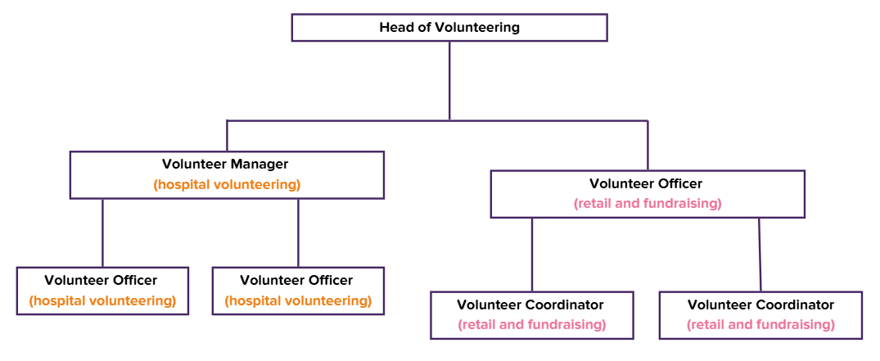
Key Job specifics and responsibilities

Recruitment, induction and recognition
- Responsible for the day-to-day processes of engaging, recruiting, and retaining a diverse team of hospital volunteers.
- Ensure that volunteers in hospital roles are recruited and inducted holistically, safely and inclusively, in line with the charity’s values – to work together, to transform and to be transparent.
- Ensure that volunteers in hospital roles are recruited in line with charity recruitment procedures and guidelines and following SAFER recruitment practices as appropriate.
- Ensure that volunteers in hospital roles are recruited in line with the agreed LTHT MOU, and in line with NHS England recruitment procedures as required.
- Work collaboratively with partnership organisations in order to promote Leeds Hospitals Charity volunteering opportunities.
- Support Volunteer Manager for Hospitals to develop and deliver a recruitment plan for hospitals volunteering to ensure recruitment targets are met.
- Support the Volunteer Manager for Hospitals on delivering a communication strategy that supports recruitment targets for your area of delivery.
- Manage corporate volunteering processes and procedures for hospital roles.
- Work with the Volunteer Manager for Hospitals to ensure that all volunteers are offered an inclusive, rewarding, sustainable and equitable reward and recognition programme that regularly says thank you and aids retention.

Training
- Deliver a volunteer training programme that ensures every volunteer in hospital roles receives appropriate mandatory and optional training as required by their role and has the opportunity for additional learning and development opportunities.
- Ensure hospital volunteers complete up to date mandatory training as provided by LTHT before starting in their roles and provide assurance on mandatory training completion including refresher training where required.
- Design and build mandatory and optional training courses for volunteers in eLearning and face-to-face formats.
- Roll out delivery of relevant follow-on training for volunteers to increase their knowledge, skills and confidence as well as to enhance Leeds Hospitals Charity as a charity.
- Work with the Volunteer Manager for Hospitals to ensure volunteers receive appropriate safeguarding training.
- Deliver volunteer management training for LHC and LTHT staff with Volunteer Supervisor responsibilities in their roles, to ensure best practice standards are maintained across the charity and the hospital in relation to managing charity volunteers.

Strategy and management
- Provide support to the Volunteer Manager for hospitals to deliver and evaluate an ambitious and impactful volunteer strategy and framework that engages all stakeholders and works alongside the charity’s strategy.
- Support the Volunteer Manager for Hospitals to deliver the hospital volunteering service for Leeds Hospitals Charity in the hospitals allocated to your role as outlined by the Head of Volunteering.
- Work with the Volunteer Manager for Hospitals and LTHT to identify and create appropriate volunteer roles that support LTHT and LHC’s strategic aims, and comply with all health & safety, safeguarding and best practice procedures.
- Line manage volunteers in specific roles offering regular 1-2-1 sessions to monitor successes, needs and aspirations from volunteering with LHC – including pathways into paid employment.
- Be a creative leader of volunteers committed to the ongoing development and improvement of procedures, services and ways of working.
- Work with the Volunteer Manager for Hospitals to build a culture of volunteering across the charity that champions the voices of volunteers and captures and promotes the impact of volunteering.
- Produce weekly, monthly and quarterly recruitment and training reports as required by the Volunteer Manager for Hospitals.
- Build and maintain networks across the city with third sector and private sector organisations, identifying potential for collaboration and partnership.

Governance
- Keep up-to-date with all legal requirements concerning the recruitment and placement of volunteers.
- Ensure risk assessments are up to date for all roles in your area of delivery.
- Responsible for identification and management of risks relating to volunteering in the hospital and reporting these to the Volunteer Manager for Hospitals.
- Adhere to all policies and procedures in relation to volunteering across the charity, ensuring all volunteering activity in the hospital complies with best practice
- Responsible for ensuring that the volunteer management database (CRM) is kept up to date for hospital volunteering and utilised in line with internal processes.
- Ensure the terms of the Memorandum of Understanding with LTHT are upheld in hospital volunteering to ensure standards are met and assurance is provided related to volunteers working on hospital premises.
- Responsible for supporting staff across the charity with problem solving issues relating to conduct and behaviour, in line with the Problem Solving Procedure.
- Responsible for reporting volunteer safeguarding concerns or issues to the Volunteer Manager for Hospitals.
- Responsible for reporting volunteer complaints to the Volunteer Manager for Hospitals.

Other
- Work with the Volunteer Manager for Hospitals to identify areas for improvement in your area of delivery using reports and data to drive decision making.
- Ensure accurate and auditable volunteer records are maintained.
- Provide occasional support to other areas of the Volunteer Services Team as required.
- Undertake other tasks from time to time as appropriate and required by management in line with the goals of the organisation.

Other

Confidentiality and Data Protection Act
All employees of the Charity must not, without prior permission, disclose any information regarding patients or staff. In instances where it is known that a member of staff has communicated information to unauthorised persons, those staff will be liable to dismissal. Moreover, the Data Protection Act 1998 also renders an individual liable for prosecution in the event of unauthorised disclosure of information.

Health & Safety
All staff are required to make positive efforts to maintain their own personal safety and that of others by taking reasonable care, carrying out requirements of the law whilst following recognised codes of practice and policies on health and safety

Service Excellence
All staff are required to support the Charity’s commitment to developing and delivering excellent customer-focused service by treating patients, their families, friends, carers and staff with professionalism, respect and dignity.

Equality Diversity & Inclusion
No job applicant or employee is discriminated against either directly or indirectly. The Charity commits itself to promote equal opportunities and will keep under review its policies, procedures and practices to ensure that all users and provides of its services are treated according to their needs

Disclosure & Barring Service
If you are offered a position, you may be required to undertake a DBS. The Charity may administer the DBS check on your behalf or you may be asked to undertake it yourself and report the result. The Charity will cover the cost. You may also be required to participate in the DBS Update Service. This is a condition of your employment.

Review of Job Description
This job description and person specification are an outline of the tasks, responsibility and outcomes required of the role. The job holder will carry out any other duties that may reasonably be required by their line manager and amended in the light of the changing needs of the organisation, in which case it will be reviewed in conjunction with the post holder.

Terms & Conditions
As this post is based on NHS hospital premises, this post is exempt from the Rehabilitation of Offenders Act 1974, meaning that any criminal conviction must be made known at the time of application and interview. The NHS Employment Checks Standard will apply to all applicants.

Charity Activity

Charitable Activities 20% Raising Funds 80%



PERSON SPECIFICATION

 | Criteria | Measured by:
Knowledge & Experience

Essential | - 2+ years’ experience of recruiting volunteers or paid staff.  - Experience of monitoring and evaluating volunteering programmes.  - Understanding of SAFER recruitment practice.  - Experience of delivering training in different formats.  - Experience of building strong and effective partnerships.  - Experience of effectively working with stakeholders internally and externally at all levels  - Experience in the use of I.T., Microsoft Office Software and Canva.  - Experience of effective problem solving, including making difficult judgements and decisions in sensitive situations.  - Knowledge and understanding of volunteer best practice.  - Knowledge of safeguarding and GDPR in a volunteer setting. | CV/Application form & Interview
Skills and Attributes

Essential | - Excellent attention to detail for operational planning and delivery.  - Excellent team working skills, with an ability to build and maintain effective relationships.  - Strong written and verbal communication skills, including networking, influencing and relationship-building skills.  - Ability to work to deadlines and achieve results.  - Strong interview, training and presentation skills.  - Empathy and the ability to manage emotive situations with tact and compassion.  - Ability to appropriately challenge inappropriate behaviours. | CV/Application form & Interview
Education/Qualifications/Professional Registration

Essential | - Willing to enhance their own knowledge and actively share that knowledge with others. | CV/Application form/Certificates
Other

Essential | - An understanding of and able to demonstrate the Leeds Hospitals Charity values.  - Self-motivated, takes personal pride in work.  - Willing to work flexibly to meet demands of the team.  - Positive attitude, courteous and respectful towards the charity.  - Responds well to change  - Ability to work evenings and weekends as required.  - Willingness to regularly travel across Leeds as required.  - Eligibility to work in the UK. | CV/Application form/Certificates

