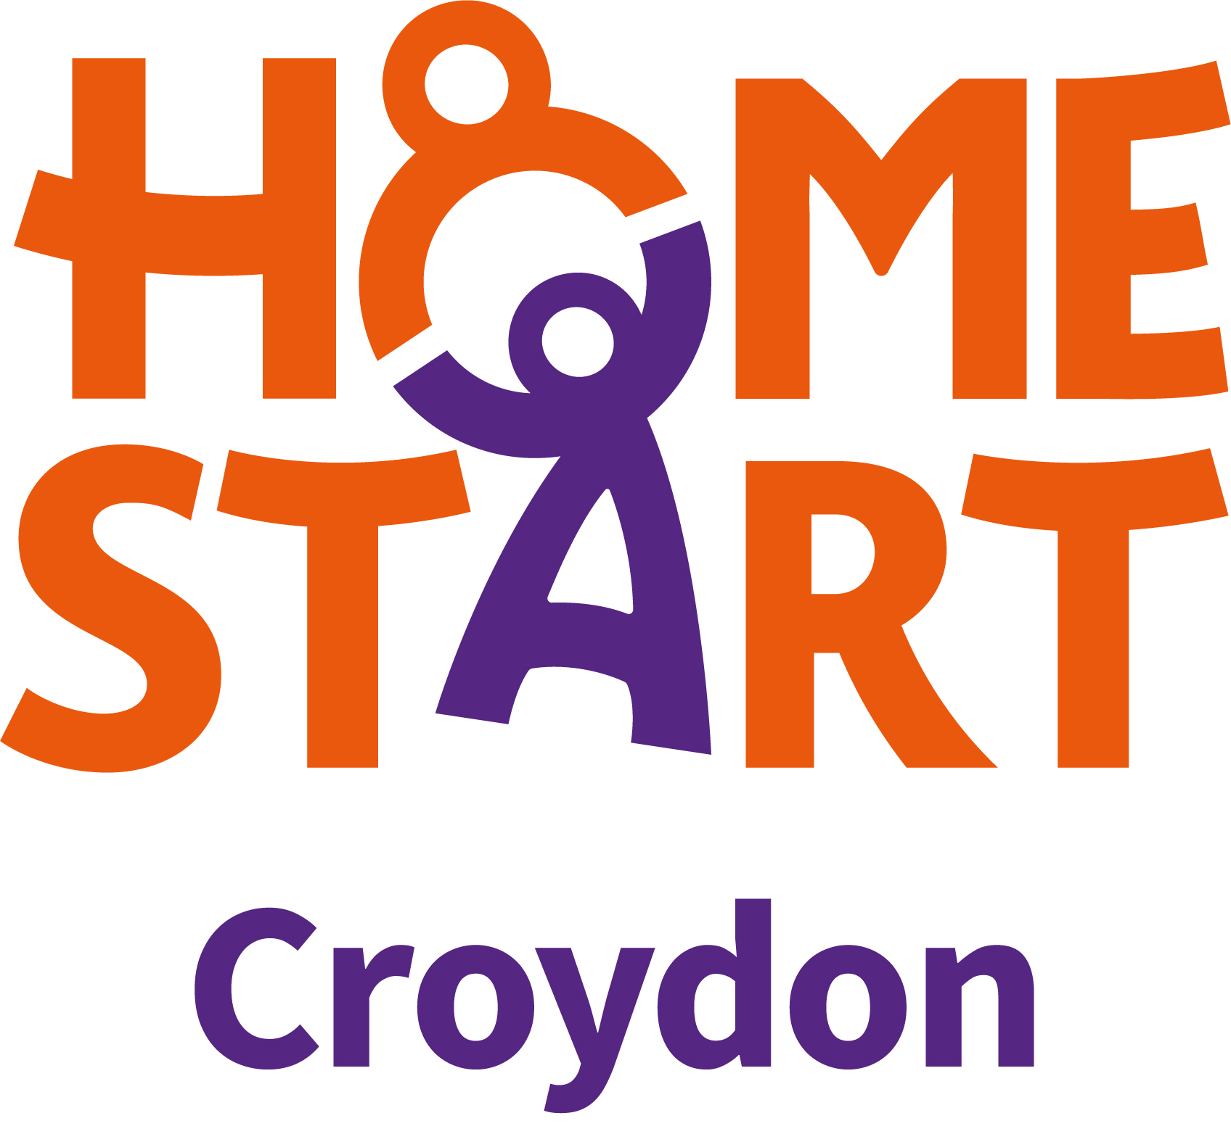

Equal Opportunities Monitoring Form – Volunteers
To ensure Home-Start Croydon’s implementation and development of its Equality Fairness and Diversity Policy, volunteer applicants are asked to complete the details below. This information, which will be used solely for monitoring purposes, will be treated as confidential and will be separated on receipt of the application form. The basic information on these forms will be transferred to a summary sheet for the purpose of retaining overall statistical information and will remain anonymised. The responses to these questions will not affect your application in any way.

Which ethnicity do you identify with?

Asian or Asian British  ☐ Indian  ☐ Pakistani  ☐ Bangladeshi  ☐ Chinese  ☐ Any other Asian background | Black, Black British, Caribbean or African  ☐ Caribbean  ☐ African  ☐ Any other Black, Black British or Caribbean background | Mixed or Multiple Ethnic Groups  ☐ White and Black Caribbean  ☐ White and Black African  ☐ White and Asian  ☐ Any other mixed or multiple ethnic background
White  ☐ English, Welsh, Scottish, Northern Irish or British Irish  ☐ Irish  ☐ Gypsy or Irish Traveller  ☐ Roma  ☐ Any other White background | Other Ethnic Group  ☐ Arab  ☐ Any other ethnic group

Which gender do you identify with?  ☐ Female  ☐ Male  ☐ Other | Do you consider yourself to have a disability?  ☐ Yes  ☐ No
What is your religion or belief?

☐ No religion
☐ Christian (including Church of England, Catholic, Protestant, and all other Christian denominations)
☐ Buddhist
☐ Hindu
☐ Jewish
☐ Muslim
☐ Sikh
☐ Other religion (please specify) ___________________

