
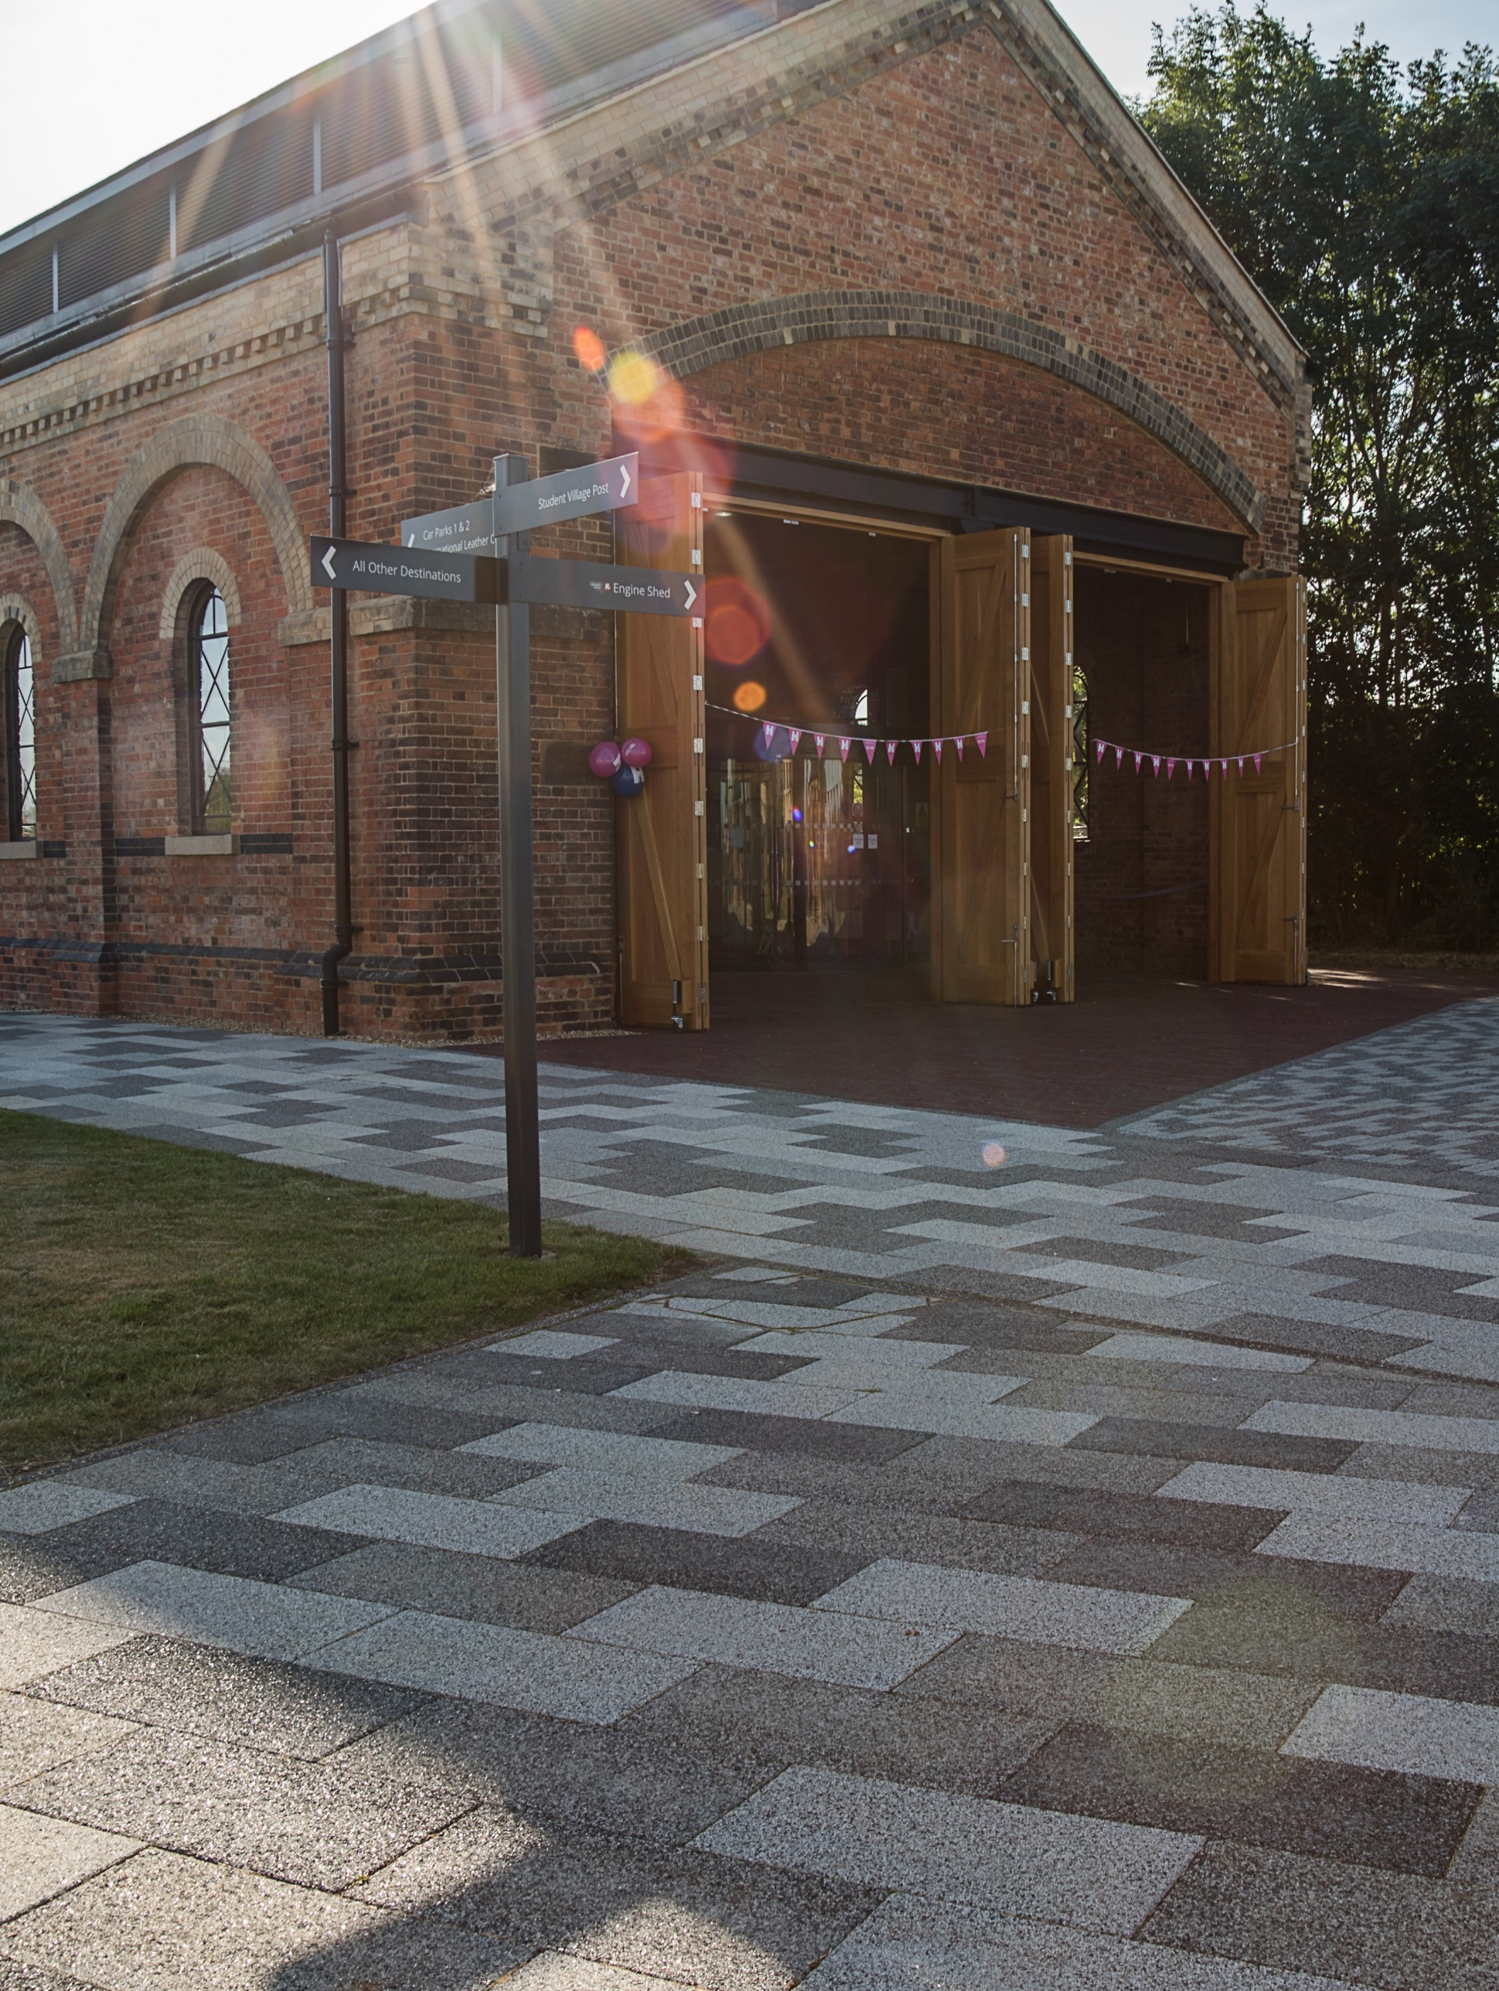
VENUE &
COMMERCIAL
MANAGER
JOB DESCRIPTION

Grade: Grade 6- £32,080 - £38,784
Responsible to: Head of Finance & Compliance
Responsible for: Deputy Venue Manager, Casual Bar and Catering Staff, Venue Security
Functional Relationships: SU CEO & Senior Leadership Team, Elected Officers, Management Accountant, Operational Leads, External clients, University Estates & Campus Services Directorate, Licencing Officer

A MESSAGE FROM THE DEPUTY CHAIR OF THE BOARD OF TRUSTEES AND CHIEF EXECUTIVE OFFICER


Thank you for considering a role with Northampton Students’ Union! As a student-led organisation, we are here to represent, support, and empower every student at the University of Northampton. Our work is driven by the needs and voices of our members, and we are constantly striving to create a positive and enriching experience for all students. By joining our team, you will be part of an organisation that is committed to making a real difference in students' lives.
Tobi Oyelami
Communities Officer 26-27

The Students’ Union is an exciting and dynamic place to work, where no two days are the same. We provide vital services, deliver impactful campaigns, and create opportunities for students to develop, grow, and thrive. Whether you are directly engaging with students, generating income for the organisation, or working behind the scenes, your contribution will play a crucial role in shaping our success and ensuring we continue to support our members in the best way possible.

We are always looking for passionate, dedicated individuals who believe in our mission and want to help us build a stronger, more inclusive community. If you share our vision of a Students’ Union that puts students first, champions diversity, and drives positive change, we would love to hear from you. This is an exciting time to join us, and we look forward to welcoming you to the team.


Set within a beautifully restored Grade II Victorian railway building, The Engine Shed is the social heart of Waterside Campus. By day, our Bar & Café offers students a welcoming space to connect, celebrate, and co-create. By night and outside term-time, the venue transforms into a distinctive destination for student events, private conferences, corporate events, weddings, an d community gatherings.
With sustainability at our core, we combine historic character with modern capability, delivering unforgettable experiences while supporting student engagement, local partnerships, and environmental responsibility.
The Venue & Commercial Manager will lead the operational, commercial, and creative development of The Engine Shed. This is a hands-on leadership role, balancing day-to-day oversight with strategic growth. You will ensure seamless delivery of student events, corporate functions, and weddings, while fostering a culture of inclusivity, sustainability, and exceptional service.
STRATEGY 2023-27
Roger Weston
Chief Executive Officer

OUR VISION

We are at the heart of student life, ensuring our students have an exceptional university experience.

OUR MISSION
Together we strive to improve the university experience by:
- Inspiring students to build strong communities where they flourish individually and collectively.
- Empowering students to make positive changes on behalf of the student community.
- Supporting students through their academic journey.

OUR GOALS
Goal 1: A Better Students’ Union- We will be at the heart of student life, increasing student engagement in union activities, involving them more in decision-making, listening to their views, and broadening our appeal.
Goal 2: An Excellent University- We will curate a strong partnership with the university at all levels by becoming a reliable and credible source of insight, establishing ourselves as a vital stakeholder, especially when decisions are made affecting students. We are firm in our belief that by responding to student opinion, the University will make effective and experience-improving changes.
Goal 3: Maximising Our Town- We will connect students with the best Northampton has to offer, as well as working with local stakeholders to improve students’ experience when living and/or studying in the town.

OUR THEMES
Theme A: Building strong student communities- We are dedicated to the development of student communities on and off campus. We want to bring students together to improve their experience and sense of belonging to the union, university, and the town.
Theme B: Empowering students to co-create an outstanding academic experience- The SU empowers student reps and groups to provide a strong, coherent voice to the university and wider community, ensuring decision making is always informed by student opinion. Our core responsibility is to make sure student voice is valued and acted upon in all areas of the institution.
Theme C: Ensure our students have the support they need to help them succeed at university- We will develop and improve SU services, and partner with UON and community support services to give students the wraparound support they need to flourish in Higher Education.

JOB DESCRIPTION

PRINCIPAL DUTIES AND RESPONSIBILITIES OF POST-HOLDER

Operational Oversight

Lead daily operations across conferencing, events, and the Bar & Café, via line management of the Deputy Venue Manager.

Ensure all areas are maintained to the highest standards of cleanliness, safety, and compliance.

Develop and implement operational policies and procedures to enhance efficiency and service quality.

Regularly evaluate venue operations and identify opportunities to develop new income streams, enhancing financial sustainability.

Create and present regular performance reports, business plans/development plans to the commercial strategy meeting'

Event Management

Plan, coordinate, and deliver a diverse range of events, from student socials to corporate conferences, private bookings and weddings.

Develop and execute a business plan to establish The Engine Shed as a premier wedding & events venue in Northamptonshire.

Liaise with clients to understand their vision and ensure bespoke, high-quality delivery.

Oversee event logistics, staffing, and setup to guarantee seamless execution.

Monitor and report on conversion metrics across the customer journey from web clicks to enquiries, enquiries to quotes, and quotes to confirmed bookings, ensuring the venue achieves maximum booking potential.

Team Leadership

Recruit, train, and supervise venue staff, including baristas, bartenders, waitstaff, and event coordinators.

Mentor student staff, supporting their professional development and transferable skills.

Foster a positive, collaborative team culture aligned with Students’ Union HR policies.

Manage staff rotas to ensure optimal coverage, cost, and service.
- Lead on required management process with staff team, including PDR's, performance and absence management.

Customer Experience

Work with our Membership Services team to deliver outstanding student-led events.

Ensure a consistently high standard of customer service across all operations.

Handle enquiries, feedback, and complaints with professionalism and care, ensuring that appropriate actions are taken to improve customer experience.

Create a welcoming, inclusive atmosphere for all guests and clients.

Financial Management

Manage budgets in consultation with the Head of Finance & Compliance, monitoring financial performance and profitability.

Revise and implement pricing strategies and implement cost-control measures.

Oversee inventory management, ordering, and stock control for the Bar & Café.

Ensure compliance with financial policies, particularly cash handling, purchasing, and stock control.

Marketing & Promotion

Collaborate with the Marketing & Communications Manager to design and deliver marketing strategies.

Work with the communications team to create promotional campaigns and materials.

Build and maintain relationships with local businesses, community groups, and potential clients.

Champion The Engine Shed’s sustainability credentials as part of its brand identity.

Health, Safety & Compliance

Act as the designated Premises Supervisor, ensuring compliance with the Licensing Act 2003.

Conduct regular risk assessments and implement safety measures.

Ensure compliance with all health, safety, and licensing regulations.

Provide staff training on health and safety procedures and emergency protocols.

To contribute to the overall effectiveness of the Union:
- Actively participate in meetings, personal development, and training events where there is a clear link to our strategy, your role or personal development.
- Ensuring that statutory and legal obligations are met.
- Ensure our financial sustainability by adhering to all financial procedures and processes of the Students’ Union.
- Promoting the Students’ Union’s various policies within your work, in particular Health & Safety, Equality & Diversity, Ethical, and Environmental.
- Contributing to the positive image of the Students’ Union with students, the University and the local community.
- Working across the Union to share skills, improve capability or capacity and in support of service delivery.
- Be flexible in your approach to work, ensuring you can work at any site as required, and unsociable hours as required to enable us to fulfil our mission.
- The job description may be altered at any time in the future in line with the level of the post to meet changing requirements, please be assure that this will only be done in full consultation with the post holder.
- Such other duties and projects as may be reasonably prescribed by the Union, appropriate to the grade and responsibilities of this post.

PERSON SPECIFICATION
The person specification will be assessed initially by the application form, followed by Interview and if required, assessment.
Attributes | Criteria | Required | Desired | Assessment Methods:  - Application Form  - Interview  - Assessed Exercise(s)
Qualifications |  |  |  | • Application Form
Skills, Knowledge and Experience | Proven experience in venue management and Business Development. | X |  | • Application Form  • Interview  • Assessed Exercises
Skills, Knowledge and Experience | Strong leadership and team management skills, with experience of supervising diverse teams | X |  | • Application Form  • Interview  • Assessed Exercises
Skills, Knowledge and Experience | Excellent customer service and communication abilities. | X |  | • Application Form  • Interview  • Assessed Exercise(s)
Skills, Knowledge and Experience | Excellent with numbers and a strong financial acumen, with experience managing budgets and financial reporting. | X |  | • Application Form  • Interview  • Assessed Exercise(s)
Skills, Knowledge and Experience | Knowledge of health and safety regulations within the hospitality and events industry. | X |  | • Application Form  • Interview  • Assessed Exercise(s)
Skills, Knowledge and Experience | Ability to work flexible hours, including evenings and weekends. | X |  | • Application Form  • Interview
Skills, Knowledge and Experience | A passion for delivering high-quality service and creating memorable experiences. | X |  | • Application Form  • Interview  • Assessed Exercise(s)
Skills, Knowledge and Experience | Personal Licence holder, or willingness to undertake personal licence training to become the venue’s Designated Premises Supervisor. | X |  | • Application Form  • Interview
Skills, Knowledge and Experience | Experience in wedding or corporate event planning. |  | X | • Application Form  • Interview
Skills, Knowledge and Experience | Background in student-focused or community venues. |  | X | • Application Form  • Interview
Skills, Knowledge and Experience | Familiarity with digital booking, event management, or marketing systems. |  | X | • Application Form  • Interview
 | Demonstrable experience of driving venue growth through data led decision making |  | X | • Interview

HYBRID WORKING

The Union is committed to supporting a flexible approach in the way we work, to meet staff’s individual needs and the Union’s organisational needs. Building on our Flexible Working policy, we recognise that the option to work remotely increases efficiency, engagement, and employee satisfaction.
Whilst hybrid working is an option, the Union will accommodate staff working from wherever they feel comfortable, including their homes or campus. The Union will not allow staff to work from outside of the UK, unless they are representing the Union at a work-related event. Managers will discuss individual needs, preferences, and circumstances with staff to find the best working arrangements that balance with the requirements of the role.
- Frontline roles (e.g., Uniexpress Retail assistant) will not be able to request for hybrid working due to the nature of their work.
- Student Facing roles (e.g., sports and societies) should be on campus at a ratio of 4:1 (80%) during term time. If the service allows, this could be flexed 3:2 (60%) during non-term time.
- Office Based roles (e.g., finance) should be on campus at a ratio of 3:2 (60%). If the service allows, this could be flexed 2:3 during non-term time (40%).

This role is classified as “Frontline”

OFFICE USE
Name of role | Area of Work | Version | Approval Committee | Approval Date | Revision Date
Venue & Commercial Manager | Commercial Services | 1 | HR (Ops) | 29/06/26 | 29/06/26

