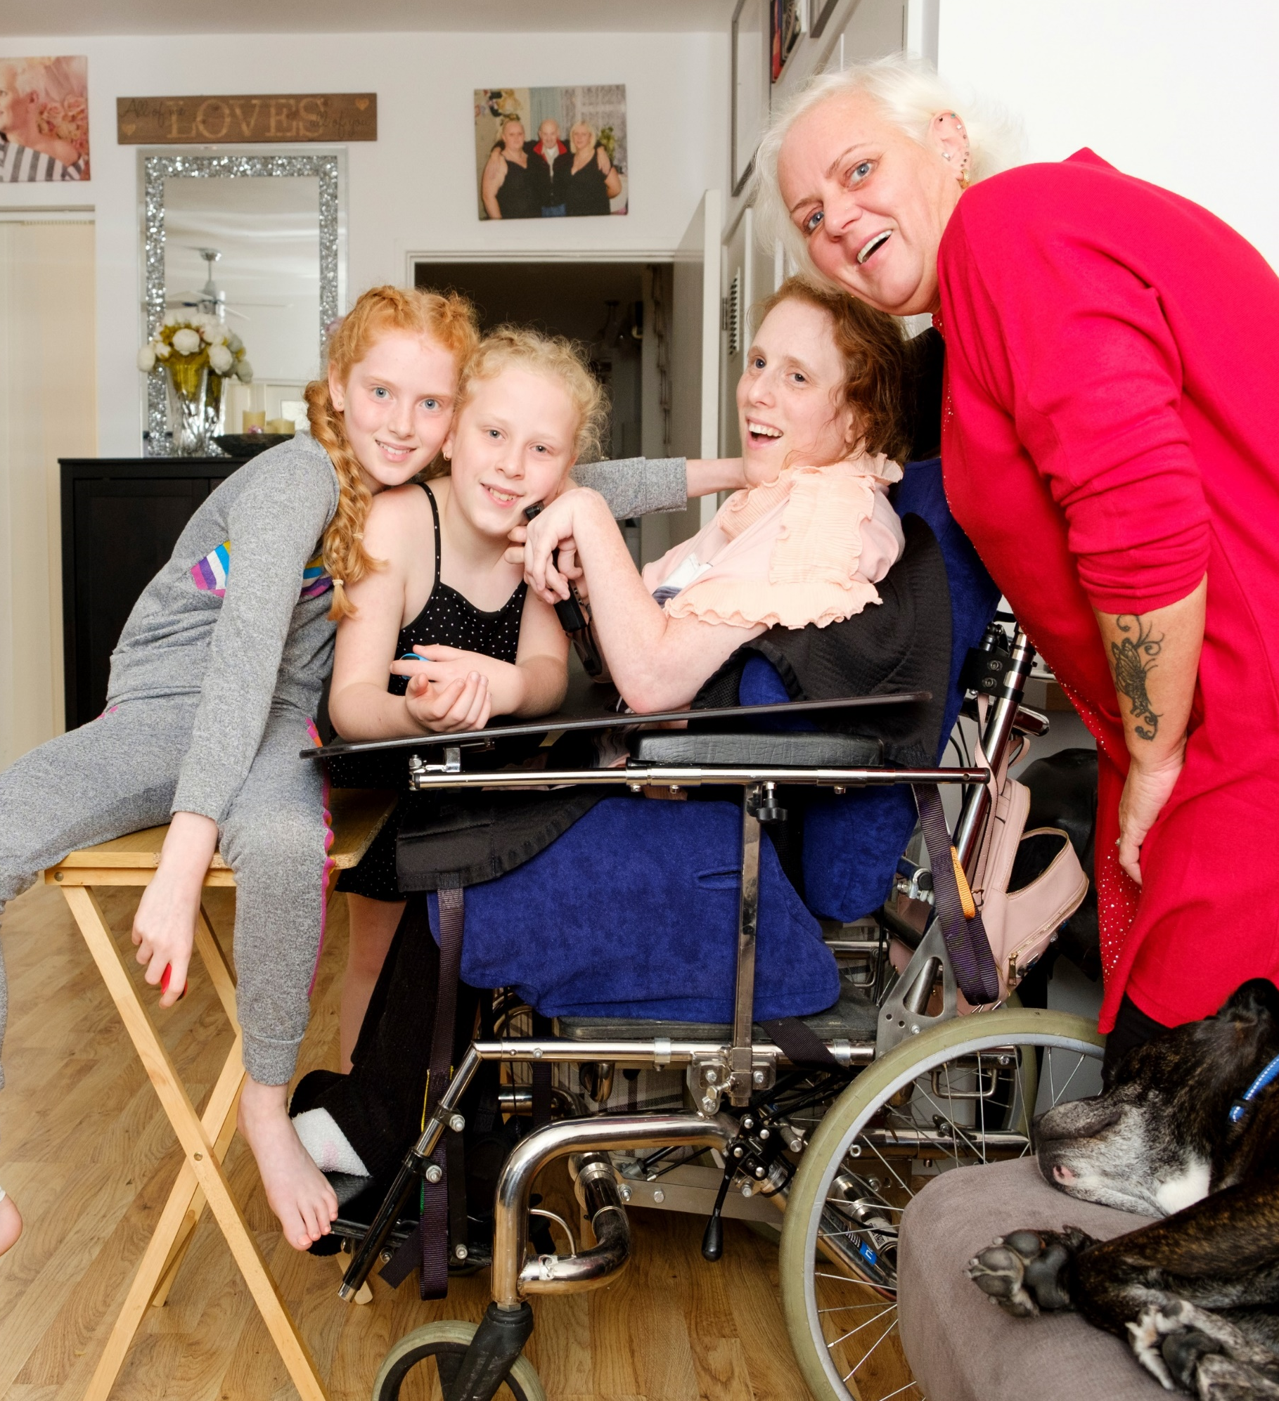


Candidate Pack
Carer Support Adviser (Essex)

Welcome

Thank you for your interest in working for Carers First as our next Carer Support Adviser (Essex).

This is a rewarding role which involves home working and some travel within the Essex Locality.

You will be joining a charity that has a new ambitious three-year strategy to grow our reach, support and impact for carers, working in collaboration and partnership with a range of statutory, voluntary and commercial organisations.

To be successful in this role you will need:

- Experience in the health and social care sector (desirable not essential)
- Proven ability to assess and support individuals’ needs effectively
- Strong written and verbal communication skills to create carer assessments, support plans and maintain accurate care records
- Confidence in using databases and digital systems for timely record-keeping
- A sensitive and respectful approach to building positive relationships with those you support
- Working knowledge and practical experience in safeguarding
- Commitment to promoting equality, diversity, and inclusion across all services

If you have the passion and drive to make a difference and you have the experience and skills we are looking for, we are keen to meet you - and welcome you to our dedicated and talented team.

Warmest wishes

Kelly Rust
Chief Executive



About us
We understand that life as a carer can be challenging. Getting the support and help you need shouldn’t be.
Any of our lives could be turned upside down due to the ill-health, frailty or disability of a family member or friend. In fact, two in three of us can expect to become a carer in our lifetime.
There are currently 5.7 million unpaid carers in the UK, however carer charities estimate that number could be as high as 10.6 million. Their huge contribution saves our economy £184 billion each year - the cost of a second NHS. Each carer’s needs and situation are unique, but many face similar challenges. They can struggle to balance employment, finances, or their own wellbeing and time for themselves with their caring role. They may not be aware of the help and support available to them - and that is why we are here.
Carers First works directly with, and for carers, providing personalised information and tailored support in the way that suits them: online, on the phone, or face to face in their local community. With the help of our supporters and volunteers, we can continue to be there for carers, helping them find balance, and to live their lives to the fullest - today, and for years to come.

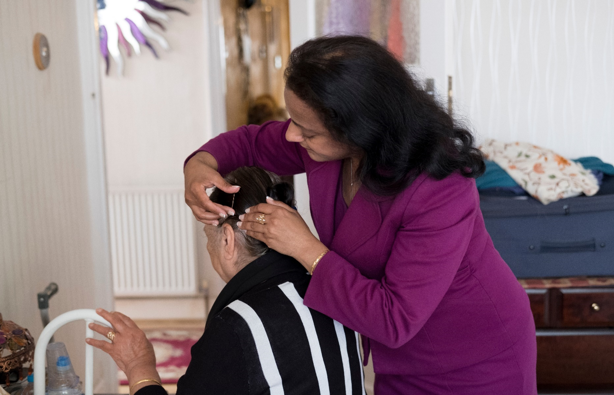
Our values
We are:

Positive
We are dedicated to working with carers to make a positive, material difference in their lives. We celebrate diversity and work in an inclusive, positive and supportive way, actively listening and valuing everyone’s contribution.

Collaborative
We recognise the importance and strength of working in collaboration with local and national organisations to deliver improved support to carers. We also know the importance of collaborating with our Carers First colleagues, sharing knowledge and learning, being curious, respecting differences and working with integrity and transparency.

Ambitious
We are ambitious and tenacious in our determination to support more carers in better ways. We will innovate and develop our programmes of support, so more carers are able to obtain the support they need, at the time they need it, to achieve a balance in their lives and enable them to live their lives to the fullest.

Diversity and Inclusion

We are proud to be a diverse and inclusive workplace.
Carers First is committed to promoting equal opportunities in employment. Employees and any job applicants will receive equal treatment regardless of age, disability, gender reassignment, marital or civil partner status, pregnancy or maternity, race, colour, nationality, ethnic or national origin, religion or belief, sex or sexual orientation (Protected Characteristics).

Carers First has an absolute commitment to equality and diversity which is about:
- Recognising and valuing difference.
- Recognising and seeking to redress inequality and disadvantage.

Our commitment is firmly founded on our belief that:
- To offer services that are personal, committed and creative we need a diverse staff team who can respond to our carers as individuals.
- To attract, keep and motivate the most talented staff, we need to:
  - Reach out to all sections of the community.
  - Provide a working environment in which everyone feels valued, respected and able to contribute.

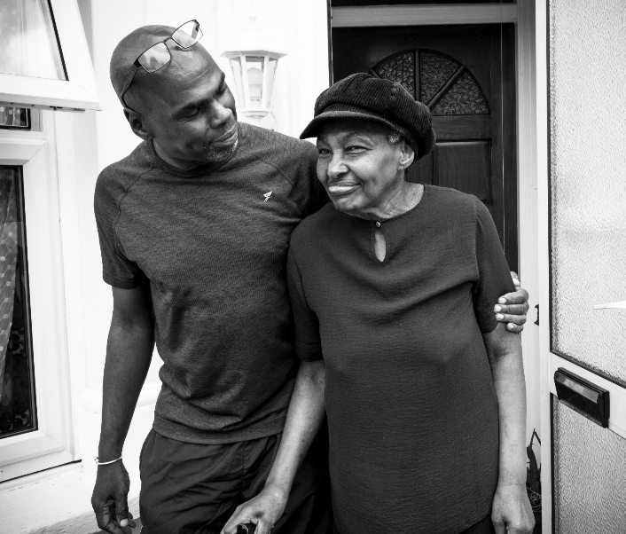
The charity recognises that true diversity in service delivery provision and within the staff group also involves a willingness to act, where necessary, at combating the effects of existing barriers to fair and equal treatment.

Our strategy 2024-2027

Our three-year strategy will enable us to grow our work to reach and support significantly more carers, deliver innovative programmes of support in coproduction with carers and forge new collaborations to scale our reach, support and impact for carers.
Strategic Objectives
Over the next three years Carers First will:

- Reach and engage more carers early in their caring role
- Develop new innovative models of collaboration, delivery and programmes with the potential to scale our reach and impact
- Achieve the highest quality of support possible, so we can maximise the difference made to carers lives
- Champion talent and diversity
- Grow and diversify our income to enable us to achieve more for carers.
Our support and services are designed with carers, ensuring the support we offer is inclusive and accessible to all carers in different communities.​
By joining Carers First, you will play a vital part in helping us achieve this. You can help us achieve something amazing.

How we work

We support young carers, young adult carers and adult carers throughout England with our comprehensive online offer including information, advice and guidance, tools, resources and training, as well as through our vibrant online peer support communities.

We also deliver locally commissioned services in Lincolnshire, Essex, Medway, Southend and in four London Boroughs.

We offer a range of support options for carers to access in ways that work best for them:

- Face-to-Face Support: Available both one-to-one and in group settings, providing personalised and community-based assistance.
- Online Support: Accessible resources and virtual sessions to ensure carers can connect with us anytime, anywhere.
- Dedicated Helpline: A trusted source of advice, guidance, and a listening ear for carers navigating their journey.
- Extensive Online Resources: Comprehensive and easy-to-use tools, guides, and information to empower carers with knowledge and confidence.
- Collaborative Partnerships: Working with organisations and communities to provide a seamless network of support tailored to carers’ needs.
Our impact and reach
Carers First Impact Framework sets out our Theory of Change and the measures and tools we use to understand the outputs, outcomes and impact of the support we provide.

Last year, we reached over 330,000 people to provide information about caring and 51,000 carers are registered with us to receive information and support.

In numbers

- 96% of carers felt more resilient in their caring role after our support.
- 95% of carers felt listened to and that their own needs were taken into account through our interventions.
- 93% of carers felt more confident and informed in their caring role after our support.


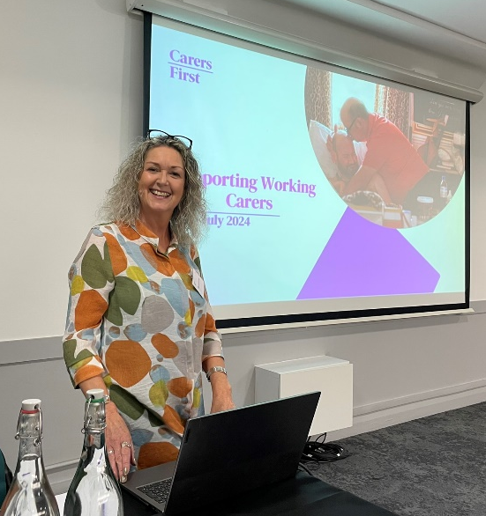


Join our team

When you join Carers First, you join a vibrant, inclusive, and supportive team who all have a shared interest in supporting unpaid carers to continue living their lives to the fullest, across the country.

In a community dedicated to caring, we believe that our employees and volunteers really do make a difference, therefore, we emphasise the importance of learning and development, as well as actively encouraging them to develop their skills with our fantastic learning and development programme. This means that all of our team become the best that they can be, whilst helping others do the same.

The role

Job Title: Carer Support Adviser (Essex)
Salary range: £24,454.04-£27,501.64 per annum
Contract: Permanent
Hours: 37 hours per week
Location: This is a Hybrid role which involves community working in Mid Essex and some home working

Job Description

Job title: Carer Support Adviser (Essex)

Reports to: Team Lead (Essex)

Purpose of the role: Supporting and working collaboratively with carers as part of a team, to deliver an innovative and engaging service which meets the needs of carers across Essex

Job Overview

The Carer Support Adviser will

- Supporting carers through collaborative working, ensuring their voices are heard and their needs are met

- Identifying opportunities for service improvement and drive new initiatives that respond directly to Carers’ experiences

- Building relationships with local community organisations to develop strong partnerships and enhance support networks

Responsibilities and Duties

- Supporting carers through collaborative working, ensuring their voices are heard and their needs are met

- Provide tailored information, advice, and support to carers in various settings including face to face, online and over the telephone.
- Providing a range of well led and innovative carer activities facilitating both 1:1 and groupwork sessions
- Follow all Carers First’s policies and procedures, adhering to relevant legislation
- Build an understanding of carers’ issues and keep abreast of changes within local and national policy and sources of support
- Ensure safeguarding is everyone’s priority, ensure adherence with Carers First safeguarding policy and in accordance with national guidance
- Undertake periodic reflective practice sessions to ensure continuous self-development
- Where localised support is not accessible or available, work collaboratively with carers to identify and access alternative grants and funding where appropriate to support their caring role.

- Identifying opportunities for service improvement and driving new initiatives that respond directly to carers’ experiences

- Ensure that carers have a say in the development, evaluation and planning to shape future service delivery
- Ensure carer support is informed by personalised engagement with carers which enables them to have a say to shape future service delivery
- Support with identifying small grant funds to add value to the range of wellbeing activities provided
- Use a range of mediums and platforms to provide a blended approach to widen access to services by carers including digital and virtual online opportunities as well as direct face to face engagement

- Listening to the carers voice, gaining feedback and using this to charge and improve service provision

- Building relationships with local community organisations to develop strong partnerships and enhance support networks

- Work with local community organisations in Essex to identify gaps in service provision for carers, promoting Carers First ‘s mission to reach more carers
- Raise the carers profile across the local area developing and maintaining Carers First excellent reputation, representing the charity professionally and with integrity
- Advocate for carers, ensuring that their views and opinions are heard across the networks engaged
- Work with the communications team to promote activities through all mediums including e-news and social media
- Ensure all external communications to carers, partners and stakeholders are in line with the Carers First brand, values and ethos.

These are the normal duties that are required for this position. However, it is necessary for all employees to be flexible, and they may be required, from time to time, to perform other duties as may be required for the efficient running of the charity. This Job Description is non-contractual, it will be subject to reviews and may change.

The postholder will take responsibility to integrate safeguarding into all aspects of their work, complying with organisational policies and frameworks.

The postholder will be expected to ensure that their work complies with contractual terms and conditions, the charity’s policies and procedures and key legislation, including the General Data Protection Regulation (GDPR) and charity law.
Person Specification

Qualifications

Education

- NVQ level 2 education or equivalent relevant experience

Skills and Experience

Working with Carers

- Experience in the health and social care sector (desirable not essential)
- Proven ability to assess and support individuals’ needs effectively
- Strong written and verbal communication skills to create carer assessments, support plans and maintain accurate care records
- Confidence in using databases and digital systems for timely record-keeping
- A sensitive and respectful approach to building positive relationships with those you support
- Working knowledge and practical experience in safeguarding
- Commitment to promoting equality, diversity, and inclusion across all services

Communication and stakeholder engagement

- Evidenced of the ability to network, develop and sustain joint work between agencies, including establishing good working relationships
- Experience of working in partnership with other organisations to deliver a range of support to individuals and families
- Ability to build positive and constructive working relationships with colleagues at all levels across the organisation

Personal Qualities

- Ability to demonstrate understanding of and an ambitious commitment to the goals and values of the charity.
- Demonstrate a positive level of professional credibility, integrity, and emotional resilience.
- Self-motivated, collaborative, and able to work flexibly, whilst maintaining good work/life balance.

Rewarding our employees
We provide a reward package for our employees upon joining Carers First.
Our reward package includes:
- 26 days Annual Leave which increases with continuous service + Bank Holidays.
- 1 days Birthday Leave
- Benenden Private Healthcare Membership (following successful probationary period)
- Pension
- Death in Service Benefit
- Employee Assistance Programme
- Carer Passports
- High Street Discount Platform
- Flexible Working Options

How to apply
To apply for a role with Carers First, please complete in full our online application form via our website: https://www.carersfirst.org.uk/about-us/working-for-us/

Appointments are subject to Carers First receiving an appropriate disclosure from the Disclosure and Barring Service that we consider acceptable.

We encourage and welcome applications regardless of gender, ethnicity, religion, disability, sexual orientation or age.

If you would like to discuss this role confidentially, please contact us at, recruitment@carersfirst.org.uk, and we will be happy to organise one of the Team to contact you.

Interview process

All successfully shortlisted candidates will be contacted directly and invited to interview. Date to be
confirmed.

Tips on completing your application
- Read the Job Description and Person Specification carefully.
- Be sure to include your employment history, details of relevant duties to the role you are applying for and any transferable skills you may have.
- Include any other work or volunteering experience you have which you feel is relevant.
- Read the Skills and Experience required for the role in the Person Specification and demonstrate clearly in your application evidence of how you meet each of these.

Office:
Michael Gill Building, Tolgate Lane, Strood, Kent ME2 4TG




