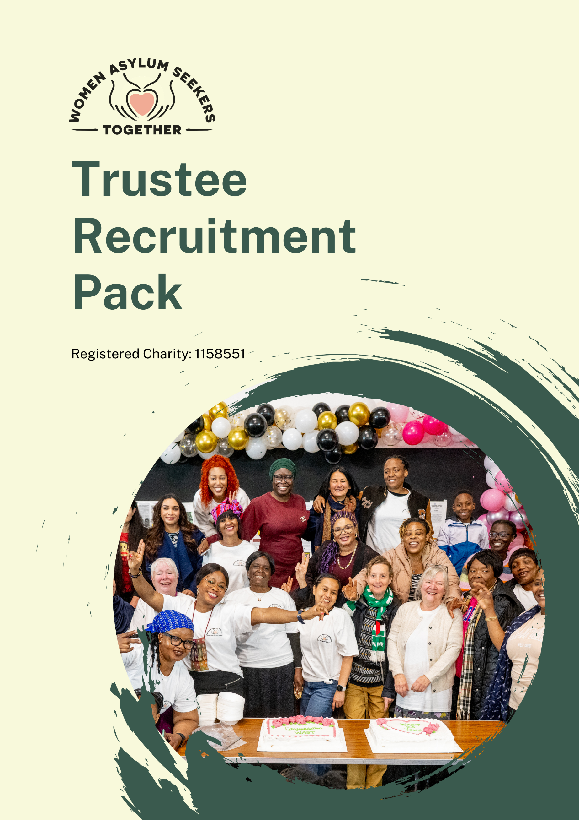

Thank you for your interest in becoming a Trustee for Women Asylum Seekers Together (WAST)
We are a grassroots organisation led by and for women seeking asylum in Greater Manchester. We campaign for social justice and women’s rights through a peer-led support model, helping women feel confident and find their place in the UK. Our aim is to build each woman’s skills and confidence so they can live their lives fully and take part in society.
Our Vision
A society where compassion, respect, inclusion and empowerment enable women to reach their potential and have a voice within an increasingly hostile environment.

Our Mission

To create a safe, inclusive, and empowering space where women seeking asylum can support one another, build their futures, and campaign for justice and equality.

Our Values
Compassion
We stand with women seeking asylum, offering understanding and strength through shared support and solidarity.
Respect
We listen to, believe, and value the experiences of women seeking asylum.
Inclusion
We welcome all women seeking asylum, creating space for every voice to be heard.
Empowerment
We raise the voices of women seeking asylum and support them to lead, shape their futures, and campaign for change.

Our Roots
WAST was set up by Farhat Khan for women seeking asylum so that they could support each other and campaign for their rights. When our Chair, Farhat, came to Britain to seek asylum with 5 children she experienced the hardship of the asylum system which often left her feeling vulnerable and traumatised whilst managing ill health and the threat of deportation.
WAST was formed in response to Farhat’s experience and was set up to create a safe space where women could feel themselves, where they could share their experiences, and empower and support one another.
WAST became a Charity in 2014 and has since expanded its work to provide regular activities, peer support, skills development and advocacy, enabling women seeking asylum to build confidence, reduce isolation and raise their voices.

Context
The asylum system in the UK is complex and challenging to navigate, with women often facing additional risks such as gender-based violence, poverty, and discrimination. The government’s hostile environment policies have created barriers that restrict access to essential services, contributing to increased social exclusion and trauma. Research shows that women seeking asylum experience higher rates of mental health issues and face systemic obstacles to safety and stability. WAST exists to counter these effects by providing a safe, empowering space where women can find solidarity, support, and a platform to raise their voices.

What We Do
At the centre of WAST’s work is its weekly trauma-informed drop-in, a safe and supportive community space where women build confidence, connect with others and access essential advice from partner organisations.
WAST also runs wellbeing activities such as the sewing group and the choir, who have performed across Manchester, as well as a Campaign group, all of which enable the women to share their voices and stories.
We recognise that WAST women want their voices to be heard, so we campaign for the rights of women seeking asylum. We self-organise and campaign with others and undertake research to build awareness so that we might influence changes to the policies that affect WAST women. We do this through lobbying MPs, taking direct action, building coalitions, speaking out and supporting one another.

How We Run
WAST is governed by the Board of Trustees who are elected by the WAST membership. Trustees may be co-opted by the Board initially but will then be elected by the membership at the next AGM. The Trustees and staff support the WAST Management Group who run WAST’s activities and campaigns and provide advice on the direction of WAST. The Management Group members are themselves women seeking asylum and are elected annually by the WAST women.
WAST has three part time staff members, the Development and Strategy Manager, Programmes and Engagement Coordinator and the Project Coordinator.
WAST is governed by the Board of Trustees who are elected by the WAST membership. The Trustees are responsible for the governance and strategic direction of our organisation which they agree with the Management Group and the WAST members. The Board holds legal liability and is responsible for running WAST effectively.
Our Future Plans
We are a women led charity and one of the ways that the WAST women are involved is through the business planning process. WAST’s current priorities include delivering wellbeing activities (with a focus on trauma-informed approaches), running asylum information workshops, and strengthening our campaigning group.
Our three current strategic objectives, identified as priorities by WAST members are:
- Champion and sustain our member-led model through strong, participative governance, decision-making, and effective operational management.
We will ensure that women seeking asylum remain at the heart of WAST’s leadership, supported by robust governance structures, effective management, and active member participation in decision-making.
- Support the well-being, resilience, and personal development of WAST members through a broad, inclusive programme of activities, events, and services.
We will provide accessible opportunities for connection, learning, and growth that reflect the needs and aspirations of our members.
- Amplify the voices of women seeking asylum and campaign for social justice, gender equality, and fairer policies and practices.
We will empower members to speak out, influence change, and challenge the injustices that affect women seeking asylum in the UK.

Becoming a WAST Trustee
Trustee roles are unpaid voluntary positions; reasonable out-of-pocket expenses will be reimbursed.
WAST is a women-led charity. In recognition of this, the Trustee roles are restricted to women and are legally exempt under Schedule 9, Part 1 of the Equality Act 2010.
All Trustees must:
- Be over 16 years of age.
- Understand and be committed to WAST, its values and what it sets out to do and how it benefits the WAST membership.
- Comply with WAST’s governing document and the law.
- Act in WAST’s best interests.
- Manage WAST’s financial, staff and volunteer resources responsibly. This means putting procedures and safeguards in place to ensure that the Charity is not vulnerable or at risk of fraud or theft.
- Act with reasonable care and skill when making decisions and taking advice.
- Ensure that WAST is accountable to the Charity Commission, its members and its funders.
Further detailed information on the role of a Trustee is available on request.
Time commitment
Trustees are expected to be willing to devote the necessary time and effort to the role. As a guide, Trustees will be expected to attend the monthly Board meeting in central Manchester, which is usually 6pm – 9pm on a Thursday evening. Some training is required for all Trustees. Other training sessions are available, and Trustees are encouraged to attend if helpful. Trustees are also encouraged to attend the annual Business Planning Meeting, and the Annual General Meeting (AGM).
The role of Treasurer will also involve some additional time to help oversee the charity’s finances. This includes checking financial reports, making sure money is spent in the right way, keeping track of budgets, and explaining financial information clearly to the Board. The Treasurer may also support staff in preparing the yearly budget and end-of-year financial reports.
The trustee role involves some opportunities for working directly with the WAST management group and helping with occasional activities, trips and events including choir performances and the Christmas party. However, the focus is on governance rather than direct work with WAST members.

What we are looking for
You do not need any previous experience of being a Trustee. Should you be appointed you will be given appropriate training.
We are particularly looking for women with lived experience of the asylum system.
We welcome aspiring Trustees from a diverse range of backgrounds, including women who have previously sought asylum and former WAST members who now have refugee status, as well as women of colour.
We are seeking a Treasurer with experience in finance and financial management to oversee WAST’s finances and support the Board in ensuring strong financial governance and sustainability.
We are also looking for three additional Trustees who can contribute their skills, experience and insight to guide the organisation’s work. We would welcome potential Trustees with a good understanding of the refugee and asylum system, as well as experience in finance, fundraising, or human resources/people management.

Making an application
- To apply for a Trustee position with WAST, please complete the application form – to show your interest in the Trustee role, how your skills and experience will contribute to WAST’s work, and any specific area you would like to focus on. All other required details, including referees and legal eligibility, are included on the form.
Please ensure the application form is submitted to recruitment@wastmanchester.com

For more information
To find out more about WAST, please see our website https://www.wastmanchester.com/
If you would like further information or an informal discussion about the Trustee’s role or about becoming a trustee, please email recruitment@wastmanchester.com

