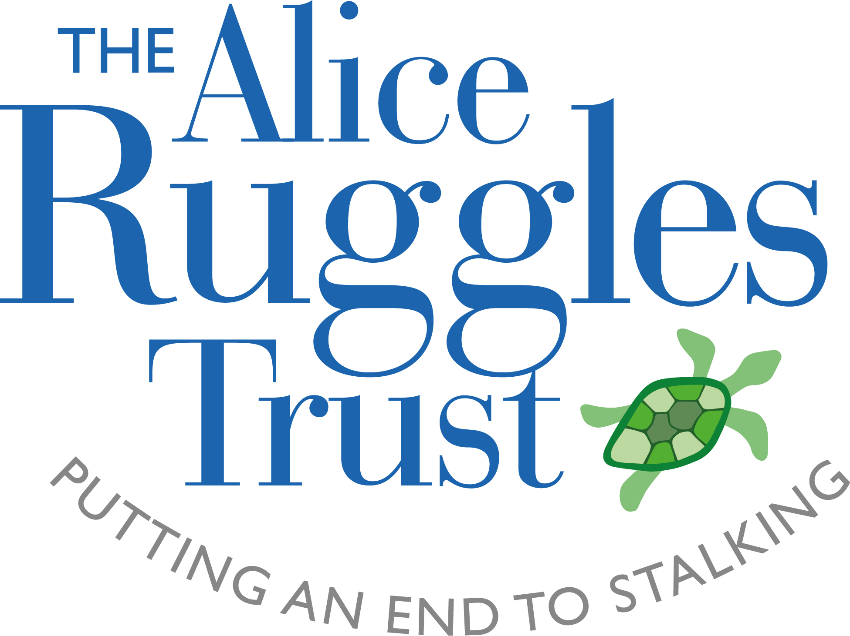
Treasurer – Role Description

As well as fulfilling the duties of a Trustee, the Treasurer maintains an overview of Alice Ruggles Trust’s financial affairs. The Treasurer ensures that effective and appropriate financial measures, controls and procedures are put in place and reports to the Board at regular intervals about the financial health of the organisation.

Treasurer role
- Overseeing the presentation of budgets, internal management accounts and annual financial statements to the Board of Trustees.
- Ensuring that proper accounting records are kept, and that appropriate accounting procedures and controls are in place.
- Ensuring that robust and comprehensive financial policies are in place and being implemented, and supporting the development of policies covering financial reserves, and cost management.
- Monitoring and advising on the financial viability of the charity.
- Overseeing financial controls and adherence to systems, regularly liaising with Managing Director.
- Advising on the financial implications of the charity’s strategic plan, including overseeing the charity’s financial risk-management process
- Ensuring investments and assets are maximised.
- Lead on the appointment of and liaison with external auditors.
- Oversee the development and implementation of systems for appraising, mitigating and reporting risk.
- Ensuring that the accounts are prepared and disclosed in the form required by relevant statutory bodies, for example, the Charity Commission.
- Keeping the board informed about its financial duties and responsibilities and liaising with the Managing Director to develop the financial understanding of the Board of Trustees.

What we are looking for

- A finance professional. A knowledge of charity finance is an advantage. Otherwise an enthusiasm to learn, drawing from sound commercial experience and an understanding of SMEs.
- A strategic thinker with an ability to balance risk and opportunity.
- Clear communicator with the ability to bring the financial information alive to non-finance specialists.
- Willing to play an active role in areas such as forecasting, setting budgets, liaising with auditors

In addition to the above, the Treasurer will also have the responsibilities and qualities of all trustees:

Responsibilities of all trustees
- Support and provide advice on Alice Ruggles Trust’s purpose, vision, goals and activities.
- Approve operational strategies and policies, and monitor and evaluate their implementation.
- Oversee Alice Ruggles Trust’s financial plans and budgets and monitor and evaluate progress.
- Ensure the effective and efficient administration of the organisation.
- Ensure that key risks are being identified, monitored and controlled effectively.
- Review and approve Alice Ruggles Trust’s financial statements.
- Provide support and challenge to Alice Ruggles Trust’s Managing Director in the exercise of their delegated authority and affairs.
- Keep abreast of changes in Alice Ruggles Trust’s operating environment.
- Contribute to regular reviews of Alice Ruggles Trust’s own governance.
- Attend Board meetings, adequately prepared to contribute to discussions.
- Use independent judgment, acting legally and in good faith to promote and protect Alice Ruggles Trust’s interests, to the exclusion of their own personal and/or any third party interests.
- Contribute to the broader promotion of Alice Ruggles Trust’s objects, aims and reputation by applying your skills, expertise, knowledge and contacts.

[As a small charity, there will be times when the trustees will need to be actively involved beyond Board meetings. This may involve scrutinising board papers, leading discussions, focusing on key issues, providing advice and guidance on new initiatives, presenting externally, or other issues in which the trustee has special expertise.]

Attributes and qualities
We are looking for people willing to bring energy, enthusiasm and commitment to the role, and who will broaden the diversity of thinking on our board.

[You do not need previous governance experience – we will provide support.]

Personal skills and qualities
- Willingness and ability to understand and accept their responsibilities and liabilities as trustees and to act in the best interests of the organisation.
- Ability to think creatively and strategically, exercise good, independent judgement and work effectively as a board member.
- Effective communication skills and willingness to participate actively in discussion.
- A strong personal commitment to equity, diversity and inclusion.
- Enthusiasm for our vision and mission.

Terms of appointment

Terms of office
- Trustees are appointed for a 3 year term of office, renewal for one further term to a maximum of 6 years.
- This is a voluntary position, but reasonable expenses will be reimbursed.

Time Commitment (Estimated at [x per month])
- Attending 4 Board meetings annually. Currently meetings are held remotely with an annual hybrid/meeting in person in Leicester .
- Monthly scheduled meeting with the Managing Director with flexibility to respond swiftly to the occasional ad hoc issue.
- Attending annual strategy / training sessions.

