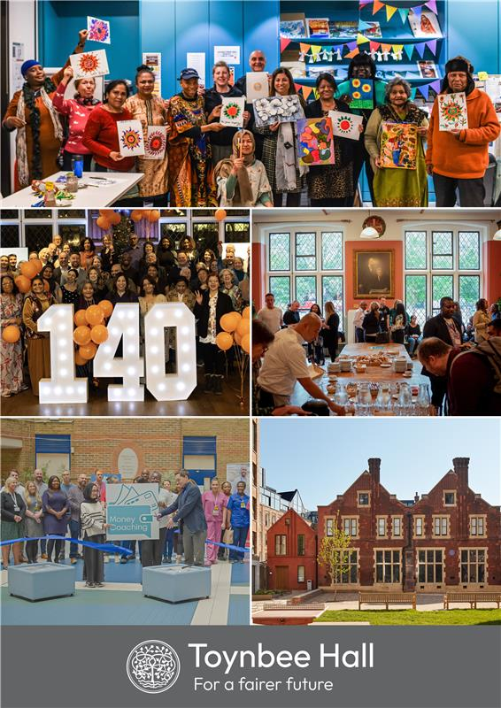

Become a Trustee at Toynbee Hall
Shaping social change since 1884
For over 140 years, Toynbee Hall has worked alongside people facing poverty and injustice to build a fairer future. We are now seeking new Trustees to join our Board and help guide the next chapter of our story.
About Toynbee Hall
Founded in the East End of London by Samuel and Henrietta Barnett, Toynbee Hall was created in response to a growing realisation that lasting social change cannot be achieved through individual efforts alone. Their radical idea was to establish a place where people could live and work alongside local communities, confront poverty directly, and develop practical solutions to carry into wider society.
That mission continues today. Toynbee Hall is both a vital source of support for individuals and a place where people come together to tackle the root causes of inequality. We provide free advice and support services, undertake research and advocacy to influence policy, and create space for communities to develop solutions to the challenges we all face.
Over the decades, many who were part of Toynbee Hall, from Clement Attlee to William Beveridge, went on to shape major social reforms. Our legacy is one of bold thinking and practical action. Today, we are building on that legacy with a Board of Trustees who share our commitment to social justice and want to help us do more.
Why Join Our Board?
Trustees play a vital role in the life of Toynbee Hall. They are the guardians of our mission and values, setting our strategy and ensuring we remain focused, effective and financially sustainable.
We are looking for Trustees who bring independent judgement, strategic thinking and creativity to help us respond to the opportunities and challenges ahead. You do not need previous experience as a Trustee as we will provide a comprehensive induction and ongoing support, but you do need a genuine enthusiasm for our mission and a commitment to building a fairer future. We are specifically seeking a Trustee to join our Finance Committee but we are also seeking to fill more than one vacancy.
We aim to have a Board that reflects the communities we serve. We are particularly keen to hear from people who live in Tower Hamlets or have a personal connection with Toynbee Hall, the East End or similar communities. We also warmly encourage applications from candidates who are Black or Asian, and from people with diverse lived experiences.
About the Finance Trustee Role
We are specifically seeking a Trustee to join our Finance Committee. For this role, you will hold a recognised financial qualification and bring experience in finance, accountancy or financial decision making. Experience in the charity sector is welcome but not essential, and what matters most is your ability to help guide our financial strategy and ensure we remain a strong and sustainable organisation.
What to Expect as a Trustee
Meetings: Our Board meets four times a year in the evening, with an additional annual away day. Trustees also serve on at least one committee, which meets up to three times a year, usually online. Board meetings are held in person at Toynbee Hall, Commercial Street, E1.
Term: Trustees are appointed for a three year term, renewable up to a maximum of nine years.
Ambassadors: All Trustees act as ambassadors for Toynbee Hall by attending events, championing our work, and helping us build new relationships and partnerships.
In return, we offer an opportunity to play a central role in shaping a historic and forward looking organisation, and to work alongside passionate staff, volunteers and fellow Trustees, all committed to tackling inequality and building a fairer future.
How to Apply
Applications are open until midday on 10 November 2025. Interviews will be held online with two of our Trustees and the Chief Executive.
Application details are here:
Before applying, we encourage you to visit our website at www.toynbeehall.org.uk to learn more about our work and impact.
We look forward to hearing from you and to welcoming new voices and ideas to our Board as we continue to shape change together.

Toynbee Hall Team

