Team Leader
Job Description
rethink.org

Work type | ☐ Home based | ☐ Agile | ☒ Field | ☐ Fixed
Location | Walsall
Service or department | Operations – Place Based - Central
Reporting to (title) | Service Manager
Responsible for staff | ☒ Yes ☐ No
Budget manager | ☐ Yes ☐ No
Disclosure and Barring check | If a new or revised role, the level must be assessed by the People Team  Enhanced Disclosure with Adults Barred List
Pay band / Job role level | 3. Professional
Evaluated On (Date): | Click or tap to enter a date.
Job Code Reference: | Click or tap here to enter text.

Post Details
Overview of the role purpose:
The Team Leader will lead a team of up to 6 mental health recovery workers providing supervision, training and mentoring, providing a person-centred approach as part of the holistic recovery plan for mental health service users.

The Team Leader will provide a pivotal role in managing a high quality service that delivered positive outcomes for service users. You will also be required to work directly with all relevant stakeholders: clinical NHS staff, consultant psychiatrists and partner agencies.

We offer people affected by mental illness with out of hours support. Providing a person centred, holistic approach. We take a strength based, focusing on assets, independence, recovery, and social inclusion with no wrong door approach.
The service provides out of hours mental health support to people over the age of 18+ who live and have a registered GP in Walsall.
The hub is open 365 days of the year, Monday to Friday 6pm-11pm, Saturday & Sunday 12noon – 11pm.
You can read more about the rewards you will receive on the full advert on our website.

I will work with the following people and teams

- Service Users
- Bank Support Workers / Support Workers
- Volunteers
- Service Manager
- Local services

Service/Team Description
Overview of the service or team:
The Hub is a safe place to turn to for people and their carers who are in need of mental health support or in emotional distress during the evening and weekends.
Our dedicated team are friendly, warm, enthusiastic, reliable, and responsive to individual needs. We are all experienced and trained mental health recovery workers who provide person-centred support. Providing a person centred, holistic and non-stigmatising environment. We take a strength based, focusing on assets, independence, recovery, and social inclusion with no wrong door approach.

The service provides out of hours mental health support to people over the age of 18+ who live and have a registered GP in Walsall.

The hub is open 7 days a week, 365 days of the year, Monday to Friday 6pm-11pm, Saturday & Sunday 12noon – 11pm.

- We provide out of hours support to those who are in crisis or in need of support outside of usual mental health service hours
- Our aim is to de-escalate and prevent crisis.
- We provide emotional support to anyone who finds themselves in distress, in need of reassurance or at times when you just want to be listened.
- We provide support by helping clients to identity coping strategies, so they are better able to cope.
- We will signpost and refer clients to other services to get additional support.

This may include:

- Self-referral
- Drop-in support
- One-to-One support
- De-escalation from crisis support
- Provision of identifying coping strategies
- Support group sessions
- Peer support
- Wellbeing workshops
- Signposting and referrals

Team Structure

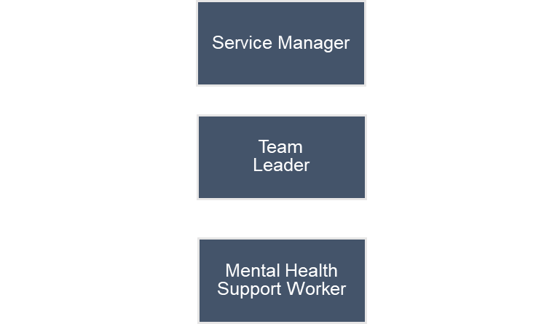

What I do and achieve
What I do:
- Effectively manage a high-quality service that adheres to principles of a crisis café.
- Work flexibly between the hours of 6pm – 11pm weekdays and 12 – 11pm weekends.
- (where applicable) Meet regularly with the Service Manager to agree priorities and work plans and deputise for the Manager as required
- To monitor and manage the performance of the Crisis café team, guiding them individually in best practice and aiming to achieve individual and team job outcome targets
- To create a culture of continuous improvement and involve service users in co-producing service developments wherever possible.
- To identify training needs of staff and arrange appropriate training to support with continuous professional development
- To support the design and delivery of in-house staff training, coaching and field mentoring and observations to ensure continuous improvement in key areas of service provision
- To support recruitment for vacant roles within the team in partnership with the clinical team
- Coordinate the work of Crisis café with the NHS Clinical teams in Walsall.
- To cover for Crisis café staff during times of leave
- To produce regular monitoring reports for internal and external stakeholders
- To identify barriers for service excellence and work with internal and external stakeholders to implement solutions to ensure a high-quality service is delivered.
- Lead the team to meet and exceed the targets for the service by facilitating a weekly meeting and providing solution focused individual monthly supervision

Who I am
I have the essentials covered:
- Minimum 3 years’ experience of working with people with mental health problems or a similar service user group within health, social services or the voluntary sector
- Must have experience of Line Managing a team
- Experience of partnership working negotiation and liaison work with other agencies
- Experience of staff supervision and coaching
- Able to use IT and tools such as MS Word, Powerpoint and Excel
- Flexibility to travel within the region
- Able to work out of ‘normal office’ hours
- Role model excellent practice, professional boundaries, standards and motivate the team to achieve performance targets
- Excellent Safeguarding knowledge and experience
- Effective delegation of appropriate tasks
- Manage change effectively and facilitate innovation
- Able to work strategically and across organisational boundaries
- To model recovery focused practice including co-production
- Outstanding interpersonal skills and ability to build rapport with a range of people
- Team orientated and work collaboratively within a mixed-disciplinary team
- Excellent written and verbal communication skills, tailored to a variety of audiences
- Excellent coaching and active listening skills, ability to ask perceptive questions that tease out important information through mentoring and coaching
- Able to work independently and use initiative to think quickly on the spot in different, and often challenging, situations
- Creative problem solving to tackle obstacles that arise and fulfil requirements of the role in innovative ways to deliver greater impact
- Can effectively manage time to meet deadlines while maintaining high standards
- Manage competing demands with project management tools and techniques
- Maintain effective and organised administration systems
- People-orientated
- Naturally interested in and energised by working with and talking to people
- Non-judgemental and trustworthy
- Capability to be warm and empathetic whilst respecting professional boundaries
- Passion and drive to make a positive difference to people's lives
- Instil hope and empower others to own their experience and choices
- Responds positively to failure and is able to translate it into a valuable learning experience
- Ability to self-reflect and understand own reactions and flex accordingly to any situation
- Patient and empathetic to others' situations without imposing own experiences or beliefs onto others
- Conscientious and professional.
- Commitment to learning
- Self-aware of personal strengths and weaknesses and actively invest in personal and professional development
I may also have:
- Mental First Aid Qualification
- Experience of delivering training
- Lived experience

What I value and how I will behave
I can demonstrate and apply Rethink Mental Illness values of:
- Passion - We are passionate about leading the way to a better quality of life for everyone severely affected by mental illness.
- Commitment - We work tirelessly to provide support for everyone severely affected by mental illness.
- Openness - We are open and transparent in all our work with beneficiaries, supporters, partners and the public to achieve change for people severely affected by mental illness.
- Hope - We offer hope of a better quality of life for all those severely affected by mental illness.
- Expertise - We constantly use our expertise to provide practical and personal support for people who are severely affected by mental illness.
- Understanding - People who are severely affected by mental illness are at the heart of everything we do in our organisation – our membership, our governance and our workforce.
- Equity - We believe that in a world where discrimination and disadvantage exist treating people with equity is critical to ensure justice and fairness for all.
I can apply and demonstrate Rethink CARES behaviours of:
- Connect – We work together, we celebrate together
- Accountable – We do what we say we will do
- Respect – We believe everyone counts
- Evolve – We challenge, we listen, we change
- Success – We deliver results

General Duties:
- I will act in accordance with the provisions of Data Protection legislation (as amended).
- I will ensure all records, personal, staff and client data are managed in line with Data Management and Information Governance policies, relevant legislation, codes of practice or contractual obligations.
- I will comply with legal and regulatory requirements such as provisions set out in the Health and Safety at Work Act 1974.
- I will act in accordance with the charity’s Health & Safety and Safeguarding policies and to notify your line manager promptly if there are any concerns.
- I will participate in regular supervision and appraisal and undertake any relevant training.
- I will work in accordance with the charity’s national policies and local operating procedures and those of external regulators or professional bodies.
- The list of duties is not exhaustive; the line manager may stipulate other reasonable requirements and projects commensurate with the general profile and grade of the post.

