

Name |  |  |  |  |  |  | D.O.B
Address
Postcode |  | Age |  | Email
Telephone |  | Mobile |  |  |  | Landline

1st Language English 2nd Language Choose an item.

Gender Choose an item. Ethnicity Choose an item.

Religion Choose an item. Sexual Orientation Choose an item.
Reason for wanting to Volunteer

2 X Referees - One referee should be a professional, while the other can be a friend or family

Name 1 |  | Telephone/Email
In what Capacity do you know this person |  | Position or Job Title
Name 2 |  | Telephone/Email
In what Capacity do you know this person |  | Position or Job Title

Preferred timeslots:
Please mark/tick the days and times you will be available to call your befriendee.
AM | PM
Monday | 9:30am – 1pm | ☐ |  | Monday | 1pm - 4:00pm | ☐
Tuesday | 9:30am – 1pm | ☐ |  | Tuesday | 1pm - 4:00pm | ☐
Wednesday | 9:30am – 1pm | ☐ |  | Wednesday | 1pm - 4:00pm | ☐
Thursday | 9:30am – 1pm | ☐ |  | Thursday | 1pm - 4:00pm | ☐
Friday | 9:30am – 1pm | ☐ |  | Friday | 1pm - 4:00pm | ☐
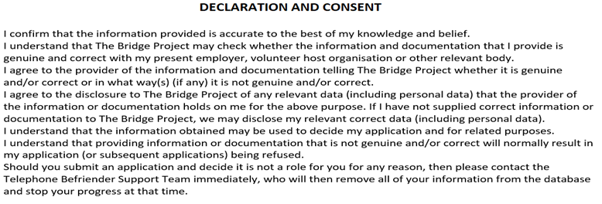

Please cross this box to confirm acknowledgement & understanding of all this document ☒

