Hospice UK Supporting Statement Form

Thank you for choosing to apply for a role with us at Hospice UK!
We don’t believe in asking you to fill in pages and pages of an application form. All we need is a copy of this supporting statement form and your CV.
To give your application the best chance of being invited for interview, we have included guidance on writing a supporting statement below. Please do follow the method described.
If you have any questions before you apply please get in touch on recruitment@hospiceuk.org

PLEASE NOTE THE CLOSING DATE FOR APPLICATIONS LISTED ON THE ADVERT AND CANDIDATE INFORMATION PACK SO YOU DON’T MISS OUT!

Personal details
Name
Email address
Mobile number
Accessibility needs

Job applied for

Where did you see this vacancy (please be as specific as you can)

Supporting statement
The supporting statement is your chance to tell us about your experience, your achievements and how you specifically suit the role you are applying for.
We want you to have the best chance of completing this section effectively, so please follow the guidance below.
Towards the end of the Job description you will see a section marked Person specification presented either in a list or in a table as in the example below, and this details the experience and knowledge we are looking for.
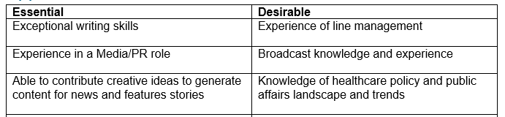
This table is an example, please refer to the person specification for the role you are applying for

The easiest and most effective way to approach your supporting statement is to take each of the ‘essential’ criteria and use them as headers for sections of your statement (if you have any of the ‘desirable’ criteria, you can use those too if you wish).
Under each you can briefly tell us how you meet that requirement (use examples where you can). At the end, maybe tell us why the role and Hospice UK interest you.
When shortlisting, the recruiting panel score all applications against the criteria so please do make sure you cover each of them.
Fill in the box below with your supporting statement. This box will expand with text.
No more than three pages please

Eligibility to work in the UK
Are you eligible to work in the UK? Yes No

Please tick how you are eligible from the list below:
- I am a UK national
- I am a national of a Commonwealth countries and I have the right to work in the UK
- I am a national of the Republic of Ireland
- I am a national from the EU, EEA or Switzerland with settled or pre-settled status or I have applied for either status by the deadline of the European Union Settlement Scheme (EUSS)
- Other eligibility (please state) _________________________________

Please note that proof of your eligibility to work in the UK will be checked if you are invited to interview.

References
We don’t need you to provide your referee details at this stage but will request them if you are offered the role

Declaration
I confirm that the above information is completed and correct and that any untrue or misleading information will give Hospice UK the right to reject my application, to withdraw any employment contract offered or, if employed, to dismiss without notice.
Signed: | Type your name if you are completing electronically
Date

TO APPLY PLEASE SEND THIS FORM AND A COPY OF YOUR CV (IDEALLY IN WORD FORMAT) TO recruitment@hospiceuk.org

Data protection
Hospice UK complies with the provision of the Data Protection Act 1998 which defines the information provided on this form as sensitive data. By signing this form you give your consent for Hospice UK to process this, and other personal data, for the purposes of recruitment, selection and determining your suitability for the post. Any data about you will be held in secure conditions, with access restricted to those who need it in connection with the application and selection process. Data may also be used for the purposes of monitoring the effectiveness of recruitment. In these circumstances all data will be kept anonymous.

