
Information for applicants for the post of: Strategic Trauma Informed Practitioner
Strategic Trauma Informed Practitioner Services & Digital Department

Thank you for your interest in the above role. This pack tells you more about Kinship, how we work, and details of the role and the people you will be working with. It also gives information on how to apply.

Role details:
Job title: Strategic Trauma Informed Practitioner
Responsible to: Programme Management and Innovation Lead
Duration: 12 months with potential extension
Location: Home based with travel to London or hybrid office-based (Vauxhall). Travel across England and Wales required.
Working Hours: Part-time - 21 hours per week. Ideally Tuesday – Thursday.
Salary: £35,000 (out of London) to £38,406 (in London) to be pro-rated for 21 hours.
Direct reports: None
Leave allocation: 24 days annual leave (30 days FTE), plus bank holidays pro rata for part time hours (1 April t0 31 March).

About Kinship:
We are Kinship. The leading kinship care charity in England and Wales. We’re here for kinship carers – friends or family who step up to raise a child when their parents aren’t able to.

We are made by and for our community of kinship carers. Like family, relationships run deep. And we hear their experiences; for too long they have been isolated without the help they need.

We support, advise and inform kinship carers. Connecting them so they feel empowered. Because a child needs the love and warmth of a thriving family.

We develop research, campaigns and policy solutions. Creating positive change across society. Because for kinship families, love alone is not enough.

Through our work we harness frustrations to fuel passion for change. And tough experiences to inspire ideas that transform lives.

And as we see momentum building, we keep using evidence to demonstrate the value of kinship care. Helping kinship carers navigate challenging circumstances. Believing in a child’s potential.

Join us. Together, let’s commit to change for kinship families.

Purpose of the role:
Kinship Minds is a transformative programme that enhances the support we provide to kinship carers in England and Wales.

Our goal is to build kinship carers' confidence and equip them with the knowledge and skills to support children in their care—especially in recognising and responding to early signs of mental health issues.

We are at the beginning of our journey to embed therapeutic and trauma-informed approaches across all areas of service delivery. This includes one-to-one support, digital resources and training, and peer support networks.

The Strategic Trauma-Informed Practitioner will lead this transition, helping us move from a trauma-sensitive organisation on a journey that becomes trauma-aware, trauma-informed, and ultimately trauma-responsive.

The type of person we’re looking for:

You will need to be able to step into this role quickly, bringing your experience of building and developing trauma informed approaches in complex services.

You will have strong leadership capabilities, able to work at pace autonomously with creativity and dynamism. You will need to have excellent attention to detail.

What you'll be doing:

This strategic and hands-on role will help Kinship strengthen its therapeutic offer and build the confidence and capacity of staff and kinship carers to understand trauma and the impact it has, and strategies to support. We are particularly interested in experience in developing trauma informed parenting training and resources.

The postholder will play a key role in developing and manualising our trauma-informed approach across core services: Kinship Connected, Kinship Reach, our Advice Service, and Peer Support Service. It will work with subject matter experts to bring develop trauma informed approaches, toolkits and resources into everyday service delivery – based on needs of kinship carers and their families.

Key responsibilities:

Strategic development and organisational culture:
- Develop and lead Kinship’s trauma-informed strategy, ensuring the implementation of trauma-informed principles across all service delivery (for example using Dr Karen Treisman’s approach).
- Lead the development and manualisation of trauma-informed practice across Kinship Connected, Kinship Reach, the Advice Service, and the Peer Support Service. This includes resources, approach and content.
- Support organisational development to embed trauma-informed values in practice, culture, policy, and leadership, working with Head of People and Culture.
- Develop reflective practice approach to support managers to staff and volunteer resilience particularly across services. This could include a train the trainer approach.
- Audit current practices and recommend systems and processes to support trauma-informed service delivery.

Capacity building and training:
- Develop and deliver capacity-building approaches and resources for kinship carers to help them identify and respond to trauma and mental health needs in children.
- Work collaboratively with subject matter experts to develop self-guided training, toolkits, and multimedia resources.
Practice development and support:
- Provide and lead expert input into the trauma informed design and delivery of Kinship Connected, Kinship Reach, Advice Service and other one-to-one support programmes.
- Guide frontline delivery staff to adopt trauma-informed practice, including the use of strengths-based approaches and flexible, family-led planning.
- Develop and oversee quality assurance frameworks to evaluate trauma-informed interventions and impact.

Stakeholder influencing and engagement:
- Represent Kinship at external events and meetings to raise awareness of the services and to influence other organisations, policy and practice.
- Be the media spokesperson for your subject expert area.
- Support Kinship’s communications and engagement strategy, such as writing copy and sourcing images for newsletters and local media to promote the service and recruit participants.
- Contribute practice expertise to the development of policy, services and programmes.

Team and culture:
- Act in the best interests of Kinship and the families we support.
- Deliver effective administration with attention to detail and keeping to deadlines.
- Take responsibility for your ongoing continued professional development.
- Work in line with Kinship’s values.
- Represent the Programmes team at Kinship team meetings.
- Represent Kinship at external meetings and events as required.

Knowledge, abilities, skills and experience:

Essential:

Experience and knowledge:
- A qualified trauma-informed practitioner with significant experience in delivering or developing trauma-informed services.
- Experience working with kinship carers or in adoption and fostering sector.
- Proven experience applying the principles of trauma-informed care across organisations, preferably in children and family services.
- Qualified or accredited practitioner in Non-Violent Resistance (NVR) or demonstrable experience using the approach in practice.
- Experience in designing and delivering training and coaching for professionals and/or families on trauma and therapeutic approaches.
- Experience supporting children and families impacted by trauma, loss, and adversity particularly in the context of social care systems and looked after children.
- Excellent understanding of kinship care and the impact of trauma on kinship families.
- Experience manualising trauma-informed approaches across multiple service areas.
- Knowledge of the mental health and therapeutic support landscape in England and Wales.
Skills and attributes:

- Ability to influence and embed systemic change across services and teams.
- Excellent interpersonal and relationship-building skills.
- Reflective, emotionally resilient, and committed to self-care and team wellbeing.
- Strong written and verbal communication skills.
- Skilled in co-production and working inclusively with people with lived experience.
- Highly organised and confident working independently and flexibly.
- Strong IT skills, including ability to support digital delivery and develop accessible resources.

Safeguarding:
- Excellent understanding of safeguarding policies and procedures focussing on contributing to a culture which values transparency, reflective practice and continuous learning.
General attributes:
- Ability and willingness to travel across the UK to represent Kinship at meetings and events.
- Travel to London office for team meetings and supervision.
- Knowledge and understanding of kinship care and/or children and families who need support.
- Knowledge of, or ability to learn quickly, about the regulations and guidance relating to different legal orders relevant to kinship carers.
- Commitment to the values, aims and objectives of Kinship.
- Ability to apply Equity, Diversity and Inclusion Principles in all areas of work.
- Right to work in the UK.

Desirable:

- Lived experience of kinship care.
- In-depth subject knowledge on kinship care and issues affecting kinship carers.
- Experience using Salesforce within a service environment.
- Familiarity with Dr Karen Treisman’s trauma-informed models and materials.
- Experience of service delivery in a charity or voluntary sector setting.

Your main relationships will be with:
- Programme Management and Innovation Lead
- Head of Programmes
- Director of Services and Digital
- Digital and Content team
- Senior Programmes Worker and Kinship Family Workers
- Service Managers and Leads in Advice, Peer Support and Training Teams
- Database Team
- Policy & Comms team
- Research & Practice team
- Kinship carers
- External funders

What it means to work at Kinship:
Our vision:
A society in which kinship carers and the children they care for are recognised, valued and supported.

Our mission:
To ensure that kinship carers and the children they care for get the support and recognition they need.

“Knowing what you do helps kinship families that really need support.
Staff at kinship are caring, passionate and positive. Colleagues are genuinely nice to work with and care about each other as well as the kinship families we support. We are always innovating to better support kinship carers.”
(Staff member at Kinship)

We want to offer you the best place to work. Our people are friendly and incredibly passionate about working alongside kinship carers.

We want you to feel proud to work here and if you join us, we'll do our best to make that happen.

Our Kinship values: 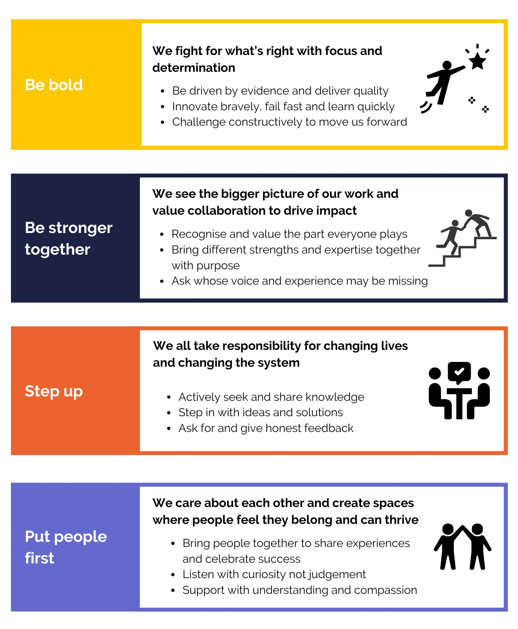

Equality, diversity and inclusion:
Kinship is committed to championing equality, diversity and inclusion. We believe our work is greatly enhanced by the varied backgrounds, experiences and views represented within our teams. We aim to create inclusive teams, celebrate differences and encourage everyone to join us and be their true self at work.

We therefore encourage applications from anyone who fits our values, whatever their religion or belief, sex, gender identity, race, age, sexuality or disability and are actively seeking candidates that can bring real innovation and commitment to us.

Candidate application information:
Please refer to the job description for this role to check that you meet the criteria in the “knowledge, skills and experience” section that are necessary for the job.

We will guarantee interviews to any candidates with experience of kinship care (either of being in kinship care or of being a kinship carer) who demonstrate that they meet the essential skills and experience outlined in the job description.

Please tell us if there are any reasonable adjustments, we can make to assist you in your application.

If you have a disability that you would like us to take into account, please tell us about this when you apply. Please let us know if we can help and remember that you can request information in large print or in a different format.

How to apply:

Any applications arriving after the closing date will not be considered for shortlisting unless there are exceptional reasons.

Kinship reserves the right to close a recruitment campaign earlier than the advertised where we have received sufficient applications so please apply early!

Please apply for the role of Strategic Trauma Informed Practitioner by sending a CV to the advertisement on https://www.charityjob.co.uk/. Please use examples to demonstrate your experience.

You will also be asked to respond to the following 5 questions through the CharityJob application system. This is instead of a covering letter. Each response should be no longer than 250 words.

1. Trauma-informed expertise
Please describe your experience of developing and embedding trauma-informed approaches across services or organisations. What frameworks or models have you drawn on, and what impact did your work have?
2. Training and capacity building
This role requires developing resources and training for kinship carers and professionals. Can you share an example of when you designed and delivered trauma-informed training or resources, and how you ensured they were engaging and accessible?
3. Experience with kinship, adoption or fostering
Tell us about your experience of working directly with kinship, adoptive or fostering families. What have you learned about the unique strengths and challenges these families face, and how has this shaped your practice?
4. Working at pace and independently
Tell us about a time when you had to quickly step into a new role or project, work autonomously, and deliver results at pace. How did you organise yourself and what was the outcome?
5. Influencing and engagement
The role involves engaging with a wide range of people — kinship carers, colleagues, external partners, and funders. Can you provide an example of how you successfully influenced or engaged diverse stakeholders to achieve a positive outcome?

You will be asked to add your notice period / earliest availability to start.

Some tips for your application:
- Make sure you’ve read the job description and the essential requirements – make sure your application reflects those points in the requirements very clearly.
- Tell us why you want to work for Kinship. We’re interested in working with people who share our values. You can read about our values above.
- Keep your response clear – use bullets points and short paragraphs if that helps. It will help the recruitment team to focus on your knowledge, skills and experience.
- Please do not use AI tools like ChatGPT to produce your answers. We use software to check, and your application will be rejected if you do.

Key dates:
Apply: Via CharityJob
Application deadline: 17 October
First interview: Weds 22 and Thurs 23 Oct AM

Kinship reserves the right to close applications early on receipt of sufficient applications. Apply early!

If you would like further information or an informal chat about this role, please contact Madeleine Musgrove (Programme Management and Innovation Lead) on Madeleine.Musgrove@kinship.org.uk

Conditions of employment and what we offer:

Working hours:
The working week is currently 35 hours per week from Monday to Friday. These may be varied by agreement with your line manager. For some roles, there will be occasions when these hours are exceeded, for example some weekend working or a requirement to attend evening meetings. In such circumstances and in agreement with your line manager you may take reasonable time off in lieu. Overtime is not paid.

Holidays:
- 30 days annual leave, plus bank holidays (1 April t0 31 March) pro rata.
- We close for three days between Christmas and New Year, which will be deducted from your annual leave allowance.

Flexible working:
Kinship will consider applications for flexible working arrangements. Kinship will enable as many jobs to be open to job sharing as is operationally practicable.

Learning and development:
We are committed to developing and enhancing the learning experience during your time at Kinship, and we are proud to offer many learning opportunities.

Health and wellbeing:
- Employee Assistance Programme (24/7 confidential advice line and counselling).
- Charity Worker Discount

Travel:
For this role, there may be occasional travel within the UK. There may also be, on occasion, the need for overnight stay. Reasonable travel, subsistence and hotel expenses will be covered using the Charity’s expenses procedures.

Pension scheme:
All staff will automatically be enrolled into a Group Personal Pension Scheme as part of our requirement to meet automatic enrolment legislation. According to the statutory requirements. We use Nest Pensions. Current employee contributions are 5% and we will contribute 3%.

Probationary period:
All new employees will be required to undertake a period of probation for six months, in which time you will be expected to establish your suitability for the post.

Community:
- Employee resource groups (including Equality, Diversity and Inclusion Working Group and Wellbeing Committee).
- Staff away days.
- Regular social activities online and in person.

Our recruitment process:

As a charity we want to hire the best people to support our vision and mission. People who are values led, high performing and passionate about doing their best for kinship carers.

We will guarantee interviews to any candidates with experience of kinship care (either of being in kinship care or of being a kinship carer) who demonstrate that they meet the essential skills and experience outlined.

We welcome applications from people from all sections of the community, irrespective of race, colour, sex, gender identity, age, disability, sexual orientation, religion or belief.

Kinship is committed to attracting, developing and retaining a diverse workforce, with a broad range of backgrounds, experiences and perspectives, and we encourage applicants from those groups currently under-represented in our organisation and sector.

Standard clauses:

- This role will require satisfactory Disclosure and Barring Service (DBS) clearance.
- The post holder must at all times carry out their responsibilities with due regard to Kinship’s Equal Opportunities Policy and Safeguarding Policy.
- Salesforce is our customer relationship management system (CRM) and all staff are expected to take accountability and responsibility for using it successfully as part of their day-to-day role to support the growth and impact of Kinship and better services for kinship carers.
- The post holder must accept responsibility for ensuring that the policies and procedures relating to Health and Safety in the workplace are adhered to at all times.
- The post holder must respect the confidentiality of data stored electronically and by other means in line with the Data Protection Act.
- The post holder must carry out their responsibilities with due regard to the non-smoking environment of all Kinship offices.

Note:
This job description is not exhaustive. Kinship reserves the right to add to or revise the job description at any time - the post holder may be required to undertake any other duties that fall within the nature of the roles and responsibilities as detailed in this document.

Any substantial or major changes will be negotiated with the post holder.

