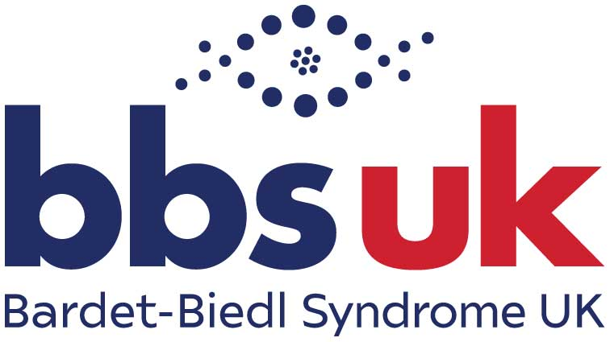
Job Description: Support Services Manager
At BBS UK, we believe that everyone living with Bardet-Biedl syndrome (BBS) should have the opportunity to live the life they choose - to thrive, not just survive.
This is an exciting opportunity for an experienced and compassionate manager with knowledge of social care, welfare and support services to lead and develop BBS UK’s integrated support service.
We are looking for someone who can combine a supportive and collaborative leadership style with clear decision-making, accountability and professional curiosity. The postholder will hold organisational responsibility for safeguarding and promoting the welfare of children, young people and vulnerable adults.
BBS UK’s integrated support service brings together our Clinics Support Service and Advice Service to provide practical, emotional and advocacy-based support to people living with BBS and their families. Through close partnership working with NHS specialist clinics and wider statutory and voluntary services, the team helps individuals navigate complex health, social care, education, welfare and housing systems, ensuring people receive timely, person-centred support that reflects their needs and goals.
The postholder will lead and coordinate the delivery of the integrated support service, providing oversight, supervision and safeguarding leadership across the team. They will ensure the service remains effective, sustainable and person-centred, while supporting continuous improvement and clear, proportionate ways of working.
Position: Permanent, 30–35 hours per week, with flexibility depending on the successful candidate

Salary: £40-£45,000 per annum (Full time equivalent)

Reports to: CEO

Direct Reports:
- 4 x Patient Liaison Officers
- 2 x Advice Workers (registered social workers)

Location:
Home-based, with travel to clinics (London and Birmingham) and BBS UK events

Key Responsibilities

1. Service Leadership & Oversight
- Lead the delivery and coordination of BBS UK’s integrated support service
- Maintain oversight of service activity, caseloads, capacity and emerging risks
- Promote consistent, person-centred and high-quality support across the team
- Support collaborative approaches to case management and decision-making
- Identify opportunities to strengthen service effectiveness and responsiveness

2. Supervision & Safeguarding
- Provide supervision to Advice Workers and Patient Liaison Officers
- Lead on safeguarding policy, practice and decision-making across the organisation, acting as Designated Safeguarding Lead (DSL)
- Act as the main point of contact for safeguarding concerns and external agencies
- Provide advice and decision-making support on complex or high-risk situations
- Promote consistent safeguarding practice and confidence across the organisation

3. Team Management & Development
- Line-manage Patient Liaison Officers and Advice Workers
- Support staff wellbeing, learning and professional development
- Foster a positive, reflective and collaborative team culture
- Manage performance and encourage continuous improvement

4. Service Development & Improvement
- Review and improve service pathways, structures and processes
- Support the development of efficient and integrated ways of working
- Reduce unnecessary administrative burden and duplication
- Contribute to service planning and development in response to patient need

5. Operational & Systems Oversight
- Oversee the effective use of case management systems (e.g. CharityLog)
- Ensure recording practices are appropriate, accurate and proportionate
- Work with the CEO to support reporting and service monitoring
- Use service information and data to support planning and improvement

6. Funding & Organisational Support
- Contribute to funding applications, monitoring and reporting requirements
- Support the collection and communication of service impact and outcomes
- Ensure service delivery aligns with organisational priorities and funding objectives

7. External Relationships
- Build and maintain effective relationships with NHS, statutory and voluntary sector partners
- Represent BBS UK externally where appropriate
- Support collaborative working to improve outcomes for individuals and families

Key Working Relationships
- CEO
- Operations Officer
- Clinical teams (NHS partners)
- External agencies (health, education, social care, voluntary sector)

Person Specification

Experience
Essential
- Proven experience managing and leading remote or geographically dispersed teams, creating a positive and motivated working culture.
- Background in delivering services for children, young people and adults with health conditions or disabilities
- Demonstrated ability to manage and support change within a service environment
- Familiarity with community-based settings (e.g. health, education, social care or voluntary sector)
- Track record of working in partnership with a range of professionals and agencies, including education, social care, statutory or voluntary sector.
- Experience supporting professional practice in complex or sensitive situations
- Ability to use data and feedback to inform service development and improvement

Desirable
- Experience in developing or improving services or projects that make a real difference to people’s health and wellbeing
- Degree-level education or equivalent professional background
- A professional background in areas such as social work, occupational therapy, or teaching.

Knowledge & Understanding

Essential
- A strong understanding of the needs of children, young people and adults living with health conditions or disabilities
- Strong knowledge of safeguarding, with experience of applying safeguarding practice in complex situations and confidence in decision-making
- Understanding of multi-agency working across health, education and social care
- Awareness of how inequality and disadvantage impact individuals and families
- Commitment to inclusive, person-centred and trauma-informed approaches

Desirable
- Awareness of the wider UK health, social care and education systems
- Familiarity with relevant legislation and guidance (e.g. Care Act, Children Act, SEND framework)

Skills & Attributes

Essential
- A supportive and approachable leadership style, with the ability to bring out the best in others
- Strong communication skills and ability to build positive relationships with a wide range of people
- Confident decision-maker, able to balance collaborative working with clear leadership and direction
- Ability to balance operational demands with strategic thinking
- Strong organisational skills and ability to manage competing priorities
- Ability to use data and insight to support decision-making
- Resilient, adaptable, and solution-focused
- Commitment to equality, diversity and inclusion
- Demonstrates professional curiosity, reflective practice and a commitment to continuous learning

Desirable
- Confidence in influencing and working with senior stakeholders
- Experience of improving or developing services

Additional Requirements
- Flexibility to occasionally work outside standard hours (e.g. events, conference), with time off in lieu
- Willingness to travel to clinics and organisational events as required.
BBS UK is committed to safeguarding and promoting the welfare of children, young people and vulnerable adults. The successful candidate will be subject to an enhanced DBS check and satisfactory references.

