Employment Application Form

Our Vision
We want to lead by example, recognising that every survivor of sexual violence and abuse deserves to be listened to, believed, respected and understood.

Our Mission
To provide a safe, supportive environment to build self-esteem and independence, to ensure that every survivor of sexual violence and abuse who accesses our service lives healthier and happier lives.

Our Values
We are kind. We treat people with care and compassion.
We never forget everyone is an individual and should be treated as such.
We are inspired by survivors’ bravery and courage, recognising their resilience.
We are independent and speak out fearlessly.
We are inclusive. We are available to all survivors.
We have integrity. We treat people with honesty and respect.
We are innovative. We are always seeking to improve and advance the methods and models we use to help survivors.
We work hard to minimise our impact on the planet.

We ask that applicants complete the information below to the best of your ability and return it by email to gillian.colchester@survivorsintransition.co.uk

Most positions at SiT will require an enhanced DBS check which will need to be conducted prior to undertaking the role. References will be requested after a provisional offer is made and a start date will not be issued to successful candidates until all references have been received and checked.

SiT is fully committed to equality and anti-oppressive practice, including supporting the rehabilitation and reintegration of offenders where appropriate, and welcomes applications from BAME and LGBTQI+ communities; those with lived experience; and those with English as a second language.

For further information please go to www.survivorsintransition.co.uk

1. Personal Details

Miss | Mr | Mrs | Ms | Mx | Other:
Surname:
First name(s):
Date of Birth:
Home address:
Postcode:
Mobile:
Email:
Role Applied For:

Please indicate your preferred method of contact
Postal Address | Telephone | Mobile | Email

Personal Statement: Please provide a statement of no more than 100 words (max) that describes you in a ‘nutshell’ and makes you the best candidate for this role.
2. Training, Education & Employment details

*Please submit an up to date CV alongside this application which details work experience, training, relevant qualifications and any additional CPD undertaken*

3. Current employment

What is your current status?
Employed | Unemployed | Retired
Self Employed | Student | Other

Current employer:
Job role:
Start date:
Summary of current duties and responsibilities:
End Date or Reason for leaving:
Notice period:
Are references available from this role?

3. Professional Statement

A job role is supplied with all applications containing information on the main requirements of the role, along with the essential and desirable qualities of the individual(s) working in that role(s). Please provide, in the box below, a written statement evidencing your suitability to the role based on your qualities to match the role and requirements.

Please continue on a separate sheet if necessary (max 2 sides of A4)
4. References

Please give details of 2 people (to whom you are unrelated and have known for at least 2 years) who will be able to offer a reference about your ability to fulfil this role.

Reference 1
Name:
Address:
Postcode:
Contact Tel:
Contact Email:
Relationship:

Reference 2
Name:
Address:
Postcode:
Contact Tel:
Contact Email:
Relationship:

5. Criminal records

For all client facing positions we require a Disclosure Barring Scheme (DBS) Disclosure.

Having a criminal record however will not necessarily bar you from working with SiT but this will depend on the nature of the opportunity sought and the circumstances and background of the offence however please note SiT is unable to work with anyone who is under investigation for or has a conviction for any sexual offence. Therefore, we are unable to proceed any applications from individuals with the same parameters.

For more details an informal chat or to have any queries you may have answered, please contact email support@survivorsintransition.co.uk to arrange an informal discussion.

If you do not consent to these checks being carried out, or if consent is withheld, we will unfortunately be unable to proceed with your application.

Do you have any unspent criminal convictions? | Yes | No
Are you prepared to complete DBS application? | Yes | No

6. Diversity Monitoring

You do not need to complete this section if you prefer not to, however as SiT is striving to ensure equality of opportunity, we wish to monitor our recruitment practices.

Please note that answers given here will not affect your application.

Date of Birth

What is your gender?
I use another term: | Man | Non-Binary | Prefer not to say
Questioning | Woman

Would you like to provide a more gender specific expression? Please write here:

Is your gender the same now as it was at birth? | Yes. No

Please tell us what pronouns you use:
He / him | She / her
They / them | My pronouns are:

How would you describe your sexuality?
Ace/Asexual | Bisexual | Gay | Heterosexual
Kink/BDSM | Pansexual | Queer | Other:
Prefer not to say

What is your ethnic origin? Please X the box that best describes you.
 | British |  | Caribbean
 | British English |  | African
 | British Northern Irish |  | Other black background
 | British Scottish |  | Other mixed background
 | British Welsh |  | Indian
 | Irish |  | Pakistani
 | Other White background |  | Bangladeshi
 | White and black Caribbean |  | Other Asian background
 | White and black African |  | Chinese
 | White and Asian |  | Other background
 | Traveller/Gypsy |  | I prefer not to say

Would you consider yourself neurodivergent?
Yes | No | Unsure

The Disability Discrimination Act describes a disability as “a physical or mental impairment which has a substantial and long-term effect upon a person’s ability to carry out normal day-to-day activities”. Using this definition, please tick the relevant box:

 | I would |  | I would not | consider myself to have a disability
 | I would |  | I would not | require any special adaptations / equipment to take up a role
If so please specify:

7. General Data Protection Regulations (GDPR) – Consent Form for Job Applicants

We are required to collect and hold data about all applicants to enable the charity to process all job applications. GDPR places a further (and new) obligation on employers to inform all applicants, in more detail why we collect data, what we do with it, and how long we expect to retain it.

In order to process your application, we must obtain your informed consent about the data that we may hold about you.
We are not planning to transfer your data outside the EEA.
We are required to hold personal and special data (ethnic monitoring data) about you in order to process your employment application.

The types of data, reason for holding the data and duration that the data is stored can be found below.
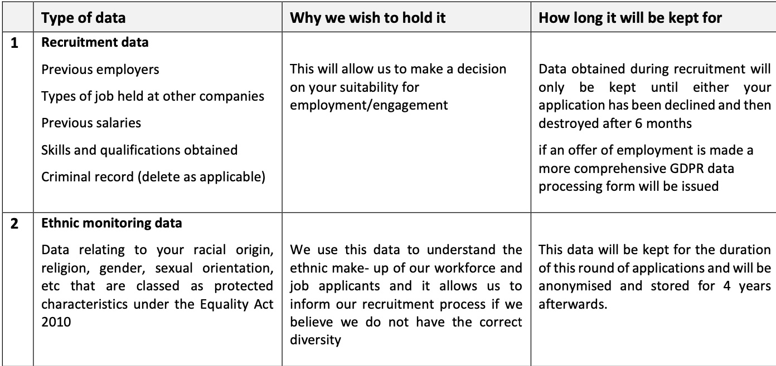

Agreement to use my data

By signing the declaration below (Section 9) I hereby freely give my prospective employer (Survivors In Transition) consent to use and process my personal data relating to my job application (examples of which are listed above).

In giving my consent:

- I understand that I can ask to see this data to check its accuracy at any time via a subject access request (SAR).
- I understand that I can ask for a copy of my personal data held about me at any time, and this request is free of charge.
- I understand that I can request that data that is no longer required to be held, can be removed from my file and destroyed. In this instance I understand that I must provide details as to why I believe that the data being held is incorrect or being held unlawfully.
- I understand that if I am unsuccessful with my application my data will be destroyed after 6 months.

8. Declaration

I confirm that the information given is true and complete to the best of my knowledge.

I understand that Survivors in Transition will:
- in considering my application, treat the information given in this form in confidence;
- not disclose information to any third party without my prior agreement;
- if I am successful in my application, retain this information to contact me.

In signing this form I give my consent for the information to be used as above.

Signed
Name

