SEXUAL WELLBEING SERVICE MANAGER

In this role you will be the clinical lead for Prostate Cancer UK and Movember’s work to transform sexual wellbeing outcomes for men with prostate cancer in the UK. You will develop, lead, deliver and evaluate a remote information and support service for patients in the highest need, directly referred from the NHS and/or partner organisations. You will also initiate and maintain relationships with partner trusts, to ensure the service delivers impact for patients and the health system.
You’ll lead a high-impact community of practice, supporting clinicians to share learnings that benefit prostate cancer patients nationwide.

IN THIS ROLE YOU’LL...
- Finalise the development of a remote information and support service for patients being treated for prostate cancer, centered on sexual health and wellbeing, in line with Movember’s Clinical Guidelines for Sexual Health and Prostate Cancer
- Work alongside Prostate Cancer UK nursing colleagues to deliver this service.
- Oversee the training and development of Prostate Cancer UK nursing colleagues to ensure they deliver the service to the highest standard.
- Work with internal teams to ensure that charity systems and processes support the complexities of this partnership service delivery model.
- Establish a formal agreement with an initial NHS trust, to deliver this service to a cohort of their prostate cancer patients.
- Oversee the growth of the service by initiating further service agreements, and sustaining relationships with, and patient referral numbers from, partner trusts
- Continuously develop and iterate the service delivery model to ensure the best outcomes for patients, and optimum alignment with clinical pathways
- Work with NHS colleagues to define and continuously refine service referral criteria, centered on patients’ level of need.
- Run a community of practice (CoP) that supports the implementation of Movember’s Clinical Guidelines for Sexual Health and Prostate Cancer
- Lead the development, coordination and delivery of the core activities of the CoP.
- Oversee associated comms and engagement, including recruitment of new members.
- Collaborate and network to evolve the work of the CoP, including harnessing best practice from other CoPs.
- Develop an impact evaluation framework to support the monitoring and reporting of the CoP’s work.
- Collaborate closely with key stakeholders at Movember, and their Sexual Health and Wellbeing Advisory Committee.
- Maintain high-quality data, making sure information is gathered and recorded in line with the requirements of the General Data Protection Regulation, ICO and Prostate Cancer UK Data Protection Policy.
- Manage data-sharing agreements with NHS trusts to ensure the data most relevant to service delivery is shared efficiently and safely.

WHO YOU ARE...
- A registered healthcare professional with experience working at a minimum Band 7 role, and extensive experience in prostate cancer care.
- Passionate about providing information and support to those with cancer and their families
- A particular interest in sexual wellbeing, ideally with experience working in erectile dysfunction clinics.
- An experienced line manager and/or service manager, with a proven track record in leading and motivating colleagues to deliver excellent services. Experience leading the collection of data to improve services.
- Confidence in assessing and critiquing others’ provision of information and support and coaching them to improve.
- A passion for quality improvement, and a track record of committed participation in communities of practice or learning networks – ideally as a lead / facilitator.
- A proactive and confident networker, able to build and sustain trusting and productive relationships with stakeholders across the healthcare environment.
- Highly motivated, with an ability to problem-solve and think creatively without close supervision or direction.
- Committed to your own personal development, and that of your peers and direct reports.
- Excellent interpersonal skills.
- Comfortable working in a hybrid organisation: able to build and sustain good working relationships (including with your direct reports), and to motivate yourself to deliver at your best, while working mainly remotely.
- Able to organise and prioritise work effectively and flexibly in a fast-changing setting, and supporting colleagues to do the same – with a focus on accountability and boundaries.
- Actively promotes our commitment to equity, diversity, inclusion and allyship.

YOUR ROLE:
THE NUTS AND BOLTS

Your line manager: Head of Support Services

Job level: Band 4

Contract: Fixed Term: 36 months

Hours: Full time; 37.5 hours per week
We’re happy to consider requests for flexible and part-time working on hiring.

Location: Hybrid working – a combination of remote and in-person working at our London Bridge office. You’d need to be in the office four days a month and we may need you to come in for specific meetings.

The role will entail occasional travel to NHS Trusts across the UK to build and sustain key relationships

WHERE DOES MY ROLE FIT IN THE ORGANISATION?

OUR CULTURE

VALUES AND BEHAVIOURS
Our values and behaviours help us make decisions, work together and guide the sorts of conversations we have on a day-to-day basis. They underpin our brand identity and give us a shared understanding of who we are and how we work together to create positive change, every day.

OUR VALUES

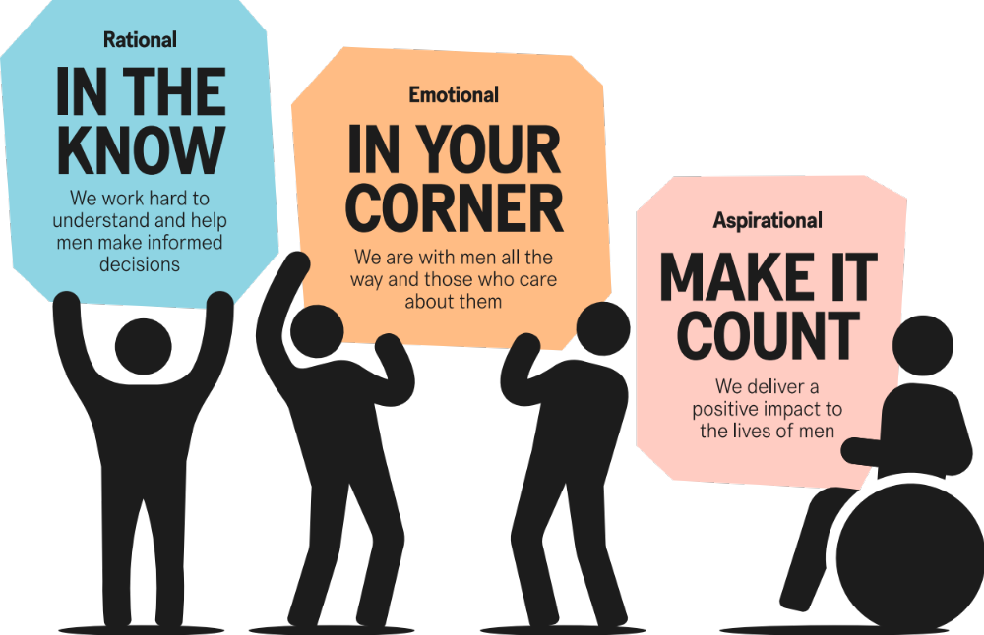

OUR BEHAVIOURS
RATIONAL | EMOTIONAL | ASPIRATIONAL
GENEROUS WITH KNOWLEDGE  Switched on and well-connected, we share our expertise and  make informed decisions.  NATURALLY CURIOUS  Constantly learning  and hungry for knowledge,  we challenge and push  for answers. | GOT YOUR BACK  Unembarrassed and reassuring, we listen, understand and stand up  for those in need.  OPEN TO ALL  Inclusive and open-minded,  we recognise everyone  is unique and embrace  different perspectives. | DO WHAT MATTERS  Impossible to ignore,  we focus on what matters to drive results and maximise  our impact.  NEVER SETTLE  Fired up and determined to make a difference in  everything we do – and driven to give our best.

