Job Description & Person Specification
Job Title: Senior Events Manager
Contract: 18 Months Fixed-Term Contract
Hours: 37.5 hours per week
Location: Flexible, with time in the London (Hammersmith) Office
Reporting to: Director of Income Generation & Engagement
People Management
Responsibilities: Events Coordinator (from March/April 2026)
Salary: £48,000 - £52,000

1st Interview: Friday 9th January 2026
2nd Interview: Tuesday 13th January 2026

About Starlight
No one enjoys medical procedures, least of all children. From facing everyday vaccinations to the most serious of surgeries and chronic conditions, all children experience varying degrees of apprehension and fear. Feeling scared, powerless, or anxious in healthcare settings doesn’t just trigger a child’s emotions; it can create traumas that impact treatment success and that can have a life-long impact. Starlight’s aim is to transform children’s health through better experiences, by putting play at the heart of every child’s healthcare.
Evidence shows that play in healthcare can reduce anxiety, fear and even pain; it helps children engage and prepare for their treatment and cope better with procedures; it minimises trauma and contributes to a better experience; and supports children to have some sense of agency and control in an environment where these opportunities are limited. Play can also reduce the number of attempts to deliver treatment, the need for sedation and the need for repeat appointments. Prioritising children’s right to play in healthcare results in healthier, happier children who are involved in their own healing and recovery as well as more efficient treatment and care.
We work in over 900 healthcare settings across the UK with an ultimate vision to ensure that no child endures trauma in healthcare.
Our Culture
We believe that our success depends upon focusing on our purpose and business results and taking individual responsibility for a culture where everyone can belong, feel safe and thrive. Our values are the agreed standards that govern our behaviour and are central to our decision-making and the choices that we make. Our development programme focuses on individual awareness of our own values, strengths, and preferences –what makes us who we are – to help all colleagues think for themselves, manage their environment, and make appropriate, balanced decisions for themselves, others and Starlight. We believe that our strength is in our differences and constantly strive towards an authentic workplace culture with equity, diversity, and inclusion as central principles.
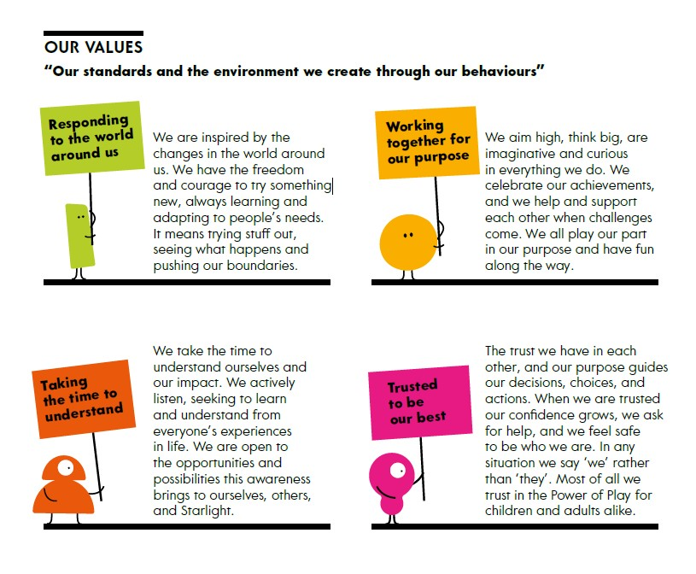
Role Overview
Starlight has a long and successful track record of delivering high-profile, high-value special events, including the prestigious Blenheim Ball, Newbury Race Day, and until recently, the Highclere Clay Pigeon Shoot. These events are supported by influential committees and play a critical role in raising income, stewarding donors and connecting supporters with our purpose.
With a gap in our Philanthropy team and maternity leave expected to begin in March, this 18-month fixed-term role exists to lead and deliver Starlight’s flagship events at a senior level, with immediate responsibility for the Blenheim Ball (April) – the event Tatler refers to as “ society’s smartest ball “chaired by Lady Alexandra Spencer Churchill; and Newbury Race Day (May) – one of Starlight’s longest-standing and most successful supporter events, hosted by Nicky Henderson and his Committee.
This is a senior, delivery-focused role designed for an experienced events professional who can hit the ground running and immediately take ownership of two flagship events. Working closely with the Committees, you will bring leadership, strategic judgement and outstanding project management to ensure these events continue to excel in reputation, income and supporter experience.

Main purpose of the job
As Senior Events Manager, you will take the lead in delivering Starlight’s most high-profile and strategically important fundraising events, with an immediate focus on the successful planning and execution of the Blenheim Ball in April and the Newbury Race Day in May. You will be responsible for shaping, driving and delivering an exceptional programme of special events that strengthens Starlight’s philanthropic ambitions, deepens supporter engagement and makes a meaningful contribution to income growth. Working closely with the Director of Income & Engagement and Events Manager, you will ensure each event is designed not only to raise vital funds but also to create powerful moments of connection that reflect Starlight’s purpose and inspire long-term commitment from donors, senior volunteers and partners.
You will bring significant experience of leading complex, committee-driven events and the confidence to operate at a senior level. You will naturally take ownership—anticipating challenges, guiding volunteers and stakeholders through decisions, and ensuring that income, stewardship and guest experience are all delivered at the highest possible standard. With a strong commercial mindset, it will be instinctive for you to maximise income opportunities, manage expenditure rigorously and identify new avenues for value creation across every element of event design and delivery.
Relationship building will be central to your success in this role. You will thrive when working with Trustees, committees, senior volunteers, high-value supporters and corporate partners, quickly establishing trust and demonstrating the credibility, judgement and diplomacy needed to influence and motivate others. You will also work seamlessly across the Starlight team, collaborating with colleagues in fundraising, services, communications and leadership to ensure events tell the right stories, reach the right audiences and reflect the depth and impact of our work. As Line Manager for our Events Coordinator, you will have the ability and commitment to bring out the best in people, helping them to develop and flourish in their role.
A high degree of autonomy, adaptability and initiative is essential. You will be comfortable managing multiple priorities at pace, responding to shifting demands and making balanced decisions that consider the needs of Starlight, our supporters and our beneficiaries. The role will require evening and weekend work especially around the events in April and May, and the ability to travel to event sites and committee meetings as needed.
Starlight is a small, ambitious organisation with a big vision and a track record of punching above its weight. You will join a team that is passionate about protecting play for children in healthcare and driven to make the most of every fundraising opportunity. For the right candidate, this role offers the chance to take ownership of some of the most prestigious events in the sector, work with exceptional volunteer leaders and directly influence the future growth of Starlight’s high-value fundraising.

Key Areas of Responsibility
Event Management & Development
- Lead the full end-to-end management of the Blenheim Ball and Newbury Race Day, ensuring excellence in planning, logistics, delivery and guest experience.
- Develop and manage project plans, timelines, budgets, creative direction, production, risk management and operational delivery.
- Drive income generation through sponsorship, auctions, pledges, prize sourcing and other fundraising mechanisms.
- Ensure events deliver against income targets, stewardship objectives and brand standards.
- Conduct timely follow-up, stewardship and evaluation to maximise long-term value
Committee, Volunteer & Stakeholder Engagement
- Serve as the primary operational lead for high-profile committees, providing strategic guidance, structure and momentum to volunteers.
- Build deep relationships with Chairs, committee members, Trustees and senior volunteers, ensuring they feel supported, valued and motivated.
- Prepare agendas, briefings and presentations for committee meetings, offering senior-level recommendations and insights.
Donor & Guest Experience
- Create experiences that meaningfully connect guests with Starlight’s purpose, impact and beneficiaries.
- Work with the Director of Income Generation & Engagement to embed philanthropic touchpoints and stewardship into every event.
- Ensure meticulous delivery across invitations, guest management, communications, scripts, staging, speakers and hospitality.
Strategic Contribution to Philanthropy & Events
- Provide insight and leadership to strengthen Starlight’s events strategy and integration with high-value fundraising.
- Work collaboratively with Corporate Partnerships, Trusts and other teams to maximise cross-programme value.
Administration, Finance & Governance
- Lead on data accuracy, financial tracking, CRM recording, ticketing, acknowledgements and reporting.
- Monitor income and expenditure, reforecasting as needed with the Head of Philanthropy & Events.
- Oversee supplier contracts, health & safety, insurance and compliance requirements.

Person specification

Requirement | Essential | Desirable | Evaluation*
Significant experience delivering complex fundraising events with high income targets and senior volunteer engagement. | E |  | A & I
Strong track record of committee management and influencing at a senior level. | E |  | A & I
Outstanding interpersonal, negotiation and relationship-building skills. | E |  | A & I
Excellent organisation, project management and time management, with the ability to prioritise effectively. | E |  | I
Proven ability to work independently, exercising sound judgement and initiative. | E |  | A & I
Previous experience of People Management with a nurturing approach to reviewing growth, impact and performance. |  | D | A & I
Outstanding listening and communication skills with the ability to show empathy, tact and diplomacy | E |  | I
Resilient, flexible and confident working under pressure and to tight deadlines. | E |  | A
Experience in philanthropy or major donor stewardship. |  | D | A/I
Experience designing or developing new events or fundraising propositions. |  | D | A/I
Commitment to Starlight’s purpose and values | E |  | A
*I = tested at interview, A= tested via cv / supporting statement

Please note: This job description is non-exhaustive and is subject to review with the post holder. Reasonable amendments may be made in line with the needs of the organisation.
What we offer
The opportunity and environment to be yourself and be your best. To have flexibility in where you work and the hours that you work. To join in beyond your role with our children and families, at events and activities. To work within a team with play at its heart.

A competitive salary and benefits package including ability to work flexibly between home and office, holiday entitlement of 25 days plus bank holidays increasing up to 30 days with service, office closed at Christmas in addition to holiday entitlement, matched pension contributions to 5%, life assurance, Vitality health cover, cycle to work scheme, season ticket loans.

Diversity Policy Statement
We believe that everyone has the right to be treated with consideration and respect. Starlight is committed to achieving a truly inclusive environment for all, by developing better working relationships that release the full potential, creativity, and productivity of each individual. We aim to ensure that all staff, volunteers, donors, partners, contractors, and the public are treated fairly. This will be regardless of sex, sexual orientation, gender, marital or civil partnership status, ethnicity, disability, medical status, age, religion or belief, political opinion, social or economic status, or ex-offender status.
Starlight actively welcomes candidates from diverse backgrounds.

To apply
Please apply for this role through Charity Job with your CV accompanied by a supporting statement which demonstrates how your experience matches the person specification and highlights your most relevant, recent experience for this role. In your application, we’d love to hear about what inspires you about Starlight’s purpose, beliefs and values with a statement that is very personal to you and gives us an insight into who you are, and how you would contribute to Starlight’s success with your experience, expertise and approach.

The role will close at 9am on Monday 5th January and we are actively recruiting for this post on a rolling basis, allocation for interviews may happen as candidates apply, which may be before the interview dates stated above. As we may interview before these dates, we reserve the right to close the role earlier if we receive a number of high-quality applications.

1st Interview: Friday 9th January 2026
2nd Interview: Tuesday 13th January 2026
Additional Information
Diversity Policy Statement
We believe that everyone has the right to be treated with consideration and respect. Starlight is committed to achieving a truly inclusive environment for all, by developing better working relationships that release the full potential, creativity, and productivity of each individual. We aim to ensure that all staff, volunteers, donors, partners, contractors, and the public are treated fairly. This will be regardless of sex, sexual orientation, gender, marital or civil partnership status, ethnicity, disability, medical status, age, religion or belief, political opinion, social or economic status, or ex-offender status. Starlight actively welcomes candidates from diverse backgrounds. If you are invited to an interview and need any adjustments made or have particular access needs, please let us know at that stage.
Shortlisting
Starlight is an equal opportunities employer, and we are committed to ensuring all applications are treated fairly. All applications are subject to our shortlisting process; if you are shortlisted, we will contact you and invite you to attend an interview on or before the dates in this document, please let us know on application if you have any difficulty with the dates. You will also be advised at this point if there will be any skills test, presentations etc. We may appoint to the role before the stated closing date if a suitable candidate is identified.
Employment Checks
All offers of employment are made subject to the following criteria: proof of eligibility to work in the UK, proof of residency and satisfactory employment screening, enhanced DBS and two most recent references.

