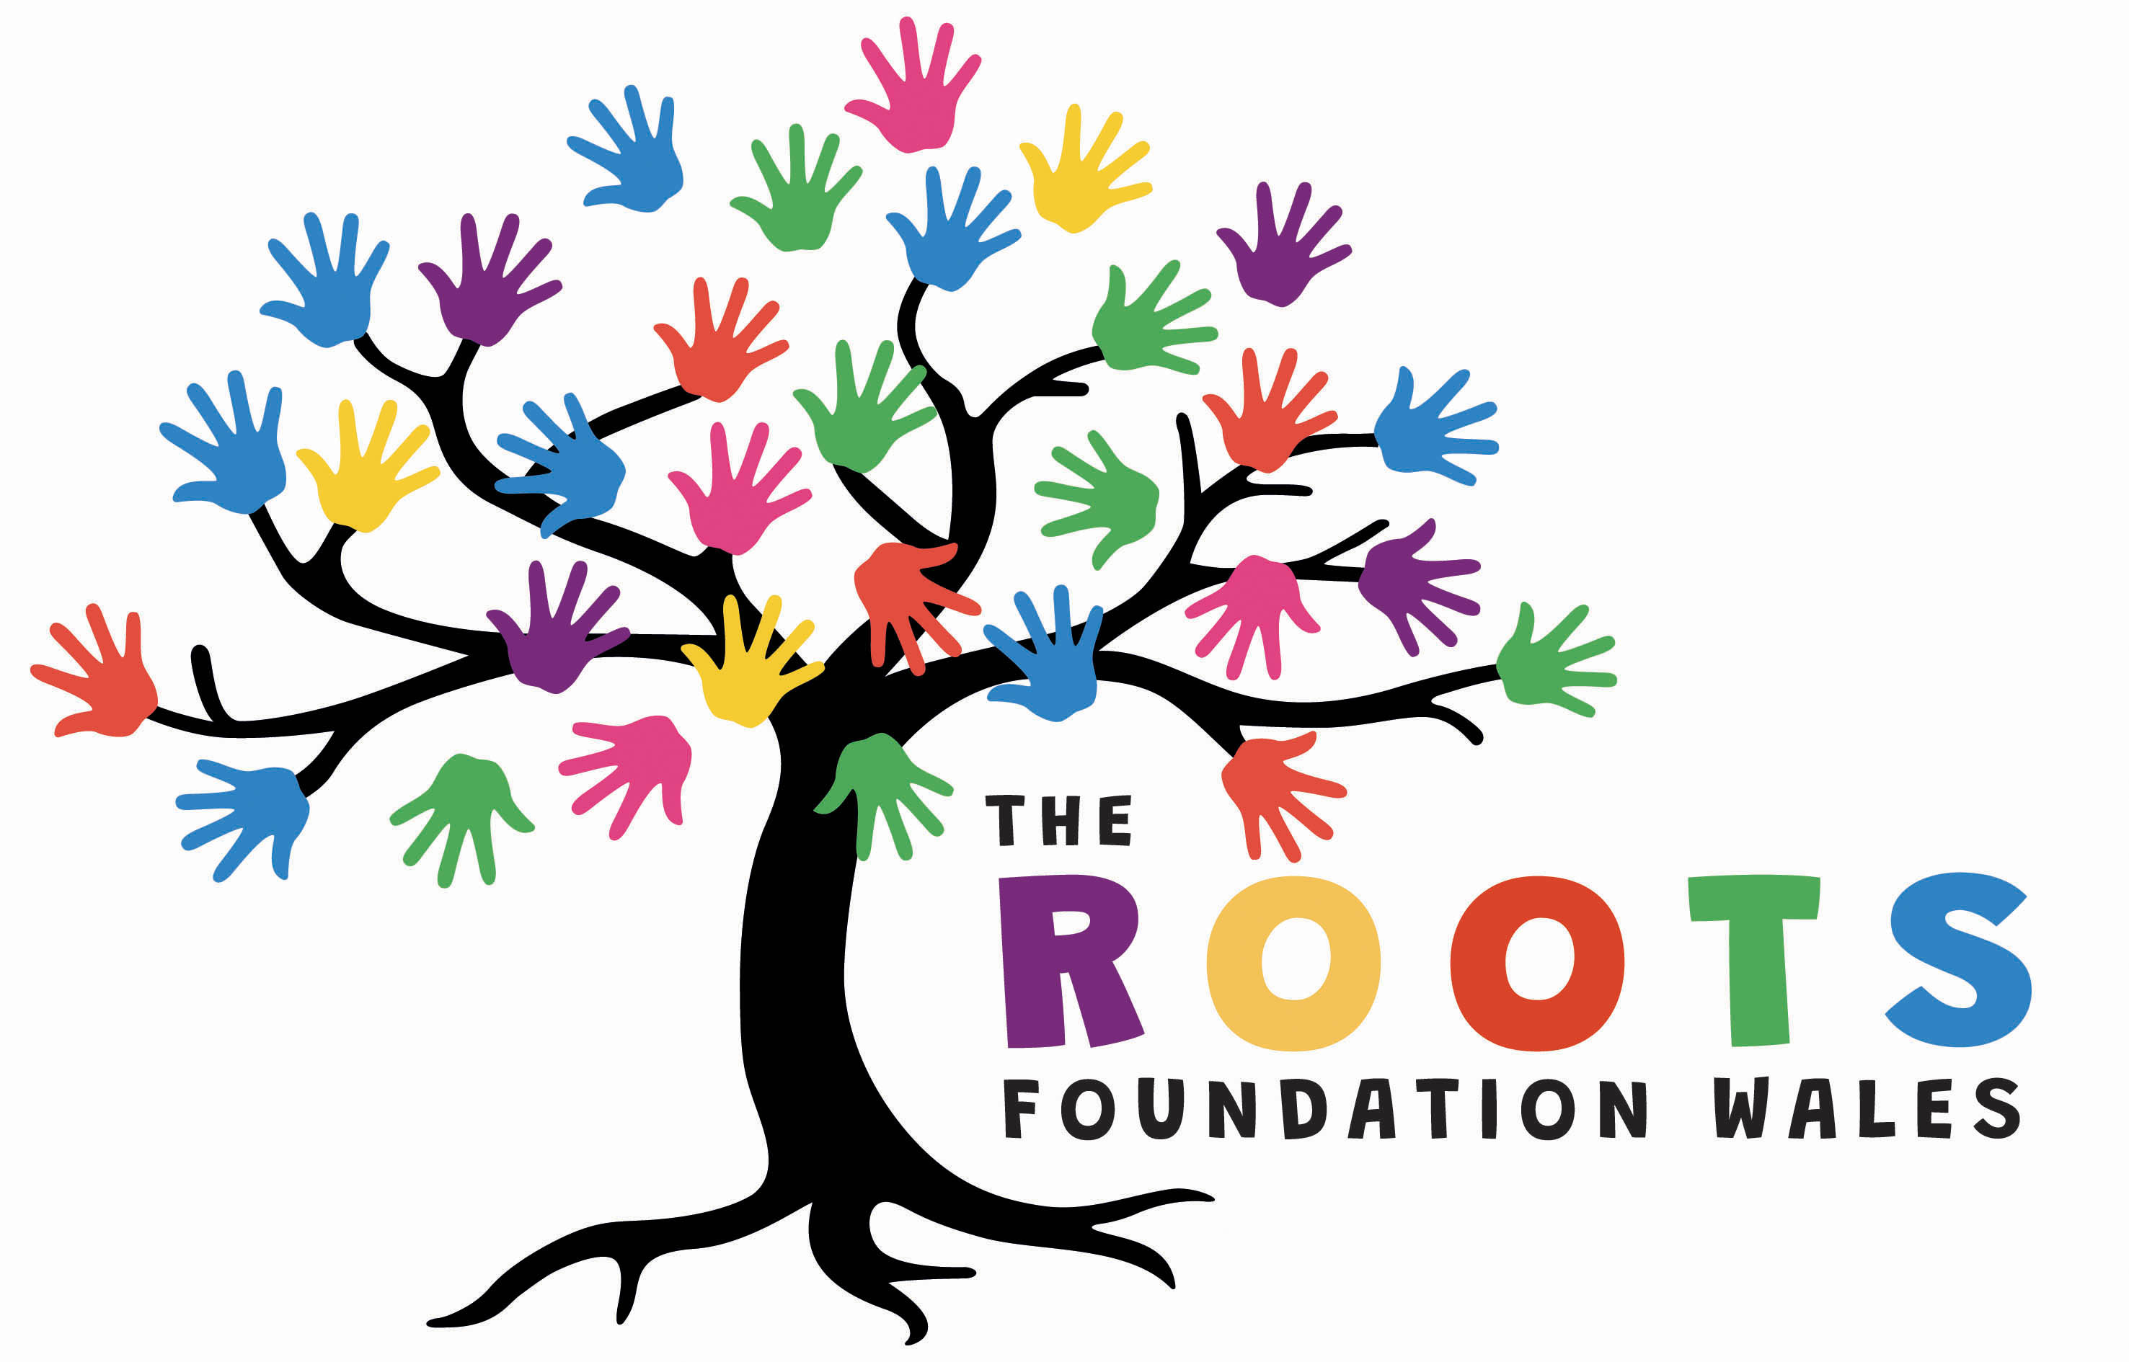

Become a Trustee at The Roots Foundation Wales
Are you a care leaver, foster carer or kinship carer? We are looking for new Trustees to join our Board and would particularly love to hear from people with lived experience relevant to our work.
Who we are
The Roots Foundation Wales is an award-winning charity based in Swansea. We support young people in care as they transition to independent living and into adulthood and we also support foster and kinship carers. Our beautiful centre was featured on BBC's DIY SOS and Children in Need in 2017 and we are proud of the community we have built here.
With the help of our young people and carers we have developed a new 3-year Strategic Plan and in 2027 we will be opening a new house with further accommodation for young people.
A message from our Youth Panel
“Roots is our home from home, it’s a place where we can share our personal experiences and always be supported. Building good relationships with the staff and other young people is very important to us. It’s important to have staff who are respectful, caring and trustworthy while being able to have fun and enjoy a bit of banter! We need someone who is honest, responsible and appreciative of the fact that Roots is like our family.”
What we are looking for
We are expanding our Board and are particularly keen to recruit Trustees with lived experience of care, including care leavers and kinship carers. We also encourage applications from young people, disabled people and Welsh speakers and from people based in Swansea and the surrounding area.
As a Trustee you will:
- Help guide the strategic direction of the charity
- Attend online board meetings every two months (usually Tuesday evening, 2 hours)
- Visit Roots 2-3 times a year as a minimum
- Work on sub-committee projects such as finance or safguarding
- Be visible and support the staff and young people
Expenses are covered and full induction and training will be provided. An enhanced DBS check is required.
You can find out more about Roots, the work we do and the current Trustees here: https://www.therootsfoundation.wales/our-team/

How to apply
We review applications on a rolling basis so please apply as soon as possible. Email Annie at annie@roots.wales to arrange a chat and find out more.
Or send a short CV and covering letter expressing your interest and explaining why you think you’d be a good fit. You are also welcome to send a short video or voice note if you would prefer. If you need any adjustments to the process please get in touch.

