2025
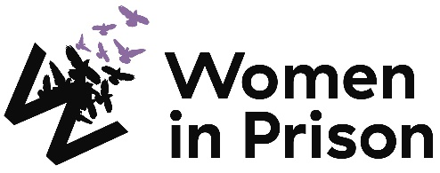

Project Worker (WomenMATTA)

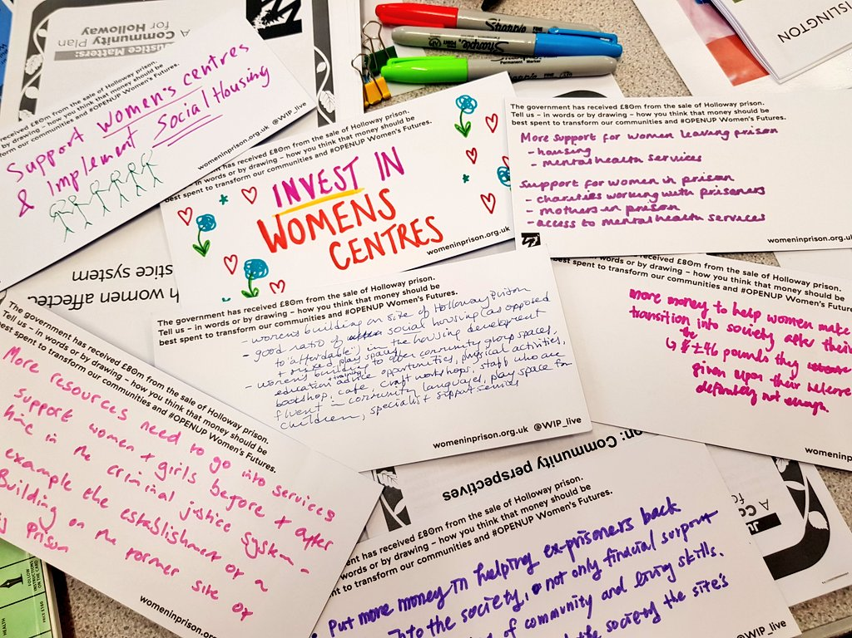

Charity no: 1118727. Company no: 5581944.

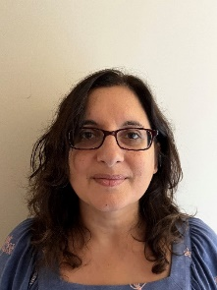

Welcome!
Dear Applicant,
Women in Prison is the only national charity focused on women in the criminal justice sector, we are women-led and know the importance of ensuring we have a clear gendered approach in all that we do. Our influencing potential and campaigning voice are substantial. We are currently in our 40th year of supporting women impacted by the criminal justice system. We work with women who are at risk of, or being, harmed by the systems that are meant to protect us.

At Women in Prison we are passionate, ambitious and grounded in the reality of women’s lives. We are proud of our roots as a feminist grassroots organisation, and we have grown from strength to strength since the 1980s, delivering services to women and campaigning for change. We exist to support women facing multiple marginalisation and exclusion, who have been let down, and their rights denied. We believe that prison doesn’t work and we want to see an end to the harmful imprisonment of women in England and Wales.
This is a very exciting time in Women in Prison. As a deeply value-led organisation, we know that our recently agreed set of values represents the unique nature of our organisation, and also need to hold us to account for how we work in an unpredictable future. Our new vision and purpose will guide us as we build a strategy during 2024 to be implemented from 2025.

We know we want to build more coproduction; deeper support to women who are disproportionately affected by the system through an intersectional lens; greater connection between the women we support and the influencing we do; an increased focus on alternatives to the system and a stronger focus on preventing women being caught up in the system.

If you are excited by our purpose, and the breadth of what this role could offer to you, we would love to hear from you.

I look forward to meeting you.
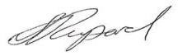

Sonya Ruparel, Chief Executive
Our Story

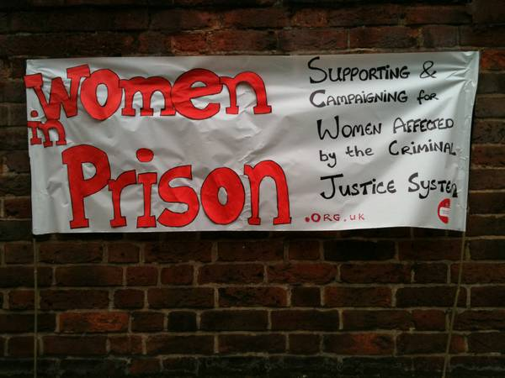

Our Vision is of a society which no longer accepts the structural inequalities that lead women and girls into contact with the criminal justice system.

Women in Prison was born out of the anger our founder – Chris Tchaikovsky – felt about what she experienced and saw when imprisoned in HMP Holloway in the 1980s.

During Chris' time in prison, a woman died after setting fire to her own cell. Chris saw that the specific needs of women in prison and the damaging effect prison sentences were having on women scarcely figured in public or political discourse. So, in 1983, alongside international criminologist Pat Carlen, Chris founded Women in Prison, pushed hard to expose this scandal and campaigned for change. Our founders wanted to increase awareness of the lives behind the women in our prisons, and the impact of poverty and abuse on women’s lives.

Chris believed the idea of sending a woman to prison as punishment was shameful and absurd.

In her words:

“Taking the most hurt people out of society and punishing them in order to teach them how to live within society is, at best, futile. Whatever else a prisoner knows, she knows everything there is to know about punishment because that is exactly what she has grown up with. Whether it is childhood sexual abuse, indifference, neglect; punishment is most familiar to her.”

In the early 1990s, the organisation was able to expand its remit beyond campaigning to deliver direct support to women affected by the criminal justice system. WIP's initial focus on prison in-reach services was then expanded to support women in the community following their release. Chris, sadly, passed away in 2002. Despite the loss of our visionary founder, Women in Prison works to carry on Chris' legacy.

Today, WIP is a national charity dedicated to making a difference to the lives of women affected by the criminal justice system. We campaign for a new system of justice - one that addresses the root causes of offending (including homelessness, substance use, mental ill health and experiences of poverty, trauma and abuse). Our women’s centres in Manchester and London and the services we provide in communities and prisons deliver holistic, women-centred support to enable those whom we work with to address the complex challenges they face.

We want to persuade decision-makers to radically reduce the women’s prison population, by demonstrating how a focus on human rights, social justice, health and investment in specialist community support services, including women’s centres, enables women to move forward with their lives. We do this by:

- Leading inspiring, passionate campaigns to replace the current system, and to radically reduce the number of women in prison, thereby freeing resources for investment in community support services, including women’s centres.
- Delivering high quality, trauma-informed, independent advocacy services for women, in communities and prisons, which focuses on early intervention, health and holistic provision as part of a ‘whole system’ multi-agency response.
- Offering a platform for women’s voices which builds women’s confidence and self-belief, strengthening an understanding of their rights and responsibilities, and provides opportunities to speak ‘truth to power’ to bring about real change

Here is a link to our most recent annual report: 2023_Annual_report__and_accounts_Women_In_Prison.pdf (womeninprison.org.uk)

Project Worker (WomenMATTA)
Reports to: Programme Manager (WomenMATTA)

Direct reports: N/A

About Women in Prison

Women in Prison is a national, women-led, feminist organisation. We deliver front line support to women harmed by the criminal justice system, through our work in prisons, in the community and ‘through the prison gate’ as they resettle back into their communities. We also campaign for systems change that addresses the root causes of offending, reduces the harmful impact of prison, and creates workable, community-based alternatives to imprisonment.
Job Description:
Job Purpose:
Women in Prison’s Project Workers deliver high-quality, trauma-informed, independent advocacy for women in communities and in prisons, which focuses on early intervention, and holistic provision as part of a ‘whole system’ multi-agency response that looks to address the root causes of women’s offending. The primary purpose of this role is to provide in-depth, ongoing support to a caseload of women in the community of Greater Manchester.

Key Responsibility Areas
- Provide high-quality, trauma-responsive support to women in contact with, or at risk of contact with the criminal justice system.
- Monitor case management systems to ensure accurate and timely data recording, aligning with contract KPIs and WIP policies.
- Develop and maintain effective partnerships with statutory and voluntary sector services to ensure coordinated, multi-agency support for women.
- Contribute to organisational development and personal growth through innovation, self-care, and professional learning.

Duties and key responsibilities
- Provide high-quality, trauma-responsive support to women in contact with, or at risk of contact with the criminal justice system:
- Provide one to one advocacy and support to a caseload of service users; adopting a person-centred approach to ensure that women are empowered to achieve independence through structured interventions.
- Complete comprehensive risk and needs assessments and co-create support plans across the nine pathways to reoffending.
- Take a collaborative multi-agency approach to supporting women, representing the core values of Women in Prison at all times, including representing and supporting women at multi-agency meetings.
- Conduct regular risk management and complete safeguarding referrals where appropriate and support women’s safety through involving them in the safeguarding process.

- Monitor case management systems to ensure accurate and timely data recording, aligning with contract KPIs and WIP’s policies:
- Ensure effective monitoring and evaluation systems and processes are in place to report on service delivery and collate feedback from service users and partner organisations.
- Ensure that staff maintain accurate, confidential service user records, following WIP’s policies and procedures, and contribute to the maintenance of the Programme’s monitoring and recording systems.
- Support with the production of monitoring and evaluation reports in line with funder and other key stakeholder requirements.

- Develop and maintain effective partnerships with statutory and voluntary sector services to ensure coordinated, multi-agency support for women:
- Take a collaborative multi-agency approach to supporting women, including representing and supporting women at multi-agency meetings.
- Build strong professional relationships with a range of stakeholders, including probation, prisons, housing, and mental health services.
- Represent WIP in community and statutory meetings, championing trauma-informed and gender-responsive approaches.

- Contribute to organisational development and personal growth through innovation, self-care, and professional learning:
- Actively participate in WIP campaigns and ensure women’s voices are included in influencing and policy work.
- Maintain awareness of developments in relevant public policy and best practice by attending training, conferences, and meetings.
- Engage in regular line management supervision and clinical support to maintain wellbeing and prevent vicarious trauma.
- Promote a culture of innovation and continuous improvement in trauma-responsive and gender-specific service delivery.

The job description does not form part of your contract of employment and can be amended from time to time as the needs of the organisation require.

Person Specification:
Skills and Experience

- Proven ability to provide strengths-based, trauma-informed support to women facing multiple disadvantages, ideally within the criminal justice system.
- Experience working with agencies that provide support around benefits, homelessness, mental health and substance misuse.
- Strong experience in conducting risk and needs assessments, developing support plans, and maintaining clear, accurate case records.
- Effective communicator, both verbally and in writing, with the ability to build trusted relationships across a range of professional and cultural contexts.
- Competent in managing a varied caseload, prioritising tasks, and working independently as well as collaboratively within a team.
- Confident IT user, including databases, reporting systems, email, and Microsoft Office tools.
- Meticulous case recording including accurate note taking and ability to summarise information to identify key themes.

Knowledge and Attributes

- Commitment to the core values and ethos of Women in Prison, including social justice and feminism
- Commitment to anti-discriminatory practice and equal opportunities and an ability to apply awareness of diversity issues to all areas of work
- Understanding of equality, diversity and inclusion and a commitment to working in a way that promotes social justice and feminism.
- Up to date understanding of safeguarding practice, policy and procedures.
- Knowledge of the impact that contact with the criminal justice system may have on women and understanding of the root causes of women’s offending and the importance of women-specific provision.
- Personal resilience and the ability to stay focused in a rapidly changing environment.

Terms and Conditions:
Start date: December 2025

Salary: £26,650 per annum

Location: Manchester and Trafford, Greater Manchester

Working hours: Full time: 35 hours per week

Contract: Fixed term until 31st March 2026 (extension subject to funding)

Annual leave: 30 days plus statutory bank holidays (if full time). All WIP staff also receive an additional 3 days leave between Christmas and New Year.

Pension scheme: WIP provides an auto enrolment pension scheme with 5% contributions from the employer and 3% from the employee.

Clinical supervision: Working with WIP can be enormously rewarding but also challenging at times. So, we provide clinical supervision through a Harley Street practice, to encourage reflective practice and support the wellbeing of our team.

Employee Assistance Programme: Confidential access to a range of support and information on a 24/7 basis. Including legal advice, emotional support, practical advice and signposting.

Cycle to Work Scheme: Eligible employees can save money and spread the cost of a new bike and accessories.

To Apply:

Applications close: rolling deadline; early applications are encouraged. We reserve the the right to close the advert early.
Interviews with Women in Prison: TBC
To apply: Submit a completed application form to applicant portal

If you require reasonable adjustments to support you during the application process, please contact the HR team on hr@wipuk.org.
We are happy to invest in developing the right person, so you are welcome to apply even if your professional experience does not fully meet the job description or person specification.

We particularly encourage applications from Black, Asian and minoritised women, and women who have personal experience of the criminal justice system.

In line with legal requirements and the nature of our work, this role:
- Is restricted to women only as a genuine occupational requirement.
- Requires the right to work in the UK.
- Is subject to an Enhanced + Adult Barred List DBS check.
- Is subject to HM Prison and Probation Service vetting (‘Enhanced Level 1’ or ‘Standard Plus’).
- Requires that the post holder is not automatically disqualified by (or can obtain a waiver from) the Charity Commission.

Equality, Diversity and Inclusion Policy

Our Principle Commitments
WIP is committed to building and valuing diverse teams and taking positive action to promote equality and challenge unfair and unlawful discrimination. We recognise that women may experience multiple and intersecting forms of discrimination based on their sex and additional, real or perceived, characteristics including age, disability, gender reassignment, marriage or civil partnership, pregnancy or maternity, race, religion, sexual orientation, social-economic background, immigration status, caring responsibilities, spent convictions or trade union membership.

WIP works to tackle discrimination and the structural inequalities women experience. We are committed to embedding diversity and inclusion in all areas of our work, including recruitment, and aim to reflect the diversity and excellence of the women that we work with. We actively encourage applications from women from a variety of backgrounds, and with a range of skills and experiences. We are particularly interested to hear from Black, Asian and minoritised women and women who have lived experience of the criminal justice system.

Policy on the Recruitment of Women with Lived Experience of the Criminal Justice System

Women in Prison actively encourages and supports the employment of women with lived experience of the criminal justice system. We believe that women’s own experiences drive the Charity forward through understanding, solidarity and passion for change.

Job Advertisements and the Application Process
We do not ask for disclosure of criminal records during the application process, to ensure that women with lived experience of the criminal justice system are assessed on their merit, without risk of discrimination and are not asked to disclose sensitive personal information unnecessarily.

If a Disclosure and Barring Service (DBS) check is required for a role, this will be stated clearly in the job advert, including the level of DBS.

Levels of DBS Checks
Basic DBS checks contain details of unspent convictions. Standard and Enhanced DBS checks contain details of unspent and spent (unless filtered) convictions and cautions (including reprimands and warnings). Enhanced DBS checks may also include other information held by police forces deemed relevant to the role or check for inclusion on the Children’s or Adults’ Barring List.
Job Offers and the Induction Process
We will only ask for a DBS check at the point of job offer.
Disclosures will be treated confidentially and only stored where necessary, in line with General Data Protection Regulation (GDPR) guidelines. Access will be restricted to limited Senior Management or HR representatives as needed to assess suitability for the role.
A criminal record will not arbitrarily bar women from employment with us. We discuss disclosures with applicants (in person, or via phone or video call), to allow them to explain the background in their own words. We consider the relevance to the role, including the type and seriousness of an offence, how much time has passed and whether the individual’s circumstances have changed. If they have restrictions on the work they are able to do, we consider whether we are able to make reasonable adjustments to facilitate their employment.
The Charity Commission does however have its own automatic disqualification rules on who can hold senior positions within a charity, which apply to our Trustee, CEO and Director of Finance and Resources positions. Although it is possible to apply for a waiver.
Women in Prison does not have a blanket ban on any criminal records and will always approach disclosures fairly and on an individual basis. We seek to balance supporting women with lived experience into employment, alongside safeguarding our current employees, service users and the organisation.

