RECRUITMENT PACK
Creative Copywriter
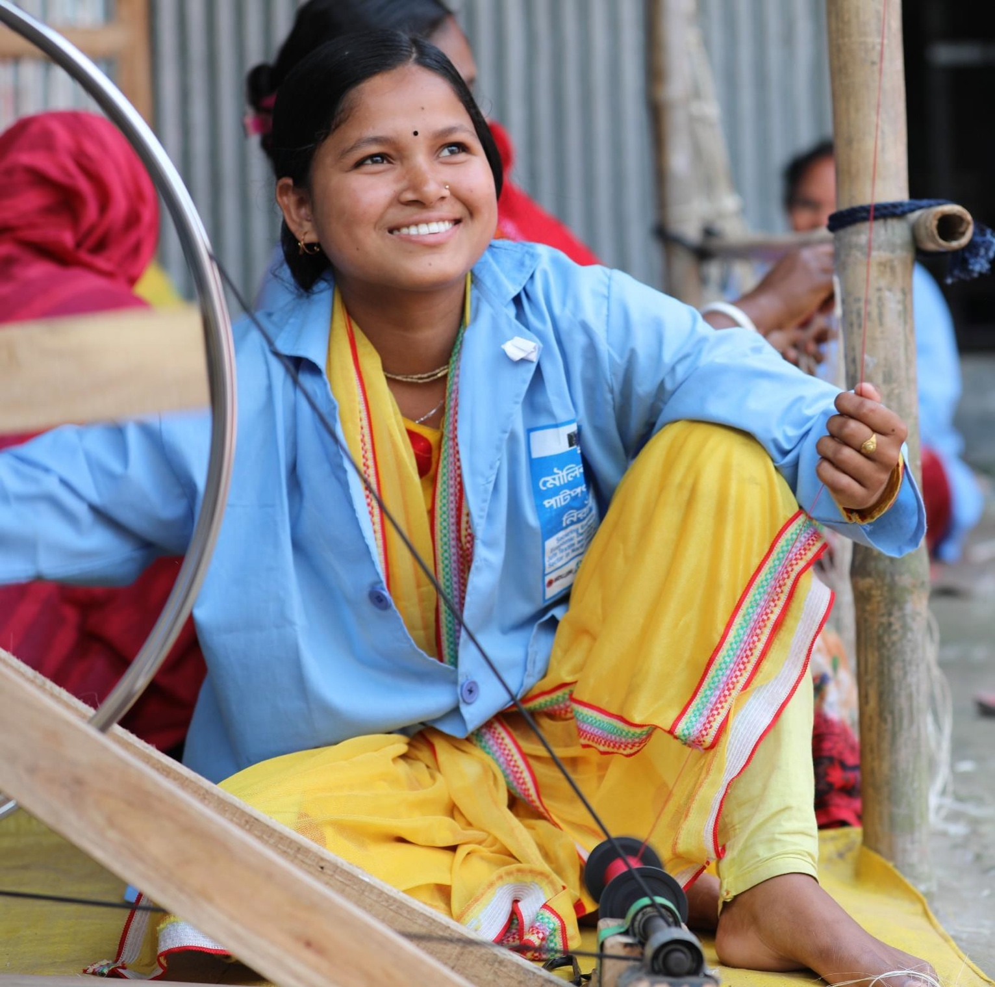
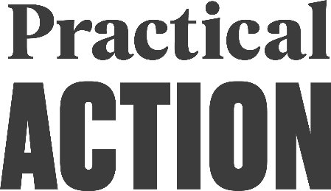
Practical Action

About the role

We are looking for an experienced Creative Copywriter with a talent for developing compelling campaign concepts and communications that inspire action, deepen engagement, and grow fundraising income across audiences and channels.

About you

You're a creative thinker and talented copywriter who knows how to turn insight into ideas and ideas into action. You enjoy developing compelling stories and campaign concepts that connect with audiences, inspire action and deliver against strategic and fundraising objectives.

You're confident translating complex information, data and lived experience into clear, engaging communications, balancing emotional impact with accuracy, authenticity and a strong call to action. You can adapt your writing for different audiences while maintaining a consistent brand voice.

You'll enjoy collaborating with designers, marketers and subject experts to develop creative work from insight through to delivery. Organised, proactive and curious, you're motivated by using your creativity to make a positive impact and are excited by the opportunity to help Practical Action inspire change through powerful storytelling.

Why join us?

The opportunity to work for an organisation that is taking practical action against poverty and the environmental crises to start the big changes the world urgently needs. A friendly and supportive culture, working with values driven and highly engaged colleagues, work life balance and flexible working – these are just some of the reasons we think Practical Action is a great place to work.

In the UK, our open plan offices are located in the centre of Rugby and near to Rugby train station but we also offer free parking.

In addition, we offer the following benefits:
  - Full time roles are contracted at 35 hours per week.
  - It is our normal practice to operate a hybrid working policy, where flexible working hours are enabled as well as remote working.
  - 27 days holiday rising with continuous service, in addition to public holidays
  - Pension scheme - employer contributes 10.5% of salary and the employee contributes 5%.
  - Enhanced family friendly policies, including maternity, adoption, paternity, and shared parental leave.
  - Life assurance (3 x annual salary).
  - Cycle to Work scheme
  - Employee Assistance Programme – access to our Wellbeing platform
  - Learning and Development Opportunities
  - Sit / Stand desks available in our modern offices.

About us

We are a global community taking practical action against poverty and today’s environmental crises. Across Africa, Asia and Latin America we partner with people experiencing these challenges, especially those who are unheard and excluded. Our approach is to identify what works on a local level, then adapt and amplify it across different regions, countries and continents. All of Practical Action’s work is focused on two connected areas for action - livelihoods and climate resilience – and we’re working to deliver three big, global changes:

Big change on food – to sustain people and planet
Big change on energy – clean and accessible for everyone
Big change on climate risk – safer lives, stronger livelihoods

Our Values
We are People Centred, striving to create an equal, fair, accessible, dignified and respectful environment for everyone we work with – from colleagues and communities, to supporters, suppliers and stakeholders.
We are Impact Driven, existing to make a positive difference, so everything we do is driven by our energy to create lasting value for the people and communities we serve.
We are Transparent and trustworthy, acting with integrity, honesty, and strong ethics, building mutual trust with everyone we work with to achieve the highest standards.
We are Innovative, and champion learning, curiosity and fresh thinking, bringing local knowledge to create global impact.
We are Resilient changemakers working for sustainable development, meeting challenges head-on, and evolving through the lessons learnt.

Additional information

We treat all applications for employment fairly regardless of gender, race, religion, ethnicity, nationality, caste, tribe, belief, age, marital status, pregnancy, caring responsibilities, sexual orientation, or disability.

Practical Action is committed to safeguarding and protecting children and vulnerable adults and as such candidates will be subject to pre-employment checks including criminal checks and terrorist financing.

To ensure that Practical Action meets its obligations of safer recruitment, appointment to posts within Practical Action will be subject to a satisfactory criminal check. Criminal checks will be conducted for all roles.

The successful applicant must already have the right to both live and work in the country that they are applying for and should be willing and able to travel.

Salary Range: Grade 4- £35000 - £38000 dependant on experience

Closing date for applications: Monday 27th July 2026

We are aiming to hold interviews in the weeks commencing: 3rd and 10th August 2026

How to apply:
If you want to work for an organisation with significant people ambitions, then we would like to hear from you.
Please submit a copy of your CV / duly filled standard application form and a supporting statement that describes your suitability for the role and contains the answers to the following questions. Email your application to Recruitment@Practicalaction.org.uk
We're interested in understanding your creative thinking, collaboration, writing approach and motivation for joining Practical Action.

• Tell us about a creative campaign you helped develop from insight to delivery.
What was your role, how did you work with colleagues or stakeholders to shape the idea, and what impact did the campaign have against its strategic, fundraising or engagement objectives?

• Tell us about a piece of copy or storytelling where you translated complex information, data or lived experience into engaging content for a specific audience. How did you balance accuracy, emotional impact, tone of voice and a clear call to action, and what was the outcome?

• What attracts you to this role and to Practical Action? How do your skills, values and experience align with our mission, and what would you hope to contribute in this role?

RECRUITMENT PROCESS PRIVACY NOTICE
Information you need to know:
Your CV/resume, covering letter or supporting statement submitted in support of an application for
any position with the Practical Action Group will be used during the recruitment process to short
list suitable candidates who will be invited to interview.
Practical Action collects a range of information about you. This includes:
• Your name, address and contact details, including email address and telephone number;
• Details of your qualifications, skills, experience and employment history;
• Information about your current level of remuneration, including benefit entitlements;
• Bank details at on-boarding stage to set you up for pay if you are successful in your job application;
• Whether or not you have a disability for which Practical Action needs to make reasonable adjustments during the recruitment process;
• Information about your entitlement to work in the UK;
We sometimes use third party job application platforms to publish and receive applications for roles at the Practical Action Group. When you apply through these portals the organisation’s privacy information will be available to you. We only work alongside other organisations in this way under a contract and if we are satisfied that they will keep your information safely and securely using it only in the same legal ways that we would.
During the recruitment process and with your permission, informing you that we are doing so, Practical Action may also collect personal data about you from third parties, such as references supplied by former employers. We may also perform checks on your identity to establish your right to work in the UK where applicable. We are also obliged to seek information about criminal convictions and offences in meeting our obligations and exercising specific rights in relation to employment.
If your application is successful, personal data gathered during the recruitment process will form part of your electronic personnel file and retained during your employment and afterwards in line with legislation including the storage of personal records and to comply with the requirements of any statutory bodies.
The legal basis for processing personal data is either contract and/or legal obligation when applying for roles and the employment contract between Practical Action and you if you are successful. If we are required by law to share your information, (e.g., in response to a warrant or court order), we will do so.
Practical Action may process information about whether or not applicants have a disability in order to make reasonable adjustments. This is to carry out its obligations and exercise specific rights in relation to employment.
Practical Action is obliged to seek information about criminal convictions and offences. Where Practical Action seeks this information, it does so because it is necessary for it to carry out its obligations and exercise specific rights in relation to employment.

We automatically delete the personal information of unsuccessful applications 12 months after the
application process ends, unless a candidate requests that we keep their details for longer. Statistical
information like ethnicity, sexuality and disability may be kept ensuring that our recruitment processes are inclusive and not discriminatory, but this information is completely anonymised.

