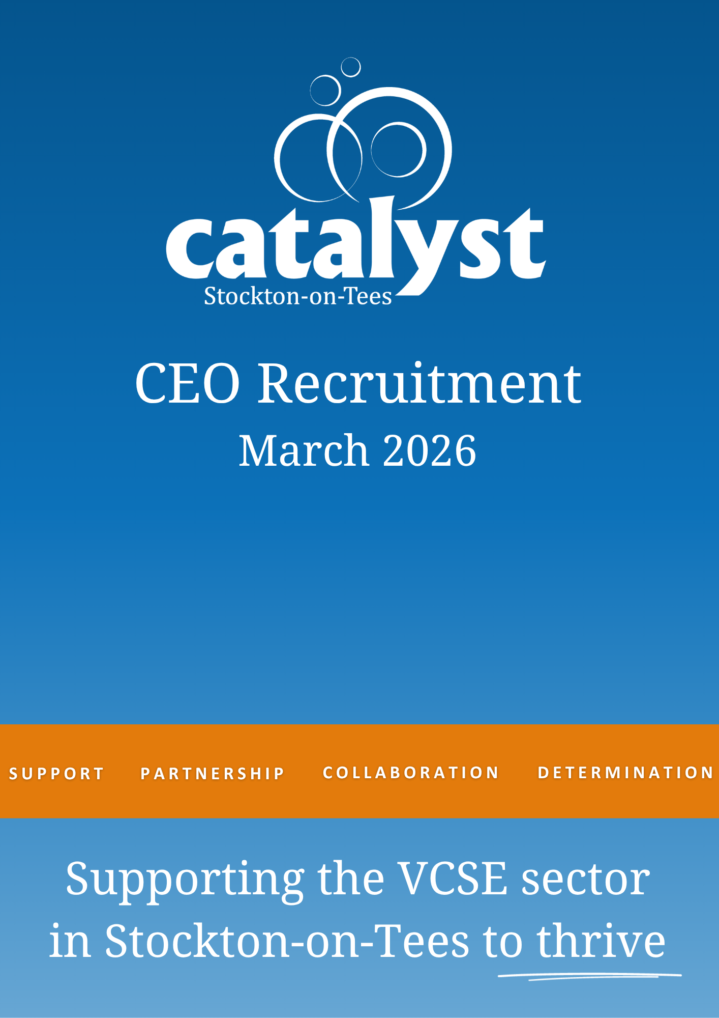

Catalyst Stockton-on-Tees Limited

YOUR APPLICATION

Dear Applicant
Thank you very much for your interest in this post. On the following pages, you will find details of the role and the selection process to assist you in completing and tailoring your application. In order to apply you should submit:
- An up-to-date CV which shows your full career history – we recommend that this is no longer than three pages;
- A supporting statement explaining why you are interested in this role, detailing how you are a good candidate for this post and how you fulfil all elements of the person specification – we recommend that this is no longer than three pages;
- The equal opportunities monitoring form – this is optional, will not be used for selection purposes and is requested for monitoring in line with our commitment to equality and diversity;
Please note that applications can only be considered if all the documentation is complete. Please send your application,
preferably in MS Word format by email to Catalyst’s Chair: ann.workman@catalyststockton.org
Applications must be received by Wednesday 15th April @ 5pm.
You will receive an acknowledgement within 24 hours of receipt and we suggest that if after that time you have not heard from us, you telephone the office (01642 733906) to ensure that it has arrived. Using a secure email address and putting the job title/ organisation in the subject line reduces the chances of any email going into spam.
Please do contact us if you wish to have an informal discussion about the role and organisation or if you have any other questions to help you decide whether
to apply.
Kind regards

Ann Workman
Chair of Trustees
Catalyst Stockton-on-Tees Ltd
01642 733906

CONTENTS

About us 3
Board of Trustees 5
Job description 9
Person specification 11
Principal terms and conditions 13
Key dates and selection process 14
Supplementary information 15

Catalyst Stockton-on-Tees Limited

Catalyst Stockton-on-Tees Limited

ABOUT US

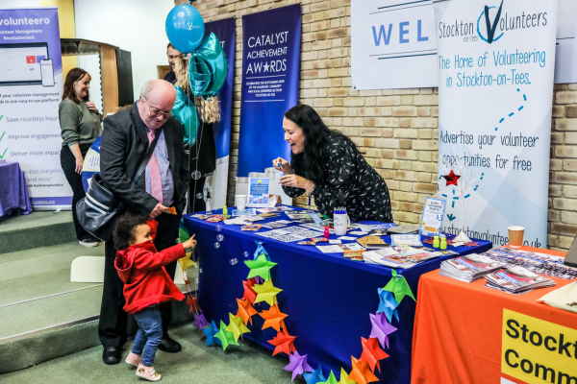

About Catalyst
Catalyst is the voice, representation and support for Stockton-on-Tees’ Voluntary, Community and Social Enterprise (VCSE) sector.
We work with a wide variety of organisations in Stockton-on-Tees, to find innovative solutions that help them to continually improve and thrive. We offer a range of specialist support, strategic operations and a commitment to push forward the conditions in which our members operate.

Vision, mission and values
Our Vision
To be a best practice infrastructure organisation in a strong, healthy VCSE sector. We have a vision of a coherent and single sector, working together in partnership with public bodies and private businesses, as well as VCSE organisations to deliver services to the community in the Borough of Stockton-on-Tees and Tees Valley.

Our Mission
Putting the Voluntary, Community and Social Enterprise (VCSE) sector in Stockton-on-Tees first.
To support and develop a strong and thriving VCSE sector delivering high quality services to people, organisations and communities in the Borough of Stockton-on- Tees and Tees Valley.

Our Values
- Leadership
- Partnership & collaboration
- Fair and inclusive
- Socially responsible
- Welcoming challenge
- Developmental
- Accountable
- Creative
- Determined & passionate
- Flexible

Our Values in delivering services.
We deliver a combination of services, training and information to achieve the following objectives:

Develop the Sector
Coordinate a range of meetings, Forums and bespoke training programmes that help improve communications between organisations. These build upon and develop existing skills in the sector.

Support Organisations
Resources and expertise in;
governance and the formation of new organisations; funding
advice and innovative
approaches to fundraising;
and practical help with sector communications.

Be Innovative and Create New Services
The clue is in the name, Catalyst can be a catalyst for the development of pilot programmes that lead to new organisations and cross sectoral pieces of work.

Be Influential to Develop Policy
Catalyst organises a network of sector-focused Forums. We are also involved with a wide range of regional and national strategic bodies to ensure that we provide the sector with a voice that is heard.

Prove Impact of Work
Undertaken
We evaluate every aspect of our work both internally and externally so we are able to
demonstrate that the work we
undertake adds value to the
delivery of public services.


Catalyst Stockton-on-
Catalyst Stockton-on-Tees Limited

BOARD OF TRUSTEES

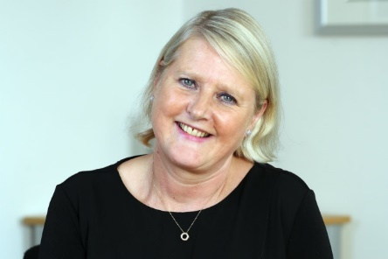
Ann Workman OBE

Chair of Trustees

Ann Workman has been the Chair of the Board of Catalyst since 2023. Ann has a passion for making a difference for people and working within the community.

A qualified Social Worker, with over 30 years of experience in Social Care and Health and a wide range of being involved in volunteer roles since being a teenager. Ann is a strong and committed leader who thrives on supporting others to help them demonstrate the best of themselves, while guiding with empathy and compassion. Ann enjoys time with her family, travel and reading.

“Catalyst is an amazing VCSE sector organisation working across Stockton-on-Tees with local people, the wider VCSE sector, Public sector, and wider partners. It is a huge pleasure to Chair the excellent Catalyst Board of Trustees and to work with the incredible Staff”

Andrew Coxon
Trustee
An experienced senior leader and consultant, Andrew Coxon joined the board in 2025. Andrew brings a diverse background and range of experience from sectors including consumer finance services, energy/oil and gas industries and further education.

Throughout his career, he has set up his own ventures in both the private and VCSE sectors. He has also held senior responsibilities across multiple industries and roles from sole trader, to small and medium sized enterprises and multinational/global PLCs.

Andrew brings a strong working knowledge of the Tees Valley and Durham region. He is an approved coach, delivering strategic direction, leadership capability, and people and talent development programmes on behalf of Tees Valley Combined Authority, Andrew is also a valued member of Catalyst’s Audit and Risk Sub-Committee.

Catalyst Stockton-on-Tees Limited

Angie Wardle
Trustee
Angie Wardle joined Catalyst’s Board as Trustee and Treasurer in 202. She brings with her 26 years of experience as a Fellow Chartered Certified Accountant, demonstrating a meticulous and highly analytical approach to Charity Finance.

Angie worked at Teesside Hospice for 17 years as Finance Director and also as Deputy CEO for a time. This gave her not only valuable charity experience, but also the knowledge expected from having responsibility for all sectors the hospice operating in. Angie now works in accountancy practice, where she began her career. She enjoys variety and satisfaction of looking after various clients but still holds the voluntary sector close to her heart. She likes to empower others and impart knowledge.

Angie also sits on Catalyst’s Audit and Risk Sub-Committee bringing a keen eye for detail and an approach to management accounts which seeks transparency for all readers no matter their background. Angie has high standards and applies these to all aspects of the organisation.


Chris Marshall
Trustee
Chris has worked in the housing sector for 15 years, with experience of housing management, customer engagement and regeneration, most recently leading teams aspiring to deliver excellent services to customers. Chris is currently the Chief Operation Officer at Railway Housing Association.

Chris has a vision for Catalyst to act as an innovative connector, to effectively join the dots between the voluntary sector to add the greatest value to the people of Stockton.

Chris also chairs Catalyst’s Governance and Remuneration Sub-Committee.

Catalyst Stockton-on-Tees Limited

Cllr Bob Cook

Trustee

Councillor Bob Cook has been an elected councillor in areas of Stockton-on-Tees for nearly 40 years and was first elected as a councillor in 1987. Bob chaired the Leisure Services Committee for the last of his four-year term. After a short break, Bob was elected to serve the Blue Hall Ward in Norton in 1993 and in 1995 he was elected councillor for Norton South. Bob was a cabinet member for Regeneration and Transport from 2000 until he was elected Council Leader in May 2011 and is currently the serving Deputy Mayor for Stockton-on-Tees.

Bob also brings 30 years of experience of the chemical industry to the Catalyst Board and is keep to help Catalyst support the VCSE sector for the benefit of the community of Stockton-on-Tees. Bob is a member of Catalyst’s Governance and Remuneration Sub-Committee.


Dr Mike Fearn
Trustee
Dr Mike Fearn brings blended knowledge of public, voluntary and private sectors. With an eclectic range of qualifications ranging from religious studies, social psychology, education, management and IT service delivery, and with practical experience gained in a range of contexts he brings a broad base of knowledge to the role and an enquiring outlook.

Mike leads third-sector engagement for a UK-based international technology company. Before this, Mike had a varied career with the largest of the UK National Lottery distributors.

This background in the Lottery Fund led Mike to a career in IT with a specific focus on the requirements of the third sector. Mike joined the board in 2020 when seeking local opportunities to contribute to the sector. Inspired by overwhelming positivity and voluntary effort in response to the COVID crisis, he wanted to engage directly in the sector. Mike chairs Catalyst’s Audit and Risk Sub-Committee.

Catalyst Stockton-on-Tees Limited

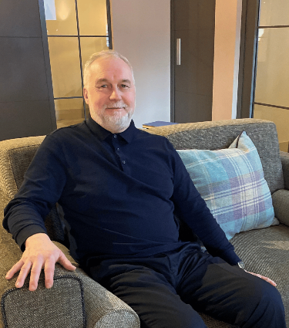
Paul Andrew Wales
Trustee
Paul is the Chief Executive of Actes Trust and is responsible for providing a strategic vision and leadership to the charity within the direction set by the Board of Trustees. Paul concentrates on developing strong partnerships, creating innovative bids, and opportunities working across Middlesbrough, Stockton, Redcar & Cleveland and wider to ensure that Actes remains a viable, growing, and a successful charity.

In addition, Paul chairs of a number of groups such as Catalyst Council of Interest, Middlesbrough’s Children & Young People Wellbeing Board, and Middlesbrough’s Financial Inclusion Group, and is also a member of Middlesbrough’s Children’s Trust.

In his spare time Paul is involved in a junior football club (which he has been involved in over 25 years), a school governor, but his favourite job is being a grandad.

Paul is keen to ensure that people, communities, and local organisations are supported in making positive changes and sees Catalyst playing a key part in making that impact within Stockton-on-Tees. Paul also chairs Catalyst’s Council of Interest.

Catalyst Stockton-on-Tees Limited

JOB DESCRIPTION

Responsible to: The Chief Executive is responsible to the Board for its success via the Chair.

Line managing: Direct line management for the Community Programmes Manager and other core staff. Currently five in total.

Summary of the role:
    - The Chief Executive Officer (CEO) serves as the leader of the organisation and is its primary public representative. Reporting to the Board of Trustees the CEO works collaboratively with the Board to ensure that the organisation fulfils its aims and objectives and creates the best strategies that ensure its future success.

Core Responsibilities:
    - Provide leadership, driving the business forward while acting in the best interest of the organisation and remaining fully accountable to the Board;
    - Ensure that Trustees and stakeholders receive appropriate advice and information on all relevant matters and enable it to fulfil its governance responsibilities;
  - Maintain an effective organisational structure, and to lead and manage the staff and ensure that their performance is appraised;
  - Lead, direct, set targets for and hold to account the Community Projects Manager and other line reports;
  - Ensure compliance with the aims and objectives of the Organisation;
  - Produce and drive forward a sustainable business plan. managing the finances and assets of the organisation.;
  - Maintain an effective working relationship between staff and the Board; draw the Board’s attention to matters that it should consider and decide upon;
  - Supervise, with the guidance of the Chair, the preparation of documents for consideration by the Board and help the Chair ensure that the business of the Board is properly conducted;
- Secure a determining influence for Catalyst in the allocation of funding to the sector;
- Undertake policy analysis and respond to consultation as required;
- Engage with relevant agencies to identify and exploit resources for the sector;
- Assist the Board in the selection and recruitment of staff, ensuring the structure of Catalyst is optimised to ensure maximum effectiveness;
- Provide an effective and accountable performance management programme for Catalyst activities including the procurement and delivery of projects and compliance with the contractual requirements;
- Develop, implement and regularly review a sector strategy in partnership with the local authority and key stakeholders that will:
  - Increase investment,
  - Increase social impact
  - Strengthen links with stakeholders
  - Develop stronger links with the private sector to increase investment through a greater commitment to Corporate Social Responsibility
  - Increase the capacity of the sector to compete effectively for commissioned services;
- Strengthen and build trusting relationships with individuals and other agencies, challenging where appropriate to drive up effectiveness and quality of service provision;
- Ensure that proper systems of control, risk assessment and risk management are established and maintained, and that regular reports on these are provided, at least annually, to the Board;
- Promote and represent the organisation as an
ambassador as appropriate;
- To take on those duties delegated from the Board defined in the Code of Governance.

The above duties and responsibilities cannot totally encompass or define all tasks that may be required of the incumbent. The outline duties and responsibilities may therefore vary from time to time without materially changing their character and or level of responsibility;

Catalyst Stockton-on-Tees Limited

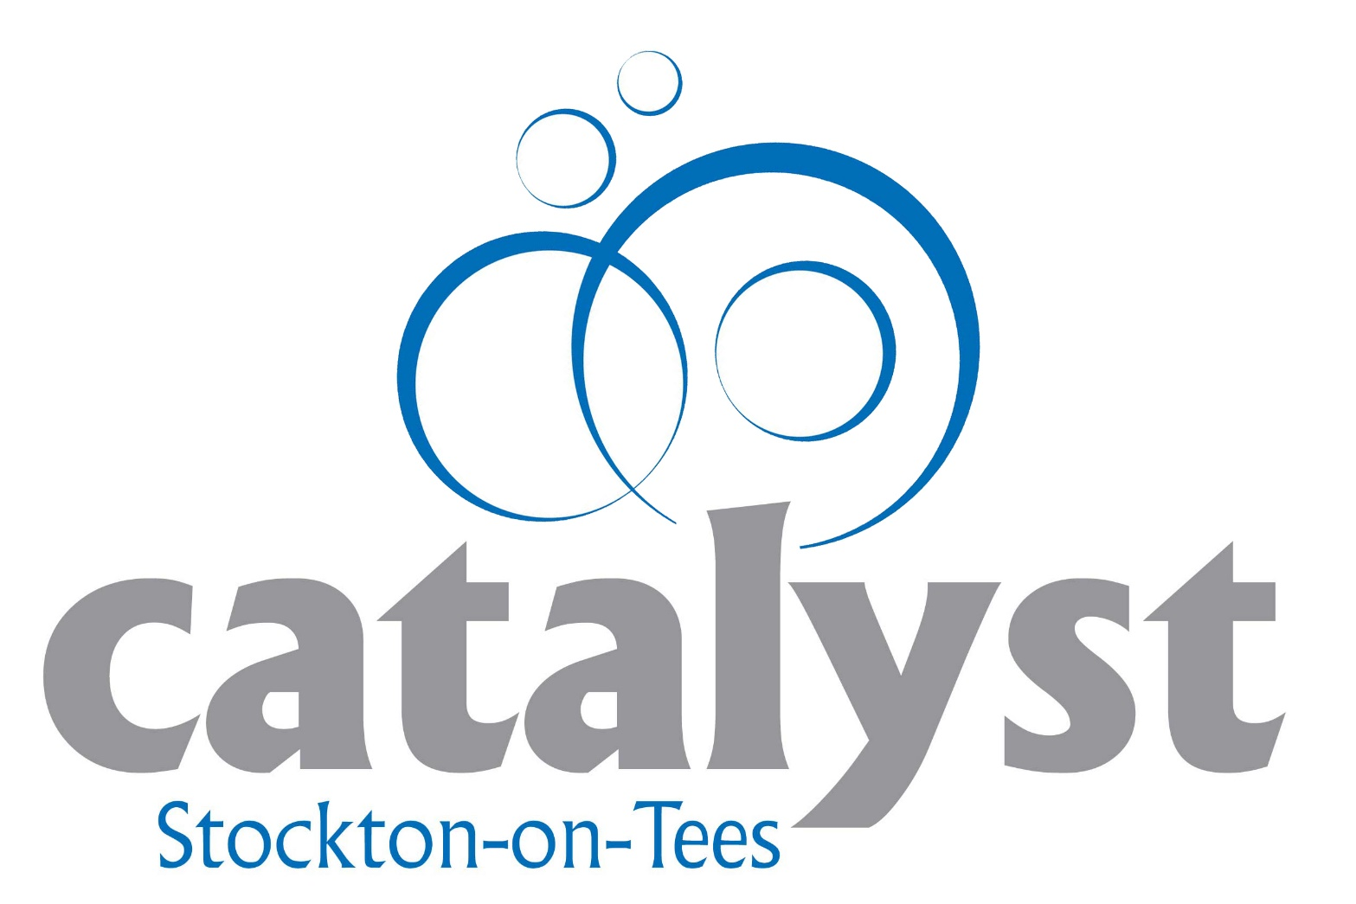

”

The Chief Executive

is responsible to the

Board for its

overall success

“
Catalyst Stockton-on-Tees Limited

PERSON SPECIFICATION

Core competencies:
    - Degree or equivalent in a related subject
    - Management Qualification Level 5
  - Ability to lead, inspire, motivate and develop staff at all levels; skilled at building motivated teams, committed to organisational vision, values and strategic objectives;
  - Understands and values the importance of setting and maintaining a positive organisational culture, and able to lead change to achieve this;
    - High level of financial literacy able to produce and present accurate financial statements;
    - Demonstration of project management including using appropriate project management tools with milestones, measurements and financial recording;
    - Excellent communication skills able to articulate and present ideas to wide variety of audiences;
    - Networking and marketing skills;
    - Effective use of a wide range of ICT including social media;
  - Well-developed inter-personal, ambassadorial, influencing, persuading, net- working, promotional and negotiating skills.

Knowledge and experience:
    - Extensive knowledge of VCSE sector with a thorough understanding of national and local context. With thorough understanding of regulations in the sector including corporate governance and supporting Board of Trustees;
    - Ability to lead and develop strategies and policies for
    - Policy development
    - Competitive tendering
- Levering of external funding;
    - Accountability for: -
- Financial management skills covering complex and multi-faceted budgets reporting internally and externally
- Measurement of social impact and its publication to advance the VCSE in Stockton on Tees
- Evidence of managing staff with at least 3 years working within the VCSE
- Evidence of appropriate CPD.

Personal Circumstances
- Full, clean driving licence and access to a car
- Demonstrable flexibility both in working hours and being able to adapt to change in what is a constantly changing political, social and financial environment
- Willingness to undertake further personal and professional development.
- Experience of leading innovation and a culture of change;
- Experience of developing and managing an excellent customer driven service;
- Evidence of effective working with customers, a wide variety of stakeholders and board members;
- An appetite to drive business growth and shape the future direction of the organisation.
Skills and abilities:
- A strong personal commitment to the VCSE and to the values of the organisation;
- Positive proactive leadership of staff and volunteers – effective delegation with a willingness to be “hands on” to support objectives;
- Strong listening skills, with ability to build appropriate relationships across all sectors acting as an ambassador for the sector.

Catalyst Stockton-on-Tees Limited

PRINCIPAL TERMS & CONDITIONS

Salary and package:  Salary is £51,500 per annum (pay award pending).  Pension: 5% employer and 5% employee contribution to the pension scheme. | Holiday entitlement:  28 days plus bank holidays | Location:  Your normal place of work will be our office  Catalyst House  27 Yarm Road  Stockton-on-Tees  TS18 3NJ,  Working from home is permitted as stated in Catalyst’s Hybrid Working Policy.  Travel across our operating areas is expected.
Working hours:  Normal hours of work are 37.5 hours per week based around the usual business working week.  However, due to the seniority of this post there is a requirement for flexibility in meeting the full responsibilities of the  post. Attendance at evening meetings may be required from time to time. | Probation and notice periods:  The probation period for the role is 3 months.

Catalyst Stockton-on-Tees Limited

KEY DATES AND SELECTION PROCESS

Closing date:

Wednesday 15th April 2026 (5pm).

All unsuccessful candidates will be offered feedback
by Chair of Trustees, Ann Workman OBE.

Interviews:

Shortlisting – Thursday 16th April 2026.

Interview presentation topic sent to successful
candidates – Friday 17th April

Interviews held – W/C May 4th.

Interviews will be held at Catalyst Stockton-on-Tees Limited, Catalyst House, TS18 3NJ

.

Catalyst Stockton-on-Tees Limited

SUPPLEMENTARY INFORMATION

To find out more please visit the website:
http://www.catalyststockton.org

