2025
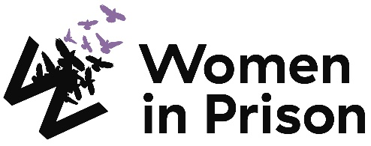

Advocate (Diversion)

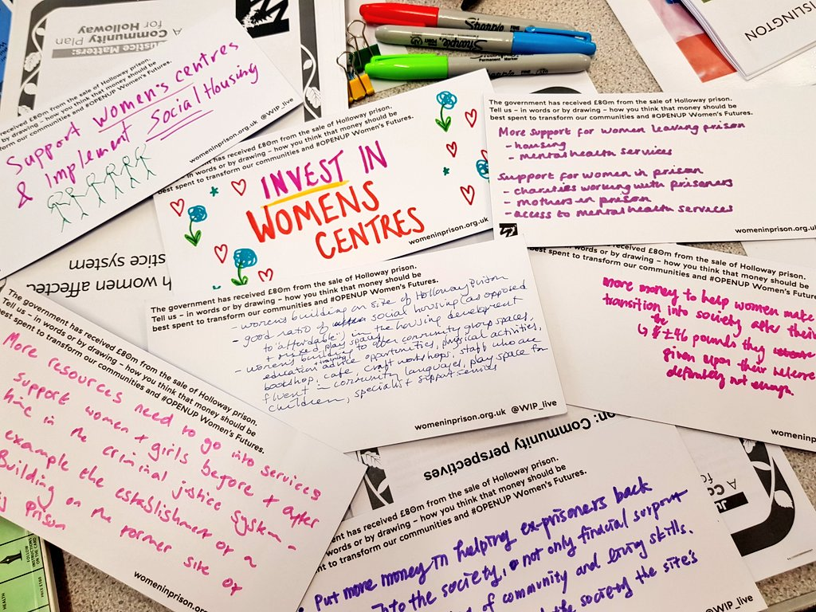

Charity no: 1118727. Company no: 5581944.



Welcome!
Dear Applicant,
Women in Prison is the only national charity focused on women in the criminal justice sector, we are women-led and know the importance of ensuring we have a clear gendered approach in all that we do. Our influencing potential and campaigning voice are substantial. We are currently in our 40th year of supporting women impacted by the criminal justice system. We work with women who are at risk of, or being, harmed by the systems that are meant to protect us.

At Women in Prison we are passionate, ambitious and grounded in the reality of women’s lives. We are proud of our roots as a feminist grassroots organisation, and we have grown from strength to strength since the 1980s, delivering services to women and campaigning for change. We exist to support women facing multiple marginalisation and exclusion, who have been let down, and their rights denied. We believe that prison doesn’t work and we want to see an end to the harmful imprisonment of women in England and Wales.
This is a very exciting time in Women in Prison. As a deeply value-led organisation, we know that our recently agreed set of values represents the unique nature of our organisation, and also need to hold us to account for how we work in an unpredictable future. Our new vision and purpose will guide us as we build a strategy during 2024 to be implemented from 2025.

We know we want to build more coproduction; deeper support to women who are disproportionately affected by the system through an intersectional lens; greater connection between the women we support and the influencing we do; an increased focus on alternatives to the system and a stronger focus on preventing women being caught up in the system.

If you are excited by our purpose, and the breadth of what this role could offer to you, we would love to hear from you.

I look forward to meeting you.


Sonya Ruparel, Chief Executive
- History and Story

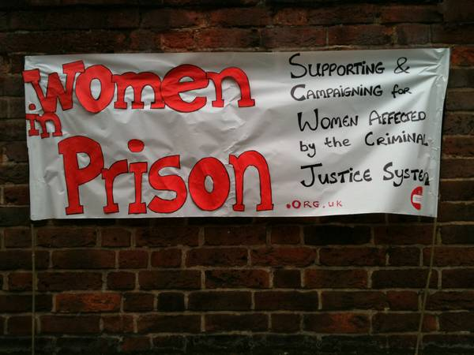

Our Vision is of a society which no longer accepts the structural inequalities that lead women and girls into contact with the criminal justice system.

Women in Prison was born out of the anger our founder – Chris Tchaikovsky – felt about what she experienced and saw when imprisoned in HMP Holloway in the 1980s.

During Chris' time in prison, a woman died after setting fire to her own cell. Chris saw that the specific needs of women in prison and the damaging effect prison sentences were having on women scarcely figured in public or political discourse. So, in 1983, alongside international criminologist Pat Carlen, Chris founded Women in Prison, pushed hard to expose this scandal and campaigned for change. Our founders wanted to increase awareness of the lives behind the women in our prisons, and the impact of poverty and abuse on women’s lives.

Chris believed the idea of sending a woman to prison as punishment was shameful and absurd.

In her words:

“Taking the most hurt people out of society and punishing them in order to teach them how to live within society is, at best, futile. Whatever else a prisoner knows, she knows everything there is to know about punishment because that is exactly what she has grown up with. Whether it is childhood sexual abuse, indifference, neglect; punishment is most familiar to her.”

In the early 1990s, the organisation was able to expand its remit beyond campaigning to deliver direct support to women affected by the criminal justice system. WIP's initial focus on prison in-reach services was then expanded to support women in the community following their release. Chris, sadly, passed away in 2002. Despite the loss of our visionary founder, Women in Prison works to carry on Chris' legacy.

Today, WIP is a national charity dedicated to making a difference to the lives of women affected by the criminal justice system. We campaign for a new system of justice - one that addresses the root causes of offending (including homelessness, substance use, mental ill health and experiences of poverty, trauma and abuse). Our women’s centres in Manchester and London and the services we provide in communities and prisons deliver holistic, women-centred support to enable those whom we work with to address the complex challenges they face.

We want to persuade decision-makers to radically reduce the women’s prison population, by demonstrating how a focus on human rights, social justice, health and investment in specialist community support services, including women’s centres, enables women to move forward with their lives. We do this by:

- Leading inspiring, passionate campaigns to replace the current system, and to radically reduce the number of women in prison, thereby freeing resources for investment in community support services, including women’s centres.
- Delivering high quality, trauma-informed, independent advocacy services for women, in communities and prisons, which focuses on early intervention, health and holistic provision as part of a ‘whole system’ multi-agency response.
- Offering a platform for women’s voices which builds women’s confidence and self-belief, strengthening an understanding of their rights and responsibilities, and provides opportunities to speak ‘truth to power’ to bring about real change

Here is a link to our most recent annual report: 2023_Annual_report__and_accounts_Women_In_Prison.pdf (womeninprison.org.uk)

Application and Recruitment

Completing the Application Form

Please complete the application form clearly and in full. The personal statement should be no more than 2000 words, clearly demonstrating how your skills, knowledge and experience relate to the Person Specification and competencies required for the post. Give examples of your work (paid, voluntary or life experience). Be positive and specify your own responsibilities rather than those of your team. Remember we’re interested in what you did and the outcome. We can only shortlist you based on the information you provide in the application form.

Please provide details of two referees, one must be your current or most recent employer, voluntary placement or educational reference.

Equalities Monitoring

WIP is committed to building and valuing diverse teams and aims to provide a working environment that promotes equality of opportunity and is free from unfair and unlawful discrimination. As part of this process, we monitor recruitment to help us understand who we are reaching, reduce inequalities and continually inform our policies and practices. Completing the equalities monitoring form is voluntary however we do encourage you to do it. The information you provide will be used for statistical purposes only, it is confidential and will not be shared with the recruitment panel.

Shortlisting

After the closing date, all applications will be reviewed by a shortlisting panel to determine how each applicants’ skills, knowledge and experience relates to the competencies required for the post (as outlined in the Person Specification and Job Description). Applicants who meet the role criteria will be invited for interview. We will only consider information enclosed in the application form when shortlisting.

Interviews

As part of the interview process you will be asked to complete an exercise before the interview. You will then meet with a panel of three people who will ask you questions relevant to the role. During the interview, you will have the opportunity to ask the panel questions about WIP, the role and the terms and conditions of service.

Feedback

Unsuccessful applicants will be informed of the outcome of their interview in writing with an offer to provide feedback. If requested feedback supported by relevant examples from the interview will be provided.
Advocate (Diversion)
Reports to: Senior Advocate (Diversion)

About Women in Prison

Women in Prison is a national, women-led, feminist organisation. We deliver front line support to women harmed by the criminal justice system, through our work in prisons, in the community and ‘through the prison gate’ as they resettle back into their communities. We also campaign for systems change that addresses the root causes of offending, reduces the harmful impact of prison, and creates workable, community-based alternatives to imprisonment.

Terms and Conditions:

Start date: To be confirmed

Salary: £30,640 pro rata (actual salary: £24,512 inclusive of £3,990 South East weighting)

Location: Across South London

Working hours: Part time: 28 hours per week

Contract: Permanent

Annual leave: 30 days plus statutory bank holidays (if full time). All WIP staff also receive an additional 3 days leave between Christmas and New Year.

Pension scheme: WIP provides an auto enrolment pension scheme with 5% contributions from the employer and 3% from the employee.

Clinical supervision: Working with WIP can be enormously rewarding but also challenging at times. So we provide clinical supervision through a Harley Street practice, to encourage reflective practice and support the wellbeing of our team.

Employee Assistance Programme: Confidential access to a range of support and information on a 24/7 basis. Including legal advice, emotional support, practical advice and signposting.

Cycle to Work Scheme: Eligible employees can save money and spread the cost of a new bike and accessories.

Job Description:
Job Purpose:
Women in Prison’s advocates deliver high-quality, trauma-informed, independent advocacy for women in communities and in prisons, which focuses on early intervention, and holistic provision as part of a ‘whole system’ multi-agency response that looks to address the root causes of women’s offending.
The Diversion programme launched in July 2019 and funded by MOPAC (Mayor’s Office for Policing & Crime). This pilot will drive multi-agency working between the police, Voluntary Community Sector (VCS) service providers and other statutory partners and is part of a wider programme of work to develop a whole system approach to identifying and addressing the needs of women involved in the criminal justice system in London.
The purpose of the project is to integrate a short-term, holistic package of support for women with an out of court disposal, to improve outcomes and offer a robust alternative to prosecution through the courts.

- Client Care
- Provide high-quality, trauma-responsive advocacy and support to women in contact with the criminal justice system over an agreed number of sessions (as per the project requirements).
- Divert women from the traditional criminal justice process, motivating them to engage in positive community activity to allow them to live safer lives, free of crime.
- Provide an in-reach service to women in the custody suite, advocating for the police to provide and alternative to charging.
- Complete safeguarding referrals where appropriate and support women’s safety through involving them in the safeguarding process.
- Take a collaborative multi-agency approach to supporting women, representing the core values of Women in Prison at all times, including representing and supporting women at multi-agency meetings.
- Involve women in the design and delivery of interventions, ensuring that they are at the heart of the work at all times.
- Undertake risk and needs assessments and develop and record individual support plans with women across the nine pathways to reoffending.
- Complete client work in line with Women in Prison’s policies and values of feminism, social justice, independence and trust.
- Ensure women are supported to achieve independence though structured intervention planning and strengths-based support and appropriate onward referrals.
- Promote a climate of understanding of women’s needs and the root causes of women’s offending.

- Monitoring and Evaluation
- Accurately document all client interaction on Women in Prison’s case management database, working in line with Women in Prison’s case management policy at all times.
- Work in line with Data Protection legislation, maintaining confidential service-user records of interventions and contact details in line with Women in Prison’s case management policy.
- Support in the collation and production of reports as requested, including ensuring that appropriate recording, monitoring and evaluation of work is completed to set deadlines.

- Communication
- Develop and utilise a variety of strategies to communicate effectively with women using our services, colleagues, external organisations, stakeholders and the general public.
- Be responsible for establishing and maintaining professional relationships internally and with other relevant statutory and voluntary sector agencies.
- Participate in the delivery of training for front-line professionals from community and statutory sector groups, in order to improve responses to women affected by the criminal justice system.
- Champion the core values of Women in Prison, including social justice and feminism in all internal and external communications, articulating their importance to the work we do.
- Ensure that relevant partners are aware of the range of services offered by Women in Prison.

- Organisational Development
- Contribute to a culture of innovation within the women’s sector, ensuring that Women in Prison remains at the forefront of best practice within the sector.
- Support Women in Prison’s campaigns work through actively contributing to ongoing campaigns and ensuring that Women in Prison provides a platform for women’s voices.

- Personal/Professional Development
- Attend and prepare for regular line management meetings, including performance development reviews.
- Attend regular clinical supervision.
- Take responsibility for self-care and managing vicarious trauma, promoting the importance of self-care both internally and externally.
- Maintain up-to-date knowledge and awareness of developments in relevant public policy and legislation by attending relevant training courses, meetings and conferences.

- General Responsibilities
- Be flexible and carry out other associated duties as may arise, develop or be assigned in line with the broad remit of the position.
- Maintain and improve competencies through continuous professional development.
- Abide by all organisational policies, codes of conduct and practices.
- Support and promote inclusion, diversity and equality of opportunity in the workplace.
- Treat with confidentiality any personal, private or sensitive information about individual organisations, clients, staff and project data.

The job description does not form part of your contract of employment and can be amended from time to time as the needs of the organisation require.

Person Specification:
- Experience
- Supporting women with a range of intersecting needs, including designing and delivering one to one and group interventions in a trauma-informed manner.
- Creating, recording and implementing interventions with women, specifically needs and risk assessments, support plans and case notes.
- Dealing with agencies that provide support around benefits, homelessness, mental health and substance misuse.

- Skills and Abilities
- Engaging and motivating clients and working with a strengths-based approach.
- Problem-solve difficult situations and deal with them calmly and effectively.
- Self-motivated with confidence to work alone but can also work co-operatively and flexibly as part of a team.
- Ability to prioritise and manage own time and workload.
- Effective communication skills verbally and in writing with people of many different backgrounds and within a range of settings.
- Meticulous case recording including accurate note taking and ability to summarise information to identify key themes.
- Ability to manage multiple demands while ensuring timely completion of case reports.
- Ability to contribute to the development of the project and think innovatively.
- IT skills at a level that supports report writing, email, internet and use of a database.

- Knowledge
- Understanding of equality, diversity and inclusion and a commitment to working in a way that promotes social justice and feminism.
- Up to date understanding of safeguarding practice, policy and procedures.
- Knowledge of the impact that contact with the criminal justice system may have on women.
- Understanding of the root causes of women’s offending and the importance of women-specific provision.
- Thorough understanding of the impact of trauma and of how to work in a trauma-informed way.

- Education/Training/Qualifications
- No specific education/training/qualification but evidence of recent continuing professional development in an area relevant to the post is required, for example mental health, diversion, immigration (SSR), substance misuse, housing or parenting.

- Personal Attributes and other requirements
- Personal resilience and the ability to stay focused in a rapidly changing environment.
- Works well in a team with a flexible approach to work.
- Commitment to the core values and ethos of Women in Prison, including social justice and feminism.
- Commitment to anti-discriminatory practice and equal opportunities and an ability to apply awareness of diversity issues to all areas of work.
- Travel across London to outreach appointments and partnership offices.
- Interested and motivated to further own skills and knowledge.

To Apply:

Applications close: Thursday 22nd January 2026 at 9am
Interviews: TBC
To apply: Submit a completed application form to the application portal. Please note, Curriculum Vitae’s (CVs) will not be accepted.

If you require reasonable adjustments to support you during the application process, please contact the HR team on hr@wipuk.org.
We are happy to invest in developing the right person, so you are welcome to apply even if your professional experience does not fully meet the job description or person specification.

We particularly encourage applications from Black, Asian and minoritised women, and women who have personal experience of the criminal justice system.

In line with legal requirements and the nature of our work, this role:
- Is restricted to women only as a genuine occupational requirement
- Requires the right to work in the UK
- Is subject to an Enhanced + Adult Barred List DBS check.
- Is subject to HM Prison and Probation Service vetting (‘Enhanced Level 1’ or ‘Standard Plus’)
- Requires that the post holder is not automatically disqualified by (or can obtain a waiver from) the Charity Commission

Equality, Diversity and Inclusion Policy

Our Principle Commitments
WIP is committed to building and valuing diverse teams and taking positive action to promote equality and challenge unfair and unlawful discrimination. We recognise that women may experience multiple and intersecting forms of discrimination based on their sex and additional, real or perceived, characteristics including age, disability, gender reassignment, marriage or civil partnership, pregnancy or maternity, race, religion, sexual orientation, social-economic background, immigration status, caring responsibilities, spent convictions or trade union membership.

WIP works to tackle discrimination and the structural inequalities women experience. We are committed to embedding diversity and inclusion in all areas of our work, including recruitment, and aim to reflect the diversity and excellence of the women that we work with. We actively encourage applications from women from a variety of backgrounds, and with a range of skills and experiences. We are particularly interested to hear from Black, Asian and minoritised women and women who have lived experience of the criminal justice system.

Policy on the Recruitment of Women with Lived Experience of the Criminal Justice System

Women in Prison actively encourages and supports the employment of women with lived experience of the criminal justice system. We believe that women’s own experiences drive the Charity forward through understanding, solidarity and passion for change.

Job Advertisements and the Application Process
We do not ask for disclosure of criminal records during the application process, to ensure that women with lived experience of the criminal justice system are assessed on their merit, without risk of discrimination and are not asked to disclose sensitive personal information unnecessarily.

If a Disclosure and Barring Service (DBS) check is required for a role, this will be stated clearly in the job advert, including the level of DBS.

Levels of DBS Checks
Basic DBS checks contain details of unspent convictions. Standard and Enhanced DBS checks contain details of unspent and spent (unless filtered) convictions and cautions (including reprimands and warnings). Enhanced DBS checks may also include other information held by police forces deemed relevant to the role or check for inclusion on the Children’s or Adults’ Barring List.
Job Offers and the Induction Process
We will only ask for a DBS check at the point of job offer.
Disclosures will be treated confidentially and only stored where necessary, in line with General Data Protection Regulation (GDPR) guidelines. Access will be restricted to limited Senior Management or HR representatives as needed to assess suitability for the role.
A criminal record will not arbitrarily bar women from employment with us. We discuss disclosures with applicants (in person, or via phone or video call), to allow them to explain the background in their own words. We consider the relevance to the role, including the type and seriousness of an offence, how much time has passed and whether the individual’s circumstances have changed. If they have restrictions on the work they are able to do, we consider whether we are able to make reasonable adjustments to facilitate their employment.
The Charity Commission does however have its own automatic disqualification rules on who can hold senior positions within a charity, which apply to our Trustee, CEO and Director of Finance and Resources positions. Although it is possible to apply for a waiver.
Women in Prison does not have a blanket ban on any criminal records and will always approach disclosures fairly and on an individual basis. We seek to balance supporting women with lived experience into employment, alongside safeguarding our current employees, service users and the organisation.

