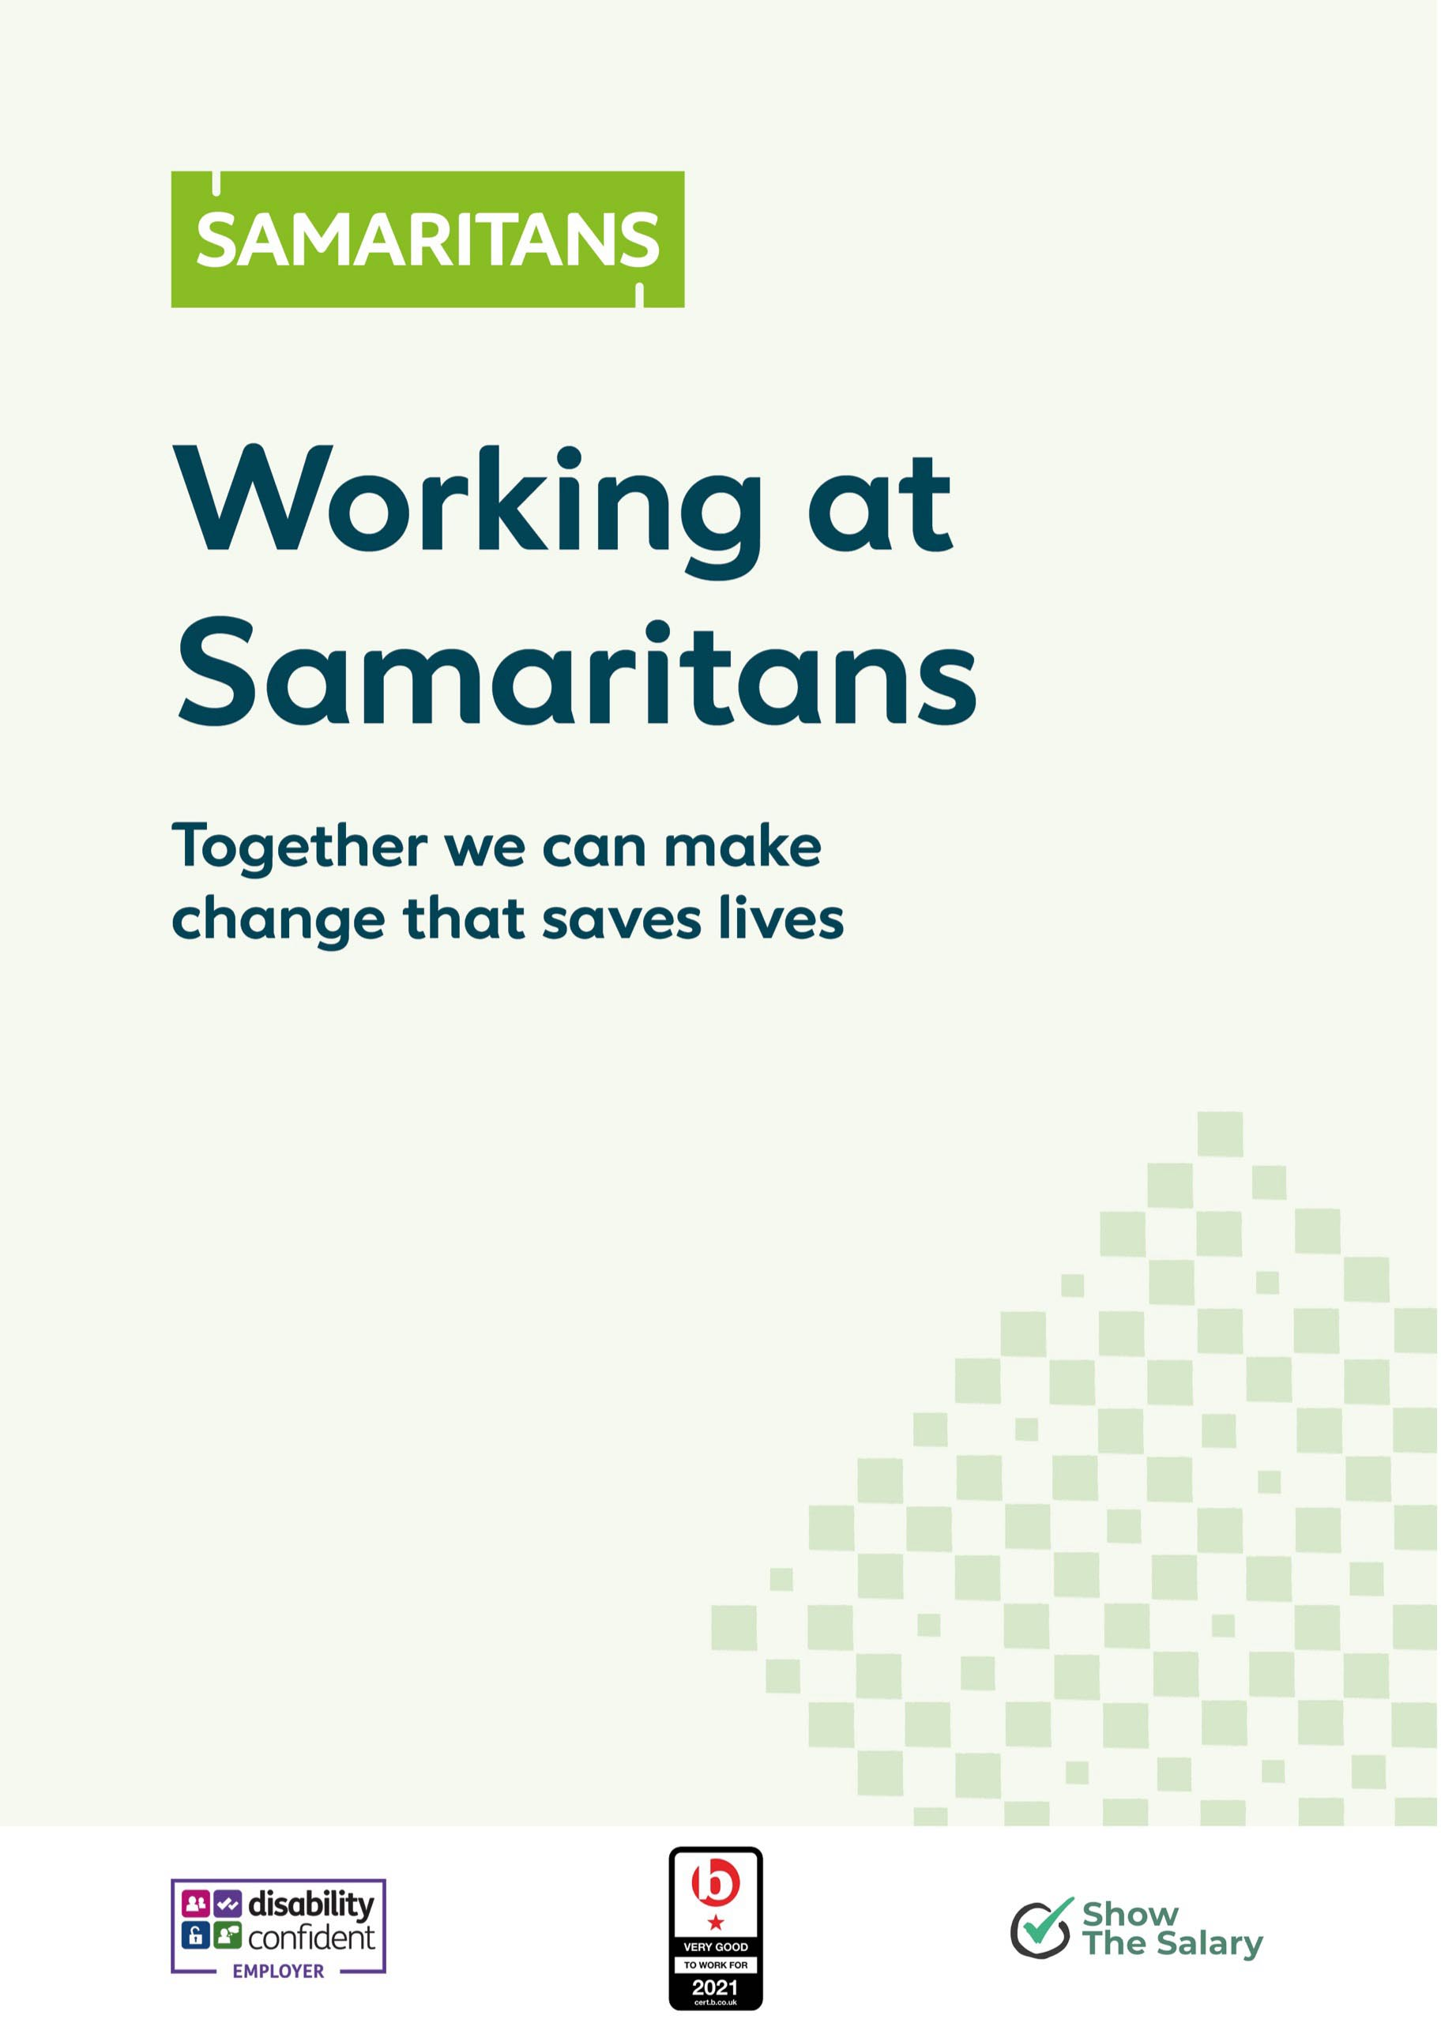



1. Welcome

I am delighted you are interested in joining our Samaritans Team.
Samaritans is an amazing charity with more than 23,000 volunteers throughout the UK and Ireland and a staff team of 300 dedicated people based at Samaritans’ offices in Ewell, Cardiff, Dublin and Edinburgh. Together Samaritans volunteers and staff are working incredibly hard to achieve our vision that fewer people die by suicide.
Every 10 seconds, we respond to a call for help. But we know there are so many others out there struggling to cope, and the ways people want to contact us are changing. That’s why we are taking steps to make it easier for people to access our support in a way that feels right to them, and at a time that works best for their lives. We are also working hard to support our incredible volunteers as they deliver Samaritans’ service so we can be there for everyone now, and in the future.
At Samaritans you’ll make a difference every day. Join us, and you’ll be part of a compassionate, collaborative team of volunteers and staff where your growth matters as much as the impact we make together. Employee experience is important to us. We are building a culture of empathy, inclusion, listening, accountability and empowerment.
We’ll do everything we can to help you grow professionally and find a healthy work-life balance. Some of our teamwork compressed working weeks, while others have flexible work patterns. We are committed to hybrid working and are also open to job shares.
Join us and bring your compassion, curiosity, and commitment to a team of volunteers and staff that’s changing lives.
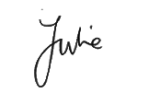
Being part of the Samaritans family fills me with pride. I hope you’ll be interested in bringing your skills, to our charity, knowing that you will be contributing to our life saving work.
Warmest wishes,

Julie Bentley
Samaritans CEO

Offices in the UK and Republic of Ireland
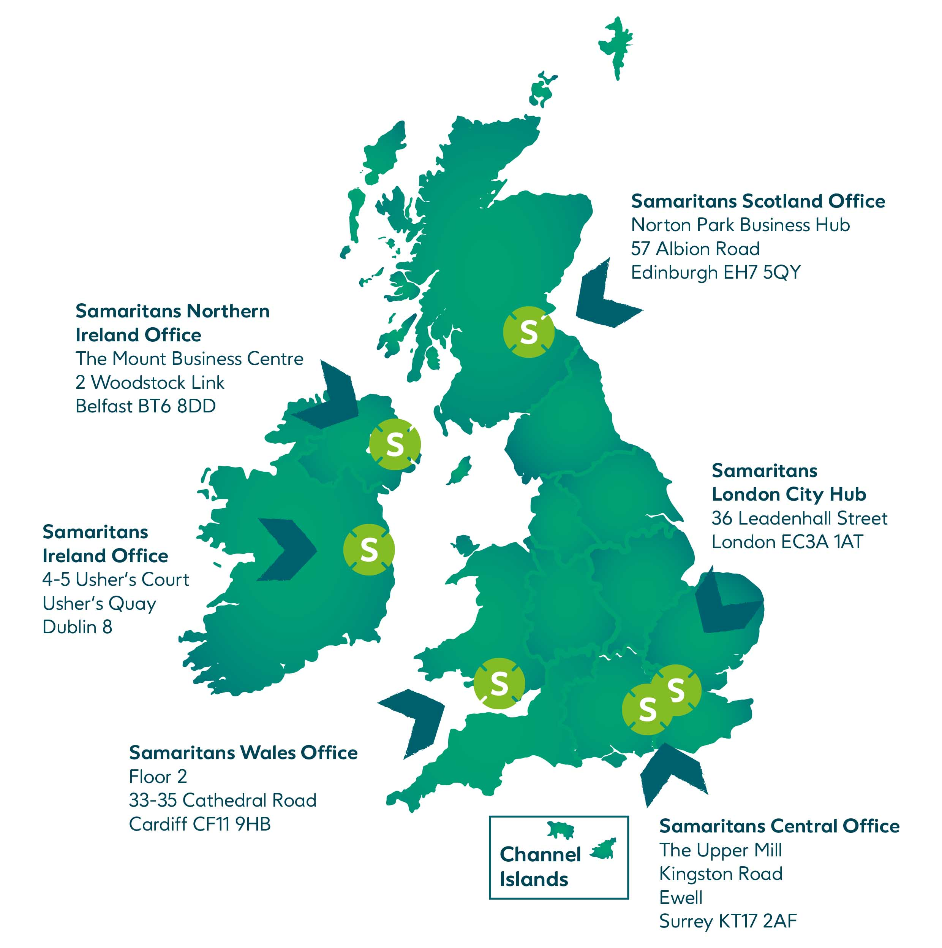
Our employees
We have around 300 employees working across the UK and Republic of Ireland. Below you’ll find details about our governance structure, an organisational chart and an overview of the teams within each Directorate.

Our values – STAR behaviours
At Samaritans, we are committed to upholding our four core values, in all our ways of working.
Support:
We’re here for each other – seeking and providing the support we need to do our best work.
Trust:
We trust each other – by taking responsibility, holding each other accountable, and delivering high-quality outcomes while staying true to our shared values.
Aspirational:
We aim high for aspirational Samaritans—striving for what we can achieve individually and together to fulfil our vision.
Respect:
We treat each other with respect—Creating an inclusive culture where people are valued for who they are, treated with dignity and fairness, and recognized for their contributions.

2. What you can expect from us
We offer a comprehensive benefits package designed to support your wellbeing, professional growth, and work-life balance.
Health and wellbeing
Your health and wellbeing are our priority. We provide a range of benefits to help you stay healthy, both physically and mentally:
- Health Cashback Plan: Access a health cashback plan covering optical, dental, and therapy treatments.
- Employee Assistance Programme (EAP): Confidential support for personal and professional issues.
- Gym Discounts: Stay active with discounts on gym memberships.
- Headspace Subscription: Enjoy a free subscription to Headspace, your personal guide to mindfulness, sleep, and focus.
- Samaritans Wellbeing Peer Support Network: Connect with our community of trained ‘wellbeing champions’, available for support.
- Employee Benefits Platform: Access to our Benefits Hub - an employee benefits platform offering exclusive perks and cash-back shopping discounts.
- Pension scheme: Benefit from a competitive pension scheme with up to 5% matched contributions.
- Death-in-Service scheme: Financial security for your loved ones with our life assurance benefit 2x your annual salary.
- Sick pay enhanced entitlements: Provision of enhanced sick pay to support you when you are unwell.
- Travel loan / season ticket loan: Interest-free loans to help with commuting costs.
- Cycle-to-Work scheme: Save money on a new bike and accessories while spreading the cost.
Work-life balance
We understand the importance of balancing your professional and personal life. Our policies and benefits are designed to support you in achieving that balance:
- Generous annual leave: Enjoy enhanced annual leave entitlements that start from 28 days and increase with your length of service, with Bank Holidays in addition and all holiday in calculated in hours to ensure you can get the greatest flexibility to meet your needs. Please note that holiday entitlement will be pro-rata for part time staff
- Flexible working arrangements: Embrace hybrid working and flexible schedules to balance your work and personal life.
- Religious bank holiday flexibility: Flexibility to swap bank holidays, to observe religious holidays important to you.
- Enhanced maternity pay: Supporting you during this important time with enhanced maternity pay.
Professional development
At Samaritans, we want everyone to learn and grow; and to develop the knowledge, skills and confidence to feel and be their best. Throughout your time with us all, you’ll have access to:
- Learning Management System: Our in-house library of self-study digital courses, tools and other resources – and where you can sign up for facilitated learning sessions and events.
- Apprenticeships: Opportunities to study for a nationally recognised qualification, from Coaching to Line Management.
- Bookboon: A digital learning resource of over 3600+ eBooks, audio learning, podcasts and online courses.
- Charity Mentoring Network: A community platform that connects charity organisations, staff and volunteers together, to build valuable mentoring relationships.
- Professional Memberships: Support with membership fees for one professional body per year, relevant to your role.

3. Equity, Diversity, and Inclusion (EDI) at Samaritans
People from all walks of life make up our Samaritans community and we are working hard to ensure that we fully reflect the communities we live and work in. We want to be a welcoming place for all our staff and volunteers. We will take focused steps to ensure better representation and to make sure we create an environment where everyone feels safe, included, and valued.

We are proud of our diversity network groups that meet regularly. These groups provide a safe and empowering space for staff and volunteers to meet others with similar lived experience and help to influence our work. We have a Sams of Colour network, LGBTQ+ network, and a Disabled Volunteers network. The groups advocate for changes and improvements, organise celebration events, and are a channel for members to have their voice heard.

Learn more about our public commitment and EDI strategic goals.

4. Hybrid and flexible working
We are a flexible organisation, and we embrace hybrid working, a mix of connecting in-person and virtually. We’re aware that the world is changing, and we all want and need different things from our work and home lives, but as a Charity with a social purpose, human connection is at the heart of our work.

Alongside time spent working remotely, we have a framework of mandated, in-person time. The expectation is that staff will work in-person at the office at least 2 days per month. The expectation for in person attendance is more for senior colleagues in the organisation. This includes a blend of in-person meetings with your line manager, team meetings, and working in-person with colleagues in other areas of the organisation. This approach enables our people to communicate, connect, and collaborate in the most effective, positive, and inclusive way, ensuring team building and effectiveness.

Our head office for Samaritans UK is in Ewell, Surrey, and this is where most of our in-person team meetings take place. Staff can also make use of our London City Hub office as required, though most England contracted staff are formally linked to the Head office in Ewell, and no staff member is based from the London city hub itself.

Samaritans Nations, Wales, Scotland and Ireland, each have their own Head office. Staff working in these Nations will have travel cost reimbursed when they need to attend meetings at the Ewell office.

New Starters are expected to attend the office on their first day, this allows for time to explore the office and local area, meet with line managers and colleagues, safe receipt of IT and phone equipment, and attend an induction with other new starters.

Further information can be found on our careers website.

5. Before you apply
Our approach to selection
We are dedicated to building a diverse, inclusive, and authentic workplace. If you’re excited about the idea of working for us, but your skills and experience don’t quite match the criteria outlined in the person specification, we encourage you to apply for the role anyway. You may be just the right candidate for this or other roles.
Please note that to be considered for any of our roles you will need to apply by clicking on the role link and completing the online application form. Please note that we can't accept speculative enquiries.
Application guidelines - artificial intelligence (AI)
At Samaritans, human connection is at the heart of everything we do. We do not use AI at any stage during the selection process. Your application will always be carefully reviewed by the recruiting manager or a member of the Talent Attraction Team.
Whilst we appreciate that the use of generative AI functions, like ChatGPT, is quickly becoming part of working life for many people, through our recruitment process we want to see your own unique ideas and writing skills. We want your application to stand out from the rest and showcase your own strengths. Therefore, we kindly ask that you don’t rely on AI tools for your application answers, cover letter or to generate interview answers.
We’re looking for you to tailor your application and CV, to our job description, as well as align with our STAR behaviours, mentioned above.
Right to work and visas
To be eligible for employment with Samaritans, you must have the right to work in the UK and Ireland. We are committed to complying with immigration legislation and cannot offer visa sponsorship at this time. Applicants will be required to provide evidence of their right to work documents during the onboarding process.
Disability confident employer
As a Disability Confident Employer, we welcome applications from candidates with disabilities and neurodiversity. We operate a guaranteed interview scheme, whereby all disabled applicants who meet the essential criteria for the role they have applied for will be offered an interview. It is crucial to note that to be guaranteed an interview through this scheme, the candidate must meet the essential criteria stated in the job description.
Safeguarding
The nature of our work means that some staff roles come into contact with children or vulnerable adults at risk. Staff members working in these roles will be subject to a criminal records check. The level of check will vary depending on the role (often Enhanced or Enhanced with Children’s Barred List). If a role requires a check, this will be stated in the job advert and job description, alongside the level of check required.
Reasonable adjustments
We aim to make our recruitment process and onboarding as accessible and inclusive as possible, and we know that by making small changes to the process, we can make a big difference to people’s experience. If you feel that an adjustment to the recruitment process will enable you to be your best, brilliant self, then just let us know what you need, and we’ll do all we can to support you. It’s really important that you share with us what you need from us to help you take part in the process. Please be assured that this disclosure will be treated sensitively and confidentially by the Talent Attraction team and only shared with those needed in the process to enable the adjustment to be made.
Feel free to chat with our Talent Attraction team about your specific needs.
Email: recruitment@samaritans.org
Once hired, we also have a reasonable adjustments policy, guidance support for managers and employees, as well as a Workplace Reasonable Adjustments Passport. We are a positive about disability employer and will do all we can to help ensure you have all you need.

6. Our application process
We want to make it as easy as possible for you to apply for our vacancies, whilst also ensuring a fair and positive experience for you.
Our standard approach is to apply with a CV and cover letter and/or some specific application questions. Where this differs, this will be stated in the job advertisement. When advertised our vacancies are usually open for a minimum of two weeks and the closing date will be stated in the advertisement.
To be considered for any role you will need to apply directly online through the advert link. You should receive an automated email when your application has been submitted.
We appreciate the time it takes to complete application forms, we’re committed to letting all applicants know of the outcome of their application, however due to our limited time resources, we can only offer feedback to candidates who have attended an interview with us.
A general guiding principle to help complete your application is to spend some time looking at the role description and to provide examples of where you meet the criteria as demonstrated in your skills and experience.
Interviews will often be virtual using MS teams or Zoom technology, in some cases in-person interviews might be preferred. You’ll be asked to select the dates and times that you are available, and the team will support you with any necessary reasonable adjustments that are required.
As part of the selection process you might also be asked to complete a task or deliver a presentation, in relation to the role you’re applying for. Full details will be provided.
In some cases you may receive the interview questions ahead of the interview, allowing you time to best prepare and know what to expect. Some roles might also go to a second stage selection process, which may be held in-person.
If you’re invited to attend an in-person interview at one of our offices, you can request the re-imbursement for reasonable costs of your travel expenses.
Candidate privacy notice
By applying for employment or engagement with us, you acknowledge the terms of this privacy notice and the use and disclosure of your personal data as set out in this privacy notice.
Read our candidate privacy notice to find out more.
Please note that we are unable to keep speculative CVs on file. To be considered for any of our staff vacancies, you would need to submit an online application.

7. Ready to make a difference? Apply now!
Dive into a role where you can truly say, 'What I do matters,' contributing to our vision, that fewer people die by suicide.
We wish you the best of luck for your application and thank you for your interest in joining the team in our life-saving work to be there for all those who need us in their darkest hours.
Regardless of the outcome of your application, we hope you will find the process a positive one, and we invite you to stay connected with us.
You can visit our careers website regularly to explore new opportunities that may align with your skills and interests. You might also want to consider other ways to contribute towards our mission, like volunteering with us.
You can also stay up to date with our latest news, events, and job opportunities by following us on LinkedIn. Please do connect with us and join our growing community.

