
Information for applicants for the post of: ROLE

Kinship Family Worker (Reading)
Programmes Department
Thank you for your interest in the above role. This pack tells you more about Kinship, how we work, and details of the role and the people you will be working with. It also gives information on how to apply.

Role details:
Job title:
Responsible to:
Duration:
Location: Home-based or hybrid (based in Kinship’s Vauxhall Office, London)
Working Hours: Full-time, 35 hours per week (flexible, working minimum of 28 hours/per week considered – pro rata)
Salary:
Direct reports:
Leave allocation: 24 days annual leave (30 days FTE), plus bank holidays pro rata for part time hours (1 April t0 31 March).

About Kinship:
We are Kinship. The leading kinship care charity in England and Wales. We’re here for kinship carers – friends or family who step up to raise a child when their parents aren’t able to.

We are made by and for our community of kinship carers. Like family, relationships run deep. And we hear their experiences; for too long they have been isolated without the help they need.

We support, advise and inform kinship carers. Connecting them so they feel empowered. Because a child needs the love and warmth of a thriving family.

We develop research, campaigns and policy solutions. Creating positive change across society. Because for kinship families, love alone is not enough.

Through our work we harness frustrations to fuel passion for change. And tough experiences to inspire ideas that transform lives.

And as we see momentum building, we keep using evidence to demonstrate the value of kinship care. Helping kinship carers navigate challenging circumstances. Believing in a child’s potential.

Join us. Together, let’s commit to change for kinship families.
Purpose of the role:
Information for applicants for the post of: Kinship Family Worker
Thank you for your interest in the above role. This pack tells you more about Kinship, how we work, and details of the role and the people you will be working with. It also gives information on how to apply.

Role details:
Job title: Kinship Family Worker (Reading)
Responsible to: Regional Programmes Manger
Duration: Fixed Term until 31 December 2027
Location: Hybrid/ Community based role with travel across Reading, Wokingham and West Berkshire
Working Hours: Part-time, 28 hours per week (0.8 FTE)
Salary: £26,500 per annum FTE
Leave allocation: 24 days annual leave (30 days FTE), plus bank holidays pro rata for part time hours (1 April t0 31 March).

About Kinship:
We are Kinship. The leading kinship care charity in England and Wales. We’re here for kinship carers – friends or family who step up to raise a child when their parents aren’t able to.

We are made by and for our community of kinship carers. Like family, relationships run deep. And we hear their experiences; for too long they have been isolated without the help they need.

We support, advise and inform kinship carers. Connecting them so they feel empowered. Because a child needs the love and warmth of a thriving family.

We develop research, campaigns and policy solutions. Creating positive change across society. Because for kinship families, love alone is not enough.

Through our work we harness frustrations to fuel passion for change. And tough experiences to inspire ideas that transform lives.

And as we see momentum building, we keep using evidence to demonstrate the value of kinship care. Helping kinship carers navigate challenging circumstances. Believing in a child’s potential.

Join us. Together, let’s commit to change for kinship families.

Purpose of role:
The Kinship Family Worker provides intensive, time-limited support to kinship carers through the Kinship Connected programme, a structured six-month intervention designed to help kinship families stabilise placements and access the support they need.

Working directly with kinship carers, you will build trusting relationships while completing structured assessments, goal setting and reviews to help families strengthen support networks and navigate services such as children’s social care, education, health and community support.

This is a community-facing role, working directly with kinship carers in homes, community spaces and through co-location with local authority teams and partner organisations.

This role is funded through the South East Sector Led Improvement Programme (SESLIP). You will support kinship carers in Reading, Wokingham and West Berkshire.

The type of person we’re looking for:

What you'll be doing:

Key responsibilities:

One-to-one support
You will provide intensive one-to-one support, directly to kinship carers for up to six-months working within the Kinship Connected delivery model. This may include, but is not limited to:
- Providing emotional and practical support to kinship carers.
- Advocating for kinship carers in meetings with professionals where appropriate.
- Establishing and facilitating a monthly support group for kinship carers in your area.
- Mapping local services and building relationships with organisations that can provide specialist support, training or activities for kinship families.
- Liaising with schools, local authorities and other professionals to coordinate support.
- Supporting kinship carers with challenges relating to the child(ren) in their kinship care.
- Signposting to relevant services, support organisations and Kinship training opportunities.
- Coordinating celebration and family events (including in Kinship Care Week).
- Supporting applications for grants for essential items or family breaks.
- Maintain accurate, timely records of all activity, assessments, support plans, contacts and outcomes on Kinship’s CRM system (Salesforce) in line with organisational policy and programme protocols.
- Complete kinship carer needs assessments, SMART goal setting, reviews and outcome recording in accordance with the Kinship Connected model.

Collaboration
- Working closely with other teams across the organisation, including, Comms and Campaigns, Peer Support, Training and Development, Advice, ensuring kinship carers are at the heart of everything we do.
- Support local authorities to understand the referral process and to make referrals to the programme
- Work with local authorities to raise awareness of kinship care
- Where possible and relevant, represent Kinship at external events and meetings

Safeguarding and risk management
Kinship has a robust safeguarding structure. You will be supported by a Designated Safeguarding Manager (DSM) and Designated Deputy Safeguarding Leads (DDSL).
In line with this policy you will
- Recognise, report, record, respond and refer and safeguarding risks via our safeguarding process with the support for the safeguard team
- Complete risk assessments for events in-line with Kinships policy
- Follow the Kinship Health and Safety policy
- Use the StaySafe (lone worker) app.

Monitoring and evaluation
- Ensure casework, home visit and meeting attendance, feedback, and other data related to service delivery are accurately recorded on our Salesforce database in line with Kinship’s policy and best practice.
- Ensure completion of carer needs Assessments with the setting of SMART goals, mid-term reviews and outcomes forms and processes are followed, recording data used to evidence impact.
- Collect case studies each quarter from carers and professional support in demonstrating impact.
- Complete monthly reports for your area and contribute quarterly reports for local authority partners
- Attend quarterly monitoring meetings
- Engage in quality assurance processes in line with ongoing programme development
General duties and tasks
- To attend and engage with Programmes team and all staff meetings
- To personally prepare for and attend case reviews, supervision, and appraisals with your line manager.
- To act at all times in the best interest of Kinship.
- To participate in the induction of new staff members and volunteers.
- To work with line manager to identify own training needs and undertake training and development.
- To engage in reflective practice, using opportunities for supervision and professional development as appropriate.
- Participate in opportunities provided by Kinship to develop your skills and knowledge such as staff training, ‘Lunch and learn’ sessions.
- To carry out other related duties as may from time to time be required to fulfil the mission of the team and organisation.
- To develop Kinship Care Week in your local area.
- Be willing to travel across England as necessary to attend events and raise the profile of the service and kinship care.
- Attend staff Away Days
Standard Clauses
- The post holder must at all times carry out their responsibilities with due regard to Kinships’ Equal Opportunities Policy and Safeguarding Policy.
- The post holder must accept responsibility for ensuring that the policies and procedures relating to Health and Safety in the workplace are adhered to at all times.
- This role will require satisfactory enhanced level Disclosure and Barring Service (DBS) clearance.
- The post holder must respect the confidentiality of data stored electronically and by other means in line with the Data Protection Act.
- The post holder must carry out their responsibilities with due regard to the non-smoking environment of all Kinship offices.

Knowledge, abilities, skills and experience:

Essential:
Experience
- Experience of family work and undertaking needs assessments both in person and remotely
- Experience of setting up and facilitating support groups on an in-person and remote basis.
- Experience of working with statutory, voluntary and community networks and the ability to represent the organisation to external stakeholders.
- Experience of dealing with safeguarding
- Experience of using a Customer Relations Management system (CRM)
Knowledge, skills and understanding
- Knowledge and understanding of kinship care and the ability to learn quickly about the regulations and guidance relating to special guardians.
- Excellent communication skills.
- Proven track record of high-level administrative work and experience of working with a case management system to record interventions.
- Excellent organisational skills
- The ability to maintain confidentiality, in line with Kinship policies and GDPR
- IT skills and experience, particularly in Work, Excel, and CRM’s such as Salesforce
- Ability to work on your own initiative and manage your diary
- The ability to manage a complex and varied workload to successfully meet project deadlines and KPI’s.
- Right to work in the UK and a Full, clean driver’s licence.
General attributes
- Positive and can-do attitude and ability manage challenging and sensitive issues with professionalism and empathy
- Commitment to the values, aims and objectives of Kinship, promoting these in all interactions, both internally and externally
- Ability to apply and champion principles of Equality, Diversity and Inclusion Principles in all aspects of work
- Flexibility to travel across London and to occasional meetings in other parts of England
- Strong interpersonal and communication skills, with the ability to build strong trusting relationships with diverse individuals and communities
- Self-motivated and well-organised, able to manage time and workload effectively while meeting deadlines and KPI’s

Desirable:
Experience
- Personal experience of kinship care
- Experience of writing copy, case studies and newsletter articles as well as shorter reports
- Experience of using Salesforce database or similar
- Knowledge and awareness of the National Kinship Care strategy for England 2024

What it means to work at Kinship:
Our vision:
A society in which kinship carers and the children they care for are recognised, valued and supported.

Our mission:
To ensure that kinship carers and the children they care for get the support and recognition they need.

“Knowing what you do helps kinship families that really need support.
Staff at kinship are caring, passionate and positive. Colleagues are genuinely nice to work with and care about each other as well as the kinship families we support. We are always innovating to better support kinship carers.”
(Staff member at Kinship)

We want to offer you the best place to work. Our people are friendly and incredibly passionate about working alongside kinship carers.

We want you to feel proud to work here and if you join us, we'll do our best to make that happen.

Our Kinship values: 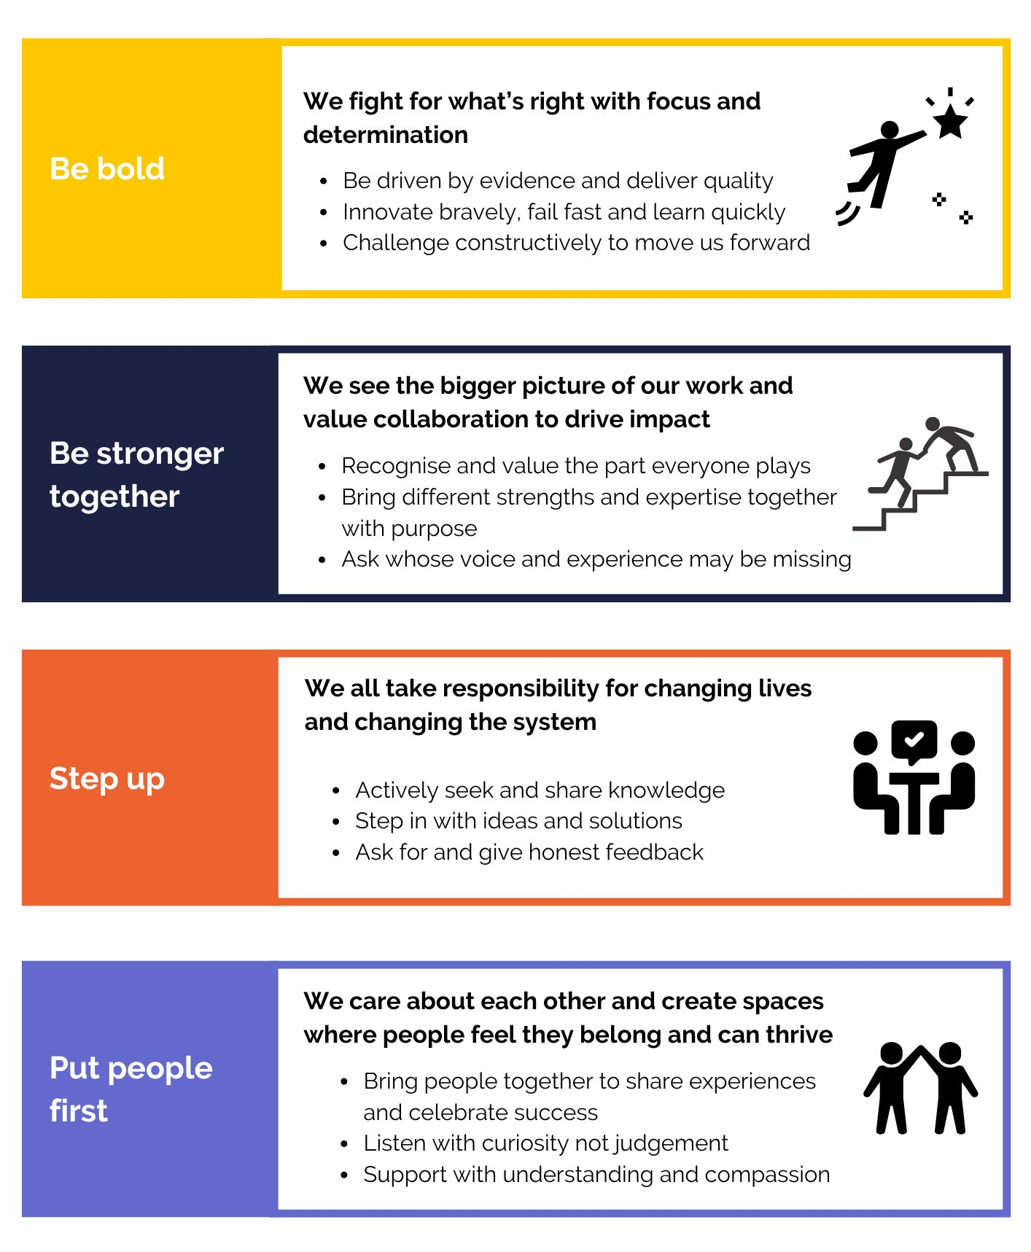

Equality, diversity and inclusion:
Kinship is committed to championing equality, diversity and inclusion. We believe our work is greatly enhanced by the varied backgrounds, experiences and views represented within our teams. We aim to create inclusive teams, celebrate differences and encourage everyone to join us and be their true self at work.

We therefore encourage applications from anyone who fits our values, whatever their religion or belief, sex, gender identity, race, age, sexuality or disability and are actively seeking candidates that can bring real innovation and commitment to us.

Candidate application information:
Please refer to the job description for this role to check that you meet the criteria in the “knowledge, skills and experience” section that are necessary for the job.

We will guarantee interviews to any candidates with experience of kinship care (either of being in kinship care or of being a kinship carer) who demonstrate that they meet the essential skills and experience outlined in the job description.

Please tell us if there are any reasonable adjustments, we can make to assist you in your application.

If you have a disability that you would like us to take into account, please tell us about this when you apply. Please let us know if we can help and remember that you can request information in large print or in a different format.

How to apply:

Any applications arriving after the closing date will not be considered for shortlisting unless there are exceptional reasons.

Kinship reserves the right to close a recruitment campaign earlier than the advertised where we have received sufficient applications so please apply early!

Please apply for the role of Kinship Family worker by sending a CV and answering the screening questions in the advertisement on https://www.charityjob.co.uk/. Please use examples to demonstrate your experience.

Please include your notice period / earliest availability to start.

Some tips for your application:
- Make sure you’ve read the job description and the essential requirements – make sure your application reflects those points in the requirements very clearly.
- Tell us why you want to work for Kinship. We’re interested in working with people who share our values. You can read about our values above.
- Keep your response clear – use bullets points and short paragraphs if that helps. It will help the recruitment team to focus on your knowledge, skills and experience.
- Don’t go over 2 pages on your covering letter.
- Please do not use AI tools like ChatGPT to produce your answers. We use software to check, and your application will be rejected if you do.

Key dates:
Apply: Via CharityJob
Application deadline: 16 November 2026
First interview: 23 November 2026

Kinship reserves the right to close applications early on receipt of sufficient applications. Apply early!

If you would like further information or an informal chat about this role, please contact Fiona Summers (Associate Director of Programmes) on Fiona.summers@kinship.org.uk

Conditions of employment and what we offer:

Working hours:
The working week is currently 35 hours per week from Monday to Friday. These may be varied by agreement with your line manager. For some roles, there will be occasions when these hours are exceeded, for example some weekend working or a requirement to attend evening meetings. In such circumstances and in agreement with your line manager you may take reasonable time off in lieu. Overtime is not paid.

Holidays:
- 30 days annual leave, plus bank holidays (1 April t0 31 March) pro rata.
- We close for three days between Christmas and New Year, which will be deducted from your annual leave allowance.

Flexible working:
Kinship will consider applications for flexible working arrangements. Kinship will enable as many jobs to be open to job sharing as is operationally practicable.

Learning and development:
We are committed to developing and enhancing the learning experience during your time at Kinship, and we are proud to offer many learning opportunities.

Health and wellbeing:
- Employee Assistance Programme (24/7 confidential advice line and counselling).
- Charity Worker Discount

Travel:
For this role, there may be occasional travel within the UK. There may also be, on occasion, the need for overnight stay. Reasonable travel, subsistence and hotel expenses will be covered using the Charity’s expenses procedures.

Pension scheme:
All staff will automatically be enrolled into a Group Personal Pension Scheme as part of our requirement to meet automatic enrolment legislation. According to the statutory requirements. We use Nest Pensions. Current employee contributions are 5% and we will contribute 3%.

Probationary period:
All new employees will be required to undertake a period of probation for six months, in which time you will be expected to establish your suitability for the post.

Community:
- Employee resource groups (including Equality, Diversity and Inclusion Working Group and Wellbeing Committee).
- Staff away days.
- Regular social activities online and in person.

Our recruitment process:

As a charity we want to hire the best people to support our vision and mission. People who are values led, high performing and passionate about doing their best for kinship carers.

We will guarantee interviews to any candidates with experience of kinship care (either of being in kinship care or of being a kinship carer) who demonstrate that they meet the essential skills and experience outlined.

We welcome applications from people from all sections of the community, irrespective of race, colour, sex, gender identity, age, disability, sexual orientation, religion or belief.

Kinship is committed to attracting, developing and retaining a diverse workforce, with a broad range of backgrounds, experiences and perspectives, and we encourage applicants from those groups currently under-represented in our organisation and sector.

Standard clauses:

- This role will require satisfactory Disclosure and Barring Service (DBS) clearance.
- The post holder must at all times carry out their responsibilities with due regard to Kinship’s Equal Opportunities Policy and Safeguarding Policy.
- Salesforce is our customer relationship management system (CRM) and all staff are expected to take accountability and responsibility for using it successfully as part of their day-to-day role to support the growth and impact of Kinship and better services for kinship carers.
- The post holder must accept responsibility for ensuring that the policies and procedures relating to Health and Safety in the workplace are adhered to at all times.
- The post holder must respect the confidentiality of data stored electronically and by other means in line with the Data Protection Act.
- The post holder must carry out their responsibilities with due regard to the non-smoking environment of all Kinship offices.

Note:
This job description is not exhaustive. Kinship reserves the right to add to or revise the job description at any time - the post holder may be required to undertake any other duties that fall within the nature of the roles and responsibilities as detailed in this document.

Any substantial or major changes will be negotiated with the post holder.

