Royal Papworth Hospital NHS Foundation Trust
Band 7 - Project Manager – Charity
Job Description/Person Specification

Role title | Project Manager – Charity (FTC) | Reporting to | Managing Director
Directorate | Fundraising | Appraised by | Managing Director
Department | Charity | Working hours | Full time/Part time  18-month FTC
Band | 7

Job Summary
The post holder will lead an ambitious new programme of charity funded activity, Brighter Spaces for Brighter Futures. An ambitious fund that will create spaces across the Royal Papworth Hospital estate to better enable staff, patients, friends and family to feel relaxed and refreshed. The fund has four distinct elements:

• Enhancing staff rest facilities
• Enhancing patient day rooms
• Creating (or enhancing) an outdoor reflection space for patients and staff
• Developing a new Charity Hub

We are looking for an experienced project manager to provide project management and support to ensure outputs are delivered effectively. This new and ambitious programme of work will require a skilled project manager to manage multiple stakeholders across the charity, Trust, patient, staff, volunteer and wider community. You will have delegated authority and responsibility to act independently and handle and deliver decisions and actions in relation to the projects within your allocated portfolio.

A key role will be the rigorous definition and oversight of the Brighter Spaces for Brighter Futures programme including risk and issue management, ensuring the effective management of project interdependencies and delivery of project objectives and outcomes.

As a Project Manager, it is vital to work collaboratively with key stakeholders such as trust directors, clinicians, senior managers and associated external agencies in implementing strategic projects, and there will be an element of liaison with internal and external organisations including professional advisers, ensuring clear, regular and consistent communication.

The post holder should be able to adjust project, and implementation plans as required to ensure that risks and issues are mitigated, and independently manage changes that occur within projects, subject to change control processes and liaison with project sponsors.

It is expected that the specific projects managed by the post holder will change over time as the portfolio of trust wide operational and strategic programmes respond to local, system and national directives.

Main duties of the job
Planning and Organisational Skills
- Provide project management expertise to assigned project teams and ensure that project leads have clear responsibilities, priorities, timescales and support them to track delivery of project progress.

- Be responsible for the development of project plans and implementation plans and maintain these on a regular basis to ensure delivery of project tasks and milestones.

- Plan the delivery of projects which may have multiple workstreams and sub sections within them, all of which may require the consideration of interdependencies, timescales, and sequencing in order to inform, plan and communicate co-ordinated, ordered action planning to achieve tight internal (within the trust) and external (outside the trust) project deadlines.

- Responsible for the organisation of project workstream meetings, project workshops, steering groups and other forums which will require complex planning and advanced liaison with key stakeholders including senior managers, enabling services such as digital and estates, as well as multiple staff groups and clinical teams across divisions. This will involve managing competing priorities and conflicting demands from different stakeholders to achieve project timescales to prevent project slippage.

- Constant oversight, monitoring and adjustment of project delivery across multiple workstreams through review, update and revision of project plans, and ongoing attention to detail to adjust and reschedule plans and meetings and expedite actions in order to achieve project milestones and minimise and mitigate risks.

- Use of professional judgement against detailed knowledge of each project’s current status, weighing up and analysing factors that impact on project delivery including level of engagement and ownership of stakeholders, governance status, project timescales and deadlines, interdependencies, current risk status to project delivery, and confidence levels regarding mitigations to provide recommendations to project groups and project sponsors on the overall status of project delivery. This many involve highlighting concerns and issues regarding project delivery and implementation which may be contentious or conflicting, requiring an understanding of wider contextual influences on project status, accountability, and capabilities.

- Working with administrators and others across the trust to organise project meetings, ensuring that regular meetings are established as needed, defining agreed terms of reference for project groups, and overseeing the cycle of meetings to support the delivery of projects.

- Work in a collaboratively and facilitative way with key stakeholders to ensure all actions related to project delivery are completed, ensuring issues and concerns are escalated to the relevant person and followed up in a timely manner to prevent project slippage.

- To plan, develop and deliver project workshops supported by project leads, ensuring relevant stakeholders are consulted to optimise the impact of outputs from workshops in gaining consensus.

- Produce data, presentation materials, project outputs and follow up information as required to support the delivery of project plans.

- Identify risks to project delivery and work with key stakeholders to identify actions to mitigate these, to ensure successful delivery to time, cost and quality.

- Use a range of project management tools, techniques and practices in support the delivery of projects.

- Use current project performance data and feedback to inform recommendations, decisions and judgements in relation to opposing views on project status, risks and issues.

Communication and Relationship Skills
- Communicate via both written and verbal channels project related information which may be complicated and made up of several component parts which may be interrelated, contentious or sensitive for different audiences.

- For example, the post holder may be required to facilitate the development of complex processes or pathways (which may be clinical or non-clinical) which impacts on multiple stakeholders who sit in different services or divisions, and collate a common and joint understanding of issues, barriers and blockers, where there may be sensitivities due to historic arrangements and ways of working.

- Use of sensitive, precise and clear language to explain complicated and conflicting information related to project delays, barriers, risks and issues.

- Formally communicate information on progress of projects to key stakeholders including project boards as required, developing bespoke tools and as well as using trust templates including presentations, highlight reports and progress papers.

- Lead on development of engagement and communication plans for projects to proactively ensure that positive and effective relations are developed and maintained between members of assigned project teams, and key internal and external stakeholders are communicated with throughout the project.

- Use negotiation, persuasion and motivational skills through the communication of sensitive information related to project performance to gain support for projects, and to ensure project delivery from across the breadth of stakeholders, patients and providers.

- Provide management and leadership to assigned project teams, agreeing responsibilities for individual projects with the Programme Manager, providing day to day technical support and balancing the workloads of individual team members.

- Support strategies to achieve acceptance, consensus and alignment of views, both formally and informally from project teams including senior managers and clinicians.

Finance and resources management
- Actively monitor expenditure against assigned project budgets and address problems at an early stage, ensuring that budget limits are not exceeded and taking corrective action as necessary.

- Authorised signature for assigned project related budgets

- Regularly review financial information and spend specific to projects, ensuring they fall within agreed funding allocations and project budgets.

- Produce detailed project plans that deliver agreed project milestones and objectives.

- Support the development of business cases, including feasibility studies, and detailed scheme designs as part of the implementation of projects and initiatives.

- Liaising with relevant administrative staff, be responsible for the timely co-ordination of minutes, agendas and papers for distribution in preparation for project meetings, ensuring this is done in a timely manner to achieve timescales and deadlines.

- Lead on the evaluation and audit of projects following completion.

- Support the commissioning and procurement of products, equipment, services, systems and facilities, as required for the delivery of projects.

Information management
- Monitor and maintain project information management systems employed within the team.

- Maintain project data collection systems that will provide accurate and timely data, including quantitative and qualitative data.

- Develop specific project data collection systems and databases as required by the project, ensuring they are maintained for the lifecycle of the project, ensuring that data and reporting is embedded as business as usual on completion of projects.

- Interpret all relevant local, system and national policies and protocols within scope that directly impact on delivery of projects.

Strategy, change and service improvement

- Champion the cycle of continuous improvement as part of the process for projects and service improvement, driving evaluation of project outcomes, review of benefits realised, and exploration of lessons learnt in the ongoing feedback loop for change management and improvement.

- Support innovative methods to gain patient and public involvement to inform project delivery and service direction, improvement, user satisfaction and as a tool for performance management.

- Regular horizon scanning of best practice and ways of working within the sector and within project management.

- As part of embedding projects and initiatives as business as usual, drive forward the development and implementation of required policies and procedures related to the project scope, which may impact within one service, or may be wider reaching across teams within the trust, or trust wide.

- This may involve analysis of existing national and regional policy to interpret and develop localised versions of trust policies, working closely with the project sponsor to ensure compliance with the trust document control and governance processes regarding policy development.

Structure
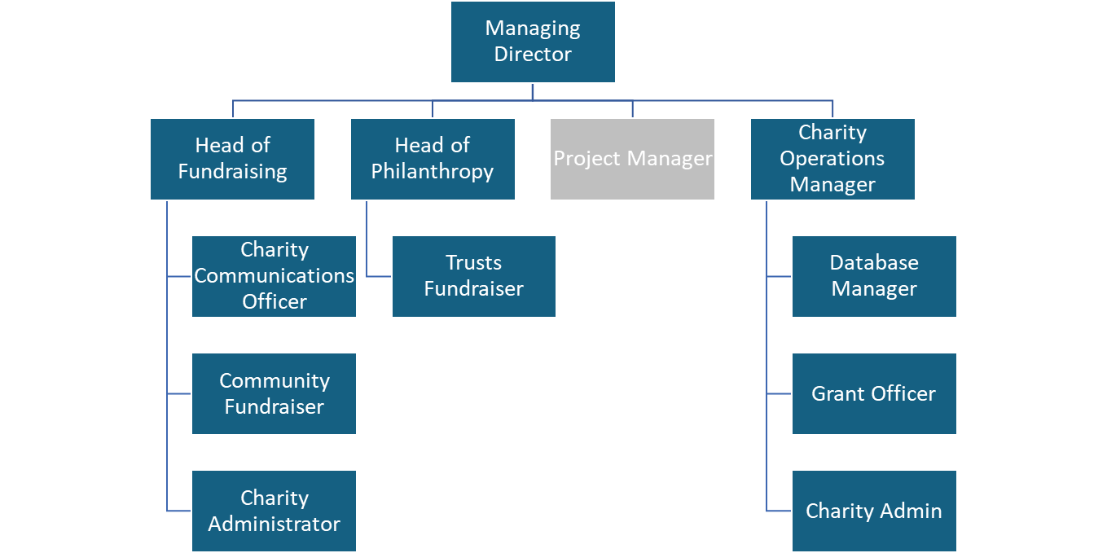

General compliance
You must uphold the Trust’s values Compassion Excellence Collaboration and associated behaviour standard and support Equality, Diversity and Inclusion.
You must perform your duties to the highest standard, with particular regard to effective and efficient use of resources, maintaining quality and contributing to improvements
You must comply with all Trust Policies and Procedures (and subsequent updates thereof) and with particular regard to

Risk Management Health & Safety Information Governance
Confidentiality Data Quality Freedom of Information
Dignity at Work Safeguarding Vulnerable People Smoke-free
Equal opportunities Being open: a duty to be candid
You will be responsible for compliance with infection prevention and control policies, procedures and standards and associated mandatory training. You must practice and encourage appropriate hand hygiene and act professionally to ensure the hospital environment, and other Trust premises, are clean, safe and tidy.
You must follow all Trust security policies and procedures and be vigilant to ensure a safe and secure environment for care
The Trust is committed to carefully screening all staff working with vulnerable people. If this applies to this post, the appointment will be subject to a satisfactory Disclosure and Barring Service disclosure of the appropriate level
You will be required to participate in the Trust’s Appraisal process and associated development review

If your role includes line management, you must ensure your direct reports participate in an annual appraisal and development review.
You must remain compliant with mandatory training requirements applicable to the post.

If your role includes line management, you must ensure your direct reports remain compliant as applicable to their roles.
You will be responsible for data quality and complying with the policies, procedures and accountability arrangements relating to maintaining accuracy and probity in the recording of the Trust’s activities.
You will be required to perform any other duties that may reasonably be required from time to time

The job description provides a general outline of the main duties and responsibilities of the role will be subject to review. In consultation with you, it may be amended to meet changes in the needs of the service and/or in your personal development requirements.

Person Specification

Contents set out below under Essential/Desirable will be assessed at the ‘shortlisting’ stage for applicants

Requirements | Essential criteria | Desirable criteria
Qualifications and Professional Registration | Educated to degree level or equivalent knowledge, skills and experience.  Formal project management qualification or equivalent experience in project management across a range of complex projects to post graduate diploma level or equivalent  Evidence of recent Continuing Professional Development. | Management qualification
Experience and Skills | Effective use of project management methodologies and techniques, including change, people and stakeholder management  Excellent interpersonal, communication (written, oral, presentation, facilitation), networking and negotiation skills  Excellent organisational skills and the ability to prioritise, meet deadlines, delegate effectively and finding innovative ways of solving or pre-empting problems  Evidence of managing successful projects and / or operational performance and improvement; including the development and monitoring of output and outcome measures.  Use of analytical and judgement skills including understanding, analysis and application of complex statistical and numerical data.  IT literate, including competency in MS Office programmes and in  particular in Excel. | Experience, or knowledge and understanding, of the changing NHS environment, strategy, and policy agendas.  MS Project
Values and Behaviours | Evidence ability to uphold the Trust’s values Compassion Excellence Collaboration.
Other  (eg ability to participate in an on-call rota) | Work flexibly, prioritise workloads and resource in response to changing demands and requirements.

Trust values and behaviour standard on next page
Our Values and Behaviours



