2025
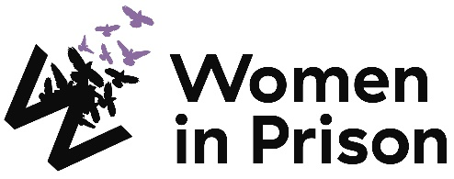

Programme Lead (Housing)

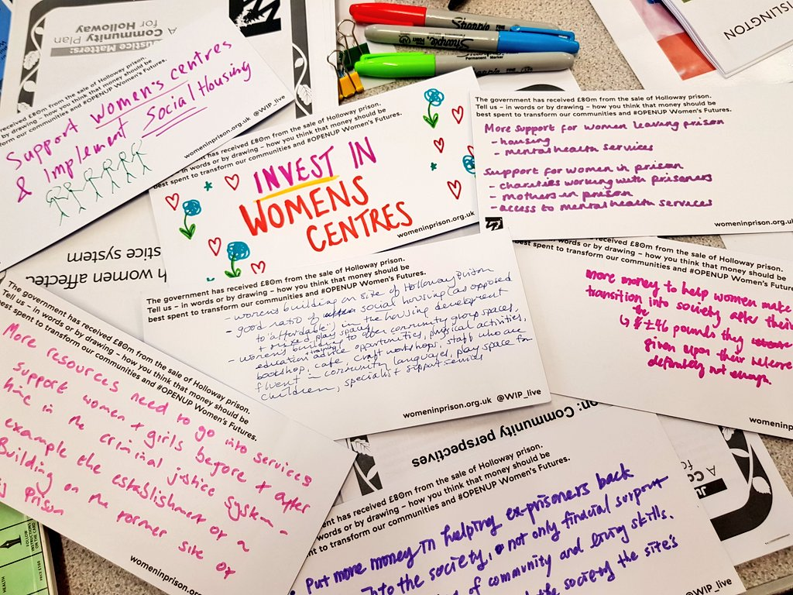

Charity no: 1118727. Company no: 5581944.



Welcome!
Dear Applicant,
Women in Prison is the only national charity focused on women in the criminal justice sector, we are women-led and know the importance of ensuring we have a clear gendered approach in all that we do. Our influencing potential and campaigning voice are substantial. We are currently in our 40th year of supporting women impacted by the criminal justice system. We work with women who are at risk of, or being, harmed by the systems that are meant to protect us.

At Women in Prison we are passionate, ambitious and grounded in the reality of women’s lives. We are proud of our roots as a feminist grassroots organisation, and we have grown from strength to strength since the 1980s, delivering services to women and campaigning for change. We exist to support women facing multiple marginalisation and exclusion, who have been let down, and their rights denied. We believe that prison doesn’t work and we want to see an end to the harmful imprisonment of women in England and Wales.
This is a very exciting time in Women in Prison. As a deeply value-led organisation, we know that our recently agreed set of values represents the unique nature of our organisation, and also need to hold us to account for how we work in an unpredictable future. Our new vision and purpose will guide us as we build a strategy during 2024 to be implemented from 2025.

We know we want to build more coproduction; deeper support to women who are disproportionately affected by the system through an intersectional lens; greater connection between the women we support and the influencing we do; an increased focus on alternatives to the system and a stronger focus on preventing women being caught up in the system.

If you are excited by our purpose, and the breadth of what this role could offer to you, we would love to hear from you.

I look forward to meeting you.
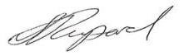

Sonya Ruparel, Chief Executive
Our Story

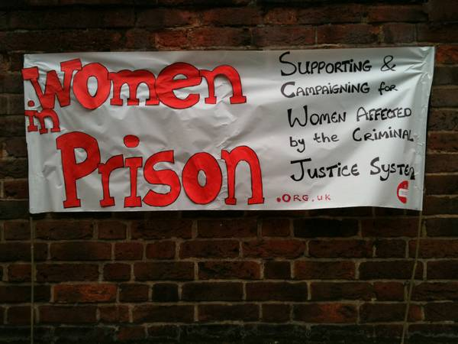

Our Vision is of a society which no longer accepts the structural inequalities that lead women and girls into contact with the criminal justice system.

Women in Prison was born out of the anger our founder – Chris Tchaikovsky – felt about what she experienced and saw when imprisoned in HMP Holloway in the 1980s.

During Chris' time in prison, a woman died after setting fire to her own cell. Chris saw that the specific needs of women in prison and the damaging effect prison sentences were having on women scarcely figured in public or political discourse. So, in 1983, alongside international criminologist Pat Carlen, Chris founded Women in Prison, pushed hard to expose this scandal and campaigned for change. Our founders wanted to increase awareness of the lives behind the women in our prisons, and the impact of poverty and abuse on women’s lives.

Chris believed the idea of sending a woman to prison as punishment was shameful and absurd.

In her words:

“Taking the most hurt people out of society and punishing them in order to teach them how to live within society is, at best, futile. Whatever else a prisoner knows, she knows everything there is to know about punishment because that is exactly what she has grown up with. Whether it is childhood sexual abuse, indifference, neglect; punishment is most familiar to her.”

In the early 1990s, the organisation was able to expand its remit beyond campaigning to deliver direct support to women affected by the criminal justice system. WIP's initial focus on prison in-reach services was then expanded to support women in the community following their release. Chris, sadly, passed away in 2002. Despite the loss of our visionary founder, Women in Prison works to carry on Chris' legacy.

Today, WIP is a national charity dedicated to making a difference to the lives of women affected by the criminal justice system. We campaign for a new system of justice - one that addresses the root causes of offending (including homelessness, substance use, mental ill health and experiences of poverty, trauma and abuse). Our women’s centres in Manchester and London and the services we provide in communities and prisons deliver holistic, women-centred support to enable those whom we work with to address the complex challenges they face.

We want to persuade decision-makers to radically reduce the women’s prison population, by demonstrating how a focus on human rights, social justice, health and investment in specialist community support services, including women’s centres, enables women to move forward with their lives. We do this by:

- Leading inspiring, passionate campaigns to replace the current system, and to radically reduce the number of women in prison, thereby freeing resources for investment in community support services, including women’s centres.
- Delivering high quality, trauma-informed, independent advocacy services for women, in communities and prisons, which focuses on early intervention, health and holistic provision as part of a ‘whole system’ multi-agency response.
- Offering a platform for women’s voices which builds women’s confidence and self-belief, strengthening an understanding of their rights and responsibilities, and provides opportunities to speak ‘truth to power’ to bring about real change

Click here for our most recent annual report

Programme Lead (Housing)
Reports to: Head of Community Programmes

Direct reports: Senior Advocate (Housing), x2 Advocates (Housing), Senior Advocate (DA – Housing Pilot)

About Women in Prison

Women in Prison is a national, women-led, feminist organisation. We deliver front line support to women harmed by the criminal justice system, through our work in prisons, in the community and ‘through the prison gate’ as they resettle back into their communities. We also campaign for systems change that addresses the root causes of offending, reduces the harmful impact of prison, and creates workable, community-based alternatives to imprisonment.
Job Description:
Job Purpose:
To lead the development and delivery of WIPs housing programme which aims to improve housing outcomes for women affected by the criminal justice system (CJS) by delivering trauma-informed housing advocacy across South London and Manchester and influencing the policy and systemic drivers that lead women into the CJS and undermine their access to safe, secure housing.

Key Responsibility Areas

- To lead the development and delivery of WIP’s housing programme in South London and Manchester, ensuring high quality, trauma responsive services.
- Develop effective pathways with local housing teams and providers, including through co-design with women with lived experience, developing training and resources to improve the knowledge and understanding on women impacted by the CJS.
- Provide effective leadership to direct reports, fostering a positive, supportive and collaborative team culture.
- Work collaboratively with the external affairs team to provide programme insights to influence policy and systems change to prevent criminalisation of women due to homelessness and housing insecurity.

Duties and key responsibilities

- To lead the development and delivery of WIP’s housing programme in South London and Manchester, ensuring high quality, trauma responsive services:
- Building on learning from the current housing programme, implement new strands: a court pathway in Croydon, new programme delivery in Manchester, and a housing pilot in Lambeth.
- Actively involve women in the development and delivery of services through the provision of meaningful engagement opportunities.
- Ensure that interventions are responsive to and meet the needs of women from diverse and minoritised communities.
- Work alongside the Monitoring & Evaluation team and external evaluators to gather evidence on outcomes and impact of the programme, centring women’s voices.
- Accurately document all client interaction on relevant databases, always working in line with Women in Prison’s case management policy, and data protection legislation.
- Support in the collation and production of reports, including ensuring that appropriate recording, monitoring and evaluation of work is completed to set deadlines.

- Develop effective pathways with local housing teams and providers, including through co-design with women with lived experience, developing training and resources to improve the knowledge and understanding on women impacted by the CJS:
- Develop and establish effective partnerships and referral pathways with local statutory and voluntary services.
- Contribute to regular local strategic and operational meetings with funders and partners.
- Work with women with lived experience to design and deliver training and resources to external organisations to improve the housing sector response to women impacted by the CJS.
- Support the wider WIP team to increase knowledge on housing legislation and pathways through providing support and advice, and training to internal colleagues.
- Represent the needs and experiences of women affected by the criminal justice system with external policymakers and agencies.

- Provide effective leadership to direct reports, fostering a positive, supportive and collaborative team culture:
- Provide line management and supervision to direct reports, ensuring they receive regular support, supervision, and opportunities for development.
- To directly line manage staff in a way that supports their empowerment, accountability progression and development.
- Deliver team meetings, reflective practice, and staff learning and development opportunities.
- Effectively manage a dispersed team who work across different locations, ensuring team cohesion and consistency in approach and practice.
- To embed the organisation’s values through feminist leadership and anti-oppressive practice.

- Work collaboratively with the external affairs team to enable programme insights to influence policy and systems change to prevent criminalisation of women due to homelessness and housing insecurity:
- Support a national systems change approach through identified key learning and recommendations from the housing programme, including from local systems change activities.
- Identify issues and themes from the programmes that support Women in Prison’s influencing agenda and work with women to bring their voice into our influencing work.
- Develop relationships with key stakeholders nationally, sharing insights from WIPs housing programme and influencing priorities.
- Maintain up-to-date knowledge and awareness of developments in relevant public policy and legislation by attending relevant training courses, meetings and conferences.

The job description does not form part of your contract of employment and can be amended from time to time as the needs of the organisation require.

Person Specification:
Skills and Experience
- Significant experience as a housing specialist or able to demonstrate equivalent.
- Supporting women with a range of intersecting needs, including designing and delivering trauma-informed, strengths-based interventions.
- Experience providing culturally appropriate support to meet the needs of people from diverse backgrounds
- Developing effective partnerships and new ways of working.
- Experience of leadership roles, such as managing or coaching colleagues.
- Working a solution focused way to address challenging situations.
- Knowledge of safeguarding practice, policy and procedures.
- Effective communication skills verbally and in writing with people of many different backgrounds and within a range of settings
- Experience of delivering presentations and/or training
- IT skills at a level that supports report writing, email, internet and use of a database.
- Understanding of equality, diversity and inclusion and a commitment to working in a way that promotes social justice and feminism.
- Knowledge of the impact that contact with the criminal justice system may have on women.
- Troubleshoot and problem solve difficult situations, and deal with them calmly, diplomatically, efficiently and effectively.
- Working collaboratively with external agencies or partner organisations at a strategic level.

Personal Attributes and other requirements
- Commitment to the core values and ethos of Women in Prison, including social justice and feminism.
- Commitment to anti-discriminatory practice and equal opportunities and an ability to apply awareness of diversity issues to all areas of work.
- A strong collaborative leadership style.

Terms and Conditions:
Start date: 2nd February 2026

Salary: £35,755 (plus £3,990 London / South East weighting if applicable).

Location: Based in either London or Manchester, with travel to the other location, and some home working.

Working hours: 35 hours per week

Contract: Permanent

Annual leave: 30 days plus statutory bank holidays (if full time). All WIP staff also receive an additional 3 days leave between Christmas and New Year.

Pension scheme: WIP provides an auto enrolment pension scheme with 5% contributions from the employer and 3% from the employee.

To Apply:

Applications close: Monday 22nd December at 9am
Interviews with Women in Prison: w/c 12th January 2026
To apply: Submit a CV and cover letter (max 2 pages of A4) to Application Portal

If you require reasonable adjustments to support you during the application process, please contact the HR team on hr@wipuk.org.
We are happy to invest in developing the right person, so you are welcome to apply even if your professional experience does not fully meet the job description or person specification.

We particularly encourage applications from Black, Asian and minoritised women, and women who have personal experience of the criminal justice system.

If you do have lived experience, please see policy below on the Recruitment of Women with Lived Experience of the Criminal Justice System.

In line with legal requirements and the nature of our work, this role:
- Is restricted to women only as a genuine occupational requirement
- Requires the right to work in the UK
- Is subject to an Enhanced and Adult Barred List DBS check.
- Is subject to HM Prison and Probation Service vetting (‘Enhanced Level 1’ or ‘Standard Plus’)
- Requires that the post holder is not automatically disqualified by (or can obtain a waiver from) the Charity Commission

Equality, Diversity and Inclusion Policy

Our Principle Commitments
WIP is committed to building and valuing diverse teams and taking positive action to promote equality and challenge unfair and unlawful discrimination. We recognise that women may experience multiple and intersecting forms of discrimination based on their sex and additional, real or perceived, characteristics including age, disability, gender reassignment, marriage or civil partnership, pregnancy or maternity, race, religion, sexual orientation, social-economic background, immigration status, caring responsibilities, spent convictions or trade union membership.

WIP works to tackle discrimination and the structural inequalities women experience. We are committed to embedding diversity and inclusion in all areas of our work, including recruitment, and aim to reflect the diversity and excellence of the women that we work with. We actively encourage applications from women from a variety of backgrounds, and with a range of skills and experiences. We are particularly interested to hear from Black, Asian and minoritised women and women who have lived experience of the criminal justice system.

Policy on the Recruitment of Women with Lived Experience of the Criminal Justice System

Women in Prison actively encourages and supports the employment of women with lived experience of the criminal justice system. We believe that women’s own experiences drive the Charity forward through understanding, solidarity and passion for change.

Job Advertisements and the Application Process
We do not ask for disclosure of criminal records during the application process, to ensure that women with lived experience of the criminal justice system are assessed on their merit, without risk of discrimination and are not asked to disclose sensitive personal information unnecessarily.

If a Disclosure and Barring Service (DBS) check is required for a role, this will be stated clearly in the job advert, including the level of DBS.

HM Prison and Probation Service (HMPPS) vetting
If HMPPS vetting is required for a role, this will be stated in the advert. Women in Prison has to adhere to this vetting requirement in order to deliver some of its services. We actively encourage and support women with lived experience to apply for our roles, but it should be noted that vetting must be passed to be appointed to roles with this requirement; there is no comprehensive list of reasons why vetting may be failed, though there is evidence to suggest that vetting may be failed for the following reasons: -

- Offenses against vulnerable people
- Offenses motivated by hate or discrimination
- Domestic abuse offenses
- Murder
- Firearms offenses
- Dishonesty-related offenses, such as fraud
- Multiple offenses
- Offenses involving violence, drugs, or dishonesty

Failure to disclose information
You might fail vetting if you don't disclose information about yourself or people close to you that raise concerns with the Police.

Incomplete or incorrect information
You might fail vetting if you provide incomplete or incorrect information on your application.
The level of checks you undergo will depend on the role you're applying for and the type of access you'll have. You'll need to provide supporting documentation to confirm your identity address, and right to work

Unlock can provide you with some guidance on applying for roles in the criminal justice sector.

Levels of DBS Checks
Basic DBS checks contain details of unspent convictions. Standard and Enhanced DBS checks contain details of unspent and spent (unless filtered) convictions and cautions (including reprimands and warnings). Enhanced DBS checks may also include other information held by police forces deemed relevant to the role or check for inclusion on the Children’s or Adults’ Barring List.
Job Offers and the Induction Process
We will only ask for a DBS check at the point of job offer.
Disclosures will be treated confidentially and only stored where necessary, in line with General Data Protection Regulation (GDPR) guidelines. Access will be restricted to limited Senior Management or HR representatives as needed to assess suitability for the role.
A criminal record will not arbitrarily bar women from employment with us. We discuss disclosures with applicants (in person, or via phone or video call), to allow them to explain the background in their own words. We consider the relevance to the role, including the type and seriousness of an offence, how much time has passed and whether the individual’s circumstances have changed. If they have restrictions on the work they are able to do, we consider whether we are able to make reasonable adjustments to facilitate their employment.
The Charity Commission does however have its own automatic disqualification rules on who can hold senior positions within a charity, which apply to our Trustee, CEO and Director of Finance and Resources positions. Although it is possible to apply for a waiver.
Women in Prison does not have a blanket ban on any criminal records and will always approach disclosures fairly and on an individual basis. We seek to balance supporting women with lived experience into employment, alongside safeguarding our current employees, service users and the organisation.

