Job Description & Person Specification
Job Title: Professional Training & Development Manager
Contract: Permanent
Hours: Full-time (37.5 hours per week)
Location: London, Hammersmith, with flexible / hybrid working available
Reporting to: Head of Professional Training & Development
Line Management Responsibilities: Play Professional Development Coordinator
Salary: £41,000 per annum

About Starlight
No one enjoys medical procedures, least of all children. From facing everyday vaccinations to the most serious of surgeries and chronic conditions, all children experience varying degrees of apprehension and fear. Feeling scared, powerless, or anxious in healthcare settings doesn’t just trigger a child’s emotions; it can create traumas that impact treatment success and that can have a life-long impact. Starlight’s aim is to transform children’s health through better experiences, by putting play at the heart of every child’s healthcare.
Evidence shows that play in healthcare can reduce anxiety, fear and even pain; it helps children engage and prepare for their treatment and cope better with procedures; it minimises trauma and contributes to a better experience; and supports children to have some sense of agency and control in an environment where these opportunities are limited. Play can also reduce the number of attempts to deliver treatment, the need for sedation and the need for repeat appointments. Prioritising children’s right to play in healthcare results in healthier, happier children who are involved in their own healing and recovery as well as more efficient treatment and care.
We work in over 900 healthcare settings across the UK with an ultimate vision to ensure that no child endures trauma in healthcare.
Our Culture
We believe that our success depends upon focusing on our purpose and business results and taking individual responsibility for a culture where everyone can belong, feel safe and thrive. Our values are the agreed standards that govern our behaviour and are central to our decision-making and the choices that we make. Our development programme focuses on individual awareness of our own values, strengths, and preferences –what makes us who we are – to help all colleagues think for themselves, manage their environment, and make appropriate, balanced decisions for themselves, others and Starlight. We believe that our strength is in our differences and constantly strive towards an authentic workplace culture with equity, diversity, and inclusion as central principles.
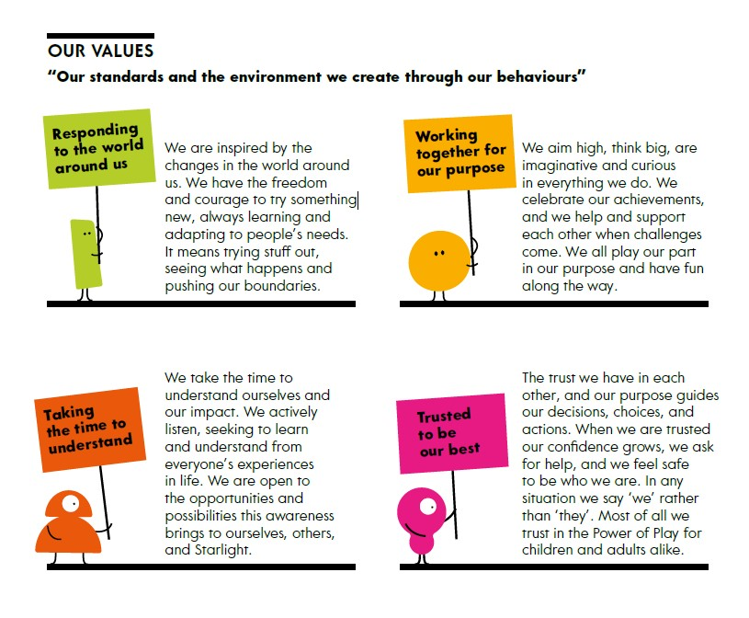
Our Strategy and the Professional Training & Development Manager role

Over recent years, we have been re-positioning Starlight from a wish-granting charity to a charity that supports children to experience the power of play in healthcare settings to improve their mental health and wellbeing. These changes have made an exponential difference to the immediate impact that we can achieve for children, as well as the opportunity to create real social value in the efficiency of treatment; and to our ability to advocate for long-term systemic change in the way children experience healthcare.
Central to improving children’s experience is having access to experienced and properly equipped play professionals. Through our Champions network and collaborative working across the healthcare sector, we have developed strong networks; shared best practice, offered opportunities for training and connection and raised awareness of the importance of play professionals and a culture of play in healthcare settings. Our Taskforce work with NHS England has also clearly outlined the need for workforce accreditation and development.
While we continue to advocate at a systemic level for the recognition of the play workforce and their need for a strategy for their development, this role is vital in providing more immediate and tangible support to the professionals who make our work possible. 3 The Professional Training & Development Manager will be integral in sharing Starlight’s knowledge of Play by training and developing key roles within health play settings to ensure Play becomes a foundation of every child’s health care journey. They will support wider understanding of the importance of a culture of play in paediatric healthcare.

Main purpose of the role
The main purpose of this role is to develop and maintain effective and mutually supportive relationships with health professionals, creating communities of practice and resourcing knowledge exchange across the sector. Through these relationships, you will deepen our understanding of the training and workforce development needs of play professionals and identify and develop opportunities for training and sharing of best practice, Working closely across the Children’s Services your work will contribute to raising awareness of the importance of a culture of play for children’s mental health and wellbeing and for the health and efficiency of the NHS.
You will report directly to the Head of Professional Training & Development and will line manage a coordinator.

Key Areas of Responsibility
1. Support the Head of Professional Training and Development to lead and manage the
Starlight programme of relationship, building, maintaining, and nurturing relationships
with health professionals in hospitals and hospices.
2. Design and manage an annual plan of training and development opportunities for health
care settings workforce. Work collaboratively to identify training needs within health care
settings.
3. Facilitate networking opportunities for professionals which enable peer-peer support for
strengthening professional development.
4. Design and deliver play training suitable for multiple roles within a health care setting for
commercial and non-commercial purposes.
5. Work with the Professional Development Coordinator to lead, facilitate and deliver focus
groups for play champions.
6. Act as an effective ambassador and advocate with external organisations on behalf of
Starlight.
7. Collaborate with Income generation and engagement teams to help identify and
maximise fundraising and PR opportunities, including the development and facilitation
of compelling case studies.
8. Ensure all programmes are informed by the best possible evidence and generates the
clearest possible data and communicating effectively the outcomes and impact of this
work.
9. Collaborate effectively with colleagues to ensure that the impact of the professional
development and training programmes is understood.
10. Contribute to the creation of reports for senior managers and external audiences.
11. Prepare and monitor budgets and effectively track spend to control costs including
managing restricted funding.
12. Undertake effective risk assessments when necessary, knowing and understanding the
Starlight safeguarding policy and procedures and implementing them throughout your
work.
13. Maintaining a service improvement focus in all areas of work, seeking opportunities to
improve Starlight’s impact.

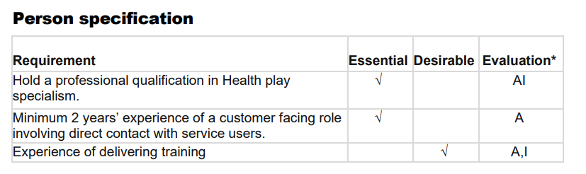
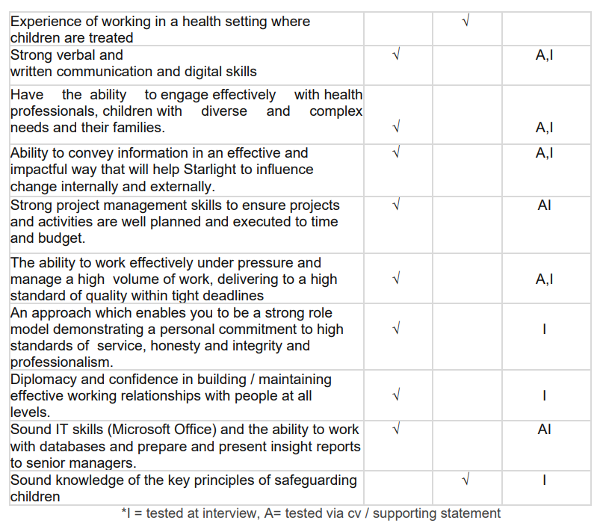

Self-Awareness and Development
- Demonstrate a high level of self-awareness, understanding of own strengths, values and preferences and their impact on the results for self, others and Starlight
- Consciously apply own strengths and preferences to manage behaviour and appropriate decision making to create a positive, inclusive and respectful working environment.
- Seek, and respond constructively to, feedback and use reflection to support personal and professional growth.
- Model calm, resilient and Starlight values led behaviour, particularly in complex or pressured situations.

What we offer
The opportunity and environment to be yourself and be your best. To have flexibility in where you work and the hours that you work. To join in beyond your role with our children and families, at events and activities. To work within a team with play at its heart.

A competitive salary and benefits package including ability to work flexibly between home and office, holiday entitlement of 25 days plus bank holidays increasing up to 30 days with service, office closed at Christmas in addition to holiday entitlement, matched pension contributions to 5%, life assurance, Vitality health cover, cycle to work scheme, season ticket loans.

Diversity Policy Statement
We believe that everyone has the right to be treated with consideration and respect. Starlight is committed to achieving a truly inclusive environment for all, by developing better working relationships that release the full potential, creativity, and productivity of each individual. We aim to ensure that all staff, volunteers, donors, partners, contractors, and the public are treated fairly. This will be regardless of sex, sexual orientation, gender, marital or civil partnership status, ethnicity, disability, medical status, age, religion or belief, political opinion, social or economic status, or ex-offender status.
Starlight actively welcomes candidates from diverse backgrounds.

To apply
Please apply for this role through Charity Job with your CV accompanied by a supporting statement which demonstrates how your experience matches the person specification and highlights your most relevant, recent experience for this role. In your application, we’d love to hear about what inspires you about Starlight’s purpose, beliefs and values with a statement that is very personal to you and gives us an insight into who you are, and how you would contribute to Starlight’s success with your experience, expertise and approach.

The role will close at 9am on 9th March 2026 and we are actively recruiting for this post on a rolling basis, allocation for interviews may happen as candidates apply. We reserve the right to close the role earlier if we receive a number of high-quality applications.

Additional Information
Diversity Policy Statement
We believe that everyone has the right to be treated with consideration and respect. Starlight is committed to achieving a truly inclusive environment for all, by developing better working relationships that release the full potential, creativity, and productivity of each individual. We aim to ensure that all staff, volunteers, donors, partners, contractors, and the public are treated fairly. This will be regardless of sex, sexual orientation, gender, marital or civil partnership status, ethnicity, disability, medical status, age, religion or belief, political opinion, social or economic status, or ex-offender status. Starlight actively welcomes candidates from diverse backgrounds. If you are invited to an interview and need any adjustments made or have particular access needs, please let us know at that stage.
Shortlisting
Starlight is an equal opportunities employer, and we are committed to ensuring all applications are treated fairly. All applications are subject to our shortlisting process; if you are shortlisted, we will contact you and invite you to attend an interview on or before the dates in this document if listed. Please let us know on application if you have any difficulty with the dates. You will also be advised at this point if there will be any skills test, presentations etc. We may appoint to the role before the stated closing date if a suitable candidate is identified.
Employment Checks
All offers of employment are made subject to the following criteria: proof of eligibility to work in the UK, proof of residency and satisfactory employment screening, enhanced DBS and two most recent references.

