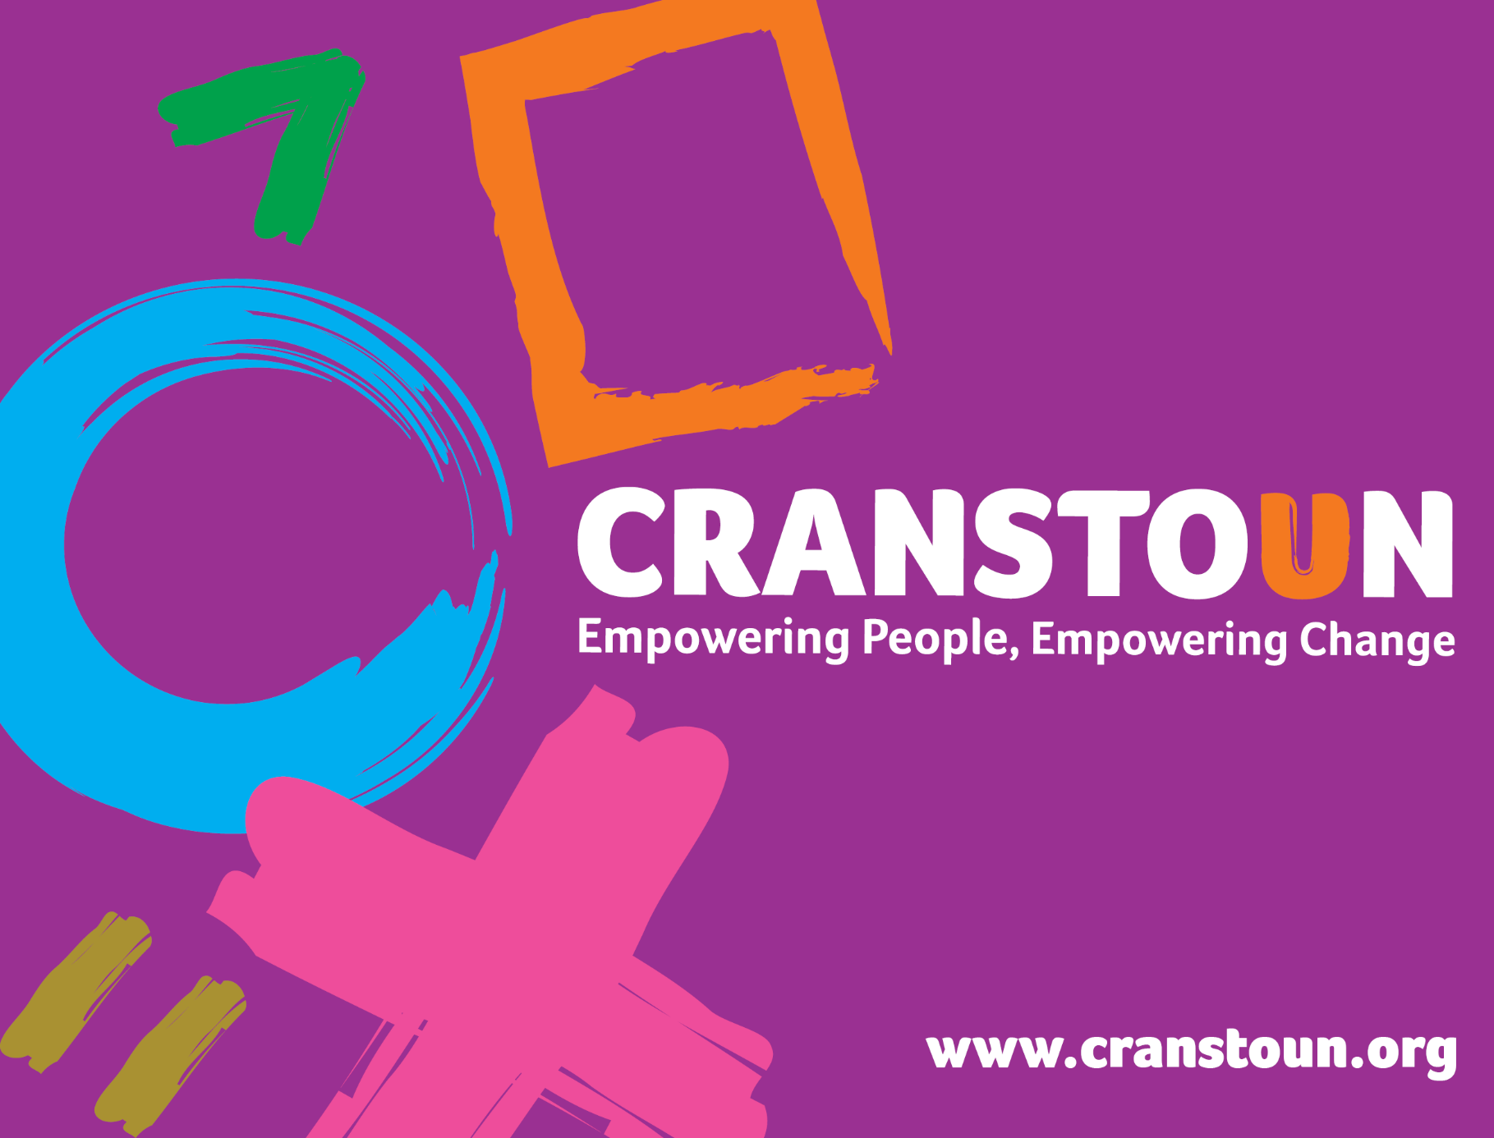

Post Information Pack
Operations Manager

Service | Cranstoun Worcestershire
Location | Worcestershire

Cranstoun is a social justice and harm reduction charity with global ambition.
Vision: To be a world-class leader in rebuilding lives.
Purpose: To inspire and empower people to live healthier and safer lives.
Values: Ambitious, Creative, Compassionate, Collaborative, Respectful.
Job description
Job purpose / context:

- Lead on the operational duties of the Service.
- Assist in the management of the designated Service, to ensure high standards of practice in service delivery, in accordance with Cranstoun polices & procedures.
- Provide leadership to your team.
- Contribute to the development of the service.
- Support the service in meeting its CQC requirements.

Responsible to:
Deputy County Manager (DCM)

Responsible for:

Engagement & Recovery Workers/Clinical Team members/Here4YOUth team members
N.b. depending on team role
1. Service development
- Liaise with all County based partners within your area of delivery to advertise and promote the Service and identify new joint working opportunities where suitable
- Work with the Service team members to develop service user-focussed services in line with contractual requirements
- Support the Service to meet the ever changing demands to meet the local community and service users needs.
- Support in the development and implementation of operational procedures
- Complete incident and complaint investigations to identify any learning or new service processes. Ensure any identified learning is shared and embedded within the team

2. Operational responsibilities and service delivery

- To enable all workers to effectively manage their duties and/or caseloads. This will be through proactive engagement, monitoring and enabling workers to manage workload capacity using key working and care coordination approaches.
- Participate in the full range of service delivery activities as directed by DCM and County Manager.
- Investigate conduct and performance issues following relevant policy and procedures where required in response to these issues.
- Support the utilisation of a trauma informed approach within your team and the wider service.
- Instil within your team, good customer care skills to provide a warm welcoming service to all users, their families, carers and referrers.
- Have a good understanding of the referral and allocation processes and be part of the administration by ensuring all referrals are processed efficiently within your team.
- Ensure that team member’s are competent in their role and deliver assessment and reviews that are holistic, user appropriate and recovery plans are based on assessment of assets, social accrual, potentials and risks
- Co-ordinate outreach where required to promote the service and conduct service user interventions at a variety of locations such as service user’s home address, hostels and other services when appropriate.
- Distribute publicity and information materials to service users, including general leaflets and materials specific to specialist services available (e.g. acupuncture, etc.).
- Contribute to the development of educational group packages to increase knowledge and understanding of substance use and their effects.
- Provide specialist advice and consultation to partner agencies.
- Support team members to use a variety of interventions such as Brief Therapies, Motivational Interviewing, ITEP/BTEI including Discovery Model to engage service users in a process of behaviour change
- Identify and prioritise needs and issues to be addressed arising from service’s data and team member, service user and partnership agency intelligence and feedback.
- With the support of the service’s MDT, oversee the case management of high risk and substance misuse or alcohol clients.
- Manage staff absence and capacity to ensure continuity of care
- Comply with the Confidentiality Policy and process of disclosure in cases where a risk warrants breach of confidentiality.
- Approve reports for safeguarding / social care meetings prepared by your team members.
- Keep safeguarding records in accordance with local policy and procedure.
3. Leadership
- Assist in the recruitment, selection, induction & training & development of staff.
- Manage team duties to ensure the efficiency and effectiveness of service to clients, ensuring that Cranstoun and Service policies & procedures are adhered to.
- Monitor staff attendance & time keeping as required.
- Deliver your required areas of the supervision model to workers in line with the Cranstoun Supervision Model, ensuring their support and development needs are met.
- Work with the DCM to facilitate effective team communication, both within the Service and across the organisation.
- Deputise for the DCM or County Manager as and when required.
- Be the strategic lead and point of contact/escalation for your area of delivery e.g. operational Adult team, Switch team, Criminal Justice, Clinical Team etc.
- Support the service in ensuring it has representation on relevant Countywide or Local Authority safeguarding and forums
- Complete incident and complaint investigations to identify any learning or new service processes. Ensure any identified learning is shared with the team.
- Work within NICE guidance and in line with evidence based practice, and follow Cranstoun clinical guidelines, policies and procedures
- Follow the organisation’s and local authority Safeguarding Policy and Procedures
- Implement Cranstoun’s service user involvement model within the team
- Provide written reports/ data for submission to the contract, commissioner or other relevant (e.g. Coroner Reports, Safeguarding Reviews) reports.
- Undertake any additional duties as may be reasonably required.

In addition to the above Job Description, Operations Managers are required to have knowledge and experience in their specific area(s) of work covered by the particular post.
Staff will be required, depending on the specifics of their role, to demonstrate the following key activities and responsibilities:

Clinical Team Operations Manager
- Manage a team of supervisors and clinicians, including the service’s Clinical Lead, ensuring the clinical service is compliant with the Care Quality Commissions requirements
- Ensure clinical team resource is allocated adequately to meet service’s supervision and clinical intervention requirements
- Provide supervision to senior practitioners and ensure that clinical team member supervision is being completed to standard
- Support County Manager in identifying and agreeing yearly audit schedule
- Ensure compliance with clinical audits and create plans to respond to recommendations
- Organise the service’s clinical setup and rota and associated interventions
- Ensure that the clinical team complete their relevant validations
- Contribute and monitor prescribing within the service with the Clinical Lead to ensure cost effective delivery of clinical interventions
- Ensure clinical equipment in use by team is calibrated as per guideline requirements
- Co-ordinate the annual mandatory training for the clinical team

Here4YOUth Operations Manager
- Ensure that you maintain an up to date knowledge of the range of substances being used by young people and indicators of use.
- Ensure referral criteria and procedures for the team conform to national standards and requirements
- Ensure that service delivery is young people focussed taking full account of each young person’s stage of development whilst safeguarding and promoting his or her welfare.
- Ensure young people’s rights are respected.
- Ensure the Service has a safe, quality & conducive environment for employees to work & young people and family members to use.
- Ensure access and specialist services for the diverse groups represented in the area.
- In conjunction with the DCM, co-ordinate the services of the team, ensuring smooth running and the meeting of deadlines and targets.
- Ensure that the services provided are of high quality, provide effective interventions and are appropriate to the needs of young people and Family members.

Person specification

Qualifications

- Demonstrable experience in Substance Misuse Services with knowledge of a prescribing service and harm reduction.
- Experience in line management including facilitating 1-2-1 Supervision/performance reviews.
- Evidence of professional/clinical knowledge gained through continuous professional development evidenced by further training/additional qualifications.

Experience

- Ability to critically reflect and evaluate interventions and service delivery, identifying areas for development.
- A demonstrable understanding of the need for, and the ability to deliver quality services.
- Experience of delivering high quality Recovery Focused and clinical interventions.
- Experience of delivering training and/or groups with differing needs using a range of styles including coaching, interactive works.
- A demonstrable knowledge of the essential CQC requirements.
- A thorough understanding of relevant legislations, and experience of translating into practice.
- An enhanced understanding of Safeguarding and how this translates into practice in Substance Misuse Services.
- Experience of giving supervision.
- Significant experience of working in a multi- disciplinary team

Skills

Leadership
- Take responsibility for relations with all relevant partners and stakeholders.
- Participate in multi-agency relationship building and working.
- Ability to understand and contribute to Cranstoun’s strategic direction.
- Willingness and desire to work in an environment of continual change.
- Ability to direct a team of practitioners in a way that creates and fosters a positive working environment.

Communication
- Clear and accurate oral and written communications.
- Able to communicate confidently and effectively with a range of stakeholders and professionals including commissioners, front line practitioners and leads within the partnership.
- Well-developed communication skills with the ability to influence and persuade key personnel to improve practice.
- Is open and shares ideas and knowledge.
- Shows respect for others and is approachable and responsive to their needs.
- Ability to communicate messages and engage fully with people even if messages are difficult.
- Set clear boundaries across relationships and set expectations of this across your team.
- Adopt a person-centred focus to communication.
- Create opportunities for development in service through external and internal communication

Teamwork
- Able to successfully manage a team to achieve targets and ensure safe delivery of interventions.
- Participate and collaborate with internal and external teams.
- Liaise with other agencies to support service users.
- Proactive engagement with change, progressive concepts, openness to learn.
- Ability to lead by example and demonstrate team work

Problem solving
- Identify and be alert to risk; manage contingency plans effectively.
- Ability to learn and apply theoretical knowledge in practical situations.
- Show creativity and innovation in our local harm reduction offer.
- Ability to make critical decisions in a timely, considered manner.
- Managing effectiveness

Attention to detail
- Maintain confidentiality of all data and information related to service users and business.
- Ability to manage own time, prioritise activities and maintain accountability for workload and service users.
- Accurate record keeping and an understanding of the importance of this across the service
- Ability to work non-judgementally.
- Awareness of range of cultural differences.

IT
- Excellent keyboard skills and excellent ability to use a data management system.
- Good IT skills and the ability to use MS Office (Outlook, Word, Excel, PowerPoint).

Other
- Willingness and desire to work in an environment of continual change.
- Proactive engagement with change and progressive concepts, with an openness to learn.
- A flexible approach to working hours and location including a late evening and weekends where required.
- Able to travel independently, in a timely manner, within work area.

Desirable criteria

- Advanced professional qualification in substance misuse, social work, NVQ, Level 3 Leadership & Management accreditation.
- Experience of PHE substance misuse datasets (e.g. NDTMS) and the understanding of the importance of providing high quality data.
- Root Cause Analysis Training.

