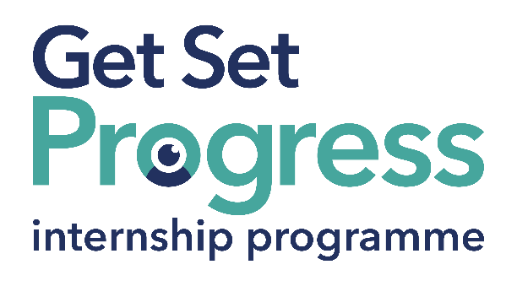

Policy and Campaigns Intern

Join us at Thomas Pocklington Trust
Thomas Pocklington Trust (TPT) and RNIB are collaborating with organisations from both the sight loss and wider charity sector as well as corporate organisations to create new opportunities for blind and partially sighted people to find employment through the Get Set Progress (GSP) Internship programme. Thomas Pocklington Trust is delighted to be offering an internship as part of the Get Set Progress scheme. This internship may be suitable for someone looking to gain experience, develop workplace skills, build confidence in employment, or take the next step in their career. We welcome applications from people at different stages of their employment journey.
Thomas Pocklington Trust is a national charity dedicated to delivering positive change blind and partially sighted people.
Our mission is to support blind and partially sighted people of all ages to live the life they want to lead.

Our Values
Our values define everything we do:
Authentic - Everything we do is anchored in inclusion and the lived experience of blind and partially sighted people.
Constructive - We are proactive and have a “can do” approach, seizing opportunities and solving problems.
Tenacious - We are passionate and persistent in our work, and we will do the right thing, even when it is hard.

Job description

Role: Policy and Campaigns Intern
Department: Public Affairs and Campaigns
Reporting to: Policy and Campaigns Manager
Location: Hybrid – you’d normally be in the office once a week.
Salary: Based on the Real Living Wage
Contract type: Fixed Term, 9 month contract

Purpose of the role:

To provide junior research, drafting, monitoring and administrative support to the Public Affairs and Campaigns team. The intern will help the team progress policy, campaigning, consultation and parliamentary engagement work that supports positive change for blind and partially sighted people. This is a supported learning role, so the intern will complete defined tasks with guidance and sign-off from the team rather than owning campaigns or managing projects.

This would be a great opportunity for someone interested in policy, campaigning, public affairs or influencing work that supports positive change.

Main responsibilities:

- Carry out desk-based research into policy, public affairs, parliamentary and campaigning issues, and summarise findings clearly for colleagues.
- Help draft, update and format training and awareness resources, policy positions, key messages and briefing notes, using agreed evidence and team guidance.
- Support consultation response work by helping to track deadlines, review consultation questions, gather evidence, draft sections and coordinate internal input.
- Support parliamentary engagement by researching MPs and stakeholders, preparing invite lists and briefing materials, helping with event planning and recording follow-up actions.
- Help develop and maintain clear trackers for MP engagement, Polimonitor outputs, policy positions, consultation activity and team tasks.
- Support the Built Environment work area by helping to identify gaps, compile evidence, draft key messages and maintain stakeholder lists.
- Provide defined support to one active campaign during the placement, which may include content drafting, stakeholder research, monitoring, note-taking and administrative coordination.
- Help the team share information internally, including signposting colleagues where MP interests, local issues or campaign priorities connect with wider organisational work.
- Attend Public Affairs and Campaigns team meetings, provide updates on agreed tasks, take part in internship development activities and complete other reasonable related tasks with appropriate support.

Person specification

Essential criteria:

- Able to carry out desk-based research, identify relevant information and summarise it clearly.
- An interest in policy, campaigning, public affairs or influencing work that supports positive change for blind and partially sighted people.
- Communicates clearly in writing and in conversation with different people, as notes, briefings, campaign materials, emails or web content.
- Can plan and organise their work, manage priorities and meet deadlines.
- Can use Microsoft Office, including Word, Excel, Outlook and Teams, and is willing to learn new systems such as Salesforce and PoliMonitor.
- Able to work collaboratively with others, ask questions, respond positively to feedback and use guidance to develop and improve their work.

Important information:

- This role has a Genuine Occupational Requirement that the successful applicant be a person who is blind or partially sighted, in line with The Equality Act 2010.
- Interns need to be able to travel to the TPT Hub in London on average once a week for collaboration and for intern development events throughout the course of the internship programme (costs covered by TPT).
- Having not previously undertaken the Get Set Progress internship programme.
- Successful applicants must have the Right to Work in the UK for the duration of the Internship. Sponsorship will not be provided.

Closing date: 14th July 2026

What are the benefits of a Get Set Progress internship for me?
As part of your 9-month internship, you will be part of a large cohort of fellow interns and gain the following:
- Obtain valuable work experience within the charity sector
- Technology support (Including Microsoft Office) and upskilling opportunities
- Online and in-person Training and development opportunities
- Opportunity to present and network with Senior leaders within the Sight Loss Sector
- Opportunities to build relationships with fellow interns
- A personal mentor offering support, advice and guidance throughout your internship
- Help deliver positive changes for people with sight loss


As part of the GSP Internship programme, you will also be enrolled on the TPT Works For Me Employment Programme, where you will gain bespoke employment support, guidance and advice from the TPT Employment Team, some of the skills that you will receive support and guidance around include:
- CV writing
- Job searching
- Cover letter and speculative letter writing
- Application form writing
Interview techniques

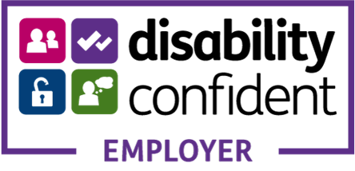

Thomas Pocklington Trust (TPT) is a charity established to provide services for visually impaired people: our mission is to improve the lives of people living with sight loss.

TPT is registered with the Disability Confident Scheme as a Disability Confident employer. Therefore, we believe in treating all employees fairly and we are committed to recruiting equally. TPT’s charitable objective and aim is to support visually impaired individuals back into work. For this reason, we are actively seeking applications from all backgrounds including disabled/visually impaired individuals and people who have lived experience of sight loss. We also guarantee all disabled applicants that reach the minimum appointment criteria an interview. We are happy to accept applications from all suitably qualified persons who have the appropriate skills and talent regardless of their age, gender, race, religion, disability, sexual orientation or marital status.

End of Document

