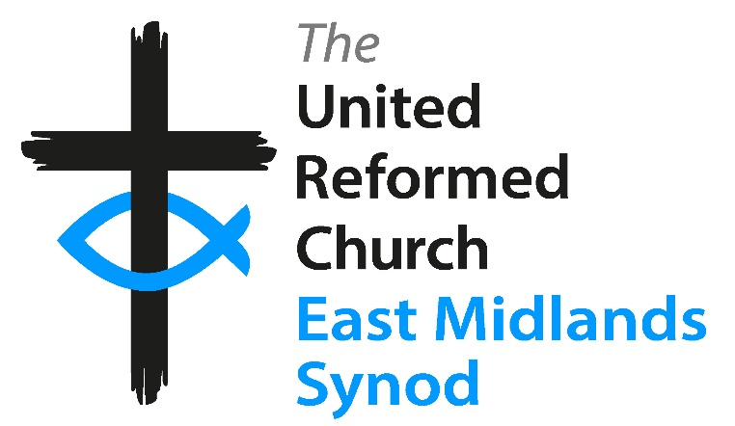

The East Midlands Synod of the United Reformed Church is seeking to appoint a Property Officer (Ref PO). This is a part-time post for 20 hours per week on a permanent contract. Salary is £44,904 FTE (pro-rata). This post is subject to an Enhanced DBS Disclosure.
Purpose of the Role:
The Synod Property Officer will support the Synod and local churches (as directed by the East Midlands Synod Trust) in respect of property issues arising within the East Midlands Synod of the United Reformed Church. They will work with, and line manage the Property Administrator.
Main responsibilities include (but not limited to):
- Oversee the property portfolio of church buildings and manses
- Undertake transactions related to the properties as required
- Advise local church premises management teams on their responsibilities for the buildings in their care and Trust on major repair works required to church buildings
We are looking for someone who:
- Is educated to degree level and/or holds relevant professional qualifications
- Understands the legal requirements involved in property transactions
- Has experience of the charity sector
- Has empathy with the Church
- Has experience of managing a portfolio of properties
For an application pack (no CVs) please contact:
Mrs Chris Willis, East Midlands Synod Office
1 Edwards Lane, Sherwood, Nottingham, NG5 3AA
Email: admin@urc5.org.uk
Closing date for applications: 31st August 2026 - Interviews to be held on 1st October 2026

