

Job Vacancy
Weldmar Hospicecare provides specialist care for adults in Dorset who have a life limiting illness, and support for their loved ones. We are dedicated to fostering a culture of equality, diversity, and inclusion across all aspects of our organisation. 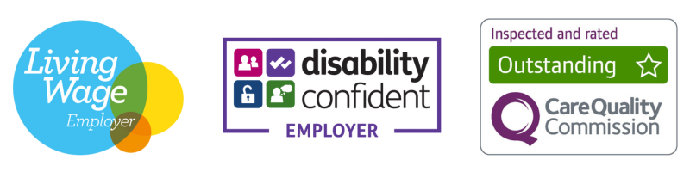
Are you a sophisticated communicator with a talent for building high value relationships? As Weldmar Hospicecare moves into an exciting new direction in fundraising, we are seeking a Philanthropy Manager to lead our engagement with key investors and high net worth individuals.

This is a brand new role designed to broaden our reach and secure the major gifts necessary to fund our specialist care services. Working alongside fellow fundraising managers, as well as the Senior Leadership Team and Trustees, and reporting to the Director of Fundraising, your key responsibilities will be to:

- Identify and research high value prospects, implementing bespoke donor journeys that move supporters from initial interest to significant financial commitment.
- Establish and lead a group of dedicated volunteers who act as champions for Weldmar across the county.
- Manage our Trust and Foundations Fundraiser, overseeing applications for grant funding and ensuring detailed, timely reporting to funders.
- Represent Weldmar at flagship events and networking opportunities, educating partners on how their investment makes a tangible difference to the specialist care Weldmar provides in Dorset.
- Using Raiser’s Edge, you will maintain meticulous records and provide regular performance and prospect reports to senior management.

You will have extensive experience in managing profitable fundraising events or securing high value income. You must be a diplomatic and persuasive negotiator, comfortable engaging with decision makers at all levels. A professional qualification (such as the IoF Diploma) is desirable, but more important is your ability to tell Weldmar’s story in a way that inspires generosity. A Basic Disclosure and Barring Service (DBS) Check is required for this role.
Closing Date: 1st June 2026 Interview date: W/C 8th June 2026
For a Candidate Pack including full job description, go to weldmarhospicecare.org/jobs
For more information, contact recruitment@weld-hospice.org.uk or call 01305 269898
Philanthropy Manager
Permanent Contract
£40,625 per annum for 37.5 hours per week

