

Philanthropy and Partnerships Manager
Recruitment Pack

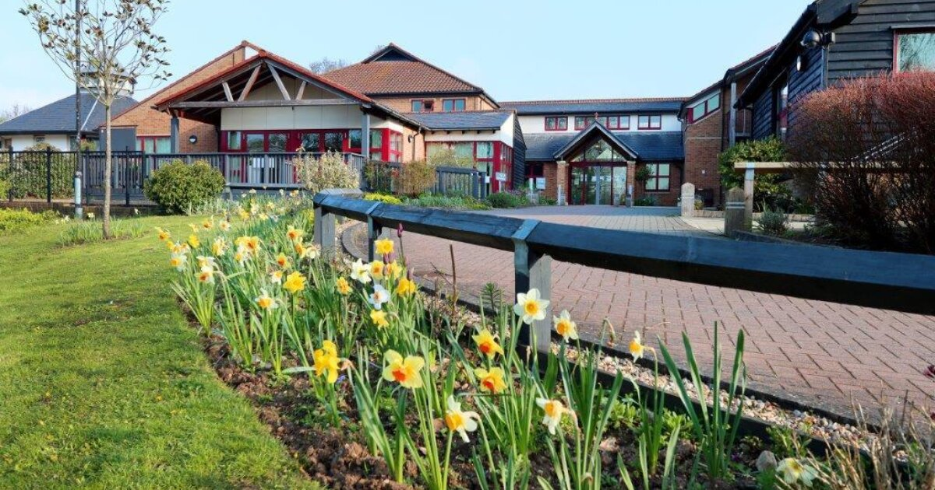

Thank you for your interest in the role of Philanthropy and Partnerships Manager at Farleigh Hospice.

The Philanthropy and Partnerships Manager role is a newly created role which will lead our high-value fundraising activity and is a key management position within the Income Generation Directorate, supporting delivery of our strategic fundraising ambitions.
We put our beneficiaries at the heart of what we do and we strive to build lasting, value-driven relationships with our supporters. The purpose of the Philanthropy and Partnerships team is to develop and grow meaningful relationships with individuals, corporates and organisations, maximising high value income to support the vital care we provide.

What are we looking for?
We are looking for a candidate who can lead the development and implementation of our philanthropy and partnerships strategy, working closely with the Director of Income Generation, Head of Fundraising and key stakeholders to ensure alignment with the wider Income Generation and organisational strategy.

What will you bring?
You will bring passion, drive and enthusiasm…
You will lead and develop Farleigh Hospice’s high-value income streams, including major donors, corporate partnerships, trusts and foundations, and legacy and in-memory giving.
You and your team will build and nurture long-term, high-value relationships, ensuring supporters receive exceptional stewardship and engagement opportunities. You will drive income growth through strategic partnerships, identifying and developing new opportunities while maximising existing relationships.
You will be responsible for delivering income targets, using insight, data and pipeline management to prioritise activity and maximise return.
You will work collaboratively across teams to deliver a joined-up supporter journey, ensuring philanthropy and partnerships activity is aligned with communications, fundraising and organisational priorities.
Of course, you will not do this alone - you will be supported by a dedicated team, which you will lead, motivate and develop to ensure a high-performing and collaborative culture.

What we offer in return
✓ A competitive salary
✓ Company pension scheme
✓ Generous annual leave
✓ Hybrid working
✓ The opportunity to be part of a purpose-driven organisation where your work makes a real difference

Philanthropy and Partnerships Manager
Location: Farleigh Hospice, North Court Road, Chelmsford / Hybrid
Hours: 30 hours per week
Reporting to: Head of Fundraising
Responsible for: Corporate Fundraiser, In Memory and Legacy Officer, Volunteers
This job description is intended only as a guide to the range of duties involved. The post holder will need to be flexible and adaptable to respond to other duties that may be required from time to time and the changes and developments within the Hospice appropriate to the role. Job descriptions are reviewed periodically to ensure the needs of the service are being met. Any changes can only be made in line with the Establishment process. Specific workplans, targets and KPIs will be set annually.

Job Purpose and Scope
To lead Farleigh Hospice’s high value income generation portfolio, including corporate partnerships, major donors, high-value stewardship, trust and foundations, legacy, in memory giving and tribute giving.
The post holder will create and deliver a strategy that deepens long-term, high value relationships, maximises philanthropic income, and positions Farleigh Hospice as a partner of choice. They will provide leadership to the Philanthropy & Partnerships Team and deliver high-quality stewardship across all relationship driven income streams.

Key Accountabilities

Strategic Philanthropy Development
- Develop and deliver a philanthropy and partnerships strategy aligned with organisational goals and the Income Generation/ Fundraising Strategy.
- Identify and cultivate high value supporters, corporate partners and trusts and foundations.
- Lead research, prospecting and pipeline development for major gifts.
- Develop compelling cases for support tailored to high value audiences.
- Plan a suitable programme of engagement events for high value audiences.

Team Leadership and line management
- Lead, motivate and help to develop the Philanthropy and Partnerships team and volunteers.
- Line manage specialist fundraisers across corporate, legacy and in memory income, providing regular 1:1 support and line management, clear objectives and ongoing feedback.
- Oversee recruitment, training and performance management to ensure a skilled, confident and motivated team.
- Promote a positive, collaborative “One Team, One Vision” culture.
- Maintain appropriate staffing levels to ensure operational continuity and delivery of activities.
Major Donor Relations
- Develop meaningful relationships with high value donors and prospects.
- Deliver personalised stewardship plans, events and engagement opportunities.
- Ensure accurate prospect research and tailored communication.

Corporate Partnerships
- Lead the development of strategic relationships with local and regional corporates including direct engagement with corporates
- Create partnership packages, sponsorship opportunities and business engagement plans.
- Plan corporate engagement to attract new supporters.
- Support stewardship, renewals and upgrades to partnerships.

Trusts and Foundations
- Lead the identification, research, application and reporting for grant income.
- Ensure high-quality submissions and compliance with funder requirements.
- Manage a pipeline of high value prospects and existing funders.

In Memory, Legacy and Tribute Giving
- Support the Legacy and In-Memory Officer with the stewardship and growth of in memory and legacy giving as required.
Governance, Due Diligence and Compliance
- Ensure all philanthropic and partnerships fundraising activity complies with the Fundraising Regulator, safeguarding, local licensing, GDPR, H&S, organisational policies, ethical and legal requirements.
- Manage risk assessments related to external partnerships and donor engagement.
- Draft, negotiate and manage partnership agreements with clear deliverables, KPIs and budgets.
- Promote a culture of continuous improvement within the team.

Data, Insight and Reporting
- Monitor and report on philanthropy and partnerships activity, including performance insights, engagement metrics, pipeline updates and income forecasting
- Use data to drive decision-making and strategy
- Support data accuracy in CRM systems and digital platforms.
- Ensure confidentiality of all personal data, commercial information and agreements.
- Ensure all fundraising activity complies with the Fundraising Regulator, safeguarding, local licensing, GDPR, H&S and organisational policies.

Cross-Team Collaboration
- Work closely with Fundraising, Marketing, Supporter Engagement and Events colleagues to ensure integrated communications and supporter journeys.
- Work closely with Marketing/PR/Communications to develop brand‑aligned materials, campaigns and promotional assets.
- Highlight supporter stories/activities to the Comms and Marketing team
- Support the team to cross-promote supporter activities (in-memory, donations, gifts in wills, retail, Local Hospice Lottery, volunteering, community and events) to promote a unified supporter offer.
- Represent Philanthropy & Partnerships at directorate planning meetings.
- Support alignment of philanthropy and partnerships activity with the wider Income Generation strategy.
- Contribute to team meetings, planning discussions and organisation wide initiatives.
- Champion Farleigh Hospice’s values and collaborate across care, retail, volunteering, communications, facilities and clinical teams to shape and deliver partnership activity and actively contribute to a “one team, one vision” culture across the organisation.
Financial and Performance Management
- Deliver against agreed income and expenditure targets.
- Manage budgets and reforecasts, ensuring effective financial tracking, invoicing and reconciliation.
- Identify opportunities for growth, innovation and efficiency.
Communication and Relationships
- Build strong internal and external relationships, representing Farleigh Hospice professionally at all times.
- Participate in team meetings and cross‑departmental working groups.
- Communicate effectively with leadership, colleagues and external contacts.
Training and Development
- Take responsibility for personal professional development, keeping up to date with best practice in philanthropy and partnerships fundraising, charity governance, regulation and sector trends.
- Engage with internal and external training opportunities.
General Responsibilities
- Ensure a good knowledge of Farleigh hospice services to enable effective supporter engagement.
- Represent Farleigh Hospice professionally within the community.
- Attend external meetings, networking events, presentations and engagement opportunities as required.
- Support and value volunteers involved in fundraising activities
- Engage with other hospice fundraisers and the wider sector to keep up to date with new developments and best practice
- Undertake any other duties as required by the Head of Fundraising or Director of Income Generation

Person Specification
Section | Criteria | E/D | A/T/I
Experience | Significant experience in philanthropy, corporate partnerships, major donor fundraising, trusts or similar. | E | A/I
Experience | Experience managing a portfolio of high value relationships. | E | A/I
Experience | Proven experience line managing fundraising staff. | E | A/I
Experience | Demonstrable success in securing significant gifts or grants. | E | A/I
Experience | Experience developing strategies, cases for support and stewardship plans. | E | A/I
Experience | Hospice or healthcare charity experience. | D | A/I
Experience | Experience working with professional partners (funeral directors, solicitors, wealth advisers). | D | A/I
Skills and Abilities | Excellent relationship building and influencing skills. | E | A/I/T
Skills and Abilities | Strong proposal writing and communication skills. | E | A/T
Skills and Abilities | Strategic planning and analytical capability. | E | A/I
Skills and Abilities | High-level professionalism and emotional intelligence. | E | I
Skills and Abilities | Understanding of philanthropic giving motivations. | E | A/I
Skills and Abilities | Knowledge of corporate CSR, ESG or partnership frameworks. | E | A/I
Skills and Abilities | Awareness of legacy giving principles and regulations. | E | A/I
Personal Qualities | Professional, credible and empathetic communicator. | E | I
Personal Qualities | Strategic thinker with ability to inspire confidence and trust. | E | I
Personal Qualities | Highly organised and proactive. | E | A/I
Personal Qualities | Committed to Farleigh Hospice’s values and mission. | E | I
Other Requirements | Willingness to work evenings/weekends as required. | E | A/I
Other Requirements | Full UK driving licence and access to transport. | E | A
Other Requirements | Commitment to ongoing professional development. | E | A/I

Key Competencies
  - Planning and development
  - Leadership and people management
  - Relationship building and engagement
  - Philanthropy and partnerships management
  - Communication
  - Fundraising Acumen
  - Adaptability

