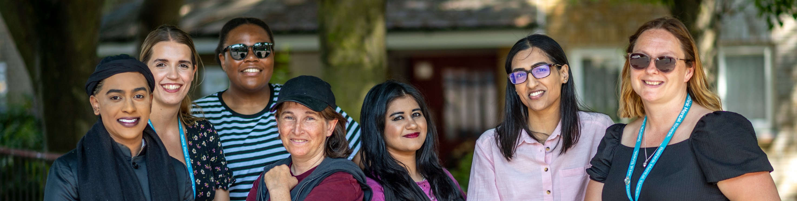


Volunteer Role Description

Your volunteer role description provides an outline of the tasks you will complete when volunteering.
Whatever your role, or however much time you donate, you will be helping to improve the lives of people severely affected by mental illness. We appreciate and value your commitment to volunteering with Rethink Mental Illness.
Role title:  Role details | Peer Support Volunteer
Where the role is based | In the community
You will be supported by | Volunteering Coordinator
Level of DBS check | Enhanced with Adults
Service details

Service | Empowering Minds Gloucestershire
Location of the service | Gloucestershire
Days and times volunteering is available | Monday – Friday, 9–5pm, with a possible weekend as required
Service code | 6751
The purpose of your role

As a Peer Support Volunteer, you will play a key role in supporting and co-facilitating our peer support groups. These groups run all around the county throughout the week.
There is flexibility with volunteering opportunities ranging from a minimum of 2-3 hours weekly to monthly commitments.
There may also be the opportunity to attend different community events to advertise our service.
You will work alongside our team of peer support workers and other peer support volunteers.
There will be full training opportunities to ensure that you are successful in your volunteering role, as well as regular check-in meetings.

The service you support

Empowering Minds is a Gloucestershire-based service for people aged 18+ with a mental illness and live in Gloucestershire or are registered with a Gloucestershire GP. We support individuals in all six localities: Forest of Dean, Tewkesbury, Gloucester, Cheltenham, Stroud and the Cotswolds.
You will complete the following tasks

- Support the peer support workers and other peer volunteers to run the group sessions.
- Create a safe space for people to share as much or as little as they want.
- Signpost people to different services when necessary.
- Collaborate with other volunteers and members of staff to support the delivery of group activities.
Necessary skills, experience, and attitude

It’s essentials to have the following:
- Lived experience with mental illness, whether that is caring for someone else or yourself.
- Reliability and good timekeeping.
- An excellent ability to emphasise with others and be non-judgemental.
- Have a good understanding of confidentiality.

Although it’s not essential, you may also have:
- Basic computer skills.
- Knowledge of the local area and organisations.


You’ll have our support and guidance,
every step of the way

Values and behaviours

You will demonstrate and apply Rethink Mental Illness values:
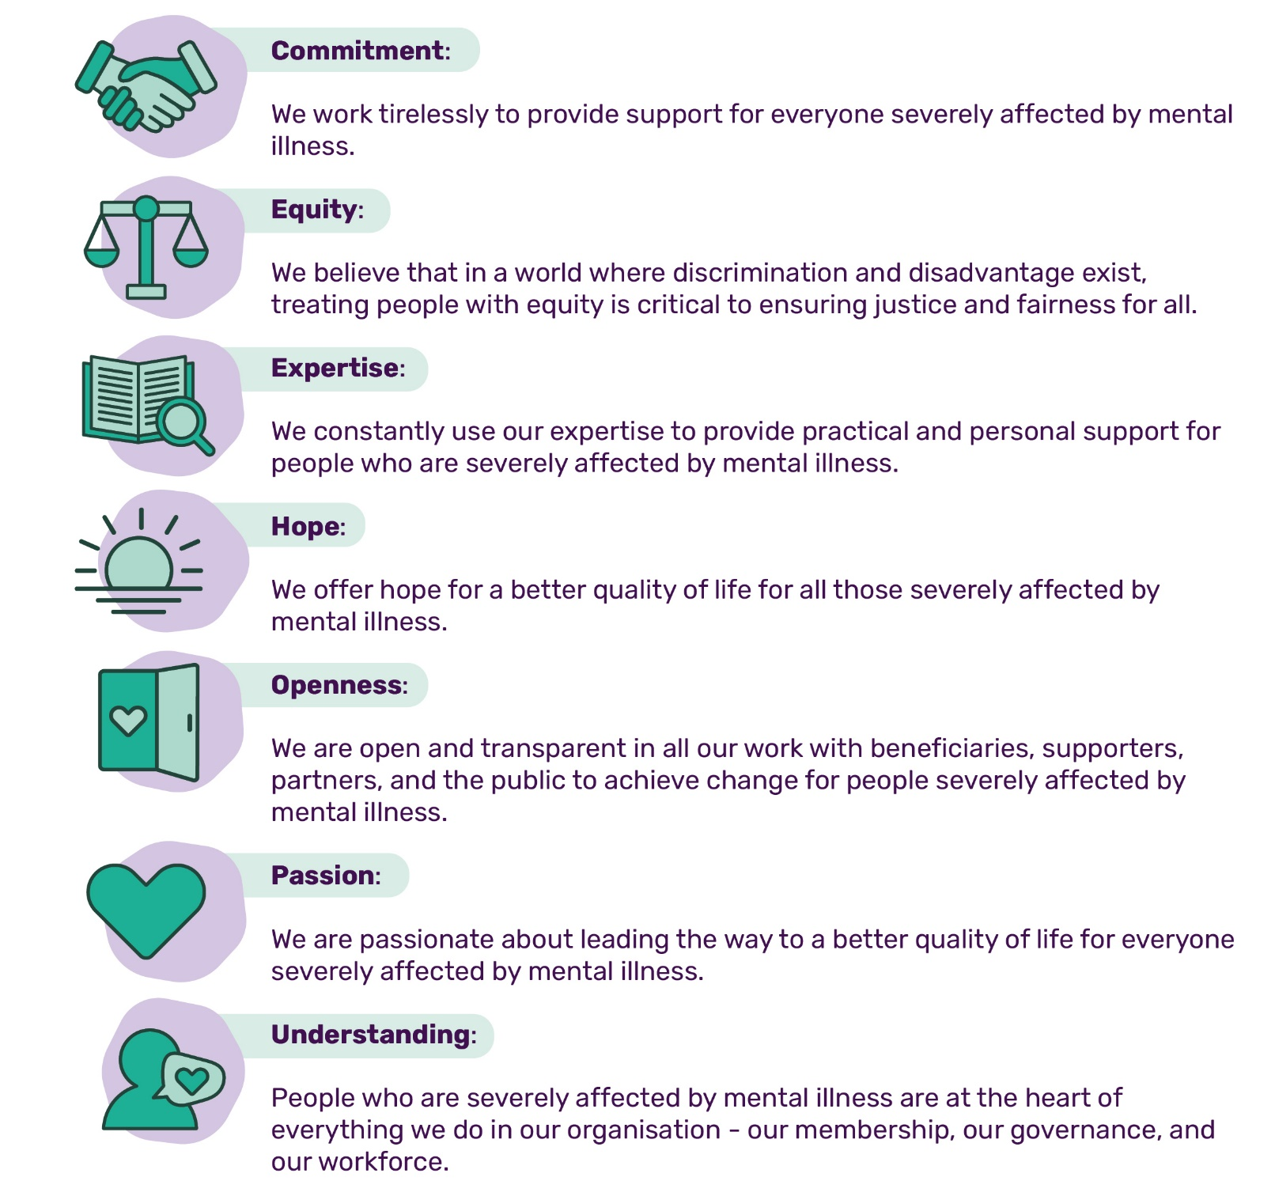
You will demonstrate and apply Rethink CARES behaviours of:
 |  |  |  |  |  |  |  | 
We work together, we celebrate together |  | We do what we say we will do |  | We believe everyone counts |  | We challenge, we listen, we change |  | We deliver results
The training and support you will receive
As part of your induction, you will complete the following e-learning modules:  - Safeguarding adults  - Data security |  |  |  |  | You will have access to:  - Regular check-in sessions with your Volunteer Manager  - A range of wellbeing resources
 | What you will get out of volunteering
 | There are lots of benefits to volunteering. Here are just a few:
 |     Develop your existing skills or learn new ones |  |     Enhance your CV and boost your employability |  |  |  |   Reimbursement for out-of-pocket expenses
 |   Find a passion and maybe a step towards a new career |  |   Access to internal vacancies |  |  |  |   Access to Rethink’s Volunteer Assistance Programme
 |   Impact positively on your own mental health, as well as others |  |   Meet new people and increase your self-confidence |  |  |  |   Gain a reference from Rethink Mental Illness

