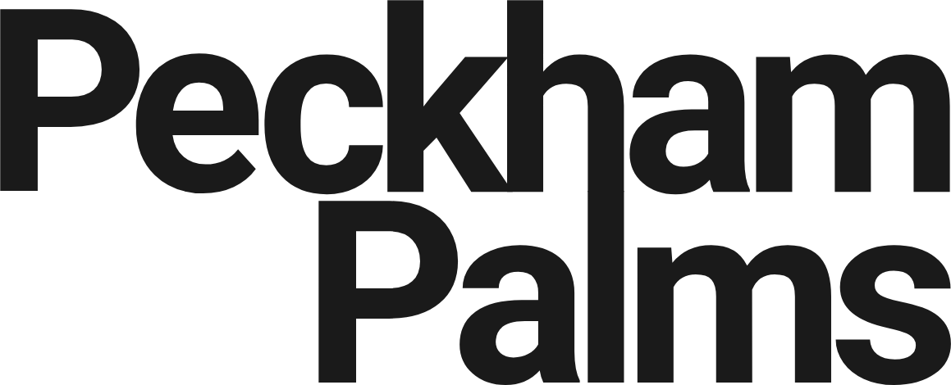
Partnership & Impact Director
Peckham Palms · Three days per week · £33,000 per annum (£55,000 FTE) · Fixed-term, 18 months · Hybrid, one day a week at Peckham Palms

About Peckham Palms
Peckham Palms is a dedicated home for Black women entrepreneurs in hair, beauty and wellbeing. We are a social landlord: we bring independent businesses together under one roof and offer space on terms designed to help them thrive.
That model exists for a reason. As parts of Peckham change and rents rise, too many of the businesses and people who give this area its culture are being pushed out. Peckham Palms is a deliberate counterweight to that: a place that keeps Black women-run enterprise rooted, visible and growing in the heart of Peckham. Our success is measured not in occupancy alone, but in the livelihoods built, the skills developed, and the culture sustained across our tenant community and the wider neighbourhood.
We are proud of what we have built, and we are ambitious about what comes next. This is a chance to help lead that next chapter.
Where we are going
Peckham Palms is in a strong and stable position, and our focus now is on building from that base. Over the next three years we want to grow the organisation's reach and resilience by securing new commercial relationships, projects, sponsorship and funding that put us on a firm long-term footing. From there, we want to grow our impact in three ways:
- Deepening our support to existing tenants, helping the businesses already at the Palms to grow and succeed.
- Building a stronger programme of community events, reaching and supporting more entrepreneurs through the Palms.
- Expanding beyond Peckham Palms, taking our pioneering social shops model to new spaces, starting with a second site in Peckham.
The Partnership & Impact Director is central to realising this. You will help translate that ambition into the partnerships, funding and income streams that make it real, and in doing so help shape the journey itself.
The role
This is a senior, outward-facing role for someone who can turn ideas into funded, delivered projects. You will identify, design and secure the partnerships and impact funding that align with our ambitions, then lead delivery of the work you bring in, strengthening the impact Peckham Palms has on our existing tenants and on the community beyond our walls.
Peckham Palms is not a charity. We are a social business, and that shapes how we fund our work. Partnerships with family offices and corporates, alongside commercial projects and sponsorship, are at the heart of the fundraising strategy this role will build and deliver. You will need to look well beyond the usual grant funding pathways, and to be as comfortable in commercial conversations as in philanthropic ones.
A core part of the job is strategy, not just execution: taking the Palms' organisational vision and shaping it into a clear partnerships and funding strategy, working out which partners, funders and income streams best fit where we want to go, and then going out and building them.
You will help to hold some of our existing funder relationships, but this role is primarily about making and delivering on new ones. We want to be clear that we have funding in place to secure our current work: you would be joining a stable, established organisation with room to build.
You will also help tell the story of the Palms. Working with the founder-Directors and freelance support, you will develop compelling narratives and assets that bring our mission to life for a broad cross-section of audiences and potential partners.
How we work
You will work alongside two experienced Directors who together co-founded Peckham Palms. They are fractional, part-time Directors: they will be your sounding board for key decisions and will offer support, but this is a role for an independent worker and leader. You will need to focus, motivate yourself and achieve a great deal without active day-to-day management. For the right entrepreneurial person, this is an unusually empowering and trusting role.
You will also work closely with our General Manager, who can support the delivery of the activations, projects and activities linked to your fundraising, helping to turn what you secure into events and work on the ground.
Beyond that, this is a standalone role: you will not have colleagues working below you. You will deliver projects by drawing on freelance and contract resources, which you will scope, cost and build into the funding you raise. The ability to budget for and manage that freelance resource is central to the job.
What you will do
- Develop a clear partnerships and funding strategy that translates the Palms' ambitions into fundable, deliverable work.
- Build and secure fundraising partnerships with family offices, corporates and other funders, alongside commercial projects and sponsorship, to support the Palms’ mission and growth.
- Develop and secure partnership projects with funders, public bodies, brands and community organisations.
- Lead the delivery of the projects you develop, end to end, from concept and bid through to execution and reporting.
- Build the cost of freelance and contract resources into your funding asks, and manage that resource to deliver without an in-house team beneath you.
- Work closely with the General Manager to deliver the activations, projects and activities that flow from your fundraising.
- Help hold and nurture relationships with existing funders and partners, while focusing primarily on building new ones.
- Work with the founder-Directors and freelancers to tell the Palms’ story, developing narratives and assets for a wide range of audiences and partners.
- Deepen the impact of the Palms on its tenant businesses and extend that impact into the wider Peckham community.
- Report on progress, outcomes and impact to the founder-Directors.
Who you are
This role will suit someone who genuinely loves working independently, and can focus, motivate themselves and achieve a great deal without close oversight.
Essential experience and qualities:
- A track record of raising, building and delivering partnership projects.
- Experience supporting partnership development and fundraising for a mission-driven business or organisation.
- Demonstrable evidence of leading successful fundraising: in the region of £50,000 if you have worked in a small organisation, or larger sums if you have been part of a bigger one. What matters is that you personally led the work.
- As a concrete guide, we would expect you to be able to demonstrate that you have raised annual funding of at least £20,000 over multiple years, or £100,000 or more as one-off funding, and to be comfortable with us taking up references to verify this.
- Confidence raising money beyond the usual grant pathways, including through family offices, corporate partnerships, commercial projects and sponsorship.
- A working understanding of the wider funding landscape, including social investment. Experience working with impact-led companies or community interest companies (CICs) would be very useful.
- An understanding of the challenges and opportunities involved in supporting Black and Black women-run businesses, and mission-driven businesses more broadly.
- An excellent communicator, able to bring a story to life and build relationships across very different audiences.
- The drive and discipline of a self-starter, comfortable owning outcomes in a trusting, low-oversight environment.
- Comfortable operating as a standalone lead, with no team reporting to you, and confident scoping, budgeting and managing freelance resource to get things delivered.
- A real commitment to supporting Black women entrepreneurs, and to the ambition, enterprise and innovation found in communities like Peckham.
- Genuine excitement about growing the Palms’ impact, both for our tenants and for the wider community.

Terms
- Salary: £33,000 per annum (£55,000 full-time equivalent, pro-rated to three days a week).
- Hours: Three days per week.
- Contract: Fixed-term, 18 months. Subject to good performance, we would look to extend the role.
- Location: Hybrid. Typically one day a week at Peckham Palms, with the rest spent meeting partners or working online. This is an outward-facing role, and it will sometimes call for flexible working, for example hosting visits and events.
- Reporting line: The Peckham Palms founder-Directors.
- Benefits: Standard holiday and pension.
How to apply
If this sounds like you, we would love to hear from you. Please send your CV and a short cover letter to info@underthepalms.co.uk that tells us:
- About a partnership or funded project you led: what you set out to do, how you raised the funding, and what it achieved.
- How your values align with ours, and what excites you about the chance to work with us.
We particularly welcome applications from people with experience in, or a passion for, hair and beauty, urban renewal and inclusive entrepreneurship, and from those with a strong understanding of Peckham and its communities. Peckham Palms is committed to being an inclusive employer, and we welcome applicants from all backgrounds.

