
- 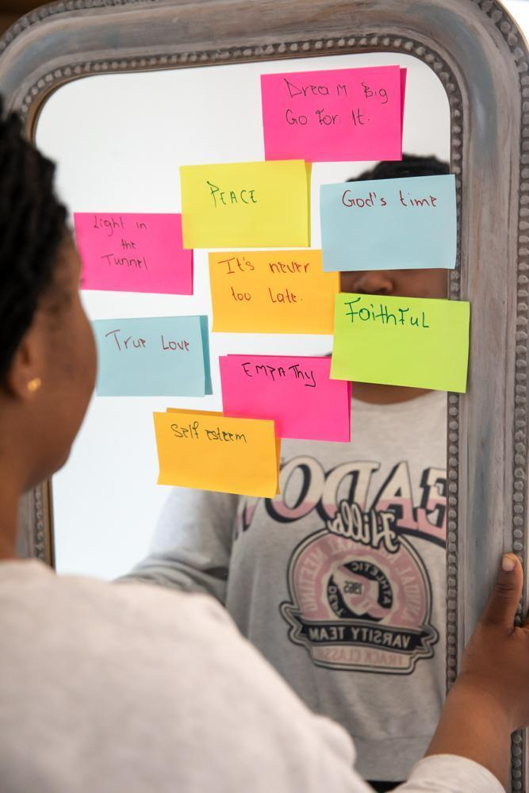
Orchards Admin Intern
(6 - 9 months)
Job Pack
Who are we?
Orchards is a Christian charity with a vision to see women free from sexual exploitation and empowered for flourishing, independent lives. We build trusting relationships with each woman and enable her to access support for lasting recovery through our main areas of work:

- transitional safe housing
- specialist trauma counselling
- tailored life and work skills mentoring
- the offer of local church life for community, care, and exploring faith for herself if she chooses.

We have a Genuine Occupational Requirement that our staff members hold a Christian faith (see below for further details). You should be comfortable bringing faith conversations and prayer into your work as appropriate, as well as participating in times of prayer with the wider Orchards team. We request that all staff commit to and uphold our ethos.

Orchards is run by women for women and is therefore this role is restricted to female applicants under the Equality Act 2010, Schedule 9, Part 1.
Purpose of the role
Orchards is looking for a reliable and organised volunteer administrator to support our vision to see more women free from sexual exploitation. This role offers hands-on experience in the VAWG sector and the chance to contribute to the smooth running of our supported accommodation services.
Key responsibilities include:
- Coordinating our inbox and managing communications sensitively and professionally.
- Supporting the operation of our four properties, including maintenance scheduling and administrative coordination.
- Supporting the set up of a new property.
- Maintaining accurate records and using systems like Salesforce with attention to detail and confidentiality.
This remote role offers flexible working, with occasional travel for meetings and property appointments, and the opportunity to develop practical skills in administration, data management, and service coordination within the VAWG sector.

Main responsibilities: | Administration  - Monitor the charity inbox and respond to enquiries in a timely, professional, and sensitive manner.  - Signpost referrals to the appropriate team members, supporting smooth service delivery.  - Raise invoices, manage incoming and outgoing post, and assist with general administrative tasks.  - Provide administrative support to the Orchards team as required  - Work closely with the Head of Operations to gain insight into day-to-day management of the charity.  Maintenance  - Schedule and coordinate repair and maintenance work across our four properties.  - Contact and liaise with contractors, learning practical coordination and negotiation skills.  - Manage bills, utilities, and service charges, gaining experience in property and financial administration.  Record Keeping  - Maintain accurate and up-to-date maintenance records for all properties.  - Support the charity in staying compliant with regulatory and internal standards.  - Develop skills in managing sensitive and confidential information systematically and securely.
Person specification: | To flourish in this role, we need you to have the following experience, skills and attributes:  - IT and systems literate:  comfortable using systems such as Salesforce, email, Google Suite and basic office software.  - Good communication skills: able to convey information politely and accurately, both in writing and verbally.  - Good timekeeping organised and systematic: able to manage their schedule, meet deadlines, keep tasks and records in order and manage multiple responsibilities.  - Willing to learn: eager to gain experience, develop new skills, problem-solve, take initiative and learn from colleagues.  - Confidential, reliable and respectful: understands the sensitive nature of our work, shows integrity, empathy, and treats all information with care. | It would be good, but not essential if you also have:  - Experience working in the charity sector  - Understanding of the issues surrounding survivors of sexual exploitation or Violence Against Women
Employment terms: | - Hours: 15 hours per week (3 days). These can be taken flexibly across the week, between 9-5 pm on weekdays, but would ideally include Tuesdays when our team meetings take place. We can also offer more volunteer hours if you would like.  - Location: Remote, with some travel for meetings. (Travel will be reimbursed)  - Salary: This is a voluntary unpaid intern position.  - Holiday entitlement: While there is no formal holiday entitlement, volunteers are welcome to arrange time off. We ask that this is communicated in advance, in discussion with their line manager, so that the service can continue to operate smoothly. The office is closed between Christmas and New Year.  - Commitment Required: Minimum 6 months  - Term-time only: We would be willing for this to be a term time only role.  Benefits:  - Being part of a supportive and prayerful team  - Regular line management  - Letters of reference at the end of the placement  - Annual individual retreat day  - Annual all-staff retreat  - Strong focus on learning and development for all staff and volunteers  - Access to external supervision  - Paid travel expenses  Please note: a basic DBS check will be required for this position.

Genuine Occupational Requirement
We believe that the Christian dimension of Orchards’ work requires our staff to be living out their own Christian faith. As a Christian charity we are committed to seeking God’s heart and will for the charity and the women we support. We believe that sexual exploitation is an injustice and recognise that we are joining in with God’s mission to bring justice to all and freedom for those being exploited. Our Christian values determine how we treat others; with respect, acceptance, love and a non-judgemental attitude. As a charity, we are seeking to enable women who have been sexually exploited to find routes out and to thrive; we will work with women of any faith background to achieve this. We respect that each individual has a different faith journey or may not want to engage with faith issues at all. We allow space for women to explore their own spirituality if they choose to do so. We offer the women we support the opportunity to be prayed for if they choose to. All paid staff and client-facing volunteers may be asked to provide prayer at the request of the women, either with the client in person or without the client being present.

Prayer is foundational to Orchards and has been since from the beginning. We ask that all staff and volunteers commit to praying regularly for the women we are supporting and are open to and willing to be part of a culture of prayer for each other and the charity. Staff represent a range of denominations and church backgrounds and we expect them to attend a regular team prayer meeting.

Partnering with local churches is essential to our delivery model; we require all staff members to be able to work very closely with the local church.

How to apply

We would love to hear from you if you are interested in applying for this role. Please email your CV and cover letter to: info@orchardsuk.org
- Your cover letter should include:
- An overview of your relevant experience and skills
- Why you are interested in working for Orchards specifically
- Reference to your Christian faith and how you might live out the Orchards ethos in practice
- Orchards will aim to meet candidates’ access requirements throughout the recruitment process. If this is applicable, then please notify us at info@orchardsuk.org.

The deadline for applications is Monday the 5th of January at 12pm.

- Interviews will take place the week beginning January 12th 2026 with a view to the successful applicant starting with us as soon as possible.
- Please note that applications will be assessed on a rolling basis, and interviews may take place before the advertised closing date. To avoid disappointment, we encourage you to send your CV and covering letter promptly.
- If you would like to discuss this role and opportunity before you apply, please contact info@orchards.org and we will do our best to arrange a phone call.

