Role Profile
Post Title: | Online Community Manager

Post Number in PeopleHub if known:
Department: | Marketing & Communications
Job Band / Job Family: | F/Business support

Effective Date:

1. Purpose
Strategic and day-to-day management of our busy and sector-leading Online Bereavement Community to ensure it grows and develops in line with organisational priorities. Our community provides a safe but vibrant place for those who have been bereaved or who are caring for somebody at the end of their life to share their story, find support and support others.

The role includes developing new online services within the online community platform that relate to the organisation’s aim of supporting people at their most difficult times.

2. Key relationships
- The role reports to the Head of Digital
- The role is part of the Marketing & Communications team but involves liaison with the Grief and Bereavement team, and as a part of any required safeguarding processes

3. Qualifications required
No formal qualifications, requirements specified in section 4

4. Proven knowledge, skills and ability
- Demonstrable experience of day-to-day online community/forum management, including moderation, to support service users
- A good understanding of UX and how the user journey contributes to an optimum experience for community members
- Experience in tracking, monitoring and reporting on platform usage to identify areas for improvement and optimisation
- A can-do approach with a passion for community management
- Working with multidisciplinary project teams and external agencies
- Excellent written communication skills and the ability to show empathy to people who are bereaved
- Excellent interpersonal and relationship-building skills
- Ability to use insights and analytics tools, such as GA4 and Hotjar
- Understanding of email newsletter best practices to maximise engagement
- Confident and experienced in working out-of-hours/on-call moderation
- Experience in managing an external moderation agency
- A strong understanding of service user audiences and their behaviours online
- Knowledge of safeguarding principles and moderation best practices.

Desirable Requirements
- Experience using Discourse to manage online communities and an email marketing system to manage email communications (knowledge of DotDigital would be advantageous)
- Experience in managing budgets
- Experience of working in the not-for-profit, bereavement or health sectors
- Wider understanding of digital marketing activity, including PPC/social media

5. Complexity and accountability
- All expenditure must be signed off by the Head of Digital. The role is empowered to liaise directly with all relevant staff, volunteers, service users and supporters across Sue Ryder.

6. Key responsibilities
- Day-to-day management of the community, including: ensuring new members are welcomed; signposting to other relevant posts or threads on the community, as well as resources on sueryder.org and external sites; making sure posts are in the relevant categories, moving and setting up new categories as necessary; removing spam and inappropriate/reported posts; responding to messages and queries from members.
- With the support of the Head of Digital, manage the relationship and performance of an external moderation agency that covers out-of-hours moderation during evenings/weekends
- To ensure safeguarding processes and measures are up to date and adhered to by Sue Ryder staff, volunteers and the out-of-hours moderation agency.
- Managing and supporting the community volunteers (currently a team of 8), including recruiting new ones as needed, ensuring they have the relevant emotional support and ongoing training.
- To act as an ambassador for the community within Sue Ryder and to external audiences (such as presenting at industry events, conferences etc), including participating in networks of other third sector online community managers.
- Identify opportunities and work with the grief and bereavement, and digital and marketing teams to develop and grow the community, reaching new and more diverse audiences.
- Work closely with the digital team to identify, prioritise and deliver bug fixes and technical updates and user experience improvements via our digital agency.
- To promote the community to internal stakeholders and how they can best engage with it.
- Set Online Community KPIs, goals and strategy, within team and organisational strategies and manage regular reporting and insights to inform future development and optimisation work.
- Work with the Marcomms team to ensure that quotes and case studies needed for marketing/PR activities are sourced, with appropriate consents obtained.
- Work with the digital team to contribute to the marketing strategy for the community.
- You will be part of the on-call team, ensuring we have community moderation support across evenings, weekends, and public holidays to assist the external agency with relevant queries.
- To be an ambassador for Sue Ryder by understanding how your role contributes to our ‘One Organisation’ vision and to demonstrate our values in all aspects of the role.
- To undertake other duties that may be necessary, that are in keeping with the nature of this role.

7. Behaviours
Operate within the Sue Ryder values and behaviours standards:
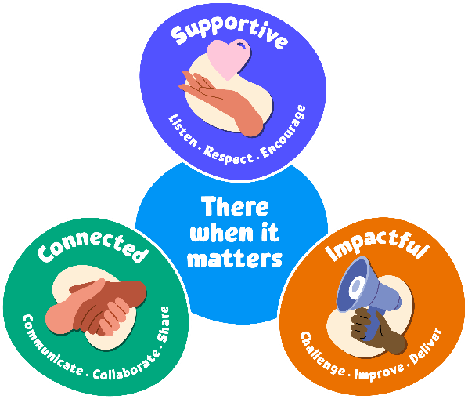
Supportive:
Our first value is supportive. We're here for people when it matters, and that includes each other. We encourage, inspire and help one another, and celebrate success.

The behaviours for this value are listen, respect and encourage.
We will take time to listen and understand; respect and value each other’s differences; and encourage and nurture each other.

Connected:
Our second value is connected. When we work together, we can achieve so much more for the people we support. We respect that everyone at Sue Ryder plays a vital part in delivering quality care.

The behaviours for this value are communicate, collaborate and share.
We will communicate effectively; actively collaborate and appreciate each other’s contribution; and share ideas, experience and knowledge.

Impactful:
Our third value is impactful. We find new and inspiring ways to positively impact the people we support – from small gestures to big breakthroughs. This proactive attitude drives us forward to achieve our ambitions and transform lives.

The behaviours for this value are challenge, improve and deliver.
We will welcome feedback and constructively challenge each other; reflect, learn and continue to improve; and each play our part to deliver the charity’s aims.

8. General
In addition to the specific duties and responsibilities outlined in this job profile, all Sue Ryder colleagues should understand the impact that their role has on achieving our organisational aims. Our values tell us how to do this, as they guide us in our choices and influence our behaviour. We ask all our staff and volunteers to follow our values while being an ambassador for Sue Ryder.
In practice, this means:
- Being able to talk confidently about Sue Ryder, our services and campaigns
- Being able to talk confidently about why we need to fundraise, how we are funded and how people can get involved
- Promoting an equitable, diverse and inclusive environment within the charity
- Keeping up to date with our internal communications; and following the correct organisation processes and using the right systems
- Always connecting with experts from across the organisation to ensure best practice and maximum impact.
Colleagues should also be aware of their specific responsibilities towards the following:
- To adhere to all health and safety and fire regulations and to co-operate with the charity in maintaining good standards of health and safety.
- To uphold ethical and professional standards and not behave in a manner that is likely to bring the charity into disrepute.
- Demonstrate a commitment to on-going registration requirements or any national professional or occupational standards associated with the role.
- Demonstrate a commitment to on-going learning and development and to participate in any training relevant to the role.
All employees are expected to be competent with the use of technology and information systems and understand their duties and responsibilities with regard to the appropriate use of data, including sensitive personal data.
This job description is not exhaustive. It merely acts as a guide and may be amended to meet the changing requirements of the charity at any time after discussion with the post holder.

