Are you passionate about improving community health and wellbeing and helping people to adopt healthier lifestyles? Do you want to make a real difference across the local community?

Northampton Town FC Community Trust is an award-winning and pioneering charity that uses the unique appeal of Northampton Town Football Club to deliver activities that connect our communities and improve people’s lives.

An exciting opportunity has arisen for a passionate, enthusiastic and driven individual to join our team in the following position:

- Health and Wellbeing Officer

You will be responsible for leading, planning and delivering health and wellbeing initiatives across the community. In doing so, you will help engage diverse groups and support individuals in leading healthier lives through impactful programmes.

You will take the lead in working with strategic partners to expand the reach and impact of our health and wellbeing programmes across the community through the set up and delivery of health hub sites. This is a fantastic opportunity to be instrumental in developing our portfolio of programmes and to widen our reach across the local community.

Why work with us?

We know that people are the key to us achieving our mission – and that’s why we look after our dedicated team. We believe that everyone on our team should grow as the organisation grows – and we do that by encouraging constant learning and development. We know that if we invest in our team, our team go the extra mile.

Benefits
· Access to bespoke CPD and training from our partners including the Premier League, EFL, Northampton Town FC & the FA.
· Ongoing support and development via monthly one to ones and an annual training plan to support your personal and professional growth.
· Free tickets to NTFC matches & club shop discounts
· Flexible working patterns and remote working available
· Free NTFC Community Trust kit package worth £150
· Access to Employee Assistance Programme (EAP) with wellbeing perks and 24/7 access to counselling services
· Work Laptop and Phone Provided

Our Values
Our values are at the heart of everything we do – they articulate who we are and how we work together to achieve our aims to help people. We want our staff embody these.
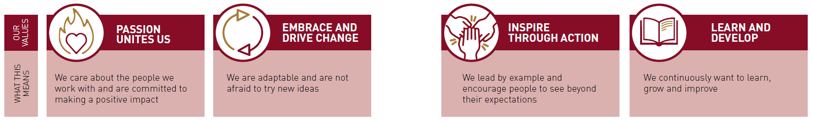
Application Process

How to Apply
All applicants must complete a job application form which is to be submitted via the NTFC CT online recruitment portal:

INSERT LINK HERE

Closing date for applications: | 9.00am, Wednesday 3 June 2026
Interview date: | W/C 8 June 2026
For more information about the vacancy please email community@ntfc.co.uk

Please be aware any offer of work is subject to a fully completed enhanced DBS disclosure and satisfactory references and any offer of employment may be withdrawn should you not meet safeguarding requirements.
We will adhere to our privacy notice in the process of reviewing all applications, a copy of this document can be found here: NTFC Privacy Notice for Applicants

Safeguarding Statement
Northampton Town FC Community Trust is committed to safeguarding the welfare of children and adults at risk and require all employees to share this commitment and promote the welfare of these groups.

Applicants will be asked about any previous convictions, cautions, reprimands, including those that are considered ‘spent’ as defined by the Rehabilitation Offenders Act 1974 (Exceptions) Order 1975 (Amended 2013). Appointment to this role is subject to a satisfactory DBS Check and references.

Equality Statement
Northampton Town FC Community Trust is committed to creating an inclusive and diverse environment and is proud to be an equal opportunity employer. We want to be an organisation that's representative of the communities we serve, which is why we strive for diversity of age, gender identity, sexual orientation, physical or mental ability, ethnicity, and perspective. Qualified applicants will receive consideration for employment without regard to race, ethnicity, religion or belief(s), gender, gender identity or expression, sexual orientation, marital status, disability, age or with regards to pregnancy or maternity.

