Role Profile
Post Title: | Senior Public Relations Officer - National
Post Number in PeopleHub if known: | Reward Specialist will add for new roles/manager or recruitment if existing role
Department: | Marketing and Communications (marcomms)
Job Band / Job Family: | The current band if known / Business Support

Effective Date:

1. Purpose
To support the delivery of organisational objectives, stories and campaigns that achieve media coverage nationally and in regional media that fall outside of our hospice catchment areas.
Lead the PR support for areas including retail, volunteering, bereavement, influencing and fundraising.
Responsible for ensuring enquiries from the media are efficiently actioned and proactively spot media opportunities and secure coverage based on the news agenda (including when on-call).
Write media assets for fundraising, retail, volunteering, healthcare, bereavement and influencing/campaigning stories, as well as pitching Sue Ryder stories to the media and liaising with journalists.

2. Key relationships
- This role reports into the senior PR manager in the national team and while it does not have line management responsibilities, you will support and supervise the PR officer on some projects and be able to explain and demonstrate best practice
- You will work closely with the team’s PR agency on both press office activity and campaigns
- You’ll get exposure to all the teams that the press office supports, including healthcare, bereavement, fundraising and influencing
- Your role leads on PR support for retail and volunteering
- Responsible for working alongside volunteers within your team if applicable

3. Qualifications required
No specific formal qualifications, requirements specified in section 4

4. Proven experience, skills and ability
- Have good attention to detail
- Be excited to learn about Sue Ryder and how we engage with the media
- Be curious about the care and support we offer
- Have a good understanding of the media and how it works
- Have previous experience of media monitoring and evaluation platforms
- Be able to write stories for the media in different formats (press release, comments, op-eds) to a good standard
- Be able to communicate clearly (written and verbal) with colleagues, journalists and other members of the media
- Have a basic understanding of crisis and reputation management PR

5. Complexity and accountability
- In this role you will be required to lead on some PR activities/projects with minimal supervision and support the PR officer with their projects, as required
- There is no budget responsibility with this role

6. Key responsibilities
Team Admin
- General admin duties
- Contributing to our monthly media highlights deck
Press office
- Ensuring journalists receive effective and efficient support when contacting the press office
- Contributing story ideas, with the team’s PR agency, to plan our editorial calendar, which ensures we have a consistent stream of creative media stories
- Writing press releases, quotes, op-eds and other media assets to a standard that requires minimal edits
- Preparing media briefings for spokespeople and storytellers (people with lived experience of end-of-life care and grief) ahead of media interviews
- Supporting storytellers when working with the media and interviewing new storytellers as required
- Lead on PR support for retail and volunteering
- Lead on PR support in some marcomms working groups as required. These will be covering briefs submitted to the department from teams such as fundraising, influencing, bereavement and healthcare
- Support the PR officer on achieving press coverage for our new product range
- Newsjacking – spotting and securing opportunities to add Sue Ryder’s voice to media stories (including when on-call as required)
- You will be part of the on-call team to ensure we have coverage for the media at evenings, weekends and public holidays
Campaigns
- Support the Senior media manger with our national campaigns, which are delivered in partnership with our PR agency
- Either writing or supporting the team/agency with press releases and setting up photo/film shoots and media interviews
- Support with the media evaluation of campaigns (see next section)
- Liaising with our stories team to include people with lived experience of end-of-life care and bereavement in our campaigns, and supporting these storytellers when working with the media
- Preparing media briefings for spokespeople ahead of media interviews
Media Monitoring and Evaluation
- You will receive training to be able to monitor and run media coverage reports via our supplier’s online platform (Vuelio)
- You will use Vuelio to build media and journalist lists for press releases and campaigns
- Support the team, as required, to monitor and share press coverage
Reputation Management
- You will support the senior PR manager and head of PR, as required, when they are working on reputation management issues
Occasional travel within England is required for this role. From time-to-time, you will be required to work outside of traditional office hours.

7. Behaviours
Operate within the Sue Ryder values and behaviours standards:
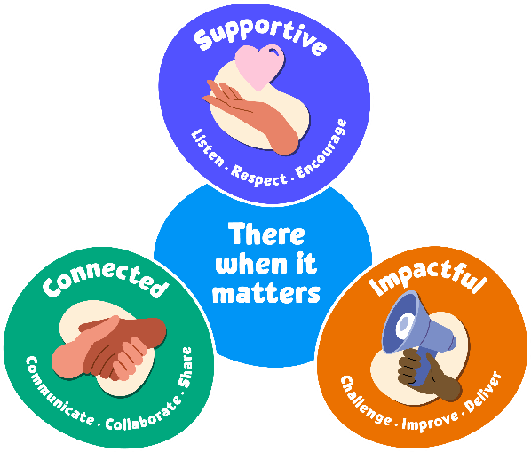
Supportive:
Our first value is supportive. We're here for people when it matters, and that includes each other. We encourage, inspire and help one another, and celebrate success.

The behaviours for this value are listen, respect and encourage.
We will take time to listen and understand; respect and value each other’s differences; and encourage and nurture each other.

Connected:
Our second value is connected. When we work together, we can achieve so much more for the people we support. We respect that everyone at Sue Ryder plays a vital part in delivering quality care.

The behaviours for this value are communicate, collaborate and share.
We will communicate effectively; actively collaborate and appreciate each other’s contribution; and share ideas, experience and knowledge.

Impactful:
Our third value is impactful. We find new and inspiring ways to positively impact the people we support – from small gestures to big breakthroughs. This proactive attitude drives us forward to achieve our ambitions and transform lives.

The behaviours for this value are challenge, improve and deliver.
We will welcome feedback and constructively challenge each other; reflect, learn and continue to improve; and each play our part to deliver the charity’s aims.
8. General
In addition to the specific duties and responsibilities outlined in this job profile, all Sue Ryder colleagues should understand the impact that their role has on achieving our organisational aims. Our values tell us how to do this, as they guide us in our choices and influence our behaviour. We ask all our staff and volunteers to follow our values while being an ambassador for Sue Ryder.
In practice, this means:
- Being able to talk confidently about Sue Ryder, our services and campaigns
- Being able to talk confidently about why we need to fundraise, how we are funded and how people can get involved
- Promoting an equitable, diverse and inclusive environment within the charity
- Keeping up to date with our internal communications; and following the correct organisation processes and using the right systems
- Always connecting with experts from across the organisation to ensure best practice and maximum impact.
Colleagues should also be aware of their specific responsibilities towards the following:
- To adhere to all health and safety and fire regulations and to co-operate with the charity in maintaining good standards of health and safety.
- To uphold ethical and professional standards and not behave in a manner that is likely to bring the charity into disrepute.
- Demonstrate a commitment to on-going registration requirements or any national professional or occupational standards associated with the role.
- Demonstrate a commitment to on-going learning and development and to participate in any training relevant to the role.
All employees are expected to be competent with the use of technology and information systems and understand their duties and responsibilities with regard to the appropriate use of data, including sensitive personal data.
This job description is not exhaustive. It merely acts as a guide and may be amended to meet the changing requirements of the charity at any time after discussion with the post holder.

