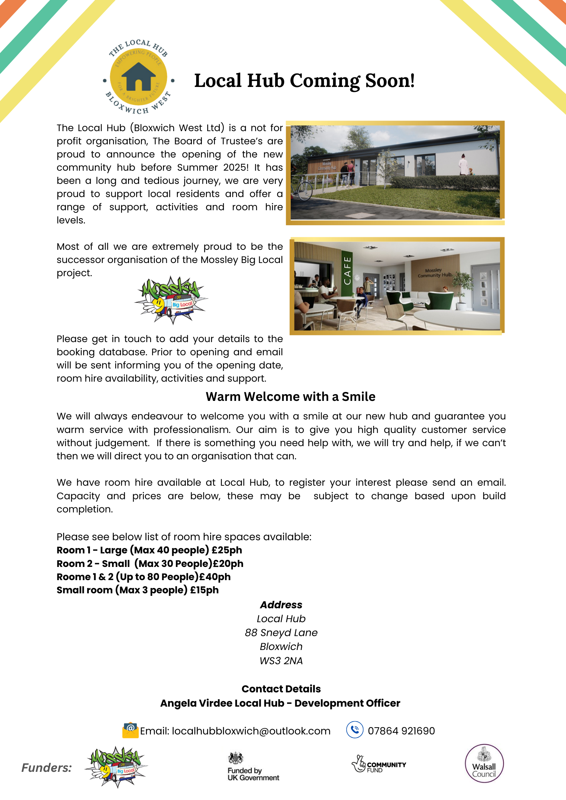

The Local Hub (Bloxwich West Ltd)
Job Application Form
Instructions to Candidates

Electronic or handwritten application forms are accepted. Handwritten forms should be completed in black ball point pen. Please complete all sections as incomplete applications may not be considered. Please attach any additional information to the main application.

Please return all parts (A, B and C) of your completed application form by email to localhubbloxwich@outlook.com , or by post to:
The Local Hub (Bloxwich West Ltd) 88 Sneyd Lane, Bloxwich WS3 2NA
If returning by post, please return the completed Self Disclosure form and Equalities Monitoring form (Part C) in a separate sealed envelope marked ‘Confidential’.

If you have any questions about this application form or the role you are applying for, please contact the named person in the Job Advert/Role Profile.

All applicants are advised to fully read the job description and person specification for the post before completing the application form.

Unless otherwise stated, applications must be received 5pm on the closing date specified in the Job Advert/Role Profile.

The Local Hub (Bloxwich West Ltd) is an equal opportunities employer and treats all applicants with fairness and transparency.

The application is separated into three parts. Parts A and C (the personal details page, Self Disclosure form and Equalities Monitoring form) will be separated from the rest of your application before Part B is submitted to the panel.

Your application will then be assessed against the responses you provide in Part B, so please ensure that you consider the Job Role Profile, Advert and Person Specification, to explain how you meet the criteria for the role.

The selection and interview process is as follows:
- We aim to inform candidates successfully shortlisted for interview within 10 days of the closing date for the vacancy. If shortlisted, you will be informed of interview time and date by email/telephone. If you have not been contacted within 15 days of the closing date, please assume you have not been shortlisted.
- All details in application forms are scored against the job description and person specification.
- Interview questions are drawn up before the interview and all interviewees will be asked the same questions

General Data Protection Regulations (GDPR) – Recruitment & Selection
Privacy Notice for recruitment
Please read this document in conjunction with our full privacy policy. This document details the specific requirements regarding data protection.
Your data
Your privacy is important to us. We are committed to safeguarding personal information and being transparent about what information we hold about individuals and what we do with it. GDPR refers to this as ‘processing’. This document sets out how we collect, store, and handle personal data.

Why we collect your data
Following a recruitment exercise information, in both paper and electronic form, will be held by The Local Hub (Bloxwich West Ltd). We will use your application data and contact details solely for the purposes of recruitment, communication regarding recruitment, consideration of your application and monitoring recruitment processes. We retain personal information following recruitment exercises to demonstrate, if required, that candidates have not been discriminated against on prohibited grounds and that recruitment exercises are conducted in a fair and transparent way. Your personal data will be used to process your employment application and, if your application is successful, to administer your personnel record. This will be limited to that information necessary for the working relationship and, where applicable, that required by law. Personnel record information of former employees is held as detailed in the Local Hub Data Protection Policy (for example, for future reference requests).

Personal Data We Collect
We collect the following personal data relating to your employment application: Contact Details (Name, Address, Email Address, Telephone &/or Mobile Number), Employment history, Qualifications. Also, Equality of Opportunity (Ethnicity, Disability Details) and commission of criminal offences and/or involvement in criminal proceedings under Special Category data.
By submitting your application, you are agreeing to the privacy statement and are agreeing to your information being held and used for the purposes described above.
How long do we keep your information for?
Successful candidate’s data will be held under the Local Hub Data Protection Policy, details of which will be made available upon the offer of employment. Unsuccessful candidate’s data will be held for a period of 6 months post recruitment exercise where upon it will be confidentially destroyed.
When we'll share your data
The Local Hub will have access to any personal data provided in this application. Personal data collected through the application process may also be shared with our Human Resources (HR) partners. We will not disclose your data to any third party unless for recruitment purposes or required to do so by law or by regulators.
Rights
You may exercise certain rights regarding your personal data. This includes the right to access your data, rectify your data and withdraw consent. Under certain circumstances you have the right to erase, transfer, object to or restrict how we use your information. Please contact the Local Hub (Bloxwich West Ltd) office if you would like to find out more or if you wish to exercise any of these rights. If you’d like to find out more about how we process your data or how to exercise your rights as a data subject, please visit www.onewalsall.org or contact us at the office on 01922 619840. For more information about your rights go to the website of the Information Commissioner’s Office at www.ico.org.uk
Legal basis for processing
The legal basis for us processing your data is:
- Consent – Article 6 (1) (a) Some processing requires your consent. We will obtain your consent before carrying out the processing.
- Contract – Article 6 (1) (b) For example, a contract of employment. If there is a contract in place, we will process your data based on the specifications of the contract.
- Contract – Article 6 (1) (f) Some processing of a successful candidates’ data is based on legitimate interests - processing employee data, where this is the case a legitimate interest’s assessment will have taken place.

Part A
Personal Details
Position Applied for

Title
Mr Mrs Ms Miss Other, please state:
First Name(s)
Surname
Address
Postcode
Telephone number
Mobile number
Email Address

Driving
Do you hold a current UK Drivers Licence? | Yes | No
Do you have access to your own vehicle? | Yes | No
References
We send a copy of the job description and person specification so that comment can be made on your suitability to the post you have applied for. Please provide the name and contact details for two people who can provide a reference. One of the referees must be your present or most recent employer. Your referees will only be contacted if you are offered the post.

Referee 1 (Current or most recent employer)
Title | Mr | Mrs | Ms | Miss
First Name(s)
Surname
Address
Postcode
Telephone number
Email Address
Please indicate in what capacity this person is known to you:

Referee 2
Title | Mr | Mrs | Ms | Miss
First Name(s)
Surname
Address
Postcode
Telephone number
Email Address
Please indicate in what capacity this person is known to you:
Specific Arrangements
Please let us know if you need any specific arrangements for interview, we will contact you separately to make arrangements.

I do/do not have any specific arrangements for interview (please delete as appropriate)

Declaration and Consent
I confirm all the information given in this application form is, to the best of my knowledge, true and complete.

I have read and consent to my personal data, as detailed on page 2, being held and utilised by The Local Hub (Bloxwich West Ltd) for the purposes stated.

Signature (electronic copies print name) | Date:

Applicants submitting electronic application forms will be requested to sign a copy of the declaration should they be invited to interview.

To help us evaluate our recruitment practices we would be grateful if you could tell us where you heard about this job opportunity (tick all that apply):
CharityJobs website | WMJobs website
Our email bulletin | A friend or colleague
Social media (e.g. Twitter) | Other (please specify)

Part B
Education and Training
Education
Please list the education and training attended and qualifications attained, starting with the latest fist. Please continue on a separate sheet if necessary.

School / college / university name and address | Dates attended | Qualification(s) achieved | Grade

Training
Please provide details of any other training you have attended in the last two years which may be relevant to the role you are applying for. This should include any informal or in-house training provided in previous employment or volunteering roles.

Past and Current Employment
Current / Last Employer
Please provide details of your current or most recent employer.

Name & address of employer | Position held
Start date | Salary and main benefits
Notice required or leaving date | Reason for leaving
Summary of key duties

Previous Employment
Please list your employment history, starting with the most recent first. Please include all roles including part-time work and explain any gaps in your employment (e.g. return to full-time education or career break). Please continue on a separate sheet if required.

Name/Address of Employer | Start and End Date | Position Held / Summary of Duties | Reason for Leaving

Previous or current Voluntary or Unpaid Work
Please list your experience of voluntary or unpaid work, starting with the most recent first. This may be for an organisation or an individual, providing care, for example. Please continue on a separate sheet if required.

Name of Organisation | Type of work delivered | Start and end dates

Sickness Absence
In the last two years, how many days sickness leave have you taken?

Personal Statement
Please provide information about why you feel you are suitable for the role you are applying for and what you will bring to the organisation. Taking into consideration the Job Role Profile, Advert and any additional information such as a Person Specification, explain how you meet the Essential Criteria for the role. Please limit this to approximately 750 words or one side of A4. The box will expand as you type. Handwritten applications should provide a personal statement on a separate sheet.

Part C
Self Disclosure Form
Position Applied for
Name
Date of Birth

Do you have any convictions, cautions, reprimands or final warnings that are not “protected” as defined by the Rehabilitation of Offenders Act 1974 (Exceptions) Order 1975 (as amended in 2013) ? (http://www.legislation.gov.uk/uksi/2013/1198/pdfs/uksi_20131198_en.pdf)

Yes - If yes, please specify on a separate sheet

No
The amendments to the Exceptions Order 1975 (2013) provide that certain spent convictions and cautions are ‘protected’ and are not subject to disclosure to employers and cannot be taken into account.
All guidance and criteria on the filtering of these cautions and convictions can be found in the DBS filtering collection.(https://www.gov.uk/government/collections/dbs-filtering-guidance)

Please note – the role you apply for may be subject to a DBS  check at the appropriate level.  Do you consent to a DBS check? | Yes | No

The Local Hub (Bloxwich West Ltd) has written policies on the secure handling of information provided by DBS and recruitment of ex-offenders and these are made available to individuals at the point of requesting them to complete a DBS application.
The Self Disclosure Form will be viewed after shortlisting has taken place.
Self Disclosure Declaration and Consent
By signing below, I confirm that the information I have provided on this form (and attached, if applicable) is accurate, true and complete. I understand that this information will not necessarily prevent me from being engaged in the role above, and that I will be given an opportunity to discuss any concerns you might have before you make a final decision on my suitability for the role.

I have read and consent to my personal data, as detailed on page 2, being held and utilised by The Local Hub (Bloxwich West Ltd) for the purposes stated.

Signature (electronic copies print name) | Date:

Equal Opportunities Monitoring
The Local Hub (Bloxwich West Ltd) operates an equal opportunities policy. To help ensure that the policy is put into practice, and for no other reason, would you please complete this form and return it with your application form. Parts A and C will be separated from the rest of your application before submission to the recruitment panel. The details will be treated as strictly confidential.
You may leave the section blank if you do not wish to disclose any information in this section.
Position Applied for
Name
Date of Birth
Gender
Is your gender identity the same as the gender you were assigned at birth?
Yes | No |  | Prefer not to say / unknown
Ethnicity
Please tick a box below that best describes your ethnic origin.
- White
British |  | Irish |  | Any other white background
- Mixed
White/Black Caribbean |  | White/Black African |  | White/Asian
Any other White background
- Asian/Asian British
Indian |  | Bangladeshi |  | Pakistani
Any other Asian background
- Black/Black British
Caribbean |  | African |  | Any other Black background
- Other Ethnic Group
Any other Ethnic background

Disability
The Local Hub (Bloxwich West Ltd) is a Disability Confident Employer, as such, if you are disabled you may be offered an interview if your meet all the essential criteria in the person specification. If you are disabled and you wish to be considered for an interview under the Disability Confident Scheme, please indicate this in the section below, and that you give consent for this information to be passed to the recruiting panel, so that they are aware you are applying under this scheme.

The Equality Act 2010 defines a disabled person as one who has physical or mental impairment which has substantial and long-term adverse effect on your abilities to carry out normal day to day activities.
Do you consider yourself to have a disability? Yes No Prefer not to say.

Please give details of your disability

Consent
I agree to information provided on this form being used by The Local Hub (Bloxwich West Ltd)in accordance with GDPR, for the purpose of diversity monitoring Consent

