
Information for applicants for the post of: Training and Event Officer

Training and Event Officer
Training Team
Thank you for your interest in the above role. This pack tells you more about Kinship, how we work, and details of the role and the people you will be working with. It also gives information on how to apply.

Role details:
Job title: Training and Event Officer
Responsible to: Training Delivery Manager
Duration: Fixed term until 31 March 2027
Location: Home-based or hybrid (based in Kinship’s Vauxhall Office, London) (with travel and work across England)
Working Hours: 28 hours a week (0.8 FTE)
Salary: £26,500 per annum pro rata plus £3,405.85 London weighting, if applicable
Leave allocation: 24 days annual leave (30 days FTE), plus bank holidays pro rata for part time hours (1 April t0 31 March).

About Kinship:
We are Kinship. The leading kinship care charity in England and Wales. We’re here for kinship carers – friends or family who step up to raise a child when their parents aren’t able to.

We are made by and for our community of kinship carers. Like family, relationships run deep. And we hear their experiences; for too long they have been isolated without the help they need.

We support, advise and inform kinship carers. Connecting them so they feel empowered. Because a child needs the love and warmth of a thriving family.

We develop research, campaigns and policy solutions. Creating positive change across society. Because for kinship families, love alone is not enough.

Through our work we harness frustrations to fuel passion for change. And tough experiences to inspire ideas that transform lives.

And as we see momentum building, we keep using evidence to demonstrate the value of kinship care. Helping kinship carers navigate challenging circumstances. Believing in a child’s potential.

Join us. Together, let’s commit to change for kinship families.
Purpose of the role:
You’ll be the main contact for the national training team providing support directly to kinship carers, training facilitators and others relating to the access and delivery of training events and workshops.
You’ll provide professional and effective administrative and technical support to training operations, including co-ordinating logistics, publishing event details, administrating the back-end data, supplier communication, financial administration and attending in person and online events to ensure smooth delivery.

Key responsibilities:

Training event coordination
- Provide administrative support, including supplier communication, coordinating logistics and delivery of all relevant general and financial administration tasks
- Be the first point of contact for the team, for both internal and external purposes
- Monitor email inboxes and respond to enquiries and complaints professionally and in line with internal process.
- Communicate effectively with all stakeholders to coordinate and confirm event logistics for in-person and online events.
- Identify and secure appropriate organisations to exhibit as part of Roadshow marketplace events, providing in-event hosting of these organisations.
- Source and secure venues and catering that meet event requirements for all in-person training events.
- Provide administrative, practical and technical support at training events both online and in-person.
- Act as central point for Zoom set-up, licenses and queries for team, kinship carers and external partners.
- Ensure all facilitators have the resources they need to hand in the right place at the right time.
- Ensure all event details are published to enable bookings to required deadlines and include accurate and up to date information.
- Think ahead and plan contingency to deal with issues, clearly communicating with all stakeholders at each stage.
Systems and processes coordination
- Monitor planned expenditure to ensure it is in line with event budgets.
- Ensure invoicing and payments are accurate and processed to time.
- Support the monitoring and reporting on training activity via our Salesforce database, including providing data reports as required.
- Support the production, update, distribution and quality assurance of workshop materials and ensure all collateral is on brand, signed off as required.
- Develop and maintain an asset register of all training materials and equipment, ensuring availability when and where it is needed.
- Ensure accurate and up-to-date information is available through all channels including on Kinship’s website, Notion and other online platforms
- Act as website champion for the team, managing and uploading all training content (workshop and events) and ensuring online training information is kept up to date.
- Provide support to the training team as required including to assist service improvements and supporting manualisation and documentation of all processes
- Set up and implement effective tools and documentation to support all operational needs of the training service.
Team culture
- Act in the best interest of Kinship and the families we support.
- Maintain and contribute up to date understanding of kinship care.
- Deliver effective administration with attention to detail and keeping to deadlines.
- Actively contribute to delivering and evidencing a high performing service.
- Take responsibility for your ongoing continued professional development.
- Work in line with the Kinship values.

Knowledge, abilities, skills and experience:

Essential:

Experience and knowledge
- Proven experience in event logistics planning and supplier communication
- Excellent customer service skills, responding to requests promptly and with due care and attention.
- Experience of delivering externally facing work of high quality and attention to detail
- Significant working experience of administrating Zoom to support event delivery
- Significant working experience of using Microsoft tools, Salesforce and other platforms and software (e.g. Notion, Asana, Wordpress) for data management, recording practice, developing promotional materials and reporting.
- Maintain accurate and up to date records ensuring all participants receive appropriate post event follow up to time
- Experience of supporting service development and improvement, working within a team to implement user-friendly processes and resources to promote best practice.
- Production of reports, managing data for evaluation purposes and customer service.
- Exceptional verbal and written communication skills, tailored to suit a range of audiences

Skills and Abilities
- Excellent organisational and time management skills
- Ability to work responsively with remote teams across multiple projects simultaneously to support impactful programme delivery.
- Ability to work collaboratively within a team environment, relating effectively to a range of people
- Ability to work flexibly, anticipating the needs across teams, to provide timely support on varied tasks prioritising effectively as required.
- Ability to apply equality, diversity and inclusion principles in all areas of work
- Ability to work resiliently in a fast-paced environment, responding to time pressures positively.
- Willingness to travel across England on occasion, as required (such as for events), working flexibly in response to the need.
Desirable:

- An understanding of social care systems and professional networks associated with social care or other related professional networks.
- Personal experience of kinship care or thorough understanding of the experience of kinship care.

Your main relationships will be with:
Internal:
- Training Delivery Manager
- Training and Quality Manager
- Training Team Leader
- Kinship Experienced Training Facilitators
- Training Facilitators
- Training and Event officers
- Associate Director of Advice, Training and Information
- Peer Support team
- Programmes Team
- Finance team
External:
- Kinship carers
- Training Facilitators
- Subject Matter Experts
- Suppliers inc. Venues & caterers
- Other relevant organisations
What it means to work at Kinship:
Our vision:
A society in which kinship carers and the children they care for are recognised, valued and supported.

Our mission:
To ensure that kinship carers and the children they care for get the support and recognition they need.

“Knowing what you do helps kinship families that really need support.
Staff at kinship are caring, passionate and positive. Colleagues are genuinely nice to work with and care about each other as well as the kinship families we support. We are always innovating to better support kinship carers.”
(Staff member at Kinship)

We want to offer you the best place to work. Our people are friendly and incredibly passionate about working alongside kinship carers.

We want you to feel proud to work here and if you join us, we'll do our best to make that happen.

Our Kinship values: 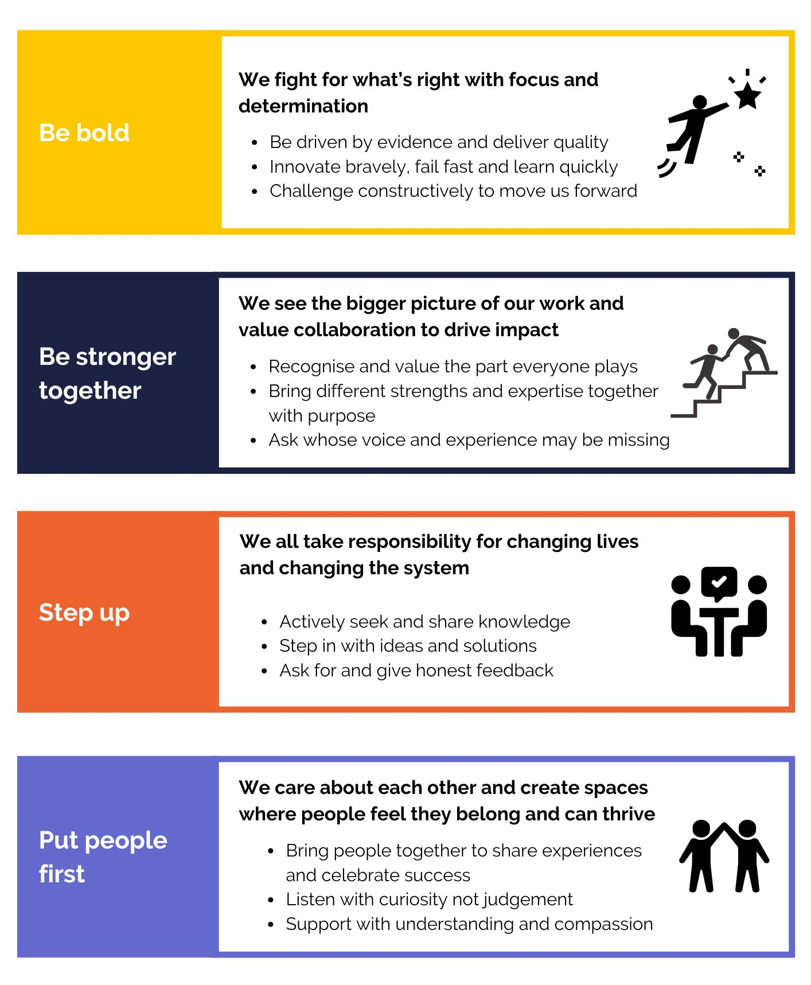

Equality, diversity and inclusion:
Kinship is committed to championing equality, diversity and inclusion. We believe our work is greatly enhanced by the varied backgrounds, experiences and views represented within our teams. We aim to create inclusive teams, celebrate differences and encourage everyone to join us and be their true self at work.

We therefore encourage applications from anyone who fits our values, whatever their religion or belief, sex, gender identity, race, age, sexuality or disability and are actively seeking candidates that can bring real innovation and commitment to us.

Candidate application information:
Please refer to the job description for this role to check that you meet the criteria in the “knowledge, skills and experience” section that are necessary for the job.

We will guarantee interviews to any candidates with experience of kinship care (either of being in kinship care or of being a kinship carer) who demonstrate that they meet the essential skills and experience outlined in the job description.

Please tell us if there are any reasonable adjustments we can make to assist you in your application.

If you have a disability that you would like us to take into account, please tell us about this when you apply. Please let us know if we can help and remember that you can request information in large print or in a different format.

How to apply:

Any applications arriving after the closing date will not be considered for shortlisting unless there are exceptional reasons.

Kinship reserves the right to close a recruitment campaign earlier than the advertised where we have received sufficient applications so please apply early!

Please apply for the role of Training and Event Officer by sending a CV and answering the questions on Charity Job, https://www.charityjob.co.uk/. Please use examples to demonstrate your experience.

Please include your notice period / earliest availability to start.

Some tips for your application:
- Make sure you’ve read the job description and the essential requirements – make sure your application reflects those points in the requirements very clearly.
- Tell us why you want to work for Kinship. We’re interested in working with people who share our values. You can read about our values above.
- Keep your response clear – use bullets points and short paragraphs if that helps. It will help the recruitment team to focus on your knowledge, skills and experience.
- Don’t go over 2 pages on your covering letter.
- Please do not use AI tools like ChatGPT to produce your answers. We use software to check, and your application will be rejected if you do.

Key dates:
Apply: Via CharityJob
Application deadline: 30 March 12PM
First interview: 7 April

Kinship reserves the right to close applications early on receipt of sufficient applications. Apply early!

If you would like further information or an informal chat about this role, please contact Shirley Jones (Associate director of advice, training and information) on shirley.jones@kinship.org.uk

Conditions of employment and what we offer:

Working hours:
The working week is currently 35 hours per week from Monday to Friday full time equivalent. At 0.8 FTE, the role shall cover Tuesday to Friday. These may be varied by agreement with your line manager. For some roles, there will be occasions when these hours are exceeded, for example some weekend working or a requirement to attend evening meetings. In such circumstances and in agreement with your line manager you may take reasonable time off in lieu. Overtime is not paid.

Holidays:
- 30 days annual leave, plus bank holidays (1 April t0 31 March) pro rata.
- We close for three days between Christmas and New Year, which will be deducted from your annual leave allowance.

Flexible working:
Kinship will consider applications for flexible working arrangements. Kinship will enable as many jobs to be open to job sharing as is operationally practicable.

Learning and development:
We are committed to developing and enhancing the learning experience during your time at Kinship, and we are proud to offer many learning opportunities.

Health and wellbeing:
- Employee Assistance Programme (24/7 confidential advice line and counselling).
- Charity Worker Discount

Travel:
For this role, there may be occasional travel within the UK. There may also be, on occasion, the need for overnight stay. Reasonable travel, subsistence and hotel expenses will be covered using the Charity’s expenses procedures.

Pension scheme:
All staff will automatically be enrolled into a Group Personal Pension Scheme as part of our requirement to meet automatic enrolment legislation. According to the statutory requirements. We use Nest Pensions. Current employee contributions are 5% and we will contribute 3%.

Probationary period:
All new employees will be required to undertake a period of probation for six months, in which time you will be expected to establish your suitability for the post.

Community:
- Employee resource groups (including Equality, Diversity and Inclusion Working Group and Wellbeing Committee).
- Staff away days.
- Regular social activities online and in person.

Our recruitment process:

As a charity we want to hire the best people to support our vision and mission. People who are values led, high performing and passionate about doing their best for kinship carers.

We will guarantee interviews to any candidates with experience of kinship care (either of being in kinship care or of being a kinship carer) who demonstrate that they meet the essential skills and experience outlined.

We welcome applications from people from all sections of the community, irrespective of race, colour, sex, gender identity, age, disability, sexual orientation, religion or belief.

Kinship is committed to attracting, developing and retaining a diverse workforce, with a broad range of backgrounds, experiences and perspectives, and we encourage applicants from those groups currently under-represented in our organisation and sector.

Standard clauses:

- This role will require satisfactory Disclosure and Barring Service (DBS) clearance.
- The post holder must at all times carry out their responsibilities with due regard to Kinship’s Equal Opportunities Policy and Safeguarding Policy.
- Salesforce is our customer relationship management system (CRM) and all staff are expected to take accountability and responsibility for using it successfully as part of their day-to-day role to support the growth and impact of Kinship and better services for kinship carers.
- The post holder must accept responsibility for ensuring that the policies and procedures relating to Health and Safety in the workplace are adhered to at all times.
- The post holder must respect the confidentiality of data stored electronically and by other means in line with the Data Protection Act.
- The post holder must carry out their responsibilities with due regard to the non-smoking environment of all Kinship offices.

Note:
This job description is not exhaustive. Kinship reserves the right to add to or revise the job description at any time - the post holder may be required to undertake any other duties that fall within the nature of the roles and responsibilities as detailed in this document.

Any substantial or major changes will be negotiated with the post holder.

