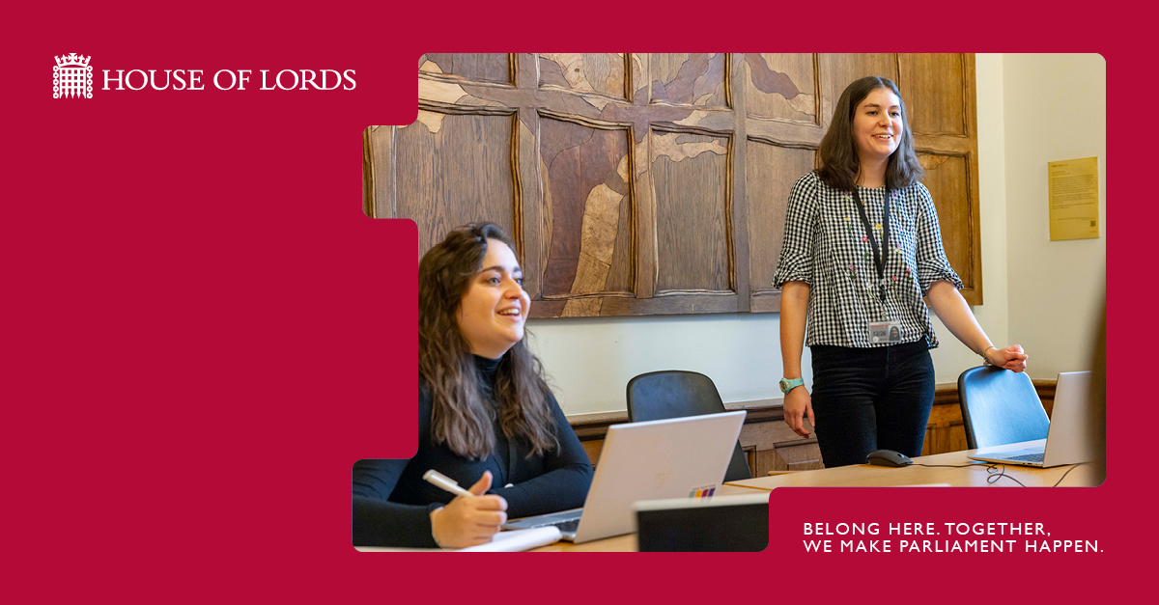
Inclusion & Diversity Manager

August 2026

BELONG HERE. TOGETHER, WE MAKE PARLIAMENT HAPPEN.

Salary: £46,500-53,700 (appointments are usually at the bottom of the pay band)

Contract: Permanent (House of Lords pay band HL7)

Location: Parliamentary Estate / hybrid working

Hours: Full-time (36 hours a week)

What you’ll do
As an Inclusion & Diversity (I&D) Manager in the House of Lords, you’ll play an important role in supporting the UK’s parliamentary democracy. Your work will help ensure Members and colleagues are able to carry out their responsibilities effectively, contributing to something bigger than any one role.
Your key objective will be to support the Head of I&D in the development and delivery of I&D priorities for House of Lords Administration and, with the House of Commons I&D team, for all of UK Parliament.
You will have specialist knowledge of I&D topics, including equality legislation and best practice, to advise colleagues and stakeholders on how best to realise the Administration’s value of inclusivity and engage with the I&D Strategy.
You will independently manage portions of the I&D Strategy, taking responsibility for delivering projects and initiatives from inception to insight gathering.
Your responsibilities will include:
- Taking responsibility for I&D’s strategic priorities, ensuring the effective roll out of activities to achieve set targets. You will manage the review and insight gathering processes of inclusion projects to ensure alignment with the I&D Strategy.
- Leading on projects and programmes and delivering against strategic objectives. This will require effective stakeholder engagement and tracking measurable outcomes.
- Building strong relationships with senior leaders, securing buy-in for the I&D team’s work.
- Providing specialist advice, particularly relating to the Equality Act 2010, and how they apply to the House of Lords.
- Responding to queries from internal and external stakeholders, including senior leaders, members, press queries and Freedom of Information requests.
- Overseeing UK Parliament’s Workplace Equality Networks to guide and support their strategic direction and alignment with the House of Lords objectives.
- Developing and supporting diversity data reports, reviewing and analysing demographic data to target I&D activities, including our annual pay gaps report.
- Working with the wider HR Office, including the other members of the I&D team and the Learning & Organisational Development team to support and co-ordinate I&D activities.
- Engaging in benchmarking exercises with external organizations to ensure the House of Lords meets a high standard of excellence in I&D. This will include delivering gap analyses and action plans based on benchmarking results.
- Delivering events and collaborating with partners to highlight traditionally under-represented groups and build the House of Lords’ reputation as an inclusive employer.
- Representing the House of Lords I&D team on internal stakeholder groups, deputising for the Head of I&D and/or providing cover as needed. For example, during annual leave.
- Contributing to the development, review and implementation of people policies and guidance.
- Presenting at I&D-related events, utilising expert knowledge and confidence in explaining I&D topics, and undertaking regular Continuous Professional Development.
- Contributing to internal and external communications that promote the I&D team’s work.
You may occasionally take on additional responsibilities in line with your role and grade.

What you’ll bring
We’re looking for someone who can bring their skills and experience to make a meaningful contribution here.
We require a qualification in a relevant discipline (most likely HR or I&D) or equivalent experience gained through relevant work experience. Please include any qualifications or other relevant experience in your CV.

Essential criteria:
The following criteria will be assessed at application and interview. We recommend that your application answers do not exceed 300 words.
- An interest in the House of Lords – Demonstrable interest in and commitment to the role of the House of Lords in parliamentary democracy.
- Experience with inclusion and diversity – Specialist knowledge and experience working in an inclusion and diversity role, including experience delivering measurable improvements through inclusion and diversity initiatives.
- Proficiency in strategic working – Experience contributing to and executing initiatives related to strategic objectives. The ability to assess the effectiveness of initiatives and adapt them to meet strategic aims.
- Competency in project management – Demonstrable ability to independently manage projects and programmes, including their design, delivery and review to quality, time and budget, alongside “business as usual” and reactive work.

Desirable criteria:
The following criteria will be assessed at interview.
- Stakeholder management skills – Proven ability to build effective working relationships with a wide range of stakeholders, including team members, senior leaders and colleagues from different backgrounds.
- Ability to problem solve – A high level of initiative and adaptability, including the ability to pick up work on short notice, offering resolutions and advice on inclusion and diversity-related issues.
- Ability to act with professionalism, tact and discretion – Demonstrable competence in managing sensitive issues tactfully and in alignment with the House of Lords Impartiality Guidance, representing the team with professionalism.

About this team
The I&D team is made up of three people and works closely with the Learning & Organisational Development (L&OD) team on projects and programmes. The team sits within Human Resources (HR) and collaborates with other functions to deliver impactful people outcomes aligned to the I&D Strategy and People Strategy.
You will report into the Head of I&D and will advise and guide more junior team members to support the team’s objectives and deliver work to a high standard.
Other key relationships will include:
- HR colleagues and the HR Senior Management team
- Line managers and colleagues throughout the House of Lords
- Members of the Lords Management Board
- Colleagues in other offices, such as the Parliamentary Health & Wellbeing service, and Communications team
- Chairs and members of the Workplace Equality Networks
- Other I&D professionals and colleagues across the parliamentary community, including the House of Commons I&D team
- Third party suppliers (e.g., managing external memberships and relationships to support our training and I&D programming)

About us
Every day, we support the UK’s parliamentary democracy. It’s work that matters — helping Members of the House of Lords examine legislation, hold government to account and contribute to national debate.
You’ll be based on the Parliamentary Estate, a unique UNESCO World Heritage site at the heart of Westminster. It’s a place shaped by history but powered by the people who work here today. From the Chamber and committee rooms to offices, kitchens and public spaces, it’s a working environment like no other — busy, varied and full of purpose.
You’ll be joining a community of colleagues from a wide range of backgrounds and professions. Researchers, specialists, project managers, digital experts, caterers, security teams and many more all play their part. Whatever your role, you’re part of something bigger — working together to keep Parliament running smoothly.
How we work is just as important as what we do. Our values guide our day-to-day behaviours:
- Respect – we treat each other with fairness, kindness and consideration
- Inclusivity – we value difference and diversity, and create space for everyone to contribute
- Professionalism – we take pride in our work and aim for high standards. We act with impartiality, integrity and openness.
- Responsibility – we take ownership of our work and actions. We hold each other to account and keep learning
We know that when people feel they belong, they can do their best work. That’s why we’re committed to building an inclusive and welcoming environment, where you’re supported to grow, develop and contribute in ways that matter.

Flexibility
We know flexibility matters. Wherever possible, we’ll support working patterns that work for you — including options like hybrid working, job share or adjusted hours.
You’ll get a very generous annual leave allowance of 30 days, which increases to 35 days after a year. Most annual leave is taken when parliament is not sitting, and we offer different types of paid special leave for when “life happens” and won’t wait until recess.
Not every role can offer the same level of flexibility, and this will depend on the nature of the work. We’ll always be open about what’s possible and talk this through with you. For this role, the following working patterns are available:
- Hybrid working – Up to 3 days a week from home with specified days in the office.
- Job-share – 2 individuals share the responsibilities of one full-time role, with an agreed split of hours and duties, ensuring sufficient overlap and coverage, and including at least 3 days on-site between postholders.
- Compressed hours – Full-time hours worked over fewer days, typically a 9-day fortnight, with at least 2 days worked on-site when parliament is sitting.
If you’re invited to interview, we’ll ask about your preferred working pattern so we can understand what works best for you.

Benefits
Alongside your pay, you’ll have access to a wide range of benefits and development opportunities. Full details can be found on our Benefits - UK Parliament page.
Benefits include a commitment to your learning and development, an in-house health and wellbeing service, on-site gym and nursery, the opportunity to attend events including the State Opening of Parliament, on-site canteens and restaurants, and the civil service pension schemes.

Being Impartial
Working here means upholding impartiality in everything you do. You’ll provide services, make decisions and carry out your responsibilities without being influenced by personal political views, or favouring one perspective over another.
In practice, this usually includes not taking part in political activity or public campaigning outside of work. If you have any questions about what this involves, please contact us at hlrecruitment@parliament.uk — we’re happy to help.
Inclusion and belonging
We’re steeped in history but not limited by it, and we want everyone to feel they belong here. We welcome applications from all candidates with diverse characteristics, including different ages, disability, sex, gender reassignment/trans, marriage and civil partnership, pregnancy and maternity, race/ethnicity, religion or belief, sexual orientation and socio-economic status, and support a range of workplace adjustments, including for caring responsibilities.
How to apply
Apply online by 23:59 on 8 September 2026.
We expect to invite shortlisted candidates to interview w/c 28 September 2026 in Westminster. We may also ask you to complete an assessment or test.
As part of your application, you’ll need to submit:
- An anonymised CV outlining your career history, responsibilities and achievements.
- An application form providing examples against the essential criteria in this job description, showing how your experience matches what we’re looking for. We recommend that your application answers do not exceed 300 words.
We’ll assess your application against the criteria, so please include clear, relevant examples.
Sharing your experience
We’ll assess your application based on what you tell us about how you meet the essential criteria in the job description, so please include clear, relevant examples.
These examples can come from work, education, volunteering or other relevant experiences. Focus on what you contributed and the difference you made.
A helpful way to do this is the STAR approach:
- Situation – set the context
- Task – explain what you needed to do
- Action – describe what you did
- Result – share the outcome and impact
These examples can come from work, education, volunteering or other relevant experiences. Focus on what you contributed and the difference you made.
A few things to know
- We can only accept applications submitted through our online portal. We can’t accept late applications, but we never close campaigns before the advertised closing date.
- We don’t use AI to shortlist applications. If you choose to use AI when preparing your application, please make sure your answers are truthful and provide specific examples
- We ask you to remove personal details from your CV (such as your name and age) as part of our commitment to inclusive recruitment. You can include names of previous employers.
Support with your application
We want everyone to feel able to apply and do their best.
If you need any adjustments during the application process, or have any questions, please contact us at hlrecruitment@parliament.uk — we’re here to help.
For guidance on applying and to learn more about our recruitment process, visit:
- Guidance for applicants - UK Parliament
- Application process - UK Parliament
Pre-employment checks
Before we can confirm an offer, you’ll need to complete some standard pre-employment checks. These help us make sure everything is in place for you to start with confidence.
These usually include:
- References
- Health checks (where appropriate)
- Security vetting
- Online presence (we will review publicly available information to assess suitability)

Security vetting
As part of working here, you’ll need to meet the same security requirements as if you worked for a government department.
For this role, a standard Counter Terrorist Check (CTC) is required. You’ll need to pass this before your appointment can be confirmed. This includes:
- Confirming your identity and right to work in the UK
- Providing your employment or academic history and address history from the past three years

If you’ve lived outside the UK for more than two of the past five years, we’re sorry that you won’t be able to pass our security checks.
In some cases, we may ask for additional information to help complete these checks — for example, if there are gaps in your employment or time spent abroad.
You can find more details in the National Security Vetting booklet
Want to know more?
You can find more information about the House of Lords at www.parliament.uk – or see member of the UK parliament in action on Parliament Live
More information about working at the House of Lords, including the variety of roles we need to support members and the House on our careers page.

