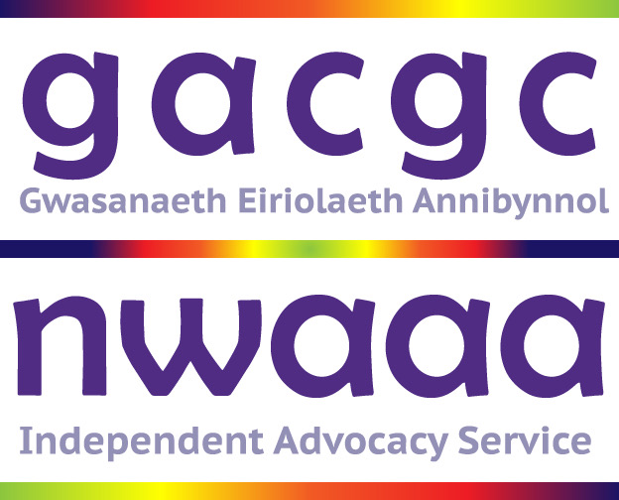

Job Application Pack

Pecyn Ymgeisio am Swydd



Part 1
Personal Details/ Manylion Personol

Full Name /Enw Llawn
Address /Cyfeiriad

Phone number / Rhif ffôn
Email / ebost
Position applied for/ Swydd yr ymgeisir amdani
How much notice would you have to give at you present employment?
Faint o rybudd sydd angen ei roi arnoch cyn gadael eich swydd bresennol?

Part 2
Training and Education / Hyfforddiant ac Addysg
Please tell us about any relevant education, further education or training that you have had
Dywedwch wrthym am addysg berthnasol, addysg bellach neu hyfforddiant a gawsoch
Qualification / Cymwysterau a enillwyd | Date

Employment History / Hanes Cyflogaeth
Please give details of your most recent employment and other relevant employment for the post to which you are applying. Please explain any gaps in your working history
Rhowch fanylion eich cyflogaeth ddiweddaraf ac unrhyw gyflogaeth arall sy'n berthnasol i'r swydd rydych yn ymgeisio amdani. Eglurwch unrhyw fylchau mewn cyflogaeth os gwelwch yn dda

Dates / dyddiadau | Job title / Teitl swydd | Reason for leaving / Rheswm dros adael
Name and address of employer / Enw a chyfeiriad y cyflogwr
Description of duties / dyletswyddau
Dates / dyddiadau | Job title / Teitl swydd | Reason for leaving / Rheswm dros adael
Name and address of employer / Enw a chyfeiriad y cyflogwr
Description of duties / dyletswyddau
Dates / dyddiadau | Job title / Teitl swydd | Reason for leaving / Rheswm dros adael
Name and address of employer / Enw a chyfeiriad y cyflogwr
Description of duties / dyletswyddau
Dates / dyddiadau | Job title / Teitl swydd | Reason for leaving / Rheswm dros adael
Name and address of employer / Enw a chyfeiriad y cyflogwr
Description of duties / dyletswyddau
Dates / dyddiadau | Job title / Teitl swydd | Reason for leaving / Rheswm dros adael
Name and address of employer / Enw a chyfeiriad y cyflogwr
Description of duties / dyletswyddau

Volunteer experiences / profiadau gwirfoddoli
Tell us about any community or voluntary work that you have been involved in
Dywedwch wrthym hefyd am waith yn y gymuned neu waith gwirfoddol yr ydych wedi'i gyflawni

Part 3
Person Specification / Y Fanyleb Person
Please tell us how you fit the requirements of the Person Specification.
Please include any explanations or evidence of experience that shows you fit the Person Specification.
Dywedwch wrthym sut rydych chi’n gymwys i ateb gofynion y Fanyleb Person.
Dylech gynnwys esboniadau neu dystiolaeth o brofiad sy’n dangos eich bod yn gweddu i’r Fanyleb.

References / Canolwr
Please give us the names and addresses of two people who we can contact for references. These referees should not be relatives. One should be your present or last employer. If in education or training your tutor will be acceptable.
Referees will not be contacted before an offer of employment without your prior consent.

Rhowch enwau a chyfeiriadau dau o bobl y gallwn gysylltu â nhw am eirdaon os gwelwch yn dda. Ni ddylent fod yn berthnasau i chi. Dylai’ch cyflogwr presennol neu ddiwethaf fod yn un ohonynt. Os ydych mewn addysg neu hyfforddiant bydd eich tiwtor yn dderbyniol.
Ni chysylltir â chanolwyr cyn cynnig swydd heb eich caniatâd yn gyntaf.
Referee / Canolwr 1
Name and contact details/ enw a Manylion cyswllt | Relationship / Perthynas
Referee / Canolwr 2
Name and contact details/ enw a Manylion cyswllt | Relationship / Perthynas

If you wish, please tell us what adjustments we may need to make to assist you at any interview
Os dymunwch, dywedwch wrthym pa addasiadau y gall fod angen i ni eu gwneud i'ch cynorthwyo mewn unrhyw gyfweliad

Are there any dates that you would be unable to attend an interview?
A oes dyddiadau na allech ddod i gyfweliad?

Travelling during the course of the job and access to transport is a requirement of the post
Mae angen teithio yn rhinwedd y swydd
Do you hold a current full driving license?
A oes gennych drwydded yrru lawn gyfredol?

If No, please give details of how you will carry out the requirements of the job
Os ateboch chi nac oes, dywedwch sut fyddwch chi’n cyflawni gofynion y swydd os gwelwch

NWAAA work with vulnerable people, it is therefore essential that all of our staff are DBS checked and cleared.
If you are offered a position with NWAAA you will be subject to an enhanced DBS check.
NWAAA reserve the right to use our discretion regarding spent or unspent convictions which may be disclosed to us as part of the recruitment process.
If you wish to disclose a conviction you may do so below.
Part 4
Declaration

Privacy Notice
All information within this application form will be processed in accordance with the GDPR 2018.
In signing this for you agree that this data is held and processed and also agree that this and any additional personal information is held and processed in accordance with the Act.
A copy of our Privacy Notice is Attached .
Caiff pob gwybodaeth yn y cais hwn ei phrosesu’n unol â Y Rheoliad Diogelu Data Cyffredinol 2018.
Wrth lofnodi hwn, rydych yn cytuno y cedwir ac y prosesir y data hwn a’ch bod yn cytuno hefyd y cedwir a phrosesir unrhyw wybodaeth bersonol ychwanegol yn unol â’r Ddeddf.

I confirm that the above information is correct to the best of my knowledge.
I accept that providing false information may lead to my dismissal.
I agree that all appropriate checks are made.
Rwy’n cadarnhau fod yr wybodaeth uchod yn gywir hyd y gwn.
Rwy’n derbyn y gall darparu gwybodaeth ffug arwain fy niswyddo.
Rwy’n cytuno y gwneir pob gwiriad priodol.

Applicants signature /
Llofnod yr Ymgeisydd
Date / dyddiad
Please return this form to/Dychwelwch y ffurflen hon at:
enquiry@nwaaa.co.uk
or
The Manager/ Y Rheolwr
North Wales Advice and Advocacy Association /Cymdeithas Cynghori ac Adfocatiaeth Gogledd Cymru
13a Llys Onnen
Parc Menai
Bangor
Gwynedd
LL57 4

