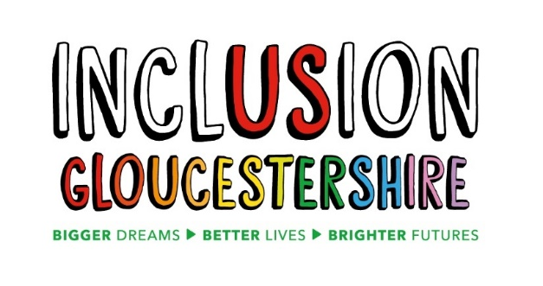

Job Description – HR Manager
Inclusion Gloucestershire is a thriving Disabled People’s Organisation with a busy HR function. We employ 90 staff, nearly all of whom are part time, and many of whom have valuable lived experience as disabled people.
The HR Manager will provide professional, compassionate, and proactive HR leadership across the charity, and is a newly created role aiming to reduce reliance on external advisors. Working within a Disabled People’s Organisation, accessibility, accountability, inclusiveness and coproduction (working with people with lived experience to develop the way we do things) are all essential elements of our HR function. The role combines operational HR delivery with strategic input, ensuring people practices are legally compliant, values-led, inclusive, and supportive of a positive organisational culture where people thrive.
Job Purpose:
To lead on day-to-day HR activity with support from a HR Administrator, in line with strategy and guidance set by the SLT, ensuring staff are supported, developed and treated fairly and consistently.
Reports to: Finance Director
Main Duties and Responsibilities
Key Responsibilities
1. Recruitment & Onboarding
- Provide recruitment support to managers, including role design, adverts, shortlisting guidance, interview support, and safer recruitment processes.
- Lead and deliver HR induction, including:
  - Group induction sessions
  - One-to-one inductions as required
- Ensure smooth onboarding and collaboration with Health & Safety colleagues on required admin.
2. HR Policies, Guidance & Compliance
- Coproduce, develop, update, and share clear HR guidance, policies, and procedures, ensuring accessibility and consistency of practice.
- Create and deliver internal training for managers and teams to ensure that processes and practices are understood.
- Oversee ongoing HR compliance, including employment law, safer recruitment practices, and audit readiness.
- Monitor and implement changes in legislation affecting the charity as an employer.
3. Staff Wellbeing & Organisational Development
- Support culture review and development work, including staff engagement, values-based practice, and wellbeing initiatives.
- Lead on organisation-wide staff support and wellbeing initiatives, including organising staff socials (alongside the Social Committee), fostering team engagement and sharing/signposting to external wellbeing support.
- Share an annual Staff Survey, and work alongside the SLT to analyse results and implement an agreed action plan in response to feedback.
4. Employee Relations & Case Management
- Lead and manage HR processes including investigations, disciplinaries, and grievance processes, ensuring timely, fair, and legally compliant outcomes.
- Provide clear guidance and support to managers about less complex HR matters.
- Maintain accurate records and ensure learning from cases is shared appropriately to inform future practice.
5. HR Advice & External Liaison
- Where necessary, liaise with external HR or legal advisors, coordinating advice, follow-up actions, and implementation.
- Interpret employment law guidance and translate it into practical, charity-appropriate HR practices.
6. HR Administration Oversight
- Oversee and manage day-to-day HR administration, as carried out by a HR Administrator, ensuring accuracy, timeliness, and confidentiality.
- Oversee HR systems, records, and reporting, delegating tasks appropriately while retaining accountability.
7. Performance Management & Development
- Provide oversight of staff support and appraisals, ensuring Managers are carrying them out consistently across the organisation.
- Review themes and trends arising from appraisals and staff surveys, identifying development needs or organisational risks.
- Support the development and delivery of a training and development plan, including some training delivery where appropriate.
8. Exit & Organisational Learning
- Lead exit interviews, capturing learning and sharing relevant themes with SLT and managers.
- Maintain exit data, run retention and sickness reports and contribute to workforce planning and retention strategies.
9. Equality, Diversity & Inclusion (EDI)
- Monitor EDI data and practices, identifying opportunities for improvement.
- Support inclusive policy development, staff awareness, and ongoing improvement aligned with the charity’s values and mission.
10. Governance & Leadership Support
- Chair monthly HR meetings, ensuring action tracking and accountability.
- Act as the key HR liaison for the Board HR Subcommittee, preparing reports and attending meetings as required.
- Provide clear HR reporting and insights to SLT and trustees where appropriate.
11. Additional Responsibilities
- Contribute to organisational planning and change activity from a people perspective.
- Undertake any other reasonable duties consistent with the role.
Essential Skills/Experience
N.B Those items marked * will be used as shortlisting criteria for this post so should be covered in an application
- CIPD qualification (Level 5 or above) or equivalent experience*
- Significant experience in a HR role, ideally within the charity or public sector*
- Strong knowledge of UK employment law and HR best practice
- Strong understanding of reasonable adjustments and inclusion of disabled employees
- Proven experience managing employee relations cases end-to-end*
- Ability to work sensitively and confidently in an inclusive organisation in which the majority of staff are disabled
- Excellent communication, judgement, and relationship-building skills
Desirable Skills/Experience
- Experience of EDI monitoring and improvement work
- Experience of organisational culture or change initiatives
- Understanding of safeguarding and safer recruitment in charity contexts
Personal Characteristics
- High level of emotional intelligence and self-awareness
- Empathetic and approachable, with a people-centred mindset
- Demonstrates integrity, fairness and impartiality at all times
- Calm and resilient when dealing with complex or emotionally charged situations
- Confident decision-maker with sound judgement
- Acts as a role model for organisational values and behaviours
- Capable of leading change and supporting others through it
- Demonstrates a genuine commitment to equality, diversity and inclusion
- Passionate about developing people and positive workplace culture
- Values continuous learning and professional development
- Employee-focused while maintaining a clear understanding of business priorities
- Organised and methodical approach to work
- Ability to manage multiple processes simultaneously

Values and Personal Beliefs

Inclusion Gloucestershire is driven by its values, at the heart of all that it does. Teams are expected to share and demonstrate these values:

- Value lived experience – as an organisation led by disabled people, for disabled people
- Respect – each other, our community, our environment, and our partners
- Include – a broad range of lived experience, because we are better together
- Empower – strong voices and choice and control for people facing disabling barriers



