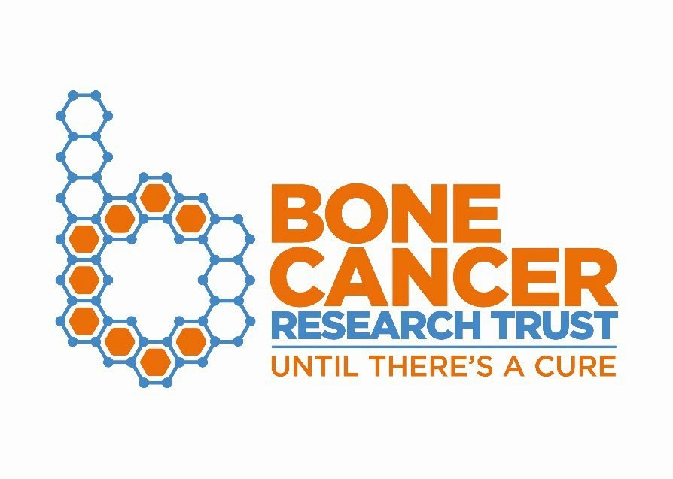
Involvement Officer
Job Information Pack

Job title | Involvement Officer
Reports to | Director of Research & Information
Line management | Currently no direct reports, but will be responsible for the coordination of members of our patient involvement panel and can supervise volunteers in the office and on site at events
Salary | £27,000 - £30,000 dependent on experience
Hours of work | Full time
Contract type | Permanent
Location | Hybrid working between our office, based in Horsforth, Leeds and home working is preferred, however, remote working will be considered for the right candidate. Nationwide travel will be required.

About the Bone Cancer Research Trust
We’re delighted that you are interested in working for the Bone Cancer Research Trust (BCRT). Included in this pack is a little background information about the organisation along with details of the job role. BCRT currently employs 30 members of staff, and we have a voluntary Trustee board of 12, based across the UK.
Our charity started in 2004, when a group of families who had lost children and young people to primary bone cancer (PBC) came together. They wanted to tackle head-on the fact that there was virtually no accessible bone cancer information, and practically no funding for research into this disease. In 2006, they registered the Bone Cancer Research Trust. Since then, we have become the leading charity dedicated to fighting primary bone cancer.
We are incredibly lucky to have a very active and highly engaged community of supporters. Through their support, we have significantly increased our income to £3 million per annum. This increase has enabled us to fund more pioneering primary bone cancer research than any other organisation in the UK. And whilst our research is finding the cures of the future, our dedicated Support & Information Service is available for all patients and their families now, offering expert advice and support through treatment and beyond. Our awareness campaigns continue to raise the profile of primary bone cancer amongst the public and healthcare professionals throughout the UK and worldwide to improve disease understanding and speed of diagnosis.
It is a truly exciting time to be joining our award-winning team, as we have recently launched our 10-year strategic plan and you will play a pivotal role in its delivery. Directly informed by our supporters and stakeholders, our future ambitions will continue to drive improvements in patient survival and ensure patients are supported to find their ‘new normal’ after treatment.
If you are excited about joining our team, please read through this job pack to see if you have the right skills we are looking for. We look forward to hearing from you!

Purpose of the role
This role sits at the junction of lived experience involvement and our charitable objectives and will build meaningful collaborations and alignment between those affected by primary bone cancer, researchers, healthcare professionals and other stakeholders. The successful candidate will be required to build relationships with and contribute to key organisations and initiatives, such as the FOSTER and Euro Ewing consortia, like minded charities and Sarcoma Patients Global Network.
The successful candidate will co-ordinate and grow our Patient and Public Involvement Panel, which currently focuses on bringing lived experience to shape and review primary bone cancer research; however, we are keen for the voices of our community to contribute to our work across all our charitable pillars including our Support & Information service and our Influencing & Advocacy work. You will also support and empower our panel to share the work of Bone Cancer Research Trust more widely to their networks, ensuring a greater awareness of the charity and the impact of our work.
This is a varied position offering the chance to apply and further develop your expertise in involvement across areas such as the shaping and reviewing of research, the capturing and sharing of lived experience through written and video stories, ensuring our health information is patient focused and understandable, and advocating with and for patients both nationally and globally.
We are looking for someone with a good grasp of both the scientific and patient landscapes, who can balance attention to detail with big-picture awareness and work confidently in highly collaborative settings with multiple stakeholders and partner organisations. This role offers a unique opportunity to make a tangible contribution and ensure that our community’s voices drive progress across the UK and further afield.
The successful candidate will be a natural communicator and will excel at building and maintaining relationships with a variety of stakeholders. A background in cancer research or research funding would be advantageous.
The role will be charity wide, working closely with staff from all areas of the charity and other key stakeholders such as Bone Cancer Research Trust Trustees, researchers, clinicians and supporters.

Key Benefits
- Flexible approach to working hours
- 30 days annual leave per year plus bank holidays
- An extra leave day in every 5th year of employment to celebrate your work anniversary
- Healthcare cash plan & Employee Assistance Programme
- 6% employer pension contributions
- Clear performance expectations and opportunity to increase salary banding annually
- Enhanced sickness, maternity and adoption leave
- Training and personal development opportunities
- Option to purchase up to 5 days additional annual leave
- Life Assurance of 4x annual salary
- Free onsite parking at our Horsforth office
- Access to clinical supervision with an external psychologist

We believe wholeheartedly in supporting our staff to do their very best, irrespective of working location. If needed, and following a workstation assessment, you will receive an allowance for a home-working workstation and all necessary home-working equipment will be provided.

Key responsibilities
- Co-ordinate all aspects of our Patient and Public Involvement Panel.
- Working with the Research, Information, Support & Advocacy Team, develop and deliver a wider patient engagement and involvement programme, providing opportunities for those with lived experience to engage with all aspects of the charity, from shaping the research we fund, working with us to advocate for improved and equitable care to sharing their experiences to support others.
- Act as a key liaison with Sarcoma Patients Global Network (SPAGN) and other patient advocacy groups, ensuring the UK primary bone cancer patient voice is represented.
- Co-ordinate our medical school partnership programme, allowing undergraduate medical and physiotherapy students the opportunity to undertake projects working directly with primary bone cancer patients.
- Co-ordinate the planning and delivery of involvement & engagement events.
- Working with the Support Service Development Manager to facilitate the capture and sharing of lived experiences through written and video stories.
- Supporting our Policy and Awareness officer to ensure that we advocate for our community to drive improvements and equity in primary bone cancer care.
- Build and maintain strong working relationships with patient advocates, researchers, funders, and partner organisations, ensuring clear communication and effective collaboration.
- Contribute to the planning and delivery of multi-stakeholder meetings, workshops, and webinars that bring together patients, researchers, and other partners to discuss research priorities and approaches.
- Support the creation and delivery of training materials, sessions, and talks for patient groups, researchers, and other stakeholders on topics such as patient and public involvement and primary bone cancer.
- Support Bone Cancer Research Trust-led research projects and initiatives and ensure the patient voice is represented.
- Work closely with the rest of the Research, Information, Support & Advocacy Team to engage researchers, healthcare workers, and like-minded organisations with Bone Cancer Research Trust. This may be through the organisation of (and attendance at) lab or hospital visits, regional workshops and conferences.
- Present the work of Bone Cancer Research Trust at conferences and meetings.
- Ensure Bone Cancer Research Trust’s database is kept up to date with any communications from or to patients, supporters, clinical colleagues and researchers.
- Carry out any other tasks that are commensurate with the general level of this post as required by the Head of Research

Personal Specification

No candidate will meet every essential and desired criterion. If your experience looks a little different from what we’ve identified and you think you can bring value to the role, we’d love to learn more about you.

Criteria | Essential | Desired | Method of Assessment
Qualifications
Educated to a minimum of A level or equivalent | X |  | Application  Form / CV
Excellent written and verbal English | X |  | Application  Form / CV
Qualifications, knowledge or experience in a biomedical science, preferably cancer biology |  | X | Application  Form / CV
Experience
Experience of working in patient involvement and engagement or working closely with service users. | X |  | Application  Form /  Interview
Proven experience in communicating science or medical information to a variety of audiences | X
Experience of working in a medical research charity |  | X
Experience in or knowledge of science funding and/or grant management | X |  | Application  Form /  Interview
Experience in or knowledge of scientific literature searches and able to understand and digest scientific writing | X |  | Application  Form /  Interview
Experience of co-ordinating volunteers |  | X | Application  Form /  Interview

Excellent written and verbal communication skills with the ability to transmit key messages in a variety of ways to varied audiences | X |  | Application  Form /  Interview
Knowledge of where to source reliable information, and the ability to interpret and present it accurately | X |  | Application  Form /  Interview
Sound understanding and experience of  Microsoft Office software including Word,  PowerPoint, Excel and Publisher | X |  | Application  Form /  Interview

Experience of using CRM databases |  | X | Application  Form /  Interview
Working with project management tools (preferably Teamworks) |  | X | Application  Form /  Interview
Knowledge and understanding of primary bone cancer and the key related issues |  | X | Application  Form /  Interview
Personal Attributes
Excellent interpersonal skills with the ability to build effective working relationships | X |  | Application  Form /  Interview
Ability to work independently and as part of an effective team | X |  | Application  Form /  Interview
Strong ability to work on own initiative with limited supervision yet knowing when to refer to line manager when necessary | X |  | Application  Form /  Interview
A shared passion for the work of the Bone Cancer Research Trust |  | X | Application  Form /  Interview
Ability to work logically, methodically and accurately with a keen attention to detail. | X |  | Application  Form /  Interview
Ability to plan and prioritise a varied workload. | X |  | Application  Form /  Interview
Willing and able to travel within the UK | X |  | Application  Form /  Interview
Holds a UK driving license |  | X | Application  Form /  Interview

How to apply
The Bone Cancer Research Trust promotes an inclusive culture. We are committed to encouraging further growth from diverse groups, and we welcome applications from people from under-represented groups or communities.
For informal discussions about the role, please contact zoe.davison@bcrt.org.uk. Please return your completed application form and equality and diversity monitoring form to sarah.yates@bcrt.org.uk by 5pm on the 24th August 2026.

