

Haileybury Youth Trust [HYT] Fundraising Manager
NGO registered with the Charity Commission: 303244
www.hytuganda.com
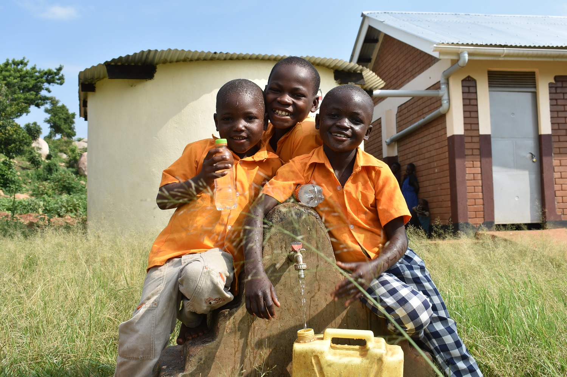

HYT is a unique, award-winning charity transforming lives in Uganda with its programmes of climate-friendly building and vocational training, working with some of the world’s poorest communities. We are passionate about working alongside refugees and local youths, sustainably and in a way that does not cost the earth.

ROLE
Fundraising Manager
(Part time - 0.5 Equivalent)
Full time equivalent of £40,000-£42,000 pa (paid as a consultant per month with no benefits)
Reporting to HYT Director
Home based

Employer Information
HYT is a small, award-winning charity (NGO) that promotes climate-friendly building and vocational training in Uganda, particularly in refugee settlements and with other marginalised groups. HYT advocates the use of a sustainable building technology as an alternative to the environmentally-damaging local brick. HYT has worked in Uganda since 2006 and has worked in most areas of the country, with a full-time staff of 13, led by the Country Manager who reports to the Director in the UK.
HYT was first established in 1892 by the then [Head] Master of Haileybury College. While HYT is an independently constituted charity, the association with Haileybury continues to be close and the Master remains a Trustee.
Since HYT’s relocation to Uganda in 2006, the Trust has enjoyed an international reputation for the quality of its construction of climate-friendly classrooms and other school buildings, rainwater harvesting tanks, latrines and simple housing. Also important is the vocational training in construction given to local youths.
In 2017 HYT was awarded the prestigious International Sustainable Buildings Award by Ashden, a globally-recognised environmental agency. The UK High Commission in Kampala made a film of HYT’s work in Bidibidi refugee settlement, shown at the COP26 Conference in Glasgow and the Trust is respected in Uganda by UNHCR and the Office of the Uganda Prime Minister.
Historically HYT has had three principal income streams: firstly funds raised through conventional channels of giving and events, mostly by members of the Haileybury community. Funds have also been generated by work commissioned by other NGOs and, finally, funds have been generated through grants, awarded in the UK and Uganda, most recently a grant from the German government to build 500 household latrines in Bidibidi settlement for South Sudanese refugees.
The Trustees have determined that for the longer term sustainability of HYT, an increased and regular funding stream is now needed and that a professional fundraiser is required to help shape and implement this new strategy as the Trust looks forward to its next decade.

Main job purpose
Working with the Director, you will devise and lead new fundraising initiatives that support the HYT Fundraising Strategy and annual income budget. Particular focus will be on regular givers, high-net-worth individuals, legacies and Trust and Foundation grants.
You will develop a strong HYT supporter network.
You will successfully locate, engage and retain HYT supporters and steward them to ensure their long-term impact on HYT and its beneficiaries.

KEY TASKS AND TARGET OUTCOMES
Work with the Director, you will devise a plan to connect with existing and potential supporters, creating a strong and engaged network
- Strong, growing, engaged network of HYT supporters who can support HYT through fundraising, by showcasing the impact of HYT activities
Research and approach potential supporters with whom HYT is not currently connected
- Continue to grow the network and prospect pipeline for fundraising opportunities. Work closely with the Director to find opportunities to engage the HYT supporter network and ensure clear consistent messaging
Ensure the HYT supporter network stays connected and clearly establishes the value of HYT programmes; good stewardship leading to greater engagement, including funding
- Work with the Director to show the HYT supporter network the impact they can make by evidencing long term outcome of programmes
Create an annual impact report to underpin a credible case for support for the long term impact of HYT programmes
- Deliver excellent stewardship for the HYT supporter network by running a programme of events and communications to engage different audiences with clear, differentiated communication plans for all members of the network. Ensure HYT supporter network is connected to HYT, value its activities and leads to funding opportunities that will develop a long-term income stream
You will work with the Director to devise and implement new fundraising initiatives through HYT supporter network and Trusts and Foundations, that will generate required income to the annual budget
- HYT has a realistic, actionable and appropriate fundraising strategy that will provide the new income required to grow HYT’s activities
Over time, deliver an income at or above the agreed income target through Trusts and Foundations, as well as the HYT supporter network
- Deliver income required by HYT to deliver its programmes and meet its commitments to beneficiaries in the short and long term
To research prospects within HYT supporter network and analyse data to inform the fundraising strategy especially regarding high-net-worth individuals and legacies and a wider base of younger, lower level givers
- Fundraising approaches are well-targeted and informed to maximise the chances of success
To create, manage and maintain relevant and accurate data as required within the HYT CRM system and protocols
- HYT retains a full and accurate database of all fundraising activities to help support long-term impact-tracking and inform future fundraising
To be proactive and target driven to move work forward and present solutions to any challenges that arise
- The post holder demonstrates clear ownership of tasks and proactively shows progression towards this, asking for support whenever needed
Provide regular reporting on performance against engagement/income targets and prospect pipeline
- HYT has clear vision of future funding and prospect opportunities
The above tasks are not an exhaustive list of duties, and you will be expected to perform different tasks as necessitated by your changing role within the charity and its objectives

SKILLS, KNOWLEDGE and EXPERIENCE
You will have (essential):
- A successful track record (at least 3 years’ experience) as a fundraiser, ideally with previous experience of alumni fundraising, major gifts, Trusts and Foundations and legacies
- Event management experience
- Highly skilled in prospect research to identify new HYT supporters to join the network, especially high net worth individuals
- A strong networker who can seek out opportunities
- Experience of leading successful fundraising initiatives as well as bid-writing and/or creating and delivering sales pitches
- Excellent communication skills, both verbal and written, with the presence and authority required to command attention at the most senior levels
- Strong persuasive and negotiating skills which result in positive outcomes, with the resilience and motivation to overcome negative responses to proposals
- A proactive, ‘can-do’ attitude that will enthuse prospective and current supporters, colleagues and volunteers
- Strong organisational skills and experience of managing a pipeline of prospective funders and accurate forecasting
- Deadline aware
- Confident use of the internet for creative research purposes, as well as standard office IT packages e.g. Word, Outlook, Excel and CRM system (when selected)
- Adaptable and responsive to the needs of a small not for profit organisation which relies heavily on a large volunteer network
- A willingness to embrace HYT’s values
You may also have (desirable):
A basic knowledge of international development issues with a particular interest in environmental and training initiatives, practice and thinking as relevant to HYT

Applications
- a letter of application and CV should be sent to Charity Job
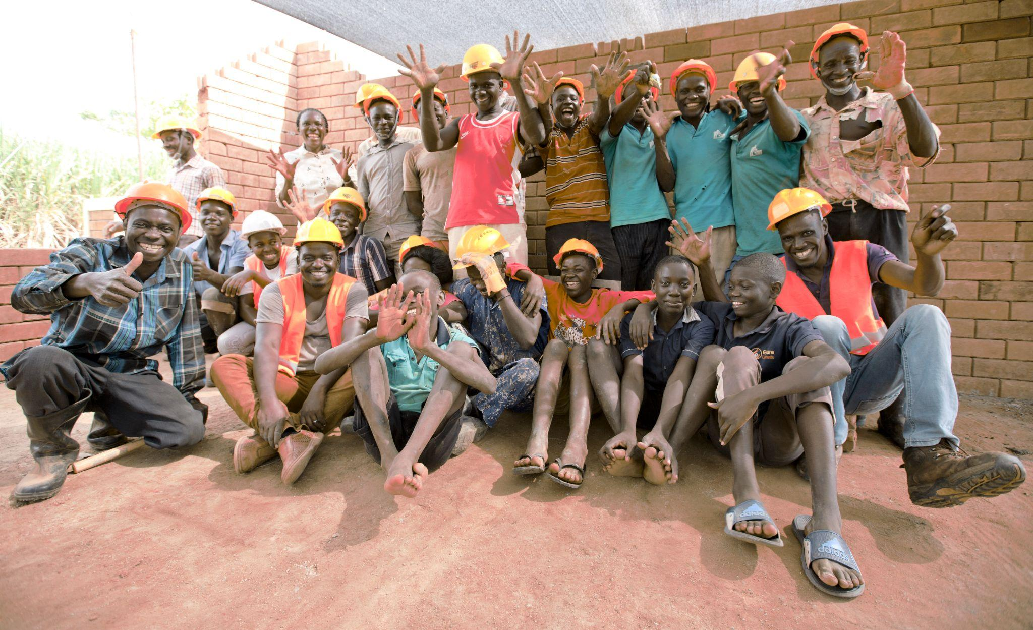
- closing date for applications: Sunday 22 March

