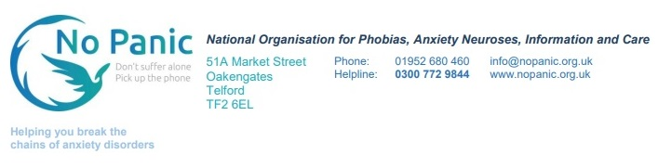
Thank you for applying to volunteer on the No Panic Helpline.
Please be aware that this is a role that involves a fair amount of commitment.
When people call the No Panic Helpline, they are often desperate for help, and need someone to be there to answer their call. We don’t want to let them down, so we need volunteers who are committed to cover their chosen shift every week, ideally for at least a year, because callers rely on someone being there to answer the phone.
Training Course
Before going on the helpline, we will give you 8 weeks training. The course is delivered over a conference call or zoom, depending on the trainer, and is 1 ½ hours on one evening a week, starting at 7pm. You will need this to equip you to go onto the helpline, so it is essential that you complete the full course.
The course will include role play and there is a small amount of homework every week, consisting of gathering more information on the anxiety disorder being discussed and, later on, a phone call with a paired trainee to practise techniques taught.
There is a small fee of £25 to cover our costs for producing the training materials.
The Helpline
Once you and your trainer are confident that you are ready for the helpline, you will be asked to select a weekly 3-hour shift – shifts are 10am-1pm, 1pm-4pm, 4pm-7pm and 7pm-10pm every day.
Once you have selected a shift that suits you, you will be added to the rota and be relied upon to cover that shift every week.
Support
For the first 6 months on the helpline, you will be on probation, so we will give you extra support. For 2 months, this will involve you calling an experienced helpliner at the end of your shifts to discuss the calls you have taken and answer your questions. After that, it will be through a monthly 1-hour support call with a group of fellow volunteers, extending to bi-monthly as you gain more experience; it is important that you attend these groups.
References
No Panic can provide a reference for you after you have worked on the helpline for one year.

