
Job Description
JOB TITLE: Grants and Fundraising Officer
LOCATION: Petty Pool Vocational College, Pool Lane, Sandiway, Cheshire, CW8 2DR
REPORTS TO: Head of Marketing and Fundraising
SALARY: £27,746.07 - £32,165.30 per annum
HOURS: 35 Hours per week - Monday to Friday 8.30am-4.30pm – Flexibility hybrid working.
DBS: Enhanced check required.
Grants and Fundraising Officer
About Petty Pool
Petty Pool is a vibrant and inclusive organisation supporting young people with learning disabilities and difficulties to achieve their full potential. We deliver education, training, outdoor learning and pathways into employment across our college, outdoor centre and wider group activities – all designed to empower, inspire and enable every individual.
The Role
We are seeking an experienced and motivated Grants and Fundraising Officer to lead and coordinate all fundraising activity across the Petty Pool Group, including Petty Pool, Cheshire Autism Practical Support, and The Ground Up Project CIC. Reporting to the Head of Marketing and Fundraising, you will be responsible for developing and delivering fundraising strategies that generate sustainable income from a variety of sources – including grants, trusts and foundations, community fundraising, events and corporate partnerships.
You’ll be joining at an exciting time of growth and development for Petty Pool and will play a vital role in helping us expand our reach and impact across the North West and beyond.
Key Responsibilities
- Strategic Leadership:
Develop and implement a cross-organisational fundraising strategy aligned with Petty Pool’s vision and income targets.
- Grants, Trusts and Foundations:
Identify, research and apply to relevant grant-making bodies; manage relationships with funders and ensure timely reporting.
- Community & Events Fundraising:
Lead on the creation and promotion of community fundraising campaigns and events to engage local supporters and stakeholders.
- Corporate Partnerships:
Build and maintain relationships with local businesses and sponsors to secure long-term support and mutually beneficial partnerships.
- Donor Stewardship:
Manage donor database and maintain strong relationships with individual and institutional donors to ensure continued support.
- Budget Management:
Monitor and report on fundraising budgets and income targets, ensuring effective ROI and compliance.
- Collaboration:
Work closely with the marketing and communications team to develop compelling fundraising materials and campaigns, and stakeholder communications.
- Reporting:
Provide regular updates to the Head of Marketing and Fundraising and senior leadership team on progress, insights, and opportunities.

Person Specification

Essential:
- Proven experience of developing and delivering successful fundraising strategies
- Strong track record of securing income from grants, trusts and foundations
- Excellent written and verbal communication skills
- Skilled at building and maintaining positive relationships with funders, donors and community stakeholders
- Highly organised with the ability to manage multiple projects and deadlines
- Confident in working independently and collaboratively within a team
Desirable:
- Experience in the education or charity sector
- Familiarity with CRM and fundraising databases (e.g. Beacon)
- Experience managing community or events-based fundraising activities

What We Offer
- A friendly, passionate and purpose-driven working environment.
- Opportunities for professional development and training.
- Flexible working options/ hybrid working.
- 28 days annual leave, plus bank holidays.
- Free meals when commuting by car sharing, walking, or cycling.
- A chance to make a real difference in the lives of young people with learning disabilities.

Our Trust is committed to safeguarding and promoting the welfare of our children and young people and expects all staff and volunteers to share this commitment.

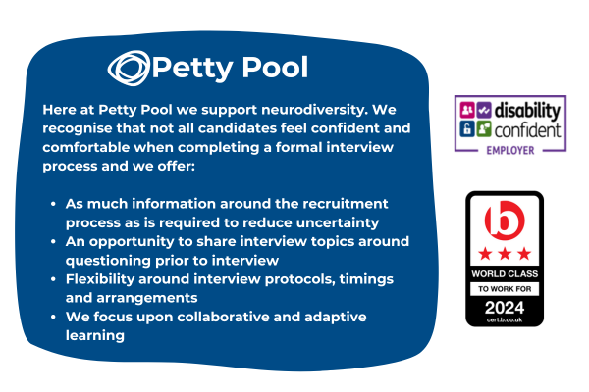
Petty Pool is an equal-opportunity employer. We are committed to equality of opportunity for all staff and applications from individuals are encouraged regardless of age, disability, sex, gender reassignment, sexual orientation, pregnancy and maternity, race, religion or belief and marriage and civil partnerships.

