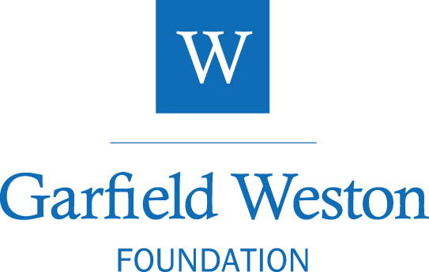

DRAFT

Role Specification
Grants & Foundation Assistant

Background Information

Established in 1958, the Garfield Weston Foundation is a family-founded charitable grant-making trust which in the last two financial years donated over £100 million a year to charities across the UK. Since it was established, it has donated over £1.7 billion. Last year, around 3,000 charities benefited from the grants awarded by the Foundation in sectors ranging from welfare and education to the arts and the environment.

The Weston Family Trustees today remain actively involved in the Foundation’s work. The Foundation’s funding was established with an endowment of shares in the family business – a successful model designed to build for the long term that has ensured that, as the businesses have grown, so too have the charitable donations.

The Foundation is well known for flexibility, as its strategy is deliberately responsive and adapts to need. Its key belief is that those at the front line of providing charitable services are best placed to identify the needs and create the most effective solutions as they understand the sectors in which they work. The Trustees aim to support talented people with practical ideas rather than to impose direction. They support quality and excellence in initiatives demonstrating clear outcomes and benefits.

Further information about the Foundation and the charities it supports can be found at:
www.garfieldweston.org

Role Purpose

This role plays a crucial and varied role in the Foundation, providing administrative support to charities at all stages of the application and grant management process, as well as to colleagues. With a strong customer service orientation, the role holder will be a key point of contact for charities with queries relating to applying to the Foundation and existing grants. The role will suit someone comfortable working with databases, and able to manage multiple priorities effectively and efficiently, and who enjoys helping people.

Key Responsibilities

- To provide administrative and systems support across the team supporting colleagues as and when required, covering a range of activities, which may include:
  - checking eligibility of applications, managing updates (incl. pledge releases),
  - managing shared inboxes, and coordinating timely and consistent responses across the team
  - Inputting, updating and maintaining data within the grants database ensuring a high standard of data integrity, enabling effective and informed funding decisions.
  - providing administrative and operations support across the grant management process and Payment processes
  - Providing support to ensure continuity of service during periods of absence or peak demand.

- To act as a key point of contact for grant applicants, providing clear, responsive and supportive guidance by phone and email, handling enquiries and ensuring a positive experience of the foundation.
- To monitor application workflows and carry out regular checks to ensure a smooth flow of grant processing, checking applicants have provided information requested .
- Contribute to the continuous improvement of grants processes and systems, identifying opportunities to enhance efficiency, consistency, and applicant experience
- Maintain the values of the organisation and support the team in delivering its mission;
- Be flexible and willing to take on other suitable responsibilities for the as are appropriate for the role, as and when they arise.

Professional Skills, Knowledge, and Experience

Skills
- Strong digital skills, with confidence in using core Microsoft products including Excel, Outlook, and Word.
- Familiarity with databases or grant management systems, with the ability to manage and maintain accurate up to date records.
- Excellent communication skills to support effective interaction with colleagues and external stakeholders in a warm and professional manner on the phone, in person and via email.
- Excellent attention to detail and ability to meet deadlines.
- Strong organisational and prioritisation skills, with the ability to manage a varied workload, work at pace, and respond flexibly to changing priorities and deadlines
- Collaborative team player, proactive in providing support and assistance to colleagues, and a focus on continuous improvement.
- Adaptable with a ‘can do’ attitude
- Passion for eth charitable sector

Experience
- Proven ability to work effectively in a team, liaising with stakeholders across all functions and building effective relationships.
- Proven ability to provide effective and reliable administrative support within a professional environment..
- Experience of working in a fast-paced environment, with the ability to plan ahead and manage competing priorities.
- Experience of working flexibility to support team objectives, adapting to changing needs on a day to day basis.
- Experience of using digital tools and systems to improve efficiency and support effective ways of working.

General Information

Hours: Full-time
Term: Fixed term: 18months (extendable by mutual agreement)
Reporting: The role reports initially to the Head of Grants. Wittington Investments Limited is the employing entity of the Garfield Weston Foundation team.
Location: The Foundation Offices in central London W1. On a discretionary basis, team members are offered the opportunity to work from home on one day a week (post probation).
The office has secure space for bicycles, showers (towels and toiletries provided) and also provides excellent facilities (refreshments & hot drinks, fresh fruit, etc).
Salary: Between £30,000 - £32,000 per annum, depending on experience.
Additional benefits: the role comes with certain additional benefits, including contribution to a company pension scheme: details can be provided upon enquiry
To apply: We are partnering with The Talent Set on this appointment, so please apply for the position with your CV only through the following link.
Deadline: DATE. Sunday 5th July at Midnight

The Garfield Weston Foundation values and celebrates diversity. We welcome and encourage all applicants and encourage you to apply if you are from a community that is often disadvantaged by society or of minority background.

