Job Description
Position | Grantmaking and Communications Officer
Division | Strategy
Reports to | Head of Charity
Accountable to | Chief of Kaizen
Band | 5
Location | Surrey and Sussex Healthcare NHS Trust [expected to work and travel to all Trust sites]
DBS Disclosure required | Yes

Job purpose

The Grantmaking and Communications Officer will play a key role in two vital areas of the charity’s work:
- Administering the funding of impactful projects for people across our services,
- Showing people the impact of this funding – making it much more visible to internal and external audiences.

The role will proactively administer the charity’s grantmaking, maintaining up to date records of committee funding decisions, and liaising with funding applicants to ensure money is spent promptly and has a positive impact for patients and staff.

The role will work with funding applicants, charity colleagues, and the Trust communications team to show people how their donations help.

You will work proactively, and independently with successful funding applicants to ensure charity funded work is completed promptly, and that charity support is acknowledged both in the hospitals, and externally. You will manage your own workload and prioritisation to gather case studies, photos, videos and quotes for use in social media posts and charity communications.

The role will act as a representative of the charity in internal and external communications. For example, through filming or taking part in video or social media interviews with beneficiaries of charitable funding. You will bring energy and enthusiasm to the role, helping inspire future supporters of the charity through seeing the impact of their support.

Our values
As an employee of Surrey and Sussex Healthcare NHS Trust, you have an individual responsibility to treat everybody with:

Dignity and Respect: we value each person as an individual and will challenge disrespectful and inappropriate behaviour. | One Team: we work together and have a ‘can do’ approach to all that we do recognising that we all add value with equal worth.
Compassion: we respond with humanity and kindness and search for things we can do, however small; we do not wait to be asked because we care. | Safety and Quality: we take responsibility for our actions, decisions and behaviours in delivering safe, high quality care.

Strategic objectives

- Deliver safe healthcare – Ensure every day in our care adds value. Reduce avoidable harm and unwarranted variation. Optimise our capacity that prioritises patient need. Protect elective care. Deliver the best care to the most people possible.

- A great place to work – Culture where colleagues feel they belong and are heard. Protect our colleagues from harm and promote wellbeing. Create opportunities for development for all. Use SASH+ to continuously improve the way we work.

- Be a valued partner – Listen and learn from our partners and community. Take a collective leadership approach based upon trust. Develop and integrate our clinical relationships across Surrey and Sussex. Build on our strengths and exchange expertise with our partners.

- Improve health outcomes – Work collaboratively at place to improve our populations health outcomes. Understand and reduce health inequalities and improve access to services. Measure outcomes to improve what we do.

- Financially Sustainable – Maximise use of resources. Minimise waste. Live within budgeted allocation. Deliver evidence-based care to ensure value for patients. Evolve service portfolio in collaboration with our partners.
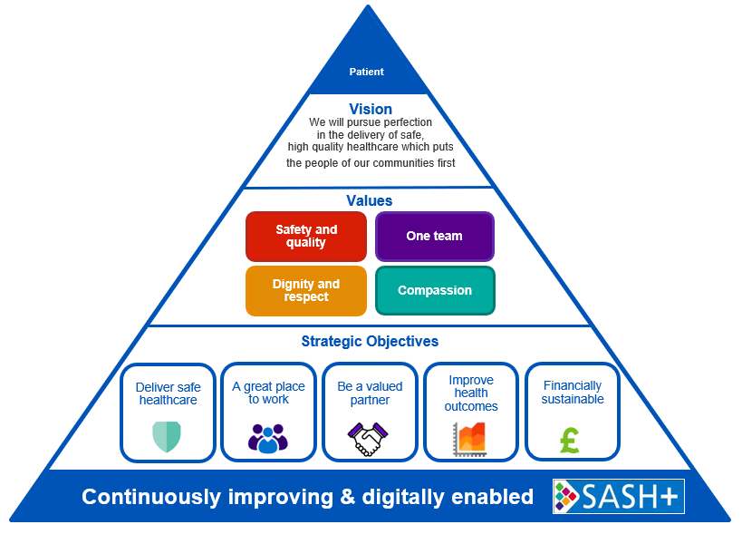

Key working relationships

- The Charity team – Head of Charity, and Fundraising Officer.
- Close SASH NHS Trust colleagues including the communications team, finance team, and procurement team.
- Trust staff who apply for funds.
- External donors and supporters.

Structure chart
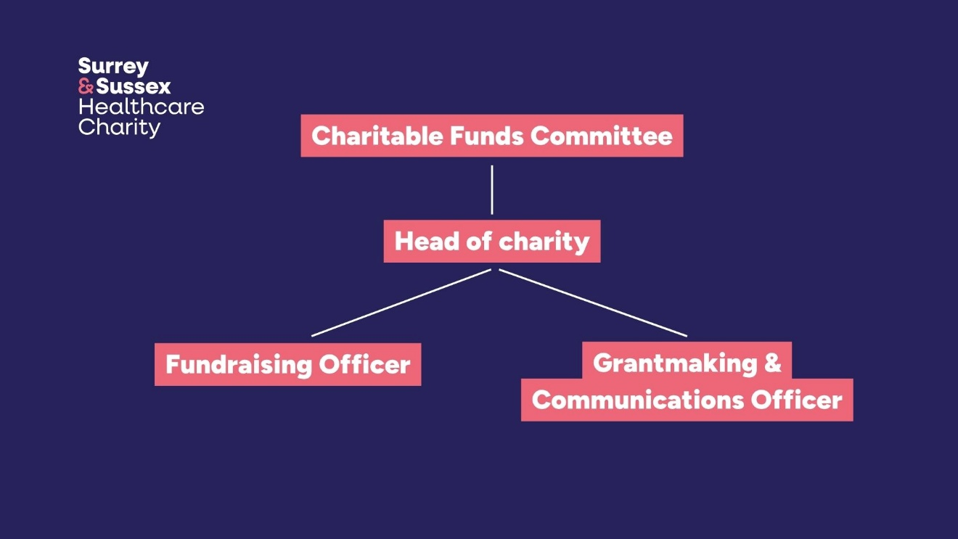

Main duties and key responsibilities

- The Grantmaking and Communications officer will be responsible for administering the charity’s grant making, working with people at all levels across SASH to ensure charity funding is used to bring about successful results and benefit to patients and staff. The role involves managing complex stakeholder relationships, influencing at all levels, and overcoming communication barriers to ensure projects are understood and supported.

- To be the main point of contact for funding applicants (usually staff at SASH) from beginning to end of their grant application. Provide advice to applicants on the application process, and ensure applicants complete their applications fully before they are submitted to the charity subgroup or committee for consideration.

- To use your own judgement and critical thinking to help advise funding applicants on how to have maximum impact through charity funding, while staying within charity spending policies and charity commission guidance.

- Using multiple information systems maintain accurate records of grants correspondence and decisions on the charity’s CRM system (Beacon CRM), and other systems as required.

- Prepare meeting agendas and minutes for the Charitable Funds Subgroup and ensure clear records of key funding decisions made by the group.

- Communicate charity funding decisions (or requests for additional information) to applicants and ensure they understand the ordering process.

- Work closely with successful funding applicants, finance and procurement colleagues, to ensure timely completion of charity funded projects.

- Proactively identify and suggest ways to improve our grantmaking policies and processes. Working to make our grantmaking as efficient and effective as possible.

- The Grantmaking and Communications Officer will maximise visibility for the charity’s support across SASH. So, patients, visitors, and external audiences see the positive impact of donations.

- The role will work proactively and use judgement to identify the best way to demonstrate the charity’s support for everything it has in recent years. In many cases this would be through putting a ‘funded by’ charity sticker on items, or designing and installing posters, wall displays, or acknowledgement in digital communications including social media.

- Plan, organise and coordinate multiple complex charitable funding projects simultaneously, managing applications through the full charity approval process, providing expert guidance to applicants, tracking progress against key milestones, and prioritising competing demands to ensure timely and effective allocation of charitable funds.
- Story gathering: To work with successful funding applicants, staff, and patients across the Trust to gather compelling examples of the impact of charity funding.

- To take photos, create or gather video content and quotes for everything the Charity funds, and use personal judgement to identify the most appropriate and powerful ways to share stories/impact of the charity’s work.

- To ensure content is provided for Social Media, Website, Digital Comms, Press Releases, the Charity Magazine and any media that will help enhance the objectives of the Royal Surrey Charity.

- To create and share charity social media content – for example Instagram stories. Working within agreed guidelines to film and share charity impact examples in an engaging, inspiring way.

- To represent the Charity in video content. For example, narrating, or presenting/taking part in engaging video interviews with people who have benefitted from charity funding.

- A great ambassador for the charity. A key representative of the charity to our beneficiaries - NHS staff and patients when projects are funded, and our external audiences – donors, and potential supporters when communicating the impact of the charity’s work.
- To support the Fundraising Officer and Head of Charity with other projects as required. This may include liaising with or thanking donors or representing the charity at internal or external events.

- To be fully aware of the Charity’s strategy and fundraising plans.

- To ensure all work is in line with NHS Trust, and Charity policies

- Working with systems including:
  - Microsoft Office
  - Social Media
    - Instagram
    - Facebook
    - LinkedIn
  - Beacon CRM (no prior knowledge of this needed – training will be provided)
  - Docusign (no prior knowledge of this needed – training will be provided)
  - NHS procurement systems including Oracle (no prior knowledge of this needed – training will be provided)

- The role will be office based at East Surrey Hospital, with regular visits to wards and departments around the Trust’s sites (including Crawley Hospital, Horsham Hospital, and others) to see charity funded projects or represent the charity.

- The post holder will require enhanced keyboard skills to full utilise digital system as well as other equipment, for example a digital camera, or mobile phone to film content or take photos.

- Occasionally the role will also involve helping represent the charity at external events. This will sometimes mean evening or weekend events. Time off in lieu can be offered where out of hours work has been required.

- Physical effort. You will need to be able to visit hospital departments, and occasionally to assist with moving charity equipment. For example, leaflets, or helping to assemble a gazebo.

- There is a frequent requirement for prolonged concentrate when managing multiple projects through to successful conclusion.

- The role will occasionally involve hearing emotionally difficult stories from members of staff or supporters of the charity who may have been through challenging experiences.

- Frequent use of VDU equipment for prolonged periods of time.

This is an outline job description designed to give an overview of the responsibilities of the post. The post holder will be expected to be flexible to respond to change and organisational need. The post holder will also be expected to contribute to the wider corporate and organisational needs of the Trust as appropriate.

Community Diagnostic Centres (CDC)
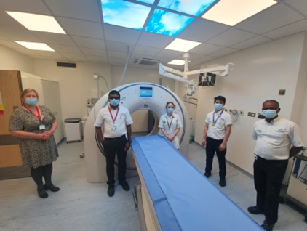
The creation of CDCs was recommended following Professor Sir Mike Richards’ Review of NHS diagnostics capacity. The recommendation was that NHS organisations across England move to providing diagnostic services in Community Diagnostic Centres (CDCs) and all health systems are expected to include a network of CDCs as part of their health services offer.

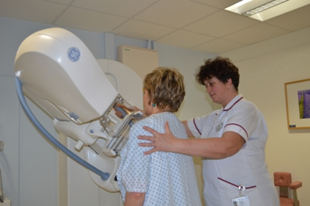
The CDCs will allow patients to access planned diagnostic care nearer to home without the need to attend acute hospital sites. These services would be separate to urgent diagnostic scan facilities, which means shorter waiting times and a reduced risk of cancellation which can happen when more urgent cases take priority. Therefore, this would lead to improved patient experience and outcomes.

CDC Ambitions

The CDCs will help achieve the following ambitions:

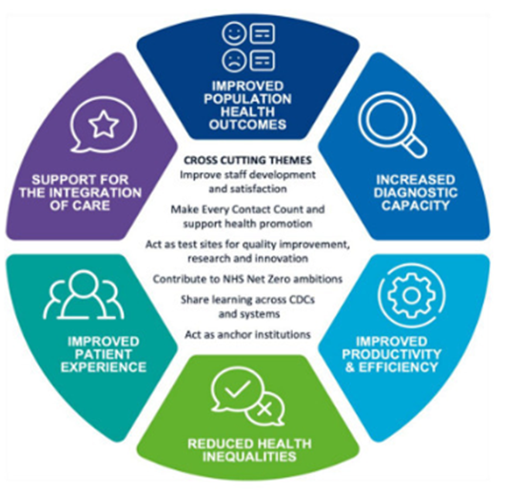
- To improve population health outcomes by diagnosing health conditions earlier, faster and more accurately
- To increase capacity in the diagnostic service by investing in new facilities, equipment and training new staff, contributing to recovery from COVID-19 and reducing pressure on acute hospital sites
- To improve productivity and efficiency by streamlining the way we provide acute and elective (planned) diagnostic services where it makes sense to do so; redesigning clinical pathways to reduce unnecessary steps, tests or duplication
- To contribute to reducing health inequalities by ensuring everyone has the same access to care and the same health outcomes
- To deliver a better diagnostic service and more personalised experience by providing a single point of access to a range of services in the community
- To support more joined-up care across primary, community and secondary care.

General

Information about the Trust
Surrey and Sussex Healthcare NHS Trust is one of the region's busiest providers of healthcare. It was formed on 1 April 1998 following a merger between East Surrey Healthcare NHS and Crawley Horsham NHS Trusts. We are often referred to as 'SASH'.
We run East Surrey Hospital in Redhill, where we have more than 700 beds and provide acute and complex services. In addition, we provide a range of outpatient, diagnostic and less complex planned services at The Earlswood Centre, Caterham Dene Hospital, Crawley Hospital and Horsham Hospital.

Every year, over 120,000 people attend our Emergency Department, we deliver nearly 4,000 babies and almost half a million people have outpatient appointments with us.
We are a major local employer, with a diverse workforce of around 5,500 staff providing healthcare services to a growing population of some 744,000 people.
Having previously been rated Outstanding by the Care Quality Commission in 2019 and winning the prestigious Health Service Journal (HSJ) award for Acute Trust of the Year in 2021, the Trust is now on an improvement journey and is fully committed to becoming an outstanding organisation once again and on delivering the improvements our staff, patients and local communities rightly expect.
We are proud to be an inclusive employer, and we work hard to create an environment where everyone feels valued and supported. At our Trust, we strive to be the best place to work and receive care. We are dedicated to supporting you in your current role while helping you grow and develop your career. As part of our team, you will have access to excellent training opportunities, flexible working, dedicated support networks, and a strong emphasis on health and wellbeing to ensure a thriving and positive work environment.
Information Governance
Whilst employed by the Trust you may have access to patient or staff information, this information must be kept confidential and must not be disclosed to anybody other than when acting in an official capacity. The unauthorised use or disclosure of patient or other personal information is a dismissible offence for Gross Misconduct under the Trust’s Disciplinary Policy and could also result in criminal prosecution. All staff must work in accordance with the General Data Protection Regulation (GDPR) and familiarise themselves with the Trust’s information governance and related policies and procedures.

If this post involves the collection, entry, change or deletion of any data items either electronic or manual (e.g. the Trust Patient Administration System) it is your responsibility to ensure that as far as is reasonably possible, you have ensured that those details are accurate and up-to-date.

If this post manages members of staff, it is your responsibility to ensure that these staff are made aware of Trust policies and procedures relating to their area of work and to ensure that these are followed at all times. This post must also ensure that staff receive adequate and relevant training required by them to enable them to carry out their duties.

All employees must familiarise themselves with and adhere to all Trust policies and procedures including the following:
- Risk Management Policy and Strategy
- Smoking on site policy
- Equal Opportunities in Employment, including the Equality Act
- The Caldicott Principles
Safeguarding children and adults at risk of abuse
All Trust employees have a responsibility to safeguard and promote the welfare of children and adults at risk of abuse. As such, you have a duty to familiarise yourself with the Safeguarding Adult and Safeguarding and promoting the welfare of Children policies available via SASHnet.

Research & Development
Our onsite SASH research and development team aims to promote a culture in which research and innovation are embedded in routine clinical practice and generate an environment in which research findings lead to improvements in the quality of patient care. It is our priority to support NIHR (National Institute for Health and Care Research) portfolio studies - these are high quality, peer reviewed studies which have been through a competitive bid process. The research outcomes will be of benefit to the NHS, patients, users and staff.

SASH is part of the NIHR Clinical Research Network Kent, Surrey and Sussex and as an employee of the Trust, you are invited to participate in our wide-ranging clinical research studies. As part of this you will be required to comply with all reporting requirements, systems and duties of action put in place by the Trust to deliver research governance standards.

No Smoking Policy
Surrey and Sussex Healthcare NHS Trust is a smoke free Trust covering trust premises, grounds and any trust owned vehicle. Staff should not smoke during their working hours and will be protected from passive smoking both in the Trust and whilst making home visits.

Intellectual Property
From time to time during the normal course of your employment you may generate Intellectual Property (IP) which may have value in the delivery of better patient care. Where such Intellectual Property (IP) is created in the course of your employment or normal duties then under UK law it will generally belong to the Trust, unless agreed otherwise in writing between you and the Trust.

The Intellectual Property policy has been approved by the Trust Board and can be found on the Trust Intranet Site. Trust Procedures are consistent with the Management Framework for Intellectual Property (IP) of the Department of Health. You are required to comply with these procedures.

Clinical Governance
The Trust has a comprehensive clinical governance programme and all clinicians are expected to be engaged with this work. For example, participation in clinical audit, morbidity/mortality meetings, reporting incidents and near misses and responding to complaints. Specialist doctors/dentists are expected to play an active role in the continued development of the service in such a way as to take into account the views of patients and their carers.

East Surrey Area
East Surrey has an enviable reputation as one of the most sought-after Home Counties in the UK. Equal distance between the South Coast and London, the county is a leafy suburb with access to some of the most popular schools in the country. The county provides an ideal place to settle with children and is a great base to explore the delights of the Surrey Downs. The City of Brighton provides a mixture of vibrant nightlife and unique shopping experiences and is in easy reach by road and rail link.

Home to the famous Ascot Ladies Day and Epsom Derby Horse Race, the county also has several well-known National Trust places including Box Hill, an area of outstanding natural beauty.

With Gatwick Airport on the doorstep, the location provides excellent access to the UK’s second largest airport and a gateway to Europe and further afield for those wanting to explore.

Sunshine Day Nursery (located at East Surrey Hospital)

Open between 07:00 and 18:00. Sunshine Day Nursery is open 52 weeks of the year except for bank holidays, Christmas and New Year's Eve.
We have a large outside play area for the children to enjoy and explore, with a castle, climbing frame/slide and soft play area with sensory garden. There is a canopy that runs along the 2/5's playrooms so the children can access the garden in all weather. All rooms have access to the garden via double patio doors.
Sunshine Day Nursery is committed to helping parents balance work/life responsibilities by providing high quality childcare and education. We offer a friendly, professional, safe and stimulating environment for your child. As a team we are caring, reliable, enthusiastic and passionate about what we do. We believe by providing an enabling environment and meeting children’s individual needs, this creates a good start in your child’s life. This is achieved by furthering their development, which promotes the foundations of their early education. We recognise that the child’s expert and prime educators are their parents/carers and build excellent relationships with parents. This is shown through parents returning with siblings and recommending us to their friends and colleagues. We also pride ourselves on our low staff turnover.
Health & wellbeing
As part of our commitment to our employees, SASH have onsite occupational health & engagement/wellbeing teams who provide a wealth of initiatives to support the health of our workforce.
Some of these include:
- Free on-site and online fitness and mindfulness sessions, including yoga, Pilates and circuit-style classes.
- Promotion of a range of wellbeing apps such as Headspace, Unmind (currently free to NHS staff)
- Weekly colleague led walking and running club.
- Quarterly staff surveys – including the annual national NHS staff survey.

Person Specification

Essential | Desirable | Evidenced by
Qualifications
- Degree level or equivalent qualification in any marketing, communications, charity related subject, business administration or equivalent relevant experience | Professional qualification in marketing, communications, charity related subject, business administration | - Application and Interview
Experience
Demonstratable experience of working independently to solve problems using a range of information | Experience of managing multiple projects, and / or projects involving a range of people  Experience of working in charity  Experience using social media in professional or voluntary role  Experience in an administrative role or a specific grant making role | - Application and Interview
Knowledge, Skills and Competencies
Well organised with the ability to work independently to systematically and proactively prioritise the most valuable / impactful work  Experience using computers, VDU equipment and digital systems  Proficient in the use of all Microsoft office packages  Strong written and verbal communication skills with the ability to communicate clearly and professionally  Confident in the use of social media platforms, particularly Instagram, Facebook and LinkedIn  Ability to build and maintain effective working relationships with a wide range of stakeholders  Able to work collaboratively and cooperatively with Trust staff at all levels, patients, donors and supporters.  Strong interpersonal skills with the ability to engage appropriately with diverse groups of people  Comfortable presenting to a range of audiences, and representing the charity in external communications (e.g. social media videos) |  | - Application and Interview
Behaviours and Values
- Flexibility in shift/working patterns to meet the needs of the service  - Is able to participate as a team member  - Willing to accept additional responsibilities as delegated by senior staff  - Displays SASH Values:  - Dignity and Respect  - One Team  - Compassion  - Safety and Quality |  | - Application and Interview

