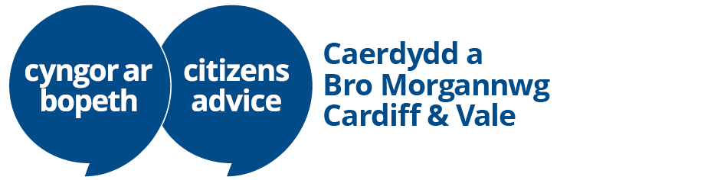

Generalist Adviser Person Specification

What we’re looking for
Your areas of knowledge and experience

There are no specific qualifications you must have for this role. However, there are several key skills and attributes that you need to be a successful generalist adviser. These include:

Skills and abilities
- Resilience: You must be confident in handling challenging or emotionally sensitive situations in a calm and professional manner
- Communication: You must have strong listening and questioning skills, with the ability to sensitively explore client issues and be able to communicate clearly and empathetically, both verbally and in writing
- Problem solving: You must be able to assess complex situations, interpret information and clearly advise clients on the options available to them
- Talking and typing: You must be able to talk and type at the same time, recording details of the client and their enquiry whilst speaking to them on the phone
- Time management: You manage time effectively to achieve performance targets

Personal Attributes
- You must be impartial and non-judgmental, with the ability to support clients from all backgrounds in a respectful, unbiased, and empathetic manner
- You are committed to upholding the values of fairness, inclusion, and respect for others in the workplace
- You are willing to learn and adapt, including receiving and acting on feedback to improve performance
- You are reliable, self-motivated, and able to work independently and collaboratively within a team
- You demonstrate professional integrity and always maintain appropriate boundaries with clients

